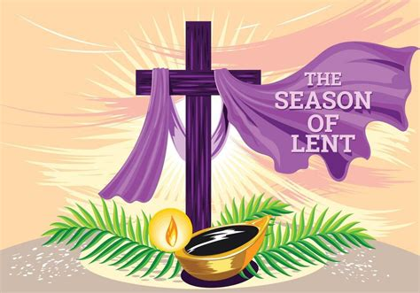

+ + + + + + + + + + + + + + +
The 3rd Wednesday in Lent
March 11th , 2026
11:00 a.m. and 7:00 p.m.
+ + + + + + + + + + + + + + +
BETHLEHEM LUTHERAN CHURCH
A congregation of The Lutheran Church-Missouri Synod
902 Hitchcock Drive SW,
Aiken, South Carolina 29803
Church Phone: (803) 649-6417
blcaikensc@gmail.com
Pastor: Rev. John B. Engwall
Office Hours By Appointment
Bethlehem Lutheran welcomes our members and guests to our worship service! Unable to join us in person? Please find us on Facebook live. The service is also posted on our website; bethlehemlutheranaiken.org.

(Stand)

423 JESUS, REFUGE OF THE WEARY
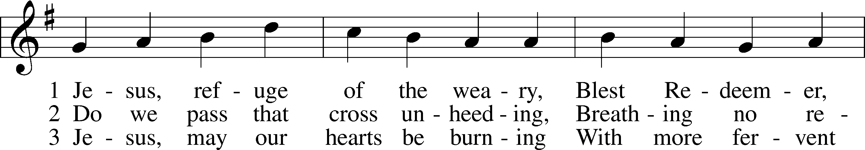
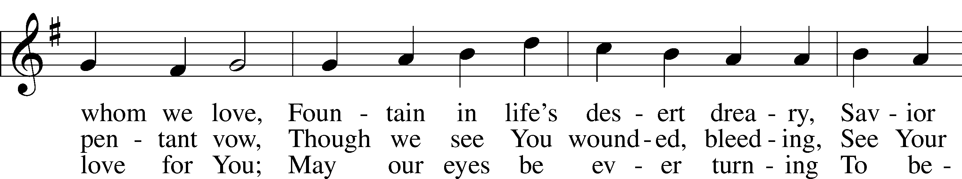
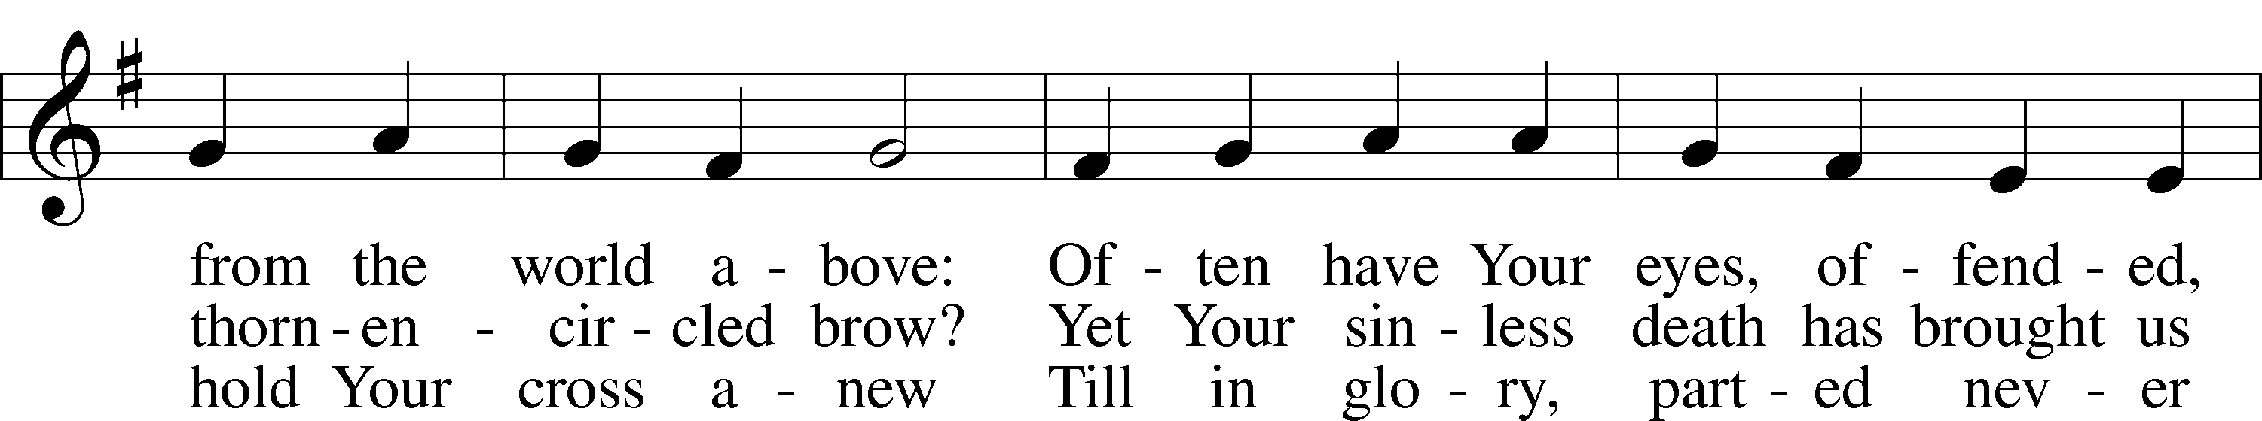
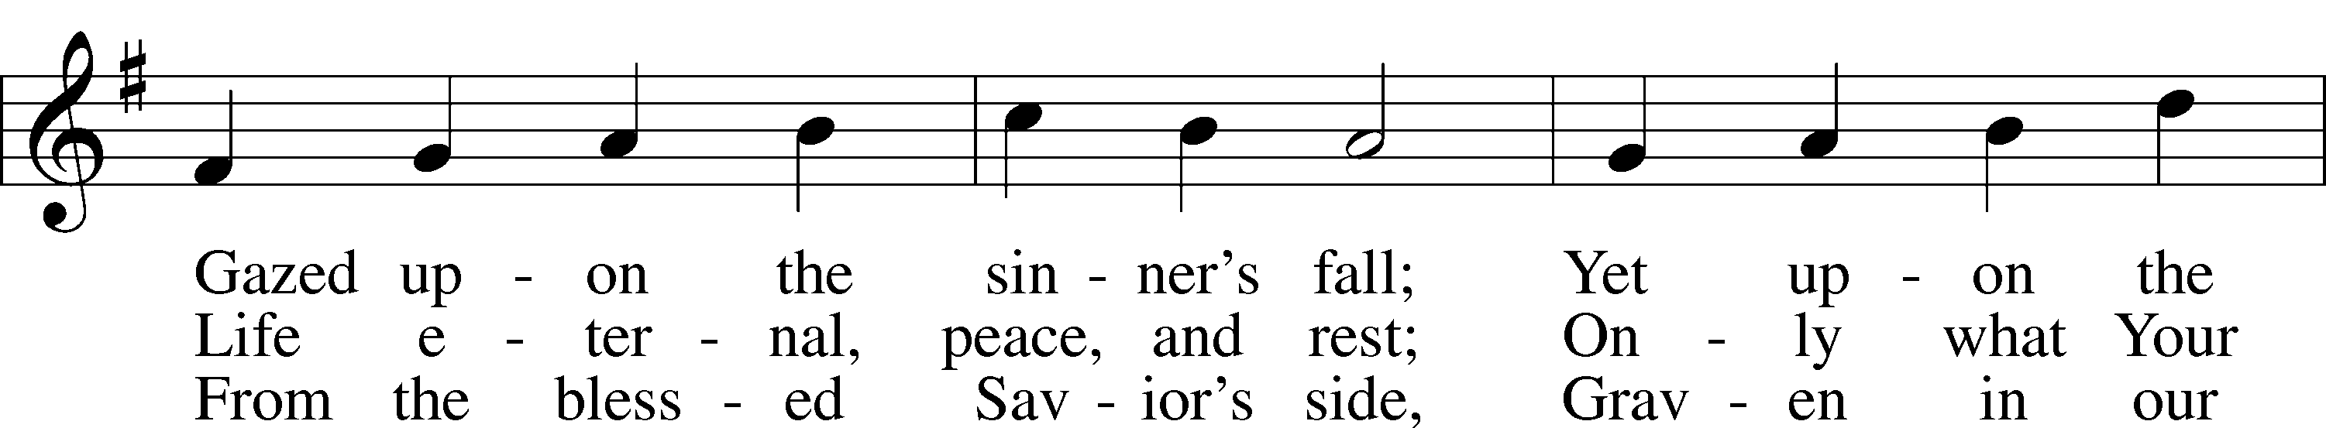
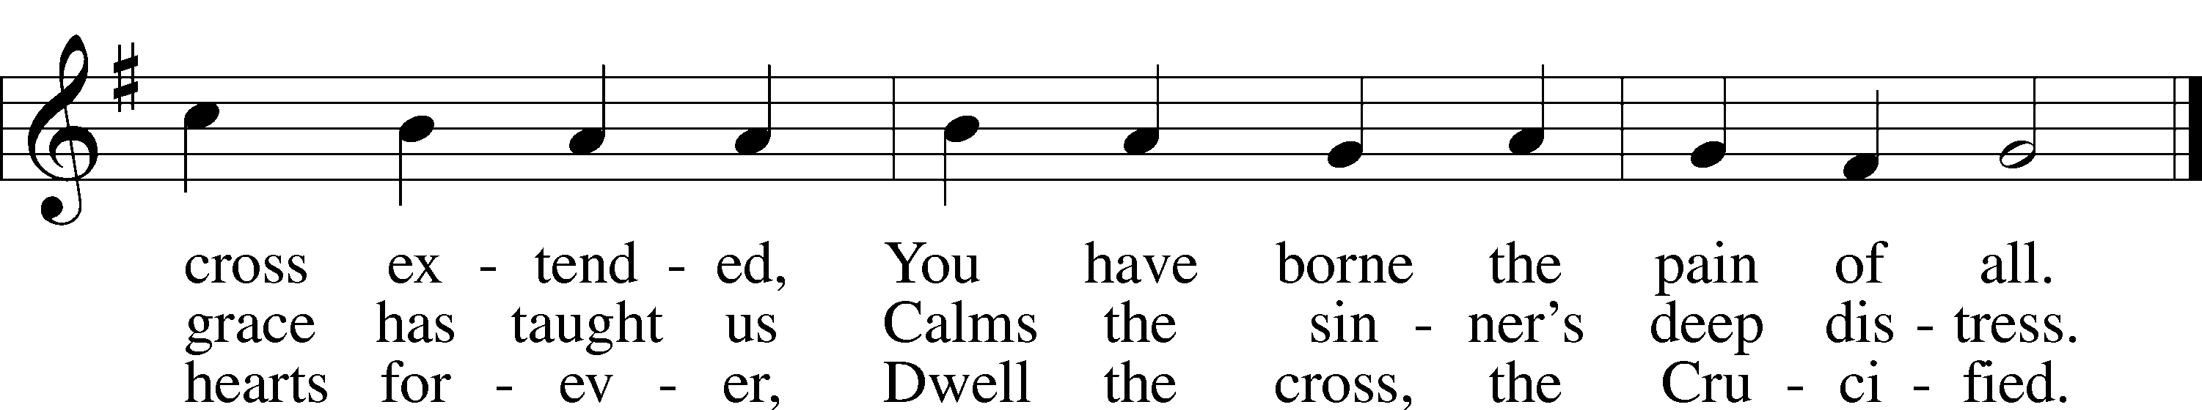
Text: Girolamo Savonarola, 1452–98; tr. Jane F. Wilde, 1826–96, alt.
Tune: Erbaulicher Musicalischer Christen-Schatz, 1745, Basel
Text and tune: Public domain

COLLECT OF THE DAY
P O God, whose glory it is always to have mercy, be gracious to all who have gone astray from Your ways and bring them again with penitent hearts and steadfast faith to embrace and hold fast the unchangeable truth of Your Word; through Jesus Christ, Your Son, our Lord, who lives and reigns with You and the Holy Spirit, one God, now and forever.
C Amen.

(Sit)

READING Exodus 17:1–7
1All the congregation of the people of Israel moved on from the wilderness of Sin by stages, according to the commandment of the Lord, and camped at Rephidim, but there was no water for the people to drink. 2Therefore the people quarreled with Moses and said, “Give us water to drink.” And Moses said to them, “Why do you quarrel with me? Why do you test the Lord?” 3But the people thirsted there for water, and the people grumbled against Moses and said, “Why did you bring us up out of Egypt, to kill us and our children and our livestock with thirst?” 4So Moses cried to the Lord, “What shall I do with this people? They are almost ready to stone me.” 5And the Lord said to Moses, “Pass on before the people, taking with you some of the elders of Israel, and take in your hand the staff with which you struck the Nile, and go. 6Behold, I will stand before you there on the rock at Horeb, and you shall strike the rock, and water shall come out of it, and the people will drink.” And Moses did so, in the sight of the elders of Israel. 7And he called the name of the place Massah and Meribah, because of the quarreling of the people of Israel, and because they tested the Lord by saying, “Is the Lord among us or not?”

READING RESPONSE
P O Lord, have mercy on us.
C Thanks be to God.

SERMON

(Stand)

APOSTLES’ CREED
C I believe in God, the Father Almighty,
maker of heaven and earth.

And in Jesus Christ, His only Son, our Lord,
who was conceived by the Holy Spirit,
born of the virgin Mary,
suffered under Pontius Pilate,
was crucified, died and was buried.
He descended into hell.
The third day He rose again from the dead.
He ascended into heaven
and sits at the right hand of God the Father Almighty.
From thence He will come to judge the living and the dead.

I believe in the Holy Spirit,
the holy Christian Church,
the communion of saints,
the forgiveness of sins,
the resurrection of the body,
and the life T everlasting. Amen.

LORD’S PRAYER
C Our Father who art in heaven,
hallowed be Thy name,
Thy kingdom come,
Thy will be done on earth
as it is in heaven;
give us this day our daily bread;
and forgive us our trespasses
as we forgive those
who trespass against us;
and lead us not into temptation,
but deliver us from evil.
For Thine is the kingdom
and the power and the glory
forever and ever. Amen.

BLESSING
P The grace of our Lord T Jesus Christ and the love of God and the communion of the Holy Spirit be with you all.
C Amen.

609 JESUS SINNERS DOTH RECEIVE
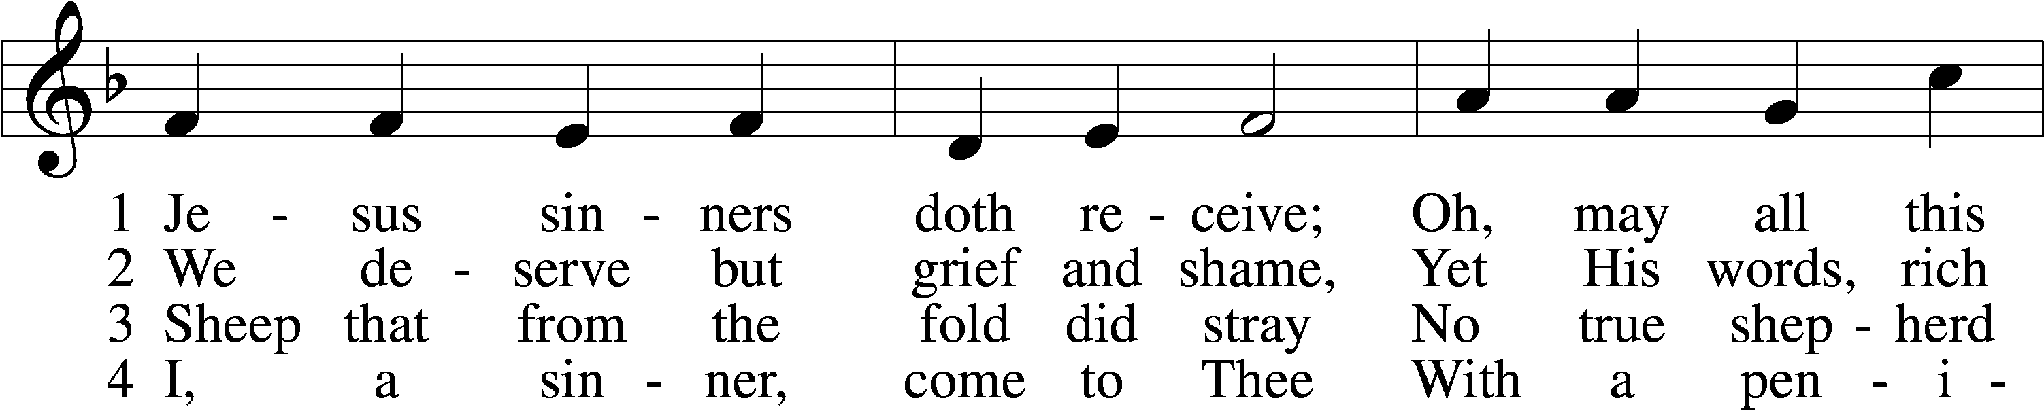
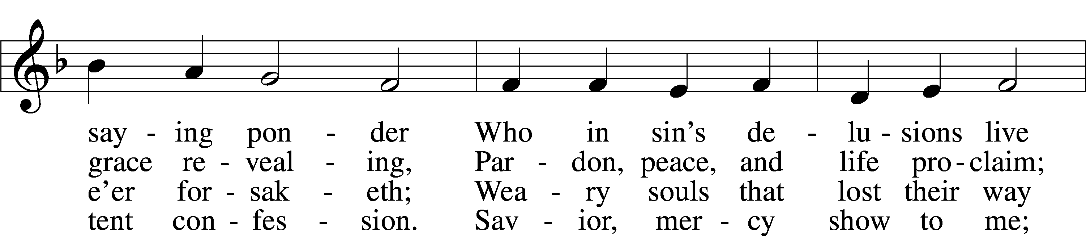
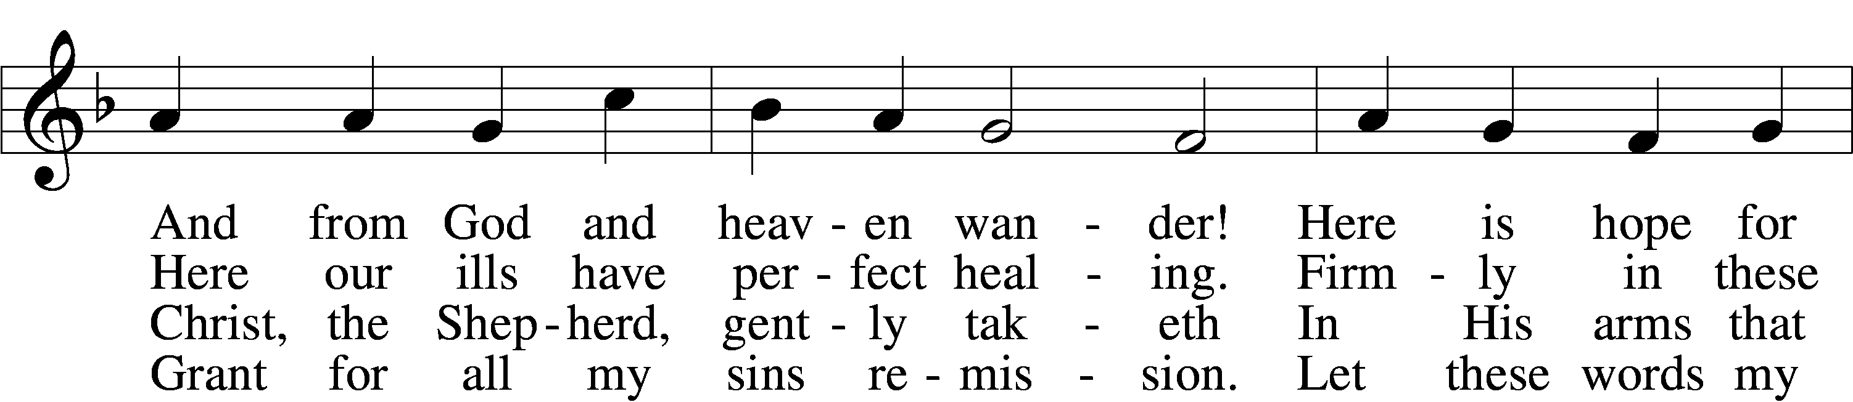
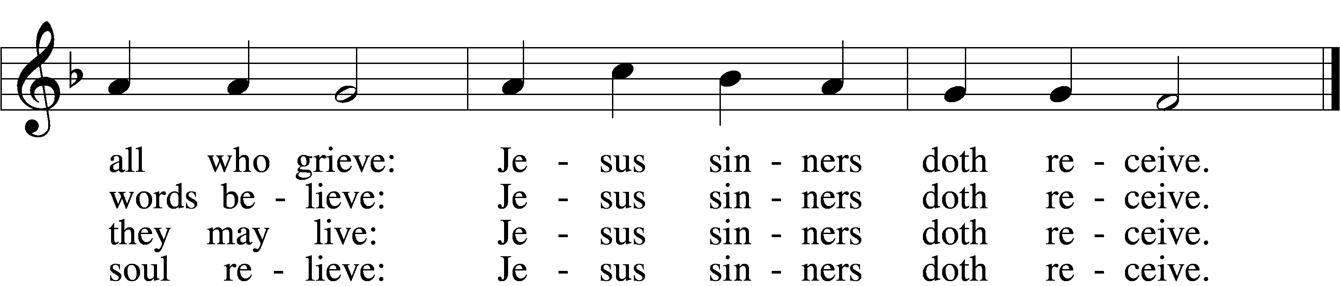

5 Oh, how blest it is to know:
Were as scarlet my transgression,
It shall be as white as snow
By Thy blood and bitter passion;
For these words I now believe:
Jesus sinners doth receive.

6 Now my conscience is at peace;
From the Law I stand acquitted.
Christ hath purchased my release
And my ev’ry sin remitted.
Naught remains my soul to grieve:
Jesus sinners doth receive. (next page)

7 Jesus sinners doth receive;
Also I have been forgiven;
And when I this earth must leave,
I shall find an open heaven.
Dying, still to Him I cleave:
Jesus sinners doth receive.
Text: tr. The Lutheran Hymnal, 1941, alt.; Erdmann Neumeister, 1671–1756
Tune: Neu-verfertigtes Darmstädtisches Gesang-Buch, 1699, Darmstadt
Text and tune: Public domain

ACKNOWLEDGMENTS
Unless otherwise indicated, Scripture quotations are from the ESV® Bible (The Holy Bible, English Standard Version®), copyright © 2001 by Crossway, a publishing ministry of Good News Publishers. Used by permission. All rights reserved.
Created by Lutheran Service Builder © 2026 Concordia Publishing House.

OUR VALUE STATEMENT: Bethlehem Lutheran Church exists under God’s grace to save the lost and to strengthen the saved so that they may live bold and courageous lives of Christian witness before a non-believing world.
Therefore, our purpose is:
- to glorify God in Word and deed,
- to nurture each other in Christian love,
- to reach out to others with our Savior’s Gospel of life and salvation.
(Rom 5:8, Matt. 28:18-20).

OUR VISION: By the Grace of God, Bethlehem Lutheran Church, is a loving family united in Christ, learning, living, and spreading His Word.

OUR MISSION: Learn the Word. Live the Word. Spread the Word.

Lent, Holy Week, and Easter Schedule of services
Lenten Wednesdays: Feb. 25th; Mar. 4th,11th,18th, 25th
-Meals at 11:30 a.m. and 6:00 p.m.; services at 11:00 a.m. and 7:00 p.m.
Palm/ Passion Sunday:March 29th
Maundy Thursday: April 2nd;
7:00 p.m. Communion service
Good Friday: April 3rd;
7:00 p.m. Tenebrae service
Easter Sunday: April 5th;
9:00 a.m. breakfast, (no Bible study)
- 10:30 a.m. Divine Service (outside, weather permitting)

