

+ + + + + + + + + + + + + + +
The First Wednesday Advent Service
December 3, 2025
11:00 a.m. and 7:00 p.m.
+ + + + + + + + + + + + + + +

BETHLEHEM LUTHERAN CHURCH
A congregation of The Lutheran Church-Missouri Synod
902 Hitchcock Drive SW,
Aiken, South Carolina 29803
Church Phone: (803) 649-6417
blcaikensc@gmail.com
Pastor: Rev. John B. Engwall
Office Hours By Appointment
Note: The format of this bulletin has been modified for use in private devotion services.
Unable to join us in person? Please find us on Facebook live.
The service is also posted on our website; bethlehemlutheranaiken.org

+ + + + + + + + + + + + + + +
The First Wednesday Advent Service
December 3, 2025
11:00 a.m. and 7:00 p.m.
+ + + + + + + + + + + + + + +

+ SERVICE OF PREPARATION +
After the bell tolls, please observe a time of silence.

WELCOME AND ANNOUNCEMENTS

(stand)

331 THE ADVENT OF OUR KING
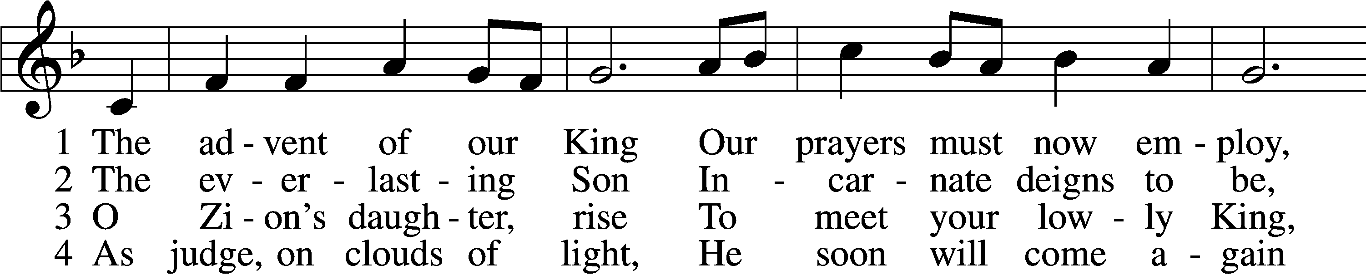
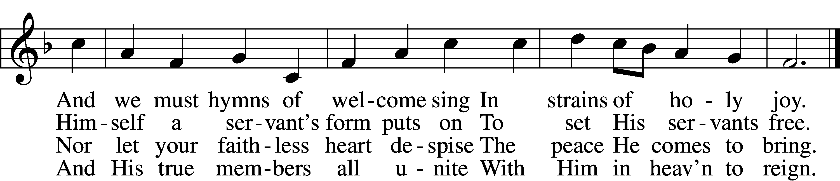

5 Before the dawning day
Let sin’s dark deeds be gone,
The sinful self be put away,
The new self now put on.

D 6 All glory to the Son,
Who comes to set us free,
With Father, Spirit, ever one
Through all eternity.
Text: Charles Coffin, 1676–1749; tr. John Chandler, 1806–76, alt.
Tune: Aaron Williams, 1731–76
Text and tune: Public domain

INVOCATION
L In the name of the Father and of the T Son and of the Holy Spirit.
C Amen.

COLLECT OF THE DAY
Stir up Your power, O Lord, and come, that by Your protection we may be rescued from the threatening perils of our sins and saved by Your mighty deliverance; for You live and reign with the Father and the Holy Spirit, one God, now and forever.
C Amen.

(sit)

READING Isaiah 11:1–10
L A reading from Isaiah, the eleventh chapter.
¹There shall come forth a shoot from the stump of Jesse,
and a branch from his roots shall bear fruit.
²And the Spirit of the Lord shall rest upon him,
the Spirit of wisdom and understanding,
the Spirit of counsel and might,
the Spirit of knowledge and the fear of the Lord.
³And his delight shall be in the fear of the Lord.
He shall not judge by what his eyes see,
or decide disputes by what his ears hear,
⁴but with righteousness he shall judge the poor,
and decide with equity for the meek of the earth;
and he shall strike the earth with the rod of his mouth,
and with the breath of his lips he shall kill the wicked.
⁵Righteousness shall be the belt of his waist,
and faithfulness the belt of his loins.
⁶The wolf shall dwell with the lamb,
and the leopard shall lie down with the young goat,
and the calf and the lion and the fattened calf together;
and a little child shall lead them.
⁷The cow and the bear shall graze;
their young shall lie down together;
and the lion shall eat straw like the ox.
⁸The nursing child shall play over the hole of the cobra,
and the weaned child shall put his hand on the adder’s den.
⁹They shall not hurt or destroy
in all my holy mountain;
for the earth shall be full of the knowledge of the Lord
as the waters cover the sea.
¹⁰In that day the root of Jesse, who shall stand as a signal for the peoples—of him shall the nations inquire, and his resting place shall be glorious.
L This is the Word of the Lord.
C Thanks be to God.

SERMON OR MEDITATION ON THE READINGS

(stand)

APOSTLES’ CREED
C I believe in God, the Father Almighty,
maker of heaven and earth.

And in Jesus Christ, His only Son, our Lord,
who was conceived by the Holy Spirit,
born of the virgin Mary,
suffered under Pontius Pilate,
was crucified, died and was buried.
He descended into hell.
The third day He rose again from the dead.
He ascended into heaven
and sits at the right hand of God the Father Almighty.
From thence He will come to judge the living and the dead.

I believe in the Holy Spirit,
the holy Christian Church,
the communion of saints,
the forgiveness of sins,
the resurrection of the body,
and the life T everlasting. Amen.

LORD’S PRAYER
L Taught by our Lord and trusting His promises, we are bold to pray:
C Our Father who art in heaven,
hallowed be Thy name,
Thy kingdom come,
Thy will be done on earth
as it is in heaven;
give us this day our daily bread;
and forgive us our trespasses
as we forgive those
who trespass against us;
and lead us not into temptation,
but deliver us from evil.
For Thine is the kingdom
and the power and the glory
forever and ever. Amen.

BLESSING
L The grace of our Lord T Jesus Christ and the love of God and the communion of the Holy Spirit be with us all.
C Amen.

515 REJOICE, REJOICE, BELIEVERS
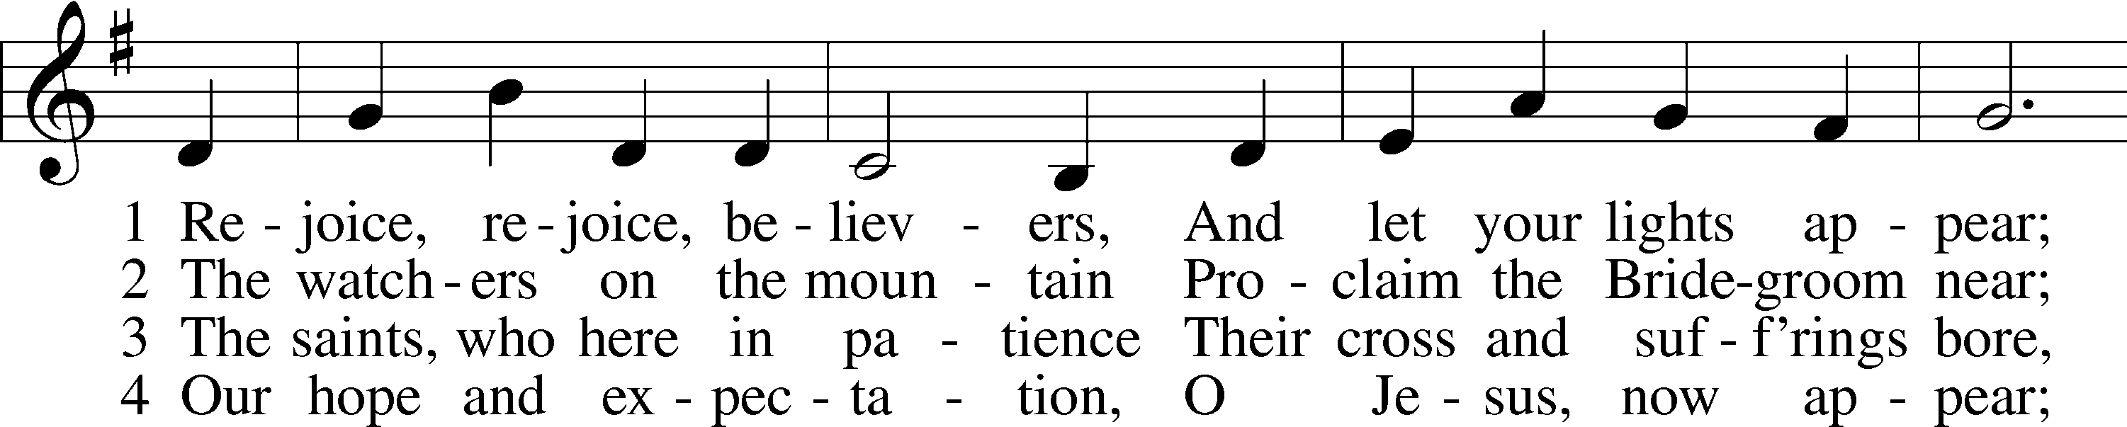
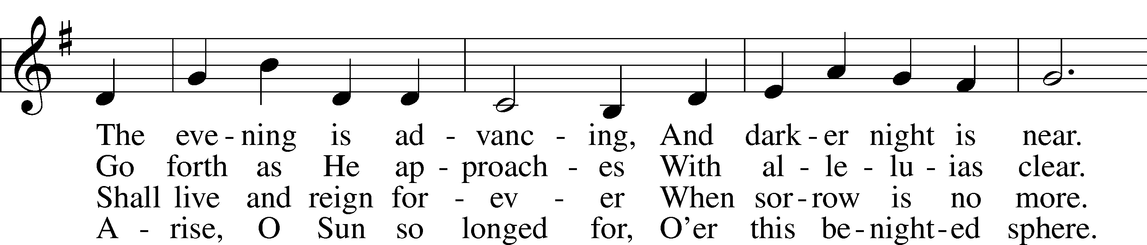
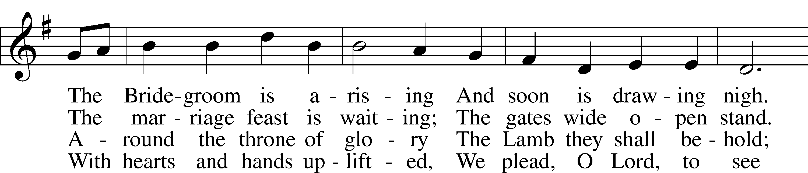
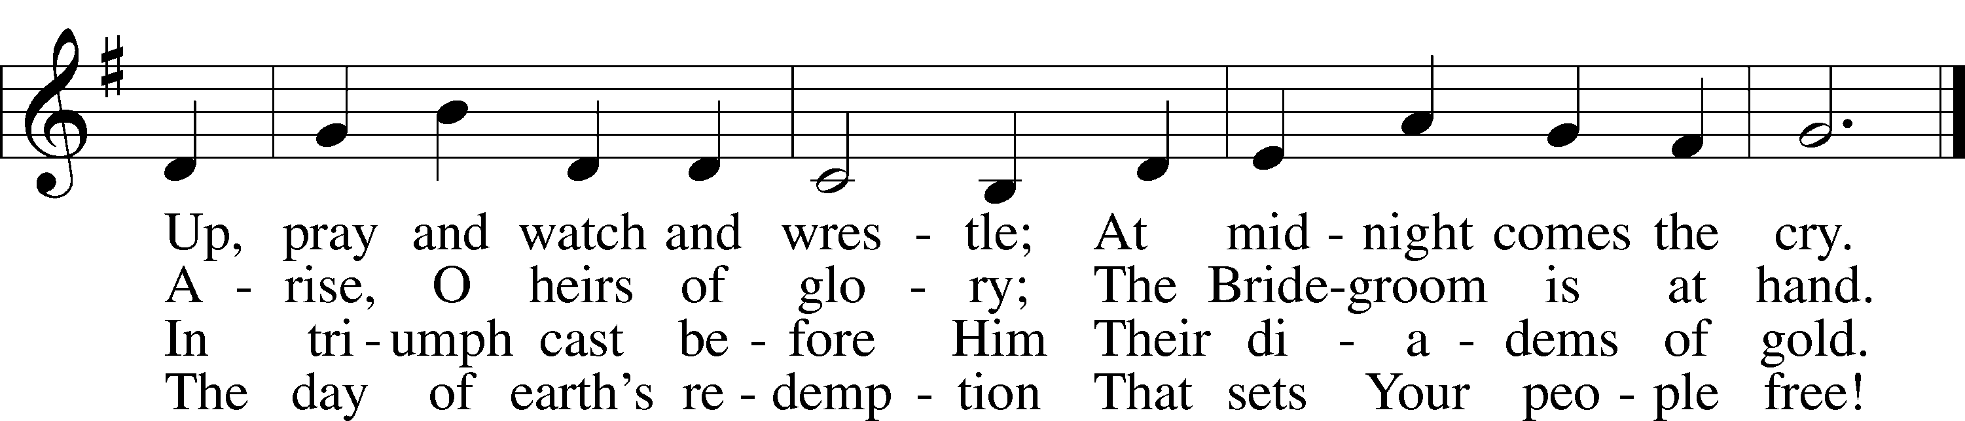
Text: Laurentius Laurenti, 1660–1722; tr. Sarah B. Findlater, 1823–1907, alt.
Tune: Swedish
Text and tune: Public domain

ACKNOWLEDGMENTS
Unless otherwise indicated, Scripture quotations are from the ESV® Bible (The Holy Bible, English Standard Version®), copyright © 2001 by Crossway, a publishing ministry of Good News Publishers. Used by permission. All rights reserved.
Created by Lutheran Service Builder © 2025 Concordia Publishing House.

