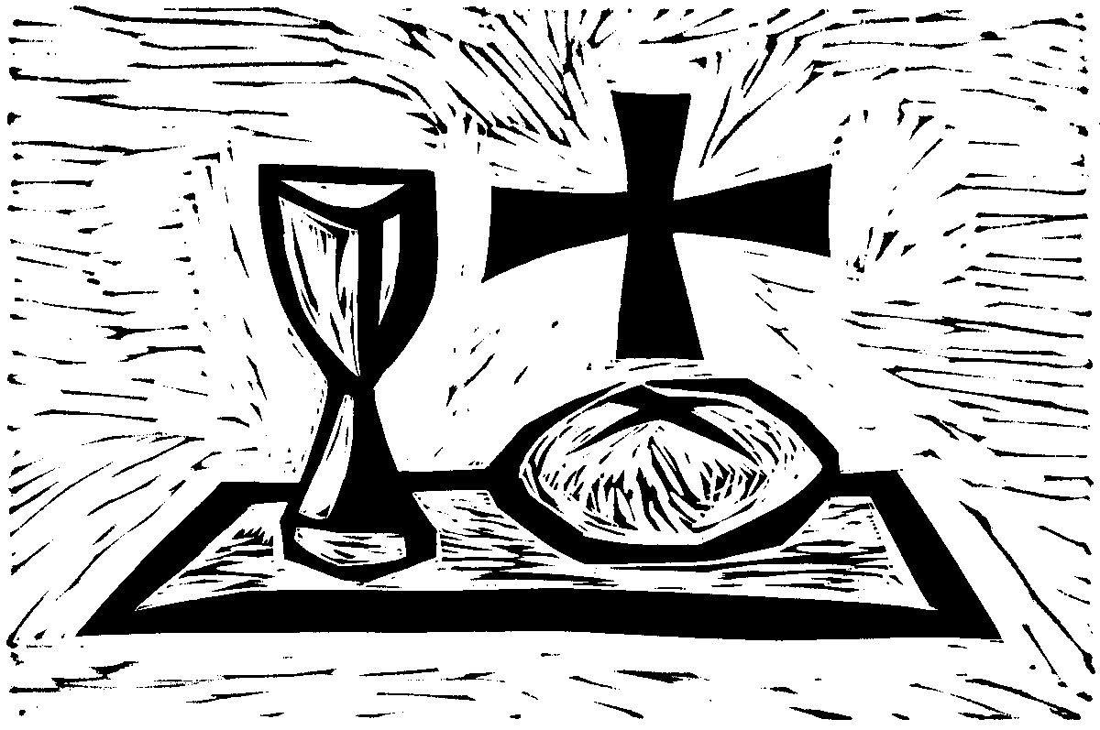
+ + + + + + + + + + + + + + +
Maundy Thursday
April 2, 2026
7:00 p.m.
+ + + + + + + + + + + + + + +

BETHLEHEM LUTHERAN CHURCH
A congregation of The Lutheran Church-Missouri Synod
902 Hitchcock Drive SW,
Aiken, South Carolina 29803
Church Phone: (803) 649-6417
blcaikensc@gmail.com
Pastor: Rev. John B. Engwall
Office Hours By Appointment
Bethlehem Lutheran welcomes our members and guests to our worship service! Unable to join us in person? Please find us on Facebook live. The service is also posted on our website; bethlehemlutheranaiken.org.

Our Policy and Practice Regarding Holy Communion
Hear the words of the Apostle Paul;
Anyone who eats and drinks without recognizing the body of the Lord eats and drinks judgment on himself. -1 Cor.11:29
Therefore, visitors are asked to please refrain from partaking of the Sacrament before speaking about this with the pastor; because we care about your spiritual well-being.
Also, because communing at this altar is a public confession that you agree with the doctrines of The Lutheran Church-Missouri Synod, and reject all contrary teachings.
Persons who are not communing today are always welcome to come forward during the distribution to receive an individual blessing; please cross your arms over your chest to indicate your desire for this. Thank you!
We commune in two alternating tables. The ushers will guide you. Non-alcoholic white wine is available in the center of the individual cup tray. Please leave empty individual cups at the altar rail.

+ SERVICE OF PREPARATION +
After the bell tolls, please observe a time of silence.

WELCOME AND ANNOUNCEMENTS

445 WHEN YOU WOKE THAT THURSDAY MORNING
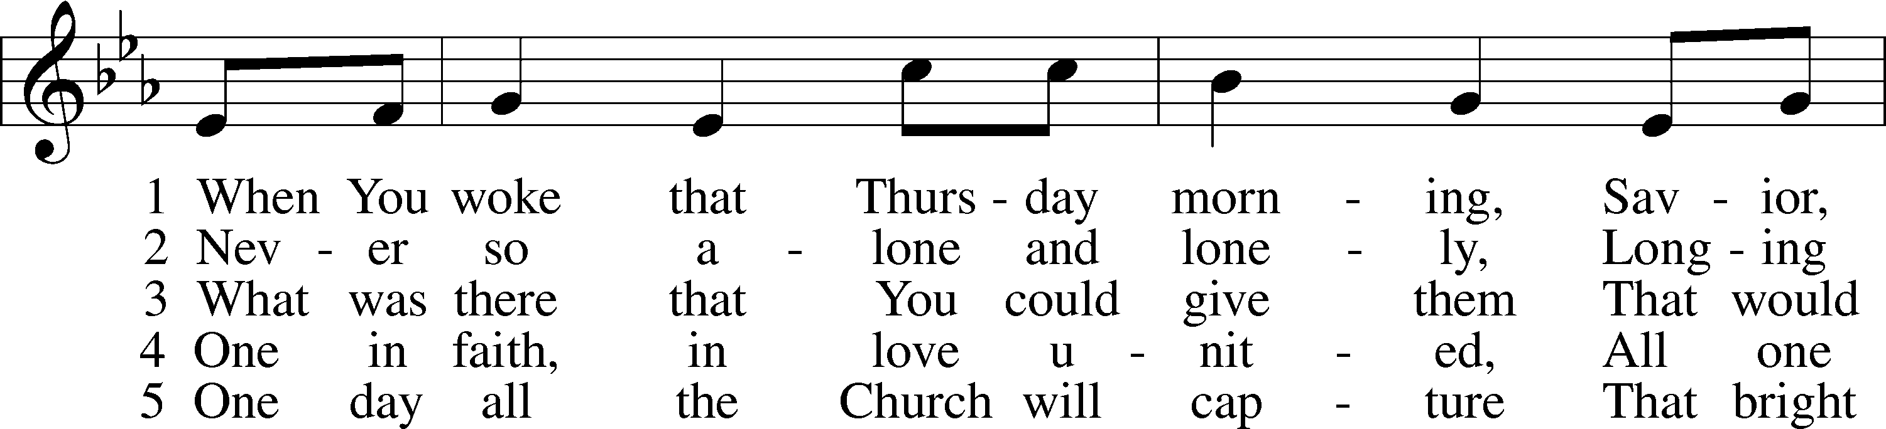
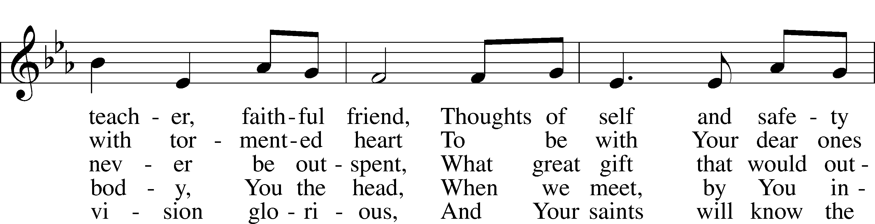
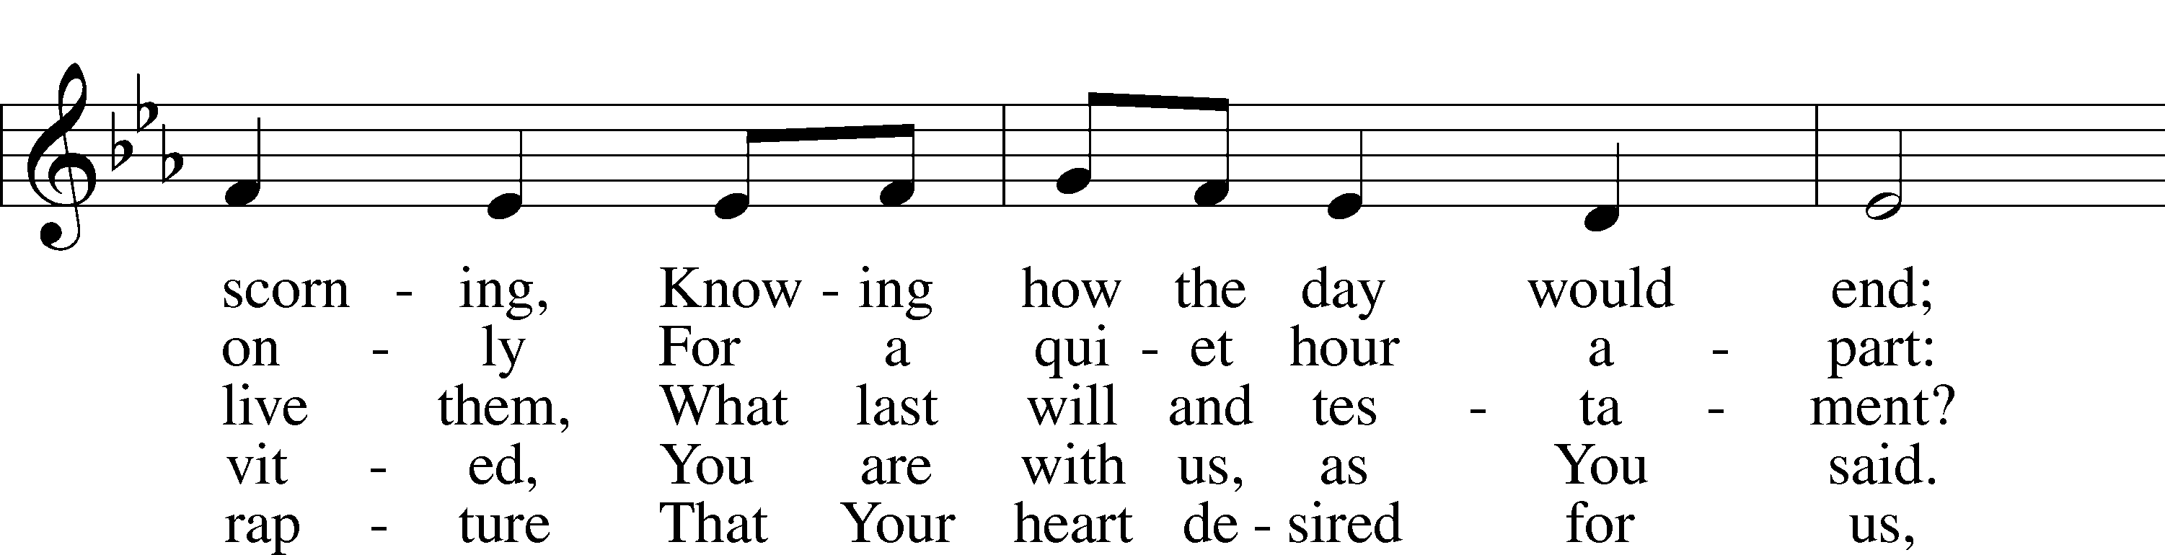
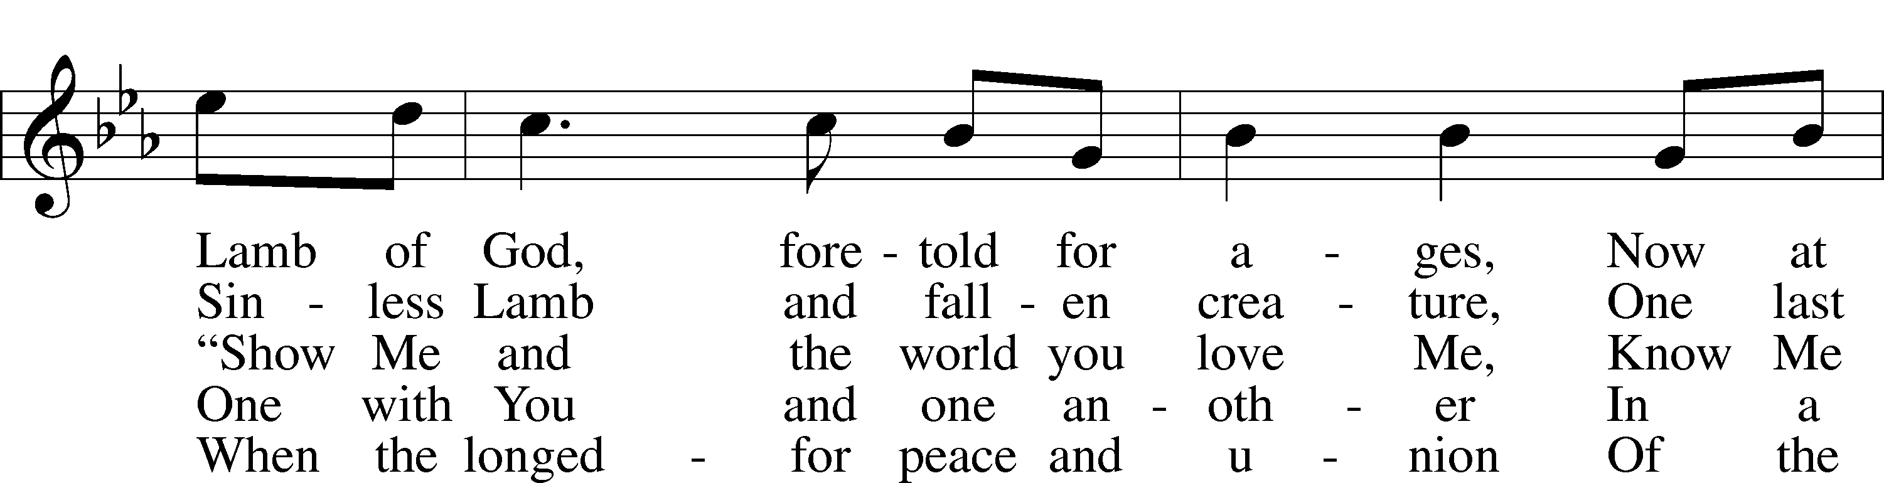
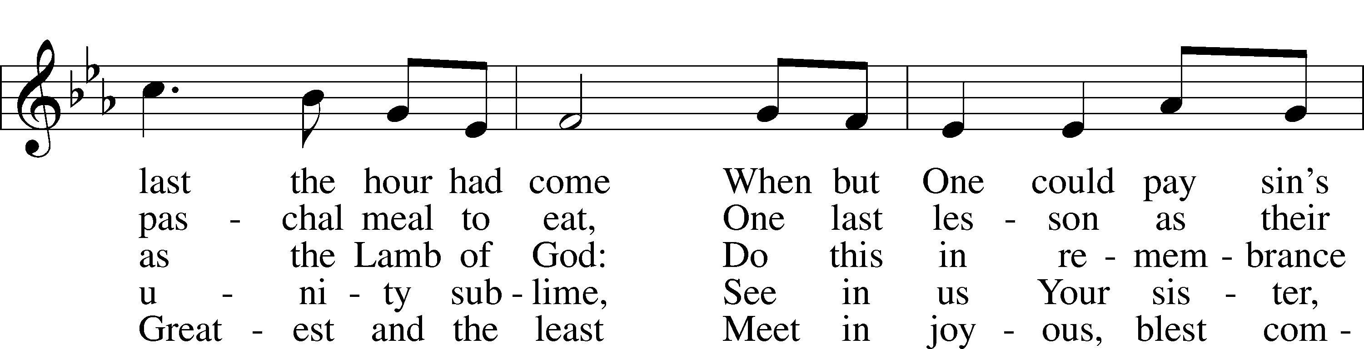
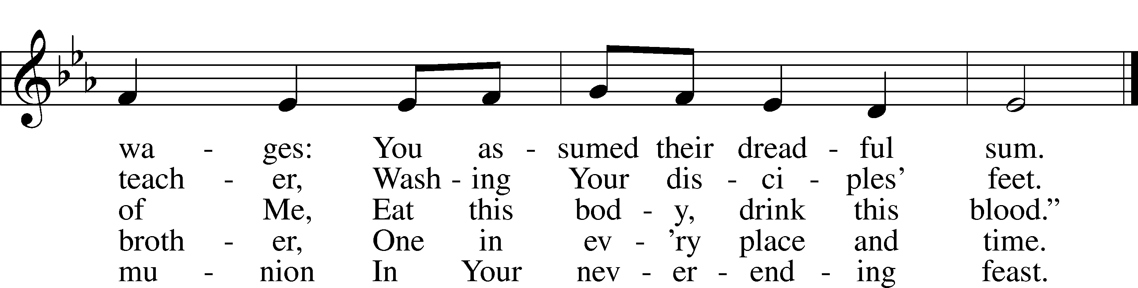
Text: Jaroslav J. Vajda, 1919–2008
Tune: Marty Haugen, 1950
Text: © 1991 Concordia Publishing House. Used by permission: LSB Hymn License no. 110004798
Tune: © 1987 GIA Publications, Inc. Used by permission: LSB Hymn License no. 110004798

(The sign of the cross may be made by all in remembrance of their Baptism.)

INVOCATION
P In the name of the Father and of the T Son and of the Holy Spirit.
C Amen.

EXHORTATION
P I will go to the altar of God,
C to God my exceeding joy.
P Our help is in the name of the Lord,
C who made heaven and earth.

(Sit)

CONFESSIONAL ADDRESS
P During this Lenten season we have heard our Lord’s call to intensify our struggle against sin, death, and the devil—all that prevents us from trusting in God and loving each other. Since it is our intention to receive the Holy Supper of our Lord Jesus Christ on this night when He instituted this blessed meal for our salvation, it is proper that we complete our Lenten discipline by diligently examining ourselves, as St. Paul urges us to do. This holy Sacrament has been instituted for the special comfort of those who are troubled because of their sin and who humbly confess their sins, fear God’s wrath, and hunger and thirst for righteousness.

But when we examine our hearts and consciences, we find nothing in us but sin and death, from which we are incapable of delivering ourselves. Therefore, our Lord Jesus Christ has had mercy on us. For our benefit He became man so that He might fulfill for us the whole will and law of God and, to deliver us, took upon Himself our sin and the punishment we deserve.

So that we may more confidently believe this and be strengthened in the faith and in holy living, our Lord Jesus Christ took bread, broke it, and gave it to His disciples and said: “Take, eat; this is My body, which is given for you.” It is as if He said, “I became man, and all that I do and suffer is for your good. As a pledge of this, I give you My body to eat.”

In the same way also He took the cup, gave thanks, and gave it to them, saying: “Drink of it, all of you; this cup is the new testament in My blood, which is shed for you for the forgiveness of sins.” Again, it is as if He said, “I have had mercy on you by taking into Myself all your iniquities. I give Myself into death, shedding My blood to obtain grace and forgiveness of sins, and to comfort and establish the new testament, which gives forgiveness and everlasting salvation. As a pledge of this, I give you My blood to drink.”

Therefore, whoever eats this bread and drinks this cup, confidently believing this Word and promise of Christ, dwells in Christ and Christ in him and has eternal life.

We should also do this in remembrance of Him, showing His death—that He was delivered for our offenses and raised for our justification. Giving Him our most heartfelt thanks, we take up our cross and follow Him and, according to His commandment, love one another as He has loved us. As our Lord on this night exemplified this love by washing His disciples’ feet, so we by our words and actions serve one another in love. For we are all one bread and one body, even as we are all partakers of this one bread and drink from the one cup. For just as the one cup is filled with the wine of many grapes and one bread made from countless grains, so also we, being many, are one body in Christ. Because of Him, we love one another, not only in word, but in deed and in truth.

May the almighty and merciful God and Father of our Lord Jesus Christ, by His Holy Spirit, accomplish this in us.
C Amen.

P Having heard the Word of God, let us confess our sins, imploring God our Father for the sake of His Son, Jesus Christ, to grant us forgiveness.

(Stand)

+ SERVICE OF CORPORATE CONFESSION+
AND
+ABSOLUTION +

(Silence for reflection on God’s Word and for self-examination.)

CONFESSION OF SINS
P O almighty God, merciful Father,
C I, a poor, miserable sinner, confess unto You all my sins and iniquities with which I have ever offended You and justly deserved Your temporal and eternal punishment. But I am heartily sorry for them and sincerely repent of them, and I pray You of Your boundless mercy and for the sake of the holy, innocent, bitter sufferings and death of Your beloved Son, Jesus Christ, to be gracious and merciful to me, a poor, sinful being.

P God be merciful to you and strengthen your faith.
C Amen.

P Do you believe that the forgiveness I speak is not my forgiveness but God’s?
C Yes.

P Let it be done for you as you believe.

ABSOLUTION
P In the stead and by the command of my Lord Jesus Christ I forgive you all your sins in the name of the Father and of the T Son and of the Holy Spirit.
C Amen.

BLESSING
P Now may the God of peace Himself sanctify you completely, and may your whole spirit, soul, and body be kept blameless at the coming of our Lord Jesus Christ. He who calls you is faithful; He will surely do it. Go in T peace.
C Amen.

(When all have been absolved, they may greet one another in the name of the Lord by saying, “Peace be with you.”)

SALUTATION AND COLLECT OF THE DAY
P The Lord be with you.
C And also with you.

P Let us pray.
O Lord, in this wondrous Sacrament You have left us a remembrance of Your passion. Grant that we may so receive the sacred mystery of Your body and blood that the fruits of Your redemption may continually be manifest in us; for You live and reign with the Father and the Holy Spirit, one God, now and forever.
C Amen.

(sit)

+ SERVICE OF THE WORD +

OLD TESTAMENT READING Exodus 24:3–11
3Moses came and told the people all the words of the Lord and all the just decrees. And all the people answered with one voice and said, “All the words that the Lord has spoken we will do.” 4And Moses wrote down all the words of the Lord. He rose early in the morning and built an altar at the foot of the mountain, and twelve pillars, according to the twelve tribes of Israel. 5And he sent young men of the people of Israel, who offered burnt offerings and sacrificed peace offerings of oxen to the Lord. 6And Moses took half of the blood and put it in basins, and half of the blood he threw against the altar. 7Then he took the Book of the Covenant and read it in the hearing of the people. And they said, “All that the Lord has spoken we will do, and we will be obedient.” 8And Moses took the blood and threw it on the people and said, “Behold the blood of the covenant that the Lord has made with you in accordance with all these words.”
9Then Moses and Aaron, Nadab, and Abihu, and seventy of the elders of Israel went up, 10and they saw the God of Israel. There was under his feet as it were a pavement of sapphire stone, like the very heaven for clearness. 11And he did not lay his hand on the chief men of the people of Israel; they beheld God, and ate and drank.

P This is the Word of the Lord.
C Thanks be to God.

GRADUAL Hebrews 9:12a, c, 15a; Psalm 111:9a
[Christ] entered once for all into the holy places, by means of | his own blood,*
thus securing an eternal re- | demption.
Therefore he is the mediator of a new | covenant,*
so that those who are called may receive the promised eternal in- | heritance.
He sent redemption to his | people;*
he has commanded his covenant for- | ever.

EPISTLE Hebrews 9:11–22
11When Christ appeared as a high priest of the good things that have come, then through the greater and more perfect tent (not made with hands, that is, not of this creation) 12he entered once for all into the holy places, not by means of the blood of goats and calves but by means of his own blood, thus securing an eternal redemption. 13For if the sprinkling of defiled persons with the blood of goats and bulls and with the ashes of a heifer sanctifies for the purification of the flesh, 14how much more will the blood of Christ, who through the eternal Spirit offered himself without blemish to God, purify our conscience from dead works to serve the living God.
15Therefore he is the mediator of a new covenant, so that those who are called may receive the promised eternal inheritance, since a death has occurred that redeems them from the transgressions committed under the first covenant. 16For where a will is involved, the death of the one who made it must be established. 17For a will takes effect only at death, since it is not in force as long as the one who made it is alive. 18Therefore not even the first covenant was inaugurated without blood. 19For when every commandment of the law had been declared by Moses to all the people, he took the blood of calves and goats, with water and scarlet wool and hyssop, and sprinkled both the book itself and all the people, 20saying, “This is the blood of the covenant that God commanded for you.” 21And in the same way he sprinkled with the blood both the tent and all the vessels used in worship. 22Indeed, under the law almost everything is purified with blood, and without the shedding of blood there is no forgiveness of sins.

P This is the Word of the Lord.
C Thanks be to God.

(Stand)

VERSE John 13:1b
Having loved his own who were in the world, he loved them to the end.

HOLY GOSPEL Matthew 26:17–30
P The Holy Gospel according to St. Matthew, the twenty-sixth chapter.
C Glory to You, O Lord.

17Now on the first day of Unleavened Bread the disciples came to Jesus, saying, “Where will you have us prepare for you to eat the Passover?” 18He said, “Go into the city to a certain man and say to him, ‘The Teacher says, My time is at hand. I will keep the Passover at your house with my disciples.’” 19And the disciples did as Jesus had directed them, and they prepared the Passover.
20When it was evening, he reclined at table with the twelve. 21And as they were eating, he said, “Truly, I say to you, one of you will betray me.” 22And they were very sorrowful and began to say to him one after another, “Is it I, Lord?” 23He answered, “He who has dipped his hand in the dish with me will betray me. 24The Son of Man goes as it is written of him, but woe to that man by whom the Son of Man is betrayed! It would have been better for that man if he had not been born.” 25Judas, who would betray him, answered, “Is it I, Rabbi?” He said to him, “You have said so.”
26Now as they were eating, Jesus took bread, and after blessing it broke it and gave it to the disciples, and said, “Take, eat; this is my body.” 27And he took a cup, and when he had given thanks he gave it to them, saying, “Drink of it, all of you, 28for this is my blood of the covenant, which is poured out for many for the forgiveness of sins. 29I tell you I will not drink again of this fruit of the vine until that day when I drink it new with you in my Father’s kingdom.”
30And when they had sung a hymn, they went out to the Mount of Olives.

P This is the Gospel of the Lord.
C Praise to You, O Christ.

(Sit)

617 O LORD, WE PRAISE THEE
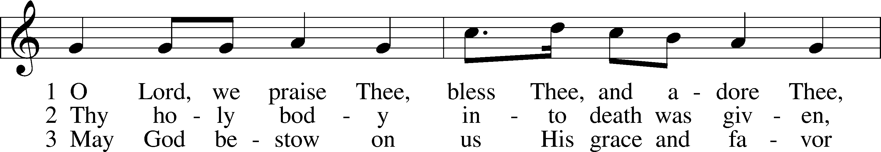
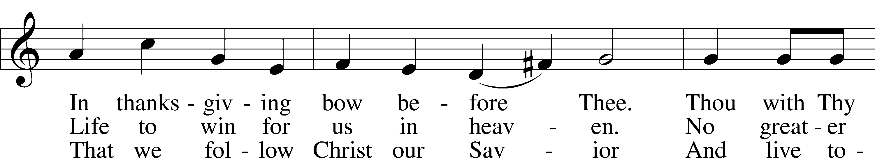
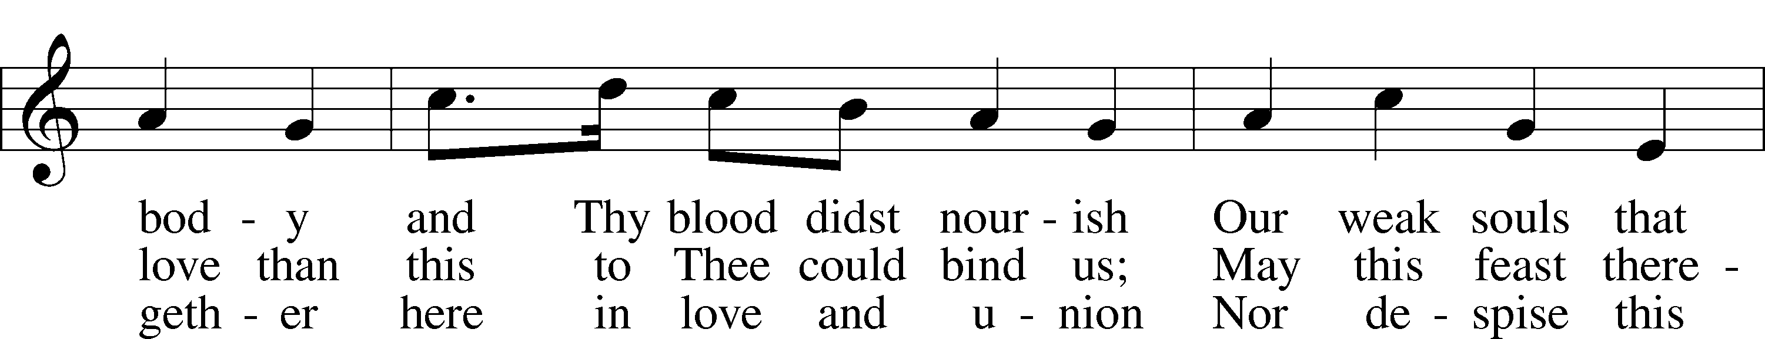
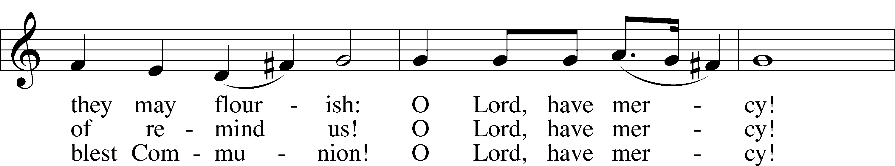
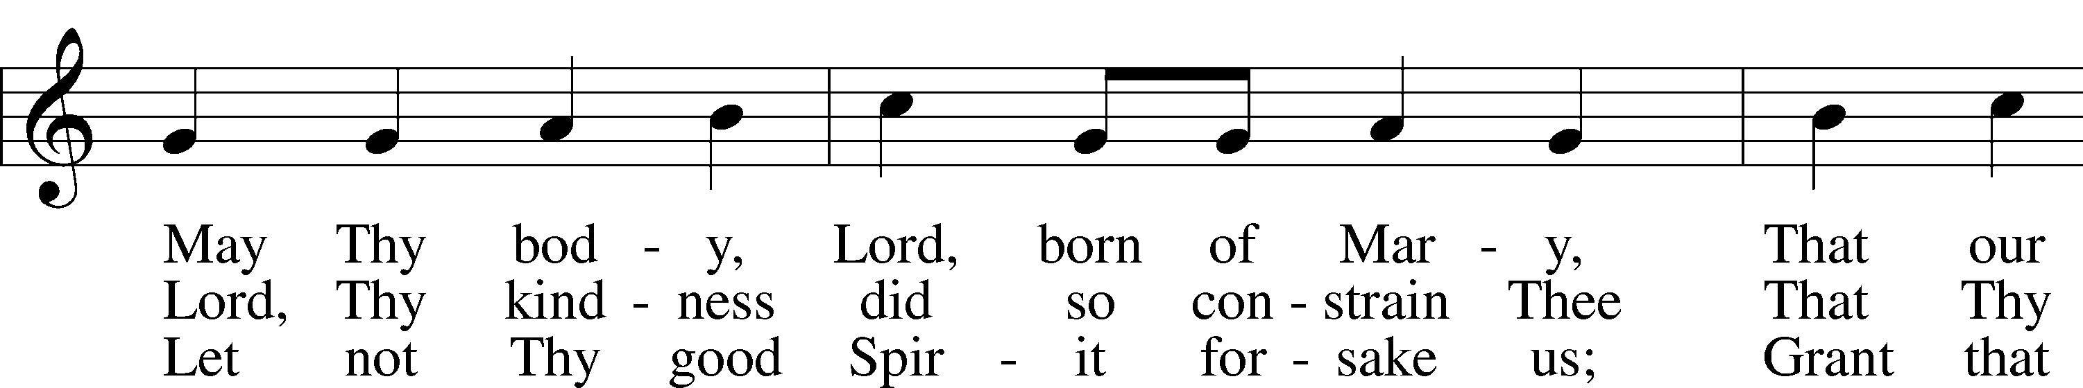
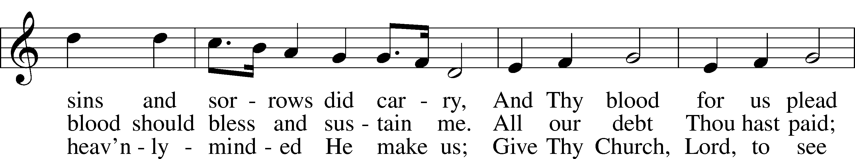
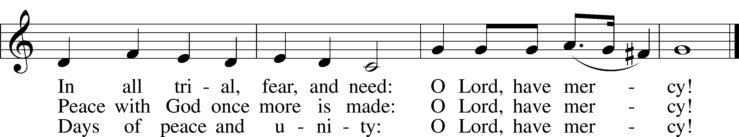
Text: tr. The Lutheran Hymnal, 1941, alt.; (st. 1): German, 14th cent.; (sts. 2–3): Martin Luther, 1483–1546
Tune: Geystliche gesangk Buchleyn, 1524, Wittenberg, ed. Johann Walter
Text: © 1941 Concordia Publishing House. Used by permission: LSB Hymn License no. 110004798
Tune: Public domain

SERMON

PRAYER OF THE CHURCH

(Stand)

+ SERVICE OF THE SACRAMENT +

PREFACE LSB 194
P The Lord be with you.
C And with thy spirit.

P Lift up your hearts.
C We lift them up unto the Lord.

P Let us give thanks unto the Lord, our God.
C It is meet and right so to do.

PROPER PREFACE (ABBREVIATED) LSB 194
P It is truly meet, right, and salutary . . . evermore praising You and saying:

SANCTUS LSB 161
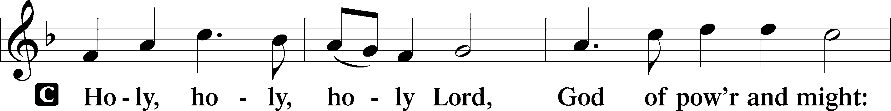
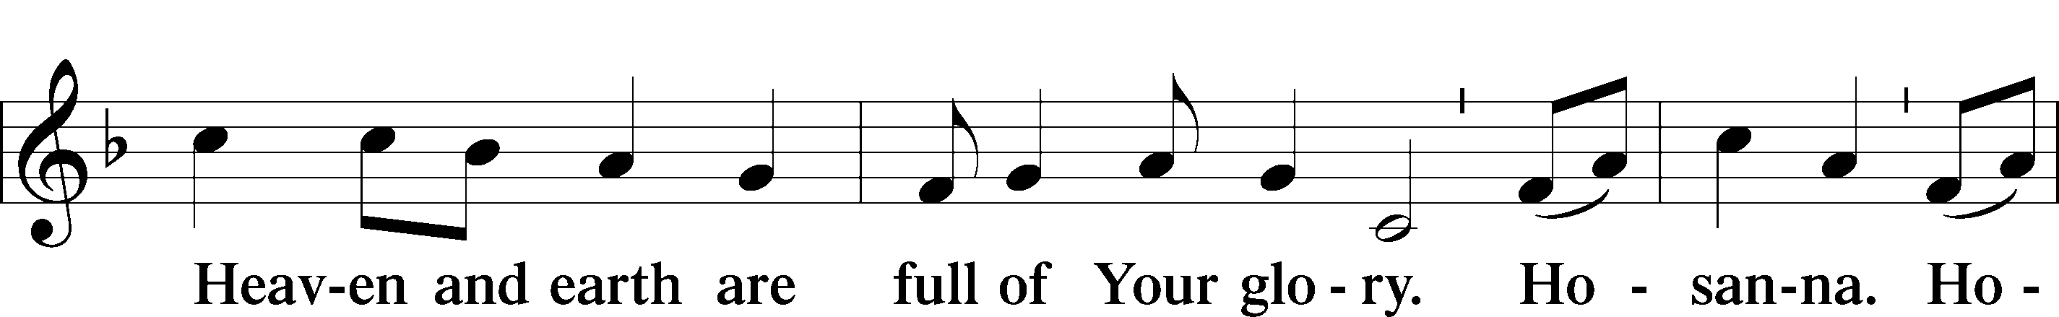
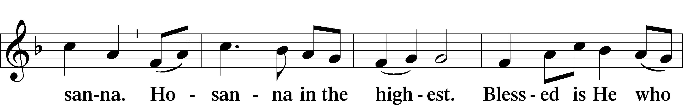
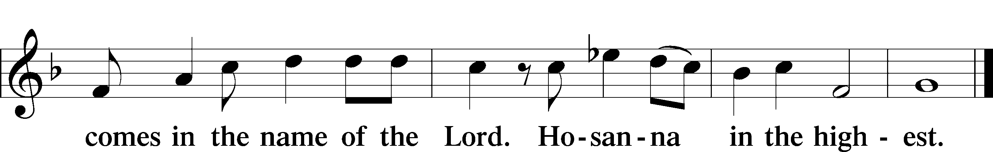

PRAYER OF THANKSGIVING
P Blessed are You, Lord of heaven and earth, for You have had mercy on those whom You created and sent Your only-begotten Son into our flesh to bear our sin and be our Savior. With repentant joy we receive the salvation accomplished for us by the all-availing sacrifice of His body and His blood on the cross.

Gathered in the name and the remembrance of Jesus, we beg You, O Lord, to forgive, renew, and strengthen us with Your Word and Spirit. Grant us faithfully to eat His body and drink His blood as He bids us do in His own testament. Gather us together, we pray, from the ends of the earth to celebrate with all the faithful the marriage feast of the Lamb in His kingdom, which has no end. Graciously receive our prayers; deliver and preserve us. To You alone, O Father, be all glory, honor, and worship, with the Son and the Holy Spirit, one God, now and forever.
C Amen.

THE WORDS OF OUR LORD
P Our Lord Jesus Christ, on the night when He was betrayed, took bread, and when He had given thanks, He broke it and gave it to the disciples and said: “Take, eat; this is My T body, which is given for you. This do in remembrance of Me.”

In the same way also He took the cup after supper, and when He had given thanks, He gave it to them, saying: “Drink of it, all of you; this cup is the new testament in My T blood, which is shed for you for the forgiveness of sins. This do, as often as you drink it, in remembrance of Me.”

PROCLAMATION OF CHRIST
P As often as we eat this bread and drink this cup, we proclaim the Lord’s death until He comes.
C Amen. Come, Lord Jesus.

P O Lord Jesus Christ, only Son of the Father, in giving us Your body and blood to eat and to drink, You lead us to remember and confess Your holy cross and passion, Your blessed death, Your rest in the tomb, Your resurrection from the dead, Your ascension into heaven, and Your coming for the final judgment. So remember us in Your kingdom and teach us to pray:

LORD’S PRAYER
C Our Father who art in heaven,
hallowed be Thy name,
Thy kingdom come,
Thy will be done on earth
as it is in heaven;
give us this day our daily bread;
and forgive us our trespasses
as we forgive those
who trespass against us;
and lead us not into temptation,
but deliver us from evil.
For Thine is the kingdom
and the power and the glory
forever and ever. Amen.

PAX DOMINI
P The peace of the Lord be with you always.
C Amen.

AGNUS DEI LSB 198
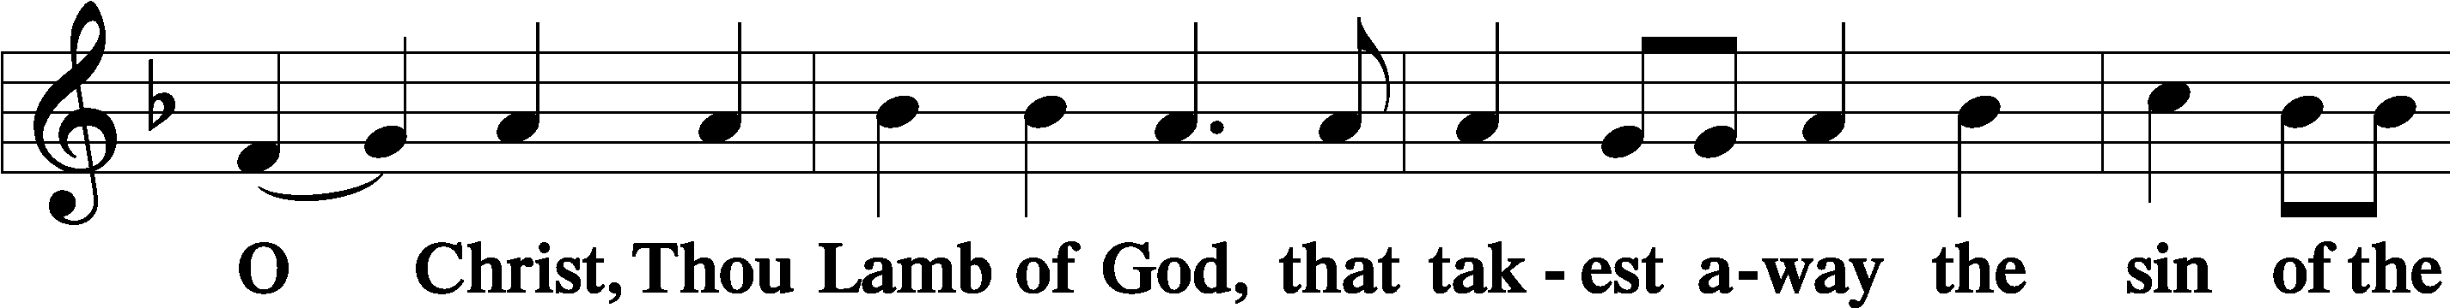
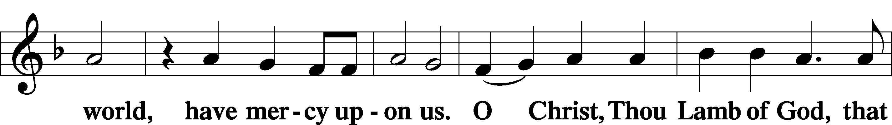
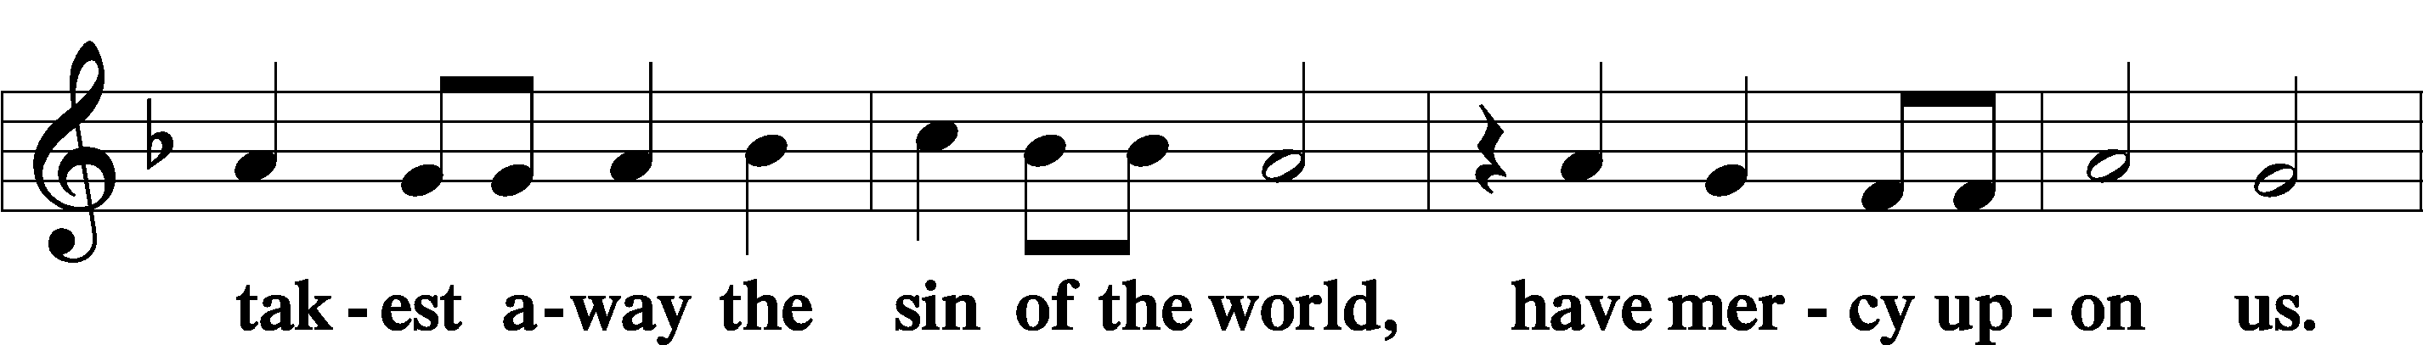
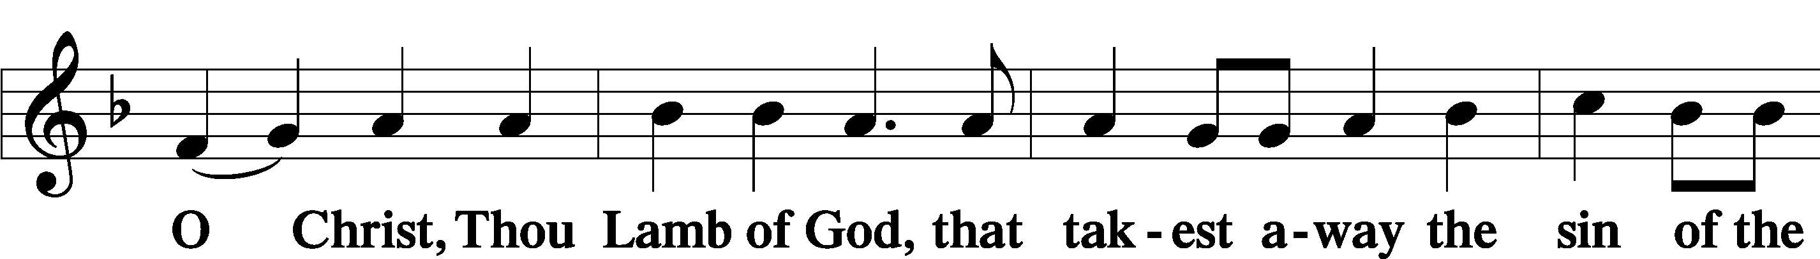
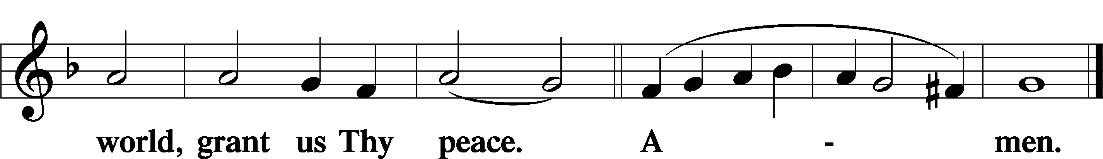

(Sit)

DISTRIBUTION
The pastor and those assisting him are communed first, then commune those who are unable to come to the altar.
The ushers will then direct all other communicants to the altar.

431 NOT ALL THE BLOOD OF BEASTS
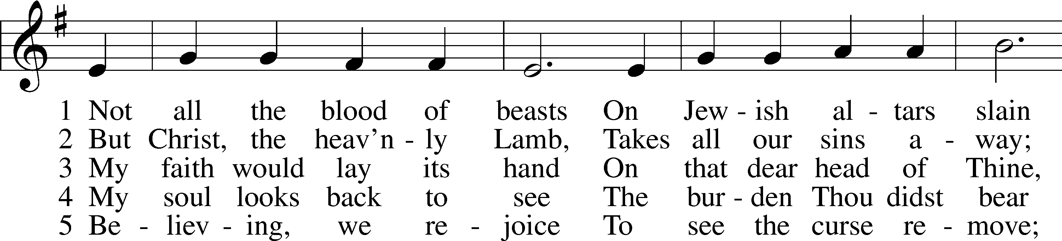
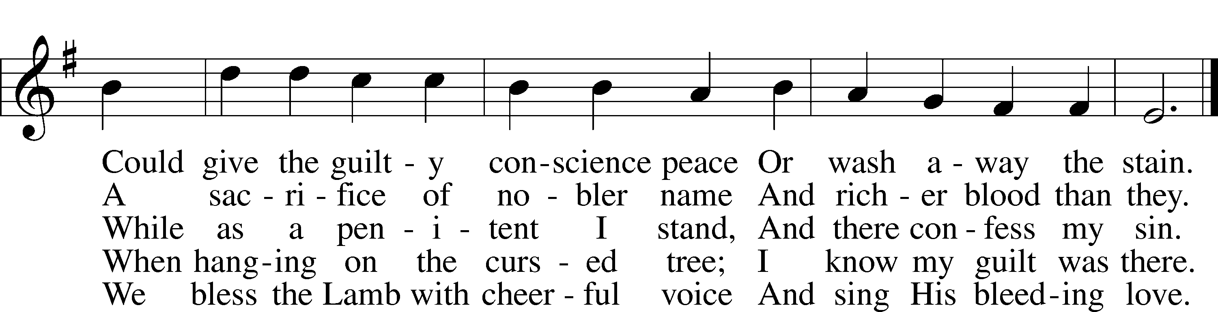
Text: Isaac Watts, 1674–1748, alt.
Tune: William Daman, c. 1540–1591
Text and tune: Public domain

(Stand)

POST-COMMUNION COLLECT
P Let us pray.
We give thanks to You, almighty God, that You have refreshed us through this salutary gift, and we implore You that of Your mercy You would strengthen us through the same in faith toward You and in fervent love toward one another; through Jesus Christ, Your Son, our Lord, who lives and reigns with You and the Holy Spirit, one God, now and forever.
C Amen.

(Sit)

+ STRIPPING OF THE ALTAR +

(The communion vessels are reverently removed from the altar, the altar is stripped, and the chancel is cleared in preparation for the solemn services of Good Friday.)

PSALM 22 Psalm 22
1My God, my God, why have you for- | saken me?*
Why are you so far from saving me, from the words of my | groaning?
2O my God, I cry by day, but you do not | answer,*
and by night, but I | find no rest.
3Yet you are | holy,*
enthroned on the praises of | Israel.
4In you our fathers | trusted;*
they trusted, and you de- | livered them.
5To you they cried and were | rescued;*
in you they trusted and were not | put to shame.
6But I am a worm and | not a man,*
scorned by mankind and despised by the | people.
7All who see me | mock me;*
they make mouths at me; they | wag their heads;
8“He trusts in the Lord; let him de- | liver him;*
let him rescue him, for he de- | lights in him!”
9Yet you are he who took me | from the womb;*
you made me trust you at my | mother’s breasts.
10On you was I cast | from my birth,*
and from my mother’s womb you have | been my God.
11Be not far from me,
for trouble | is near,*
and there is | none to help. (next page)
12Many bulls en- | compass me;*
strong bulls of Bashan sur- | round me;
13they open wide their | mouths at me,*
like a ravening and roaring | lion.
14I am poured out like water,
and all my bones are | out of joint;*
my heart is like wax;
it is melted with- | in my breast;
15my strength is dried up like a potsherd,
and my tongue sticks | to my jaws;*
you lay me in the | dust of death.
16For dogs en- | compass me;*
a company of evildoers encircles me;
they have pierced my | hands and feet—
17I can count | all my bones—*
they stare and gloat | over me;
18they divide my garments a- | mong them,*
and for my clothing they | cast lots.
19But you, O Lord, do not be | far off!*
O you my help, come quickly | to my aid! (Next Page)
20Deliver my soul | from the sword,*
my precious life from the power | of the dog!
21Save me from the mouth of the | lion!*
You have rescued me from the horns of the wild | oxen!
22I will tell of your name to my | brothers;*
in the midst of the congregation I will | praise you:
23You who fear the Lord, praise him!
All you offspring of Jacob, glo- | rify him,*
and stand in awe of him, all you offspring of | Israel!
24For he has not despised or abhorred
the affliction of the afflicted,
and he has not hidden his | face from him,*
but has heard, when he | cried to him.
25From you comes my praise in the great congre- | gation;*
my vows I will perform before those who | fear him.
26The afflicted shall eat and be satisfied;
those who seek him shall | praise the Lord!*
May your hearts live for- | ever! (next page)
27All the ends of the earth shall remember
and turn | to the Lord,*
and all the families of the nations
shall worship be- | fore you.
28For kingship belongs | to the Lord,*
and he rules over the | nations.
29All the prosperous of the earth eat and | worship;*
before him shall bow all who go down to the dust,
even the one who could not keep him- | self alive.
30Posterity shall | serve him;*
it shall be told of the Lord to the coming gener- | ation;
31they shall come and proclaim his righteousness to a people | yet unborn,*
that he has | done it.

(All leave the church in silence.)

Unless otherwise indicated, Scripture quotations are from the ESV® Bible (The Holy Bible, English Standard Version®), copyright © 2001 by Crossway, a publishing ministry of Good News Publishers. Used by permission. All rights reserved.
Created by Lutheran Service Builder © 2026 Concordia Publishing House.

