BETHLEHEM LUTHERAN CHURCH
A congregation of The Lutheran Church-Missouri Synod
902 Hitchcock Drive SW,
Aiken, South Carolina 29803
Church Phone: (803) 649-6417
blcaikensc@gmail.com
Pastor: Rev. John B. Engwall
Office Hours By Appointment
Note: The format of this bulletin has been modified for use in private devotion services.
Unable to join us in person? Please find us on Facebook live.
The service is also posted on our website; bethlehemlutheranaiken.org

+ + + + + + + + + + + + + + +
The Nativity of Our Lord (Christmas Eve)
December 24, 2025
7:00 p.m.
+ + + + + + + + + + + + + + +

Our Policy and Practice Regarding Holy Communion
Hear the words of the Apostle Paul;
Anyone who eats and drinks without recognizing the body of the Lord eats and drinks judgment on himself. -1 Cor.11:29
Therefore, visitors are asked to please refrain from partaking of the Sacrament before speaking about this with the pastor; because we care about your spiritual well-being.
Also, because communing at this altar is a public confession that you agree with the doctrines of The Lutheran Church-Missouri Synod, and reject all contrary teachings.
Persons who are not communing today are always welcome to come forward during the distribution to receive an individual blessing; please cross your arms over your chest to indicate your desire for this. Thank you!
We commune in two alternating tables. The ushers will guide you. Non-alcoholic white wine is available in the center of the individual cup tray. Please leave empty individual cups at the altar rail.

+ SERVICE OF PREPARATION +
After the bell tolls, please observe a time of silence.

WELCOME AND ANNOUNCEMENTS

365 AWAY IN A MANGER
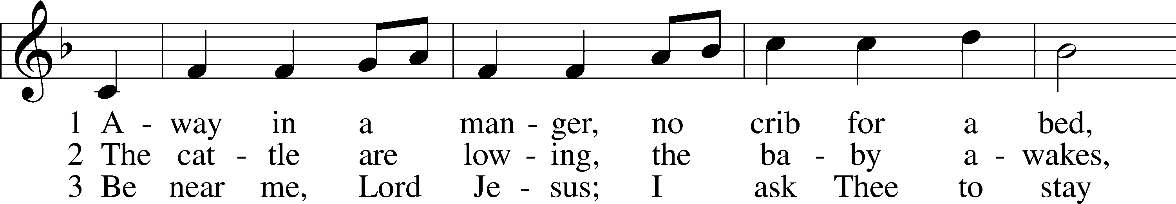
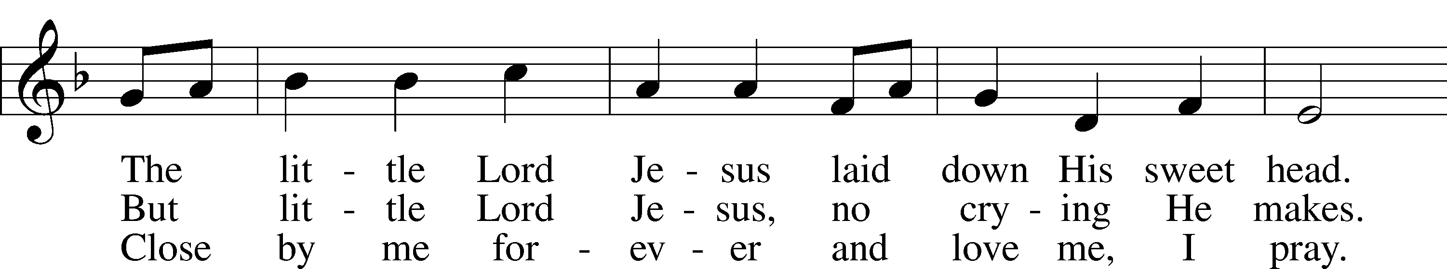
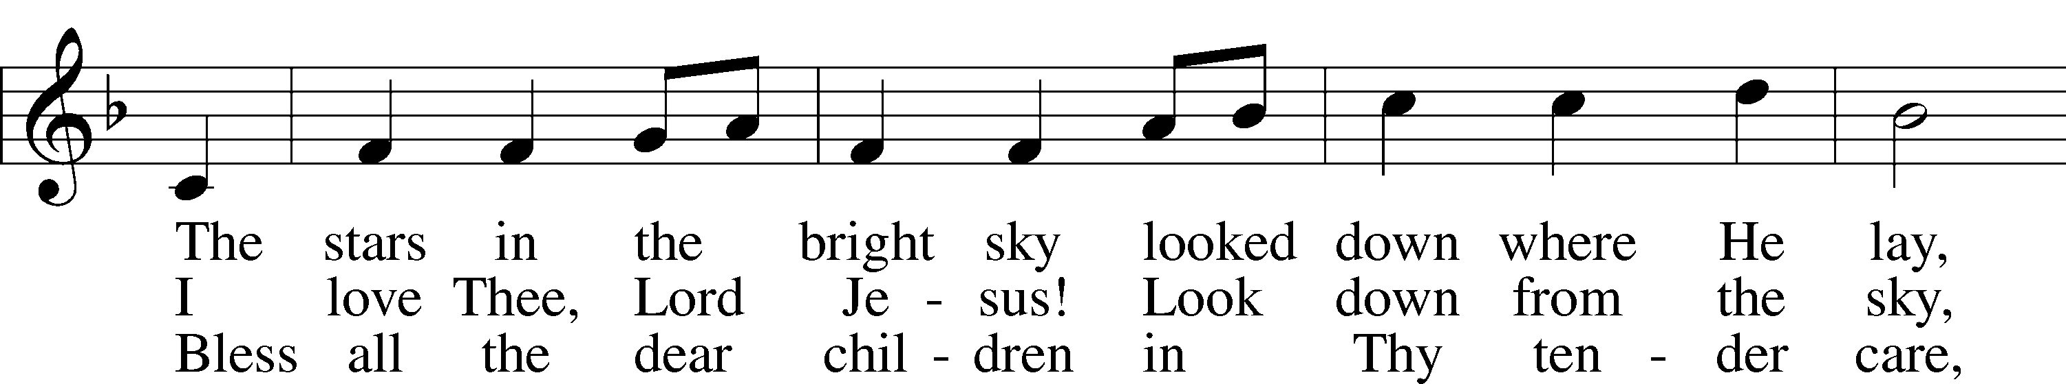
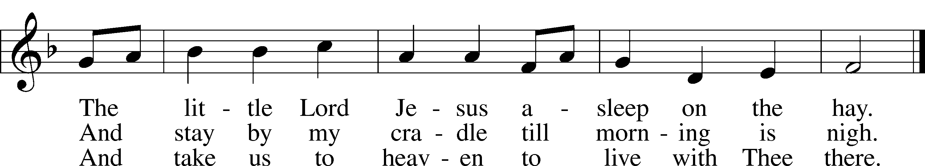
Text (sts. 1–2): Little Children’s Book, 1885, Philadelphia; (st. 3): Vineyard Songs, 1892, Louisville, alt.
Tune: William J. Kirkpatrick, 1838–1921
Text and tune: Public domain

(Stand)

SALUTATION AND COLLECT OF THE DAY
L The Lord be with you.
C And also with you.

L Let us pray.
O God, You make us glad with the yearly remembrance of the birth of Your only-begotten Son, Jesus Christ. Grant that as we joyfully receive Him as our Redeemer, we may with sure confidence behold Him when He comes to be our Judge; through the same Jesus Christ, our Lord, who lives and reigns with You and the Holy Spirit, one God, now and forever.

C Amen.

+ SERVICE OF THE WORD +

PSALM 110:1–4
1The Lord says to my Lord:
“Sit at my | right hand,*
until I make your enemies your | footstool.”
2The Lord sends forth from Zion
your mighty | scepter.*
Rule in the midst of your | enemies!
3Your people will offer themselves freely
on the day of your power,
in holy | garments;*
from the womb of the morning,
the dew of your youth | will be yours.
4The Lord has sworn
and will not | change his mind,*
“You are a priest forever
after the order of Mel- | chizedek.”

(Sit)

OLD TESTAMENT READING Isaiah 7:10–14
10Again the Lord spoke to Ahaz, 11“Ask a sign of the Lord your God; let it be deep as Sheol or high as heaven.” 12But Ahaz said, “I will not ask, and I will not put the Lord to the test.” 13And he said, “Hear then, O house of David! Is it too little for you to weary men, that you weary my God also? 14Therefore the Lord himself will give you a sign. Behold, the virgin shall conceive and bear a son, and shall call his name Immanuel.”

L This is the Word of the Lord.
C Thanks be to God.

362 O SING OF CHRIST
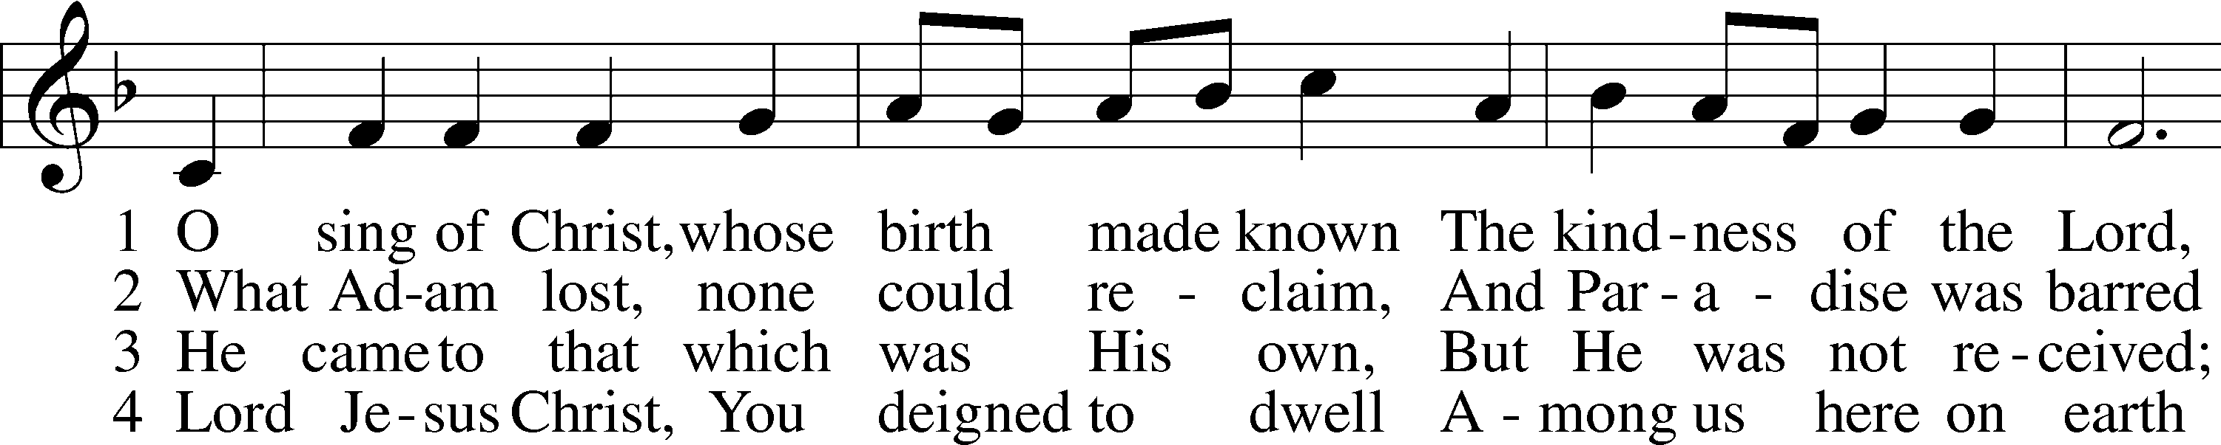
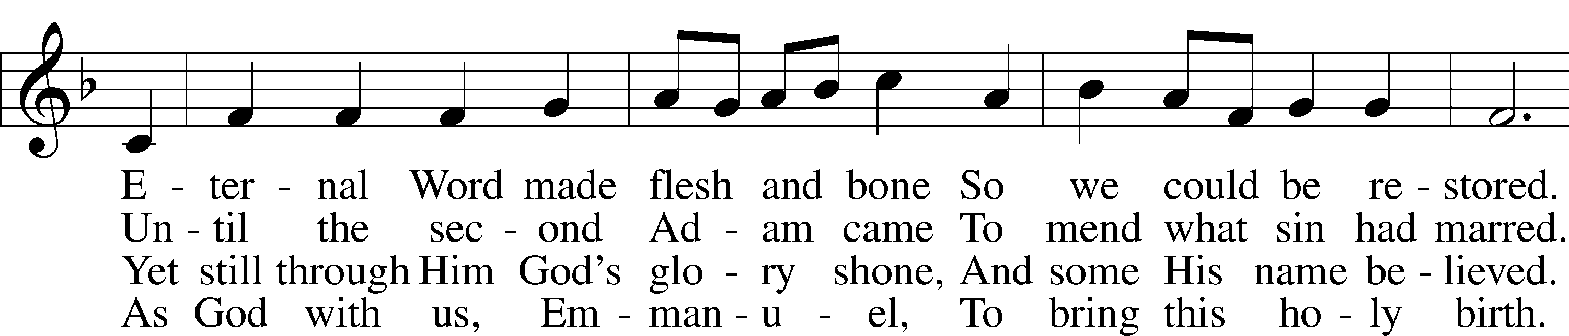
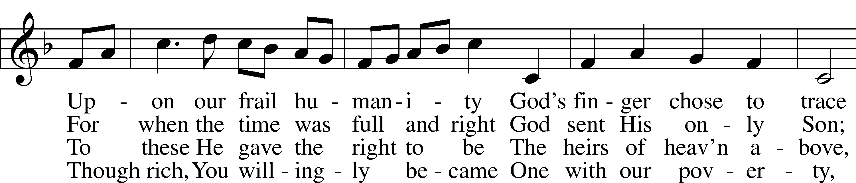
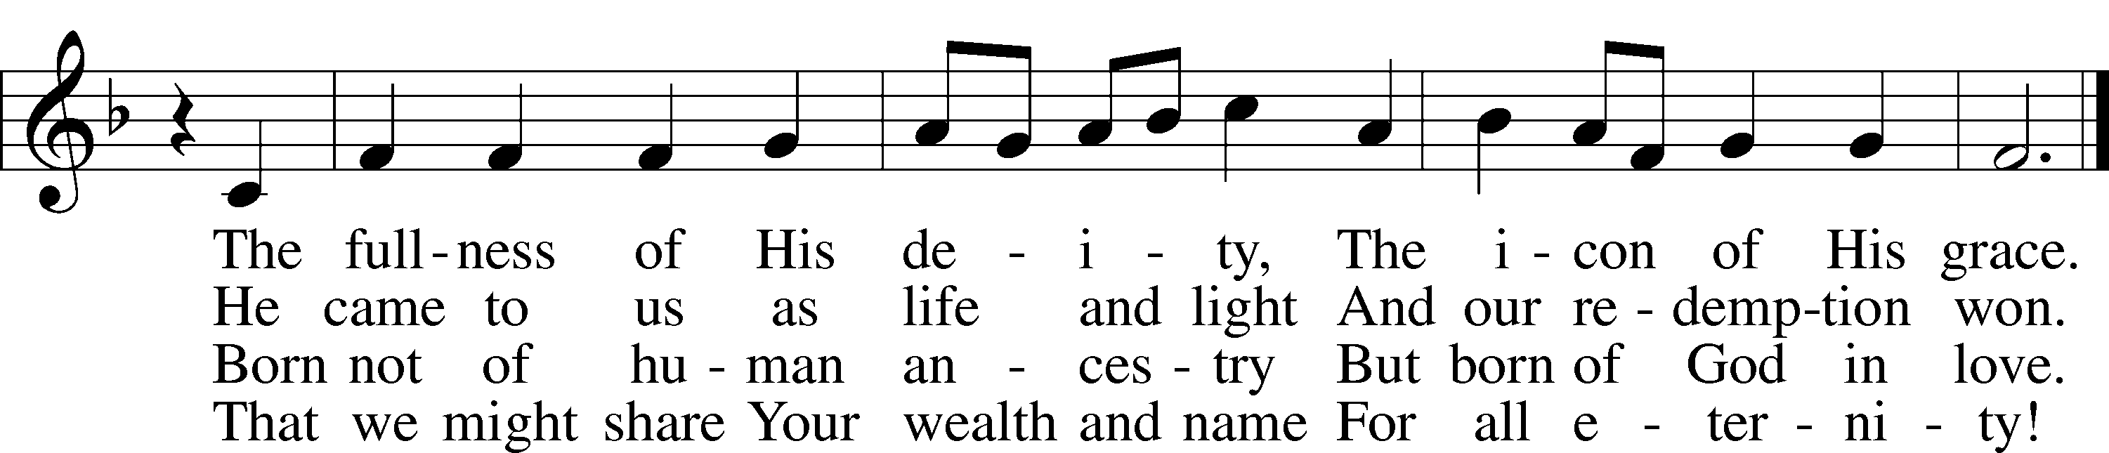
Text: Stephen P. Starke, 1955
Tune: English; adapt. Ralph Vaughan Williams, 1872–1958
Text: © 1996 Stephen P. Starke, admin. Concordia Publishing House. Used by permission: LSB Hymn License no. 110004798
Tune: Public domain

EPISTLE 1 John 4:7–16
7Beloved, let us love one another, for love is from God, and whoever loves has been born of God and knows God. 8Anyone who does not love does not know God, because God is love. 9In this the love of God was made manifest among us, that God sent his only Son into the world, so that we might live through him. 10In this is love, not that we have loved God but that he loved us and sent his Son to be the propitiation for our sins. 11Beloved, if God so loved us, we also ought to love one another. 12No one has ever seen God; if we love one another, God abides in us and his love is perfected in us.
13By this we know that we abide in him and he in us, because he has given us of his Spirit. 14And we have seen and testify that the Father has sent his Son to be the Savior of the world. 15Whoever confesses that Jesus is the Son of God, God abides in him, and he in God. 16So we have come to know and to believe the love that God has for us. God is love, and whoever abides in love abides in God, and God abides in him.
L This is the Word of the Lord.
C Thanks be to God.

384 OF THE FATHER’S LOVE BEGOTTEN
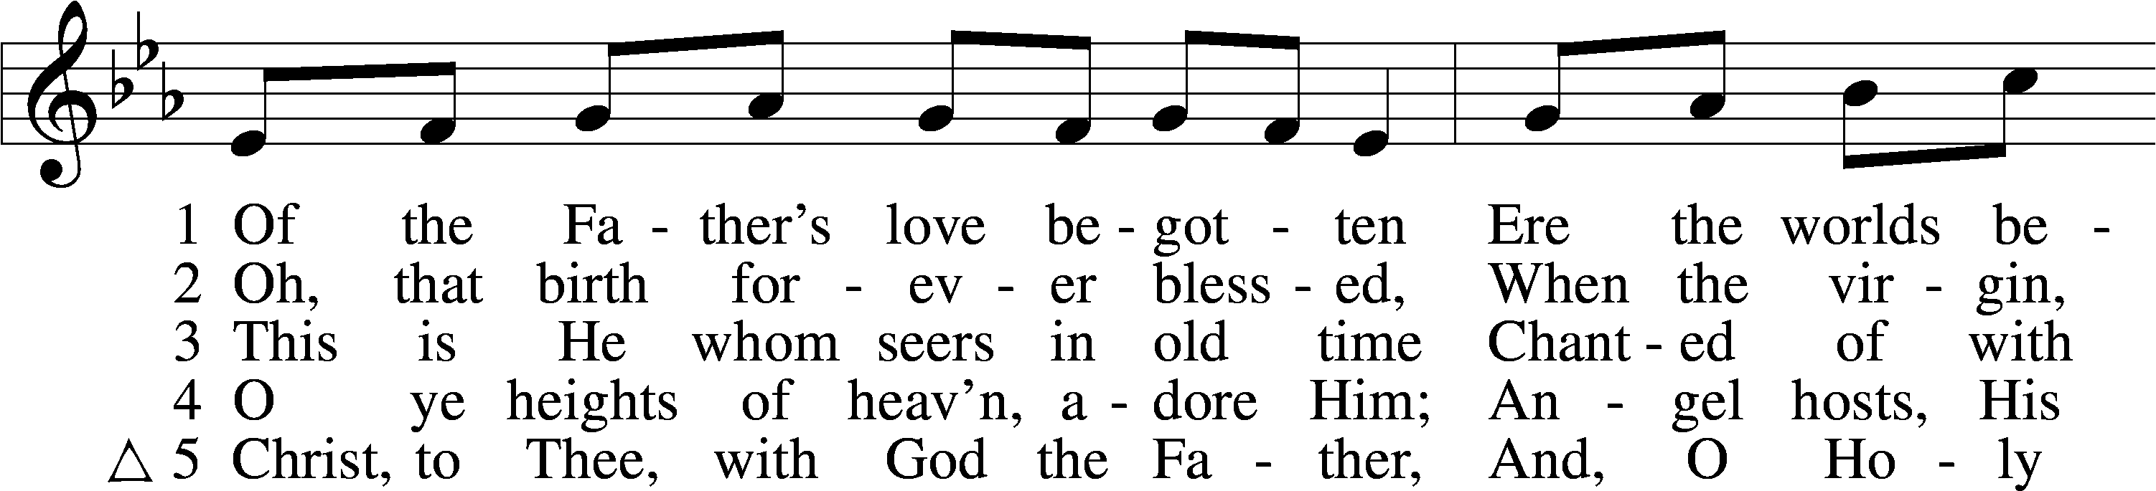
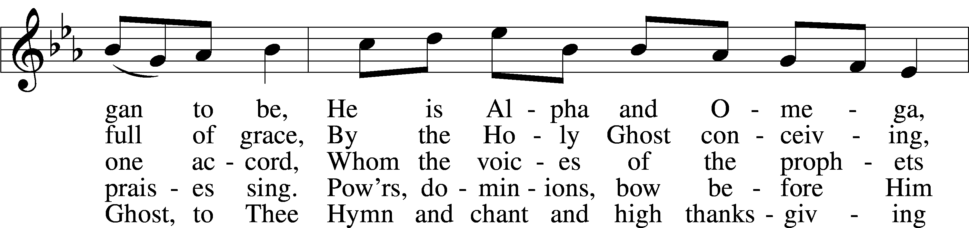
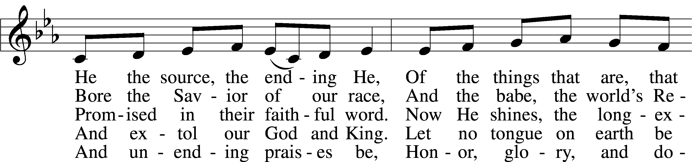
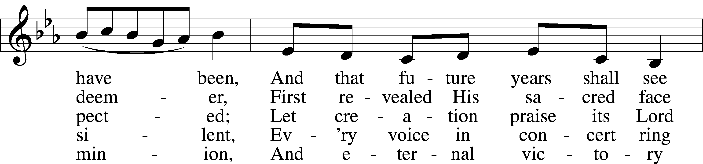
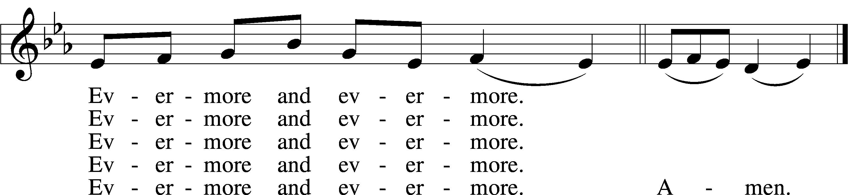
Text: Aurelius Prudentius Clemens, 348–c. 413; (sts. 1–4): tr. John Mason Neale, 1818–66, alt.; (st. 5): tr. Henry W. Baker, 1821–77
Tune: Plainsong, 13th cent., mode V
Text and tune: Public domain

(Stand)

HOLY GOSPEL Matthew 1:18–25
L The Holy Gospel according to St. Matthew, the first chapter.
C Glory to You, O Lord.

18Now the birth of Jesus Christ took place in this way. When his mother Mary had been betrothed to Joseph, before they came together she was found to be with child from the Holy Spirit. 19And her husband Joseph, being a just man and unwilling to put her to shame, resolved to divorce her quietly. 20But as he considered these things, behold, an angel of the Lord appeared to him in a dream, saying, “Joseph, son of David, do not fear to take Mary as your wife, for that which is conceived in her is from the Holy Spirit. 21She will bear a son, and you shall call his name Jesus, for he will save his people from their sins.” 22All this took place to fulfill what the Lord had spoken by the prophet:
23“Behold, the virgin shall conceive and bear a son,
and they shall call his name Immanuel”
(which means, God with us). 24When Joseph woke from sleep, he did as the angel of the Lord commanded him: he took his wife, 25but knew her not until she had given birth to a son. And he called his name Jesus.

L This is the Gospel of the Lord.
C Praise to You, O Christ.

(Sit)

359 LO, HOW A ROSE E’ER BLOOMING
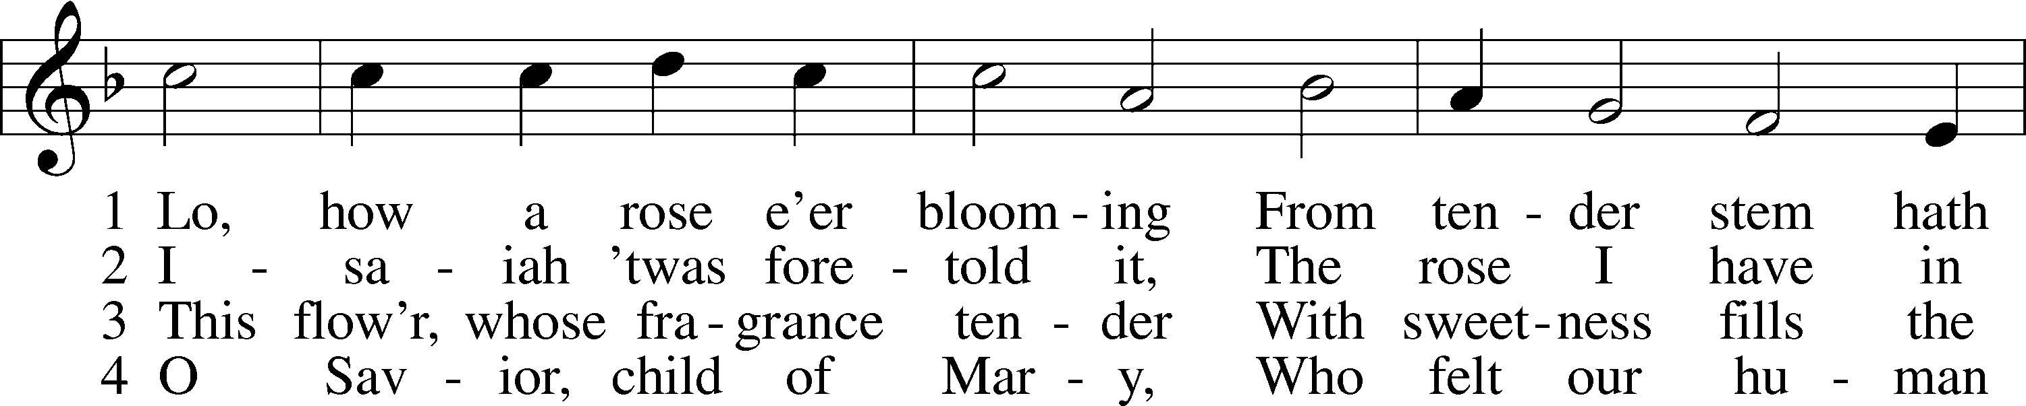
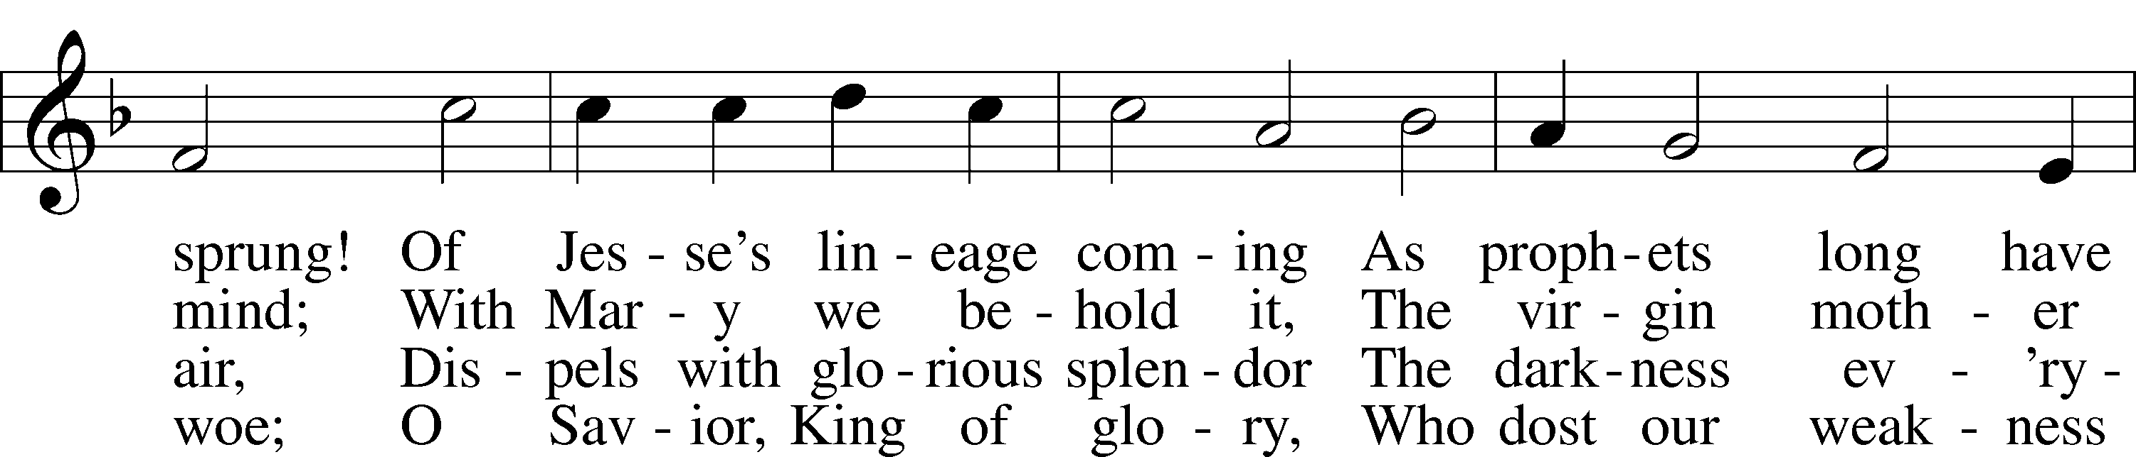
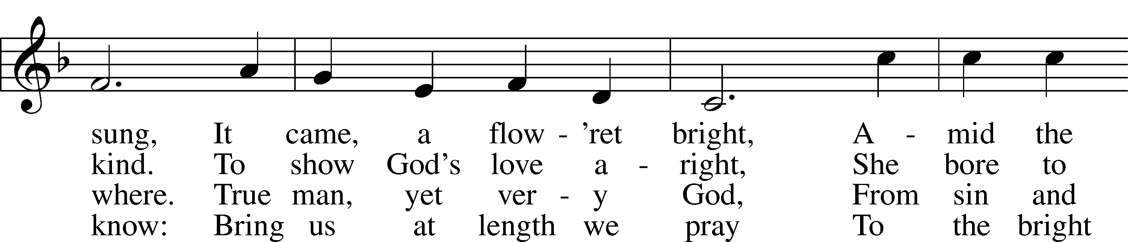
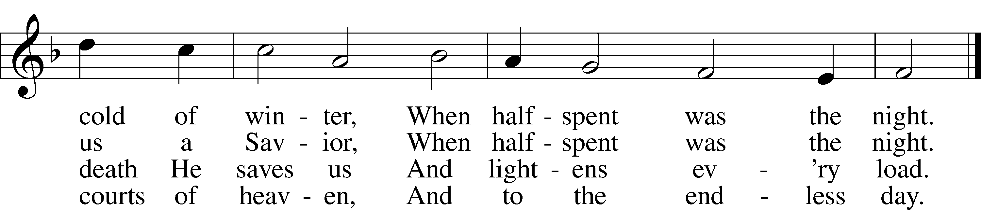
Text (sts. 1–2): tr. Theodore Baker, 1851–1934, alt.; (sts. 1–2, 4): German, 16th cent.; (st. 3): Friedrich L. C. Layriz, 1808–59; (st. 3): tr. Harriet R. K. Spaeth, 1845–1925; (st. 4): tr. John C. Mattes, 1876–1948
Tune: Alte Catholische Geistliche Kirchengeseng, 1599, Köln
Text and tune: Public domain

SERMON OR MEDITATION ON THE READINGS

PRAYER OF THE CHURCH

OFFERING
As a part of our expression of thanksgiving to God for the treasure of His salvation to us, we offer a portion of our treasure, according to what each has determined in their heart to give. Please place offerings in the collection plate at the back of the sanctuary before or after the service. Offerings can also be sent to Bethlehem Lutheran Church via U.S. Mail. Thank you!

LORD’S PRAYER
C Our Father who art in heaven,
hallowed be Thy name,
Thy kingdom come,
Thy will be done on earth
as it is in heaven;
give us this day our daily bread;
and forgive us our trespasses
as we forgive those
who trespass against us;
and lead us not into temptation,
but deliver us from evil.
For Thine is the kingdom
and the power and the glory
forever and ever. Amen.

(Stand)

BENEDICTION
L:The grace of our Lord T Jesus Christ, and the love of God, and the fellowship of the Holy Spirit, be with us all.
C: Amen.

SHARING OF THE LIGHT

(the pastor will take a large candle and light it from the Christ candle, symbolizing Christ, the Light of the world. The ushers will light their candles from the pastor's candle, and then light the candles of the worshiper nearest the aisle. Each worshiper in turn then lights the candle of the one next to them. The lighted candle remains upright; the unlit candle is tilted toward it for lighting to prevent spilling hot wax.)

363 SILENT NIGHT, HOLY NIGHT sts. 1–3
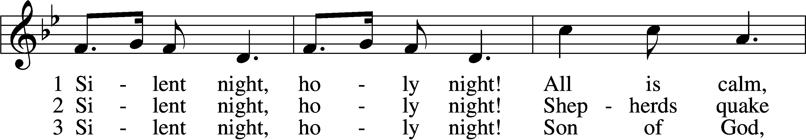
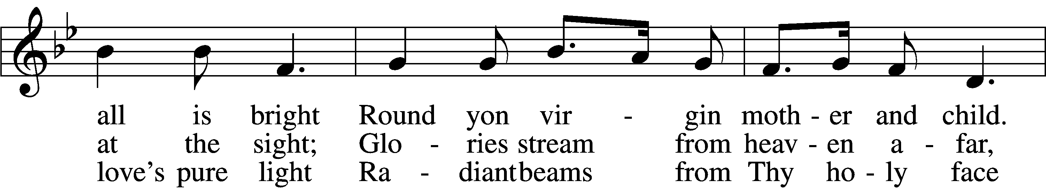
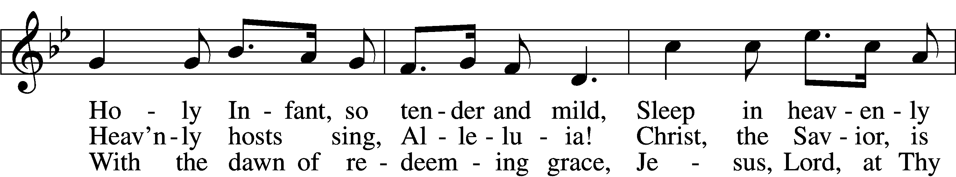
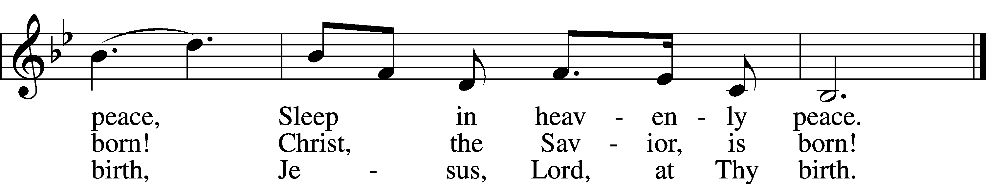
Text: Franz Joseph Mohr, 1792–1848; tr. John F. Young, 1820–85
Tune: Franz Xaver Gruber, 1787–1863
Text and tune: Public domain

(The candles are extinguished)

ACKNOWLEDGMENTS
Unless otherwise indicated, Scripture quotations are from the ESV® Bible (The Holy Bible, English Standard Version®), copyright © 2001 by Crossway, a publishing ministry of Good News Publishers. Used by permission. All rights reserved.
Created by Lutheran Service Builder © 2025 Concordia Publishing House.

2026 POINSETTIA

NAME IN MEMORY OF:

BOUKNIGHT (2) Vicky Allen (sister)
Jim Bouknight

SNELLING (2) Pat Cain (mother)

TACKEBURY (2) Mike Tackebury

TILGHMAN (2) not specified

MARTINI (1) not specified

ANONYMOUS (1) Joyce Collucci

ENGWALLS (1) Russell and Carole Engwall

ALLEN (1) not specified

Ruth (1) Daughter

