**BETHLEHEM LUTHERAN CHURCH**

***A congregation of The Lutheran Church-Missouri Synod***

902 Hitchcock Drive SW,

Aiken, South Carolina 29803

Church Phone: (803) 649-6417

blcaikensc@gmail.com

**Pastor: Rev. John B. Engwall**

**Office Hours By Appointment**

**Note:** The format of this bulletin has been modified for use in private devotion services. Unable to join us in person? Please find us on Facebook live. The service is also posted on our website: bethlehemlutheranaiken.org

**+ + + + + + + + + + + + + + +**

**The 14th Sunday after Pentecost**

**Sept 14, 2025**

**10:30 a.m.**

**+ + + + + + + + + + + + + + +**

**Our Policy and Practice Regarding Holy Communion**

**Hear the words of the Apostle Paul;**

*Anyone who eats and drinks without recognizing the body of the Lord eats and drinks judgment on himself. -*1 Cor.11:29

**Therefore, visitors are asked to please refrain from partaking of the Sacrament before speaking about this with the pastor; because we care about your spiritual well-being.**

**Also, because communing at this altar is a public confession that you agree with the doctrines of The Lutheran Church-Missouri Synod, and reject all contrary teachings.**

Persons who are not communing today are always welcome to come forward during the distribution to receive an individual blessing; please cross your arms over your chest to indicate your desire for this. Thank you!

We commune in two alternating tables. The ushers will guide you. Non-alcoholic white wine is available in the center of the individual cup tray. Please leave empty individual cups at the altar rail.

**+ SERVICE OF PREPARATION +**

*After the bell tolls, please observe a time of silence.*

**WELCOME AND ANNOUNCEMENTS**

(Stand)

864 SHEPHERD OF TENDER YOUTH

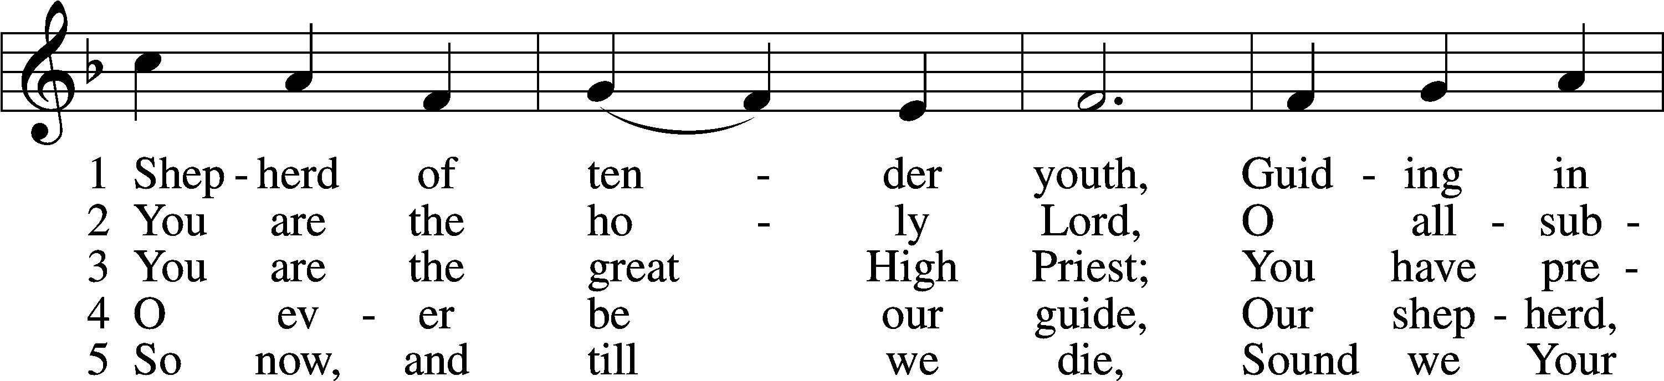

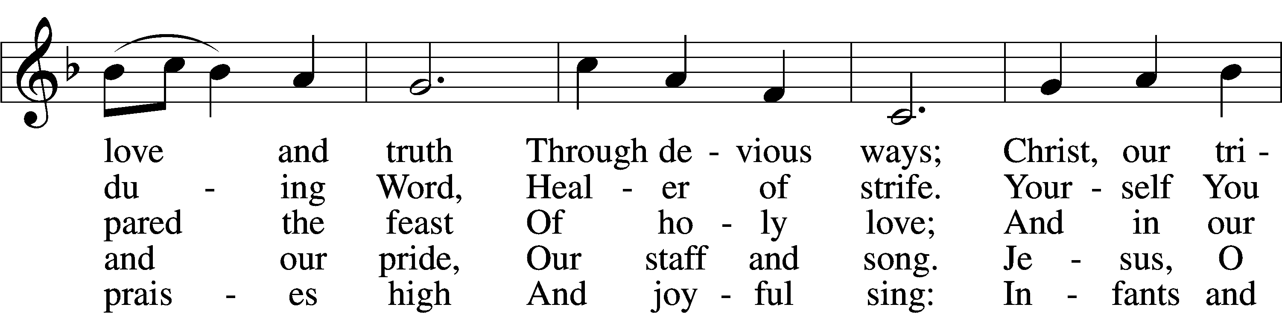

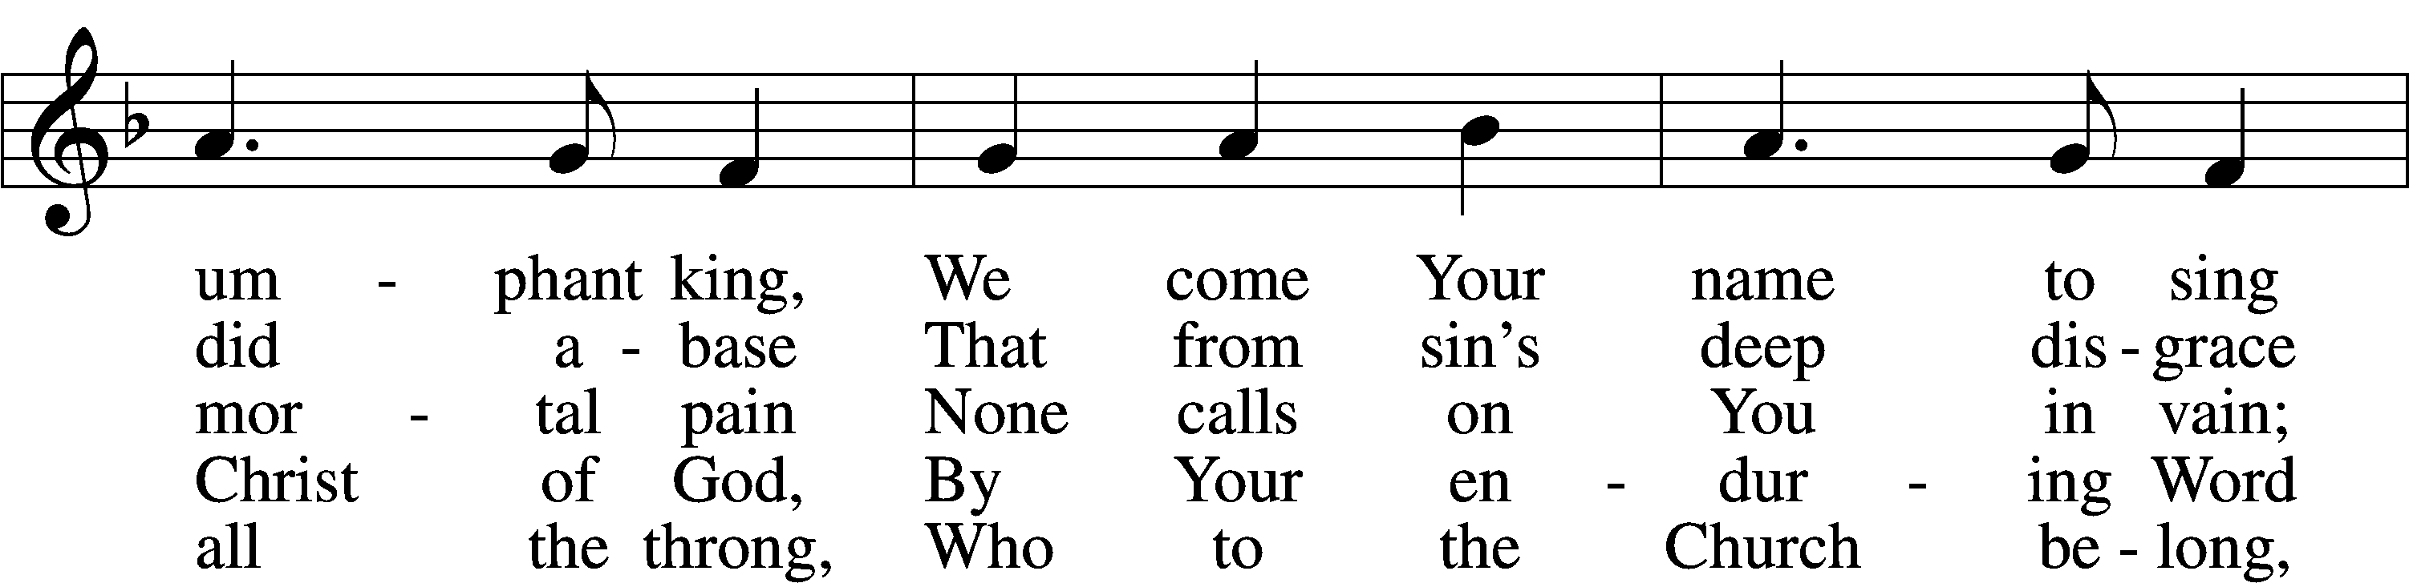

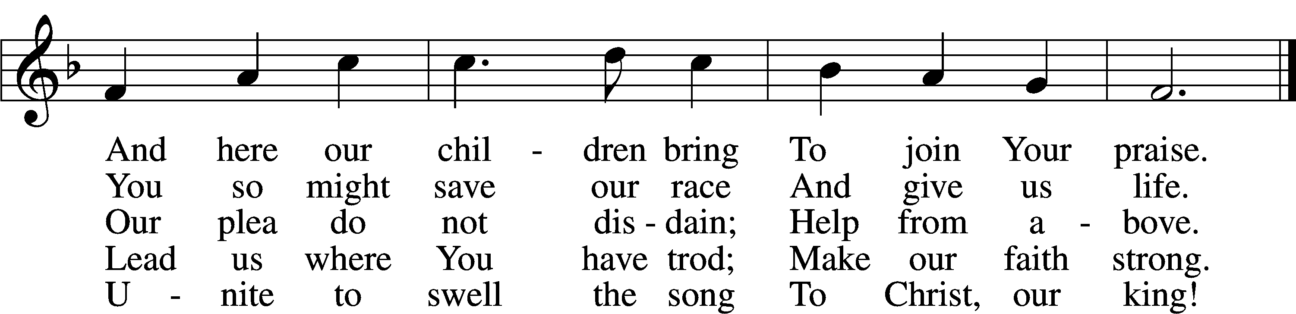

Text: attr. Clement of Alexandria, c. 170–c. 220; tr. Henry M. Dexter, 1821–90, alt.  
Tune: Felice de Giardini, 1716–96  
Text and tune: Public domain

# + CONFESSION AND ABSOLUTION +

(The sign of the cross may be made by all in remembrance of their Baptism.)

INVOCATION

L In the name of the Father and of the T Son and of the Holy Spirit.

C **Amen.**

EXHORTATION LSB 151

L If we say we have no sin, we deceive ourselves, and the truth is not in us.

C **But if we confess our sins, God, who is faithful and just, will forgive our sins and cleanse us from all unrighteousness.**

(Silence for reflection on God’s Word and for self-examination.)

CONFESSION OF SINS LSB 151

L Let us then confess our sins to God our Father.

C **Most merciful God, we confess that we are by nature sinful and unclean. We have sinned against You in thought, word, and deed, by what we have done and by what we have left undone. We have not loved You with our whole heart; we have not loved our neighbors as ourselves. We justly deserve Your present and eternal punishment. For the sake of Your Son, Jesus Christ, have mercy on us. Forgive us, renew us, and lead us, so that we may delight in Your will and walk in Your ways to the glory of Your holy name. Amen.**

**DECLARATION OF GRACE**

L In the mercy of almighty God, Jesus Christ was given to die for us, and for His sake God forgives us all our sins. To those who believe in Jesus Christ He gives the power to become the children of God and bestows on them the Holy Spirit. May the Lord, who has begun this good work in us, bring it to completion in the day of our Lord Jesus Christ.

C **Amen.**

# + SERVICE OF THE WORD +

INTROIT Psalm 30:2–5; antiphon: vv. 11a, 12b

You have turned for me my mourning into | dancing;*  
 O Lord my God, I will give thanks to you for- | ever!  
O Lord my God, I cried to | you for help,*  
 and you have | healed me.  
O Lord, you have brought up my soul | from Sheol;*  
 you restored me to life from among those who go down | to the pit.  
Sing praises to the Lord, O | you his saints,*  
 and give thanks to his | holy name.  
For his anger is but for a moment, and his favor is for a | lifetime.*  
 Weeping may tarry for the night, but joy comes with the | morning.  
**Glory be to the Father and | to the Son**\*  
 **and to the Holy | Spirit;**  
**as it was in the be- | ginning,**\*  
 **is now, and will be forever. | Amen.**  
You have turned for me my mourning into | dancing;*  
 O Lord my God, I will give thanks to you for- | ever!

KYRIE LSB 152



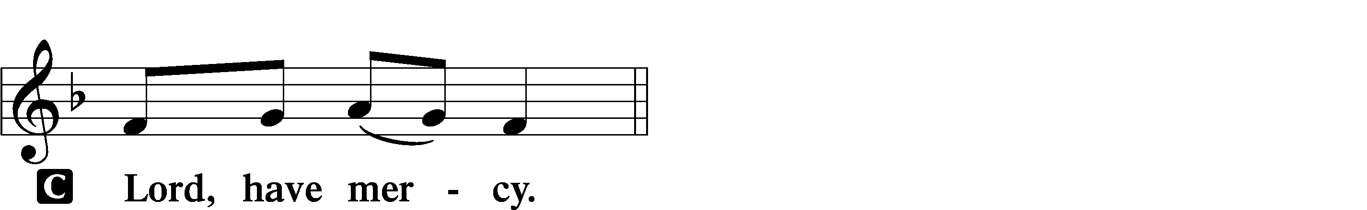

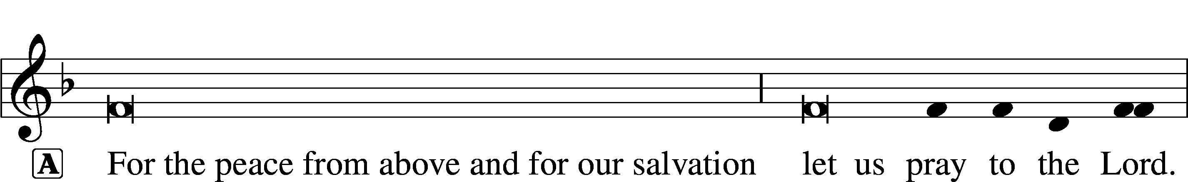

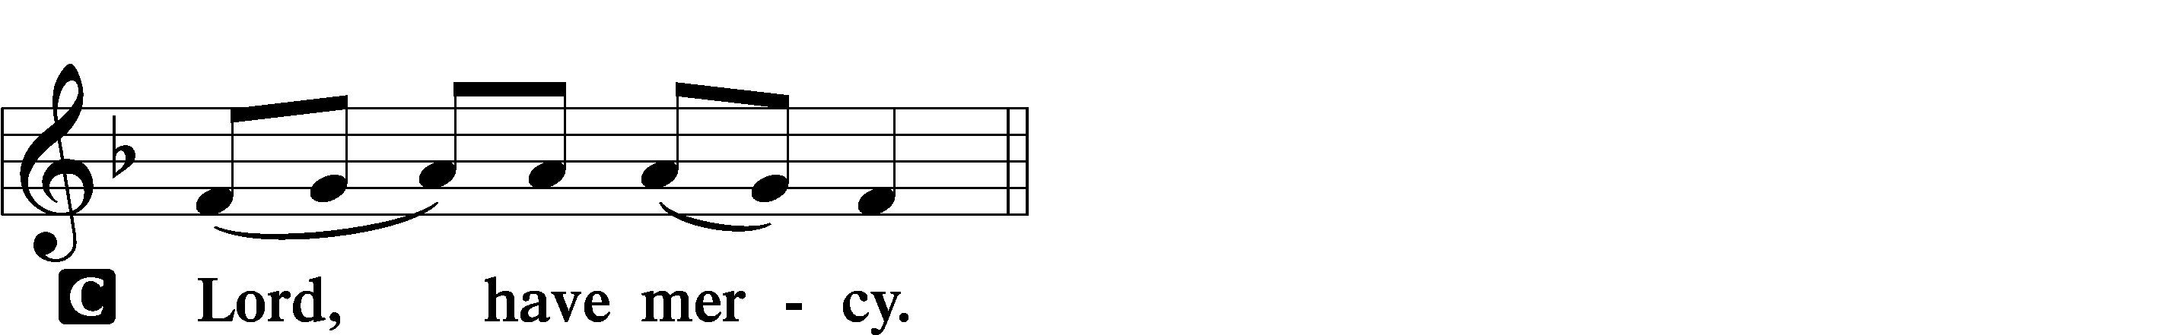

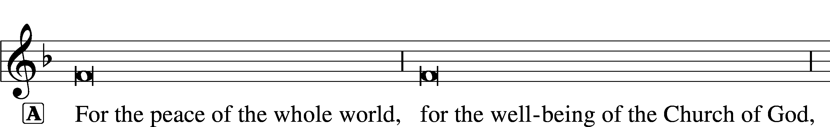

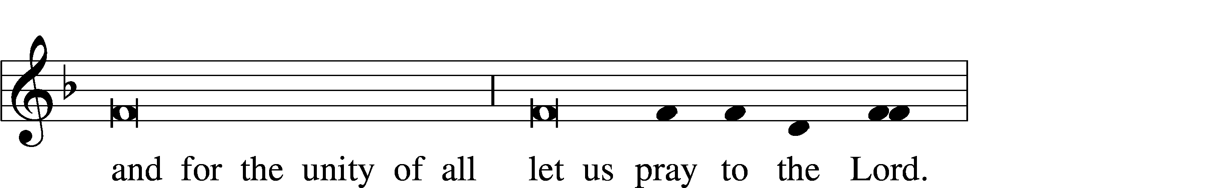

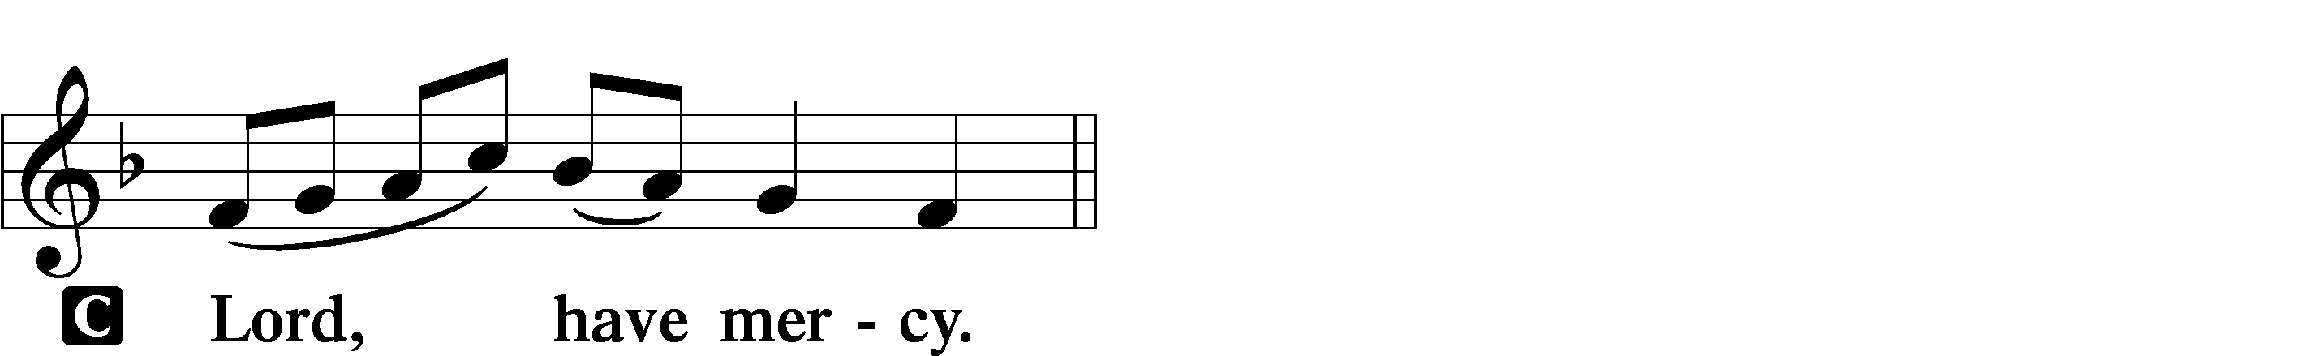

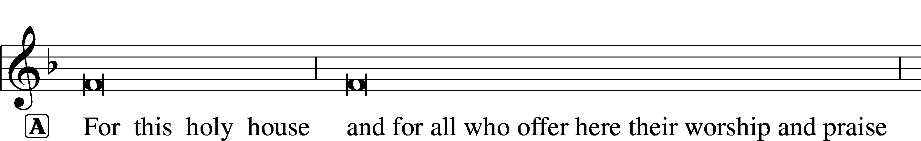



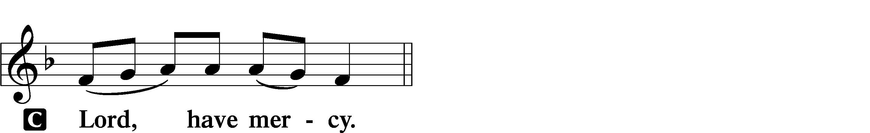

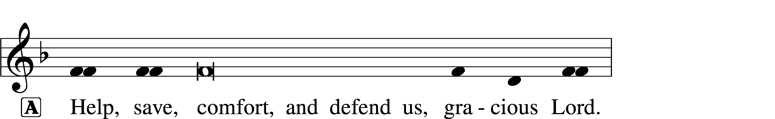



GLORIA IN EXCELSIS LSB 154

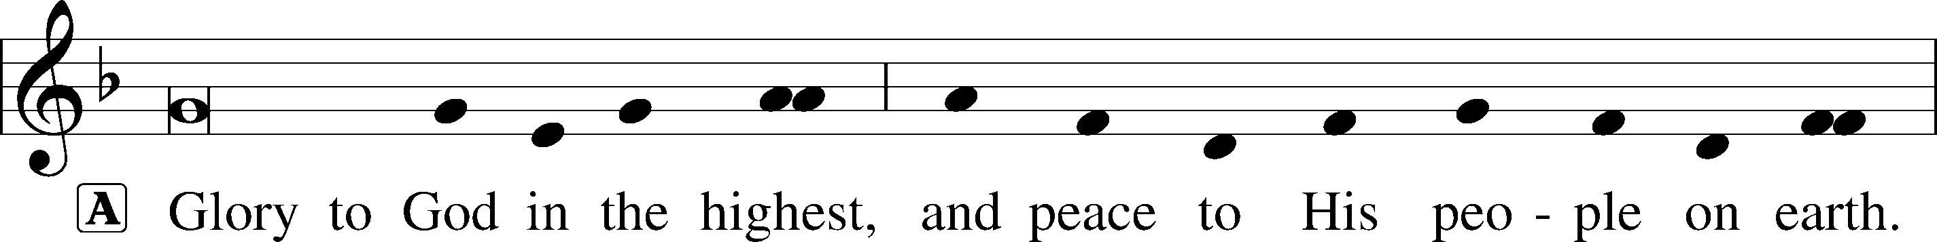

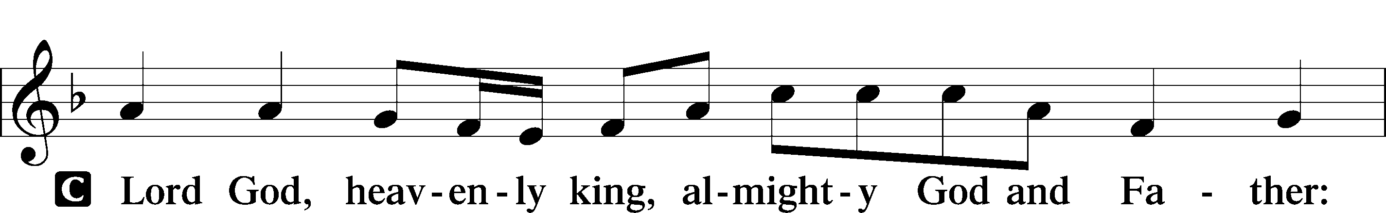

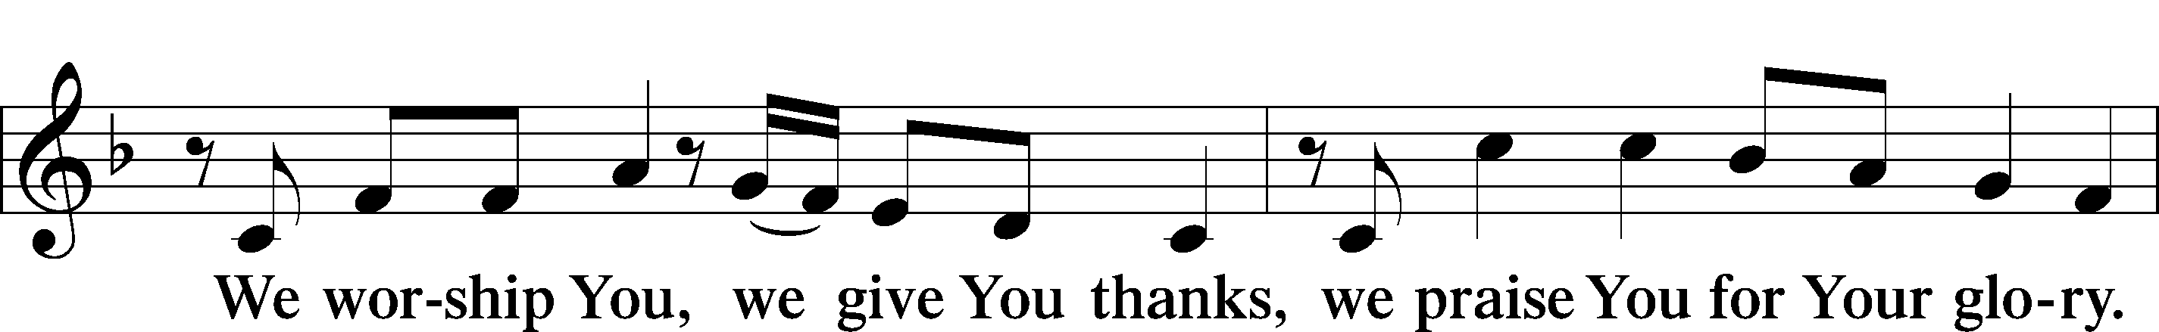

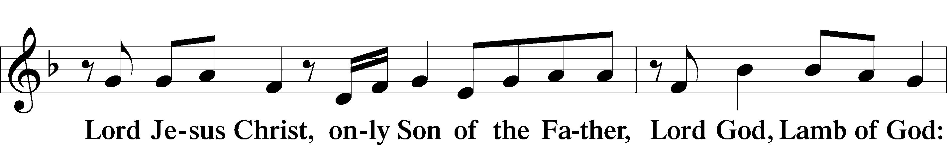

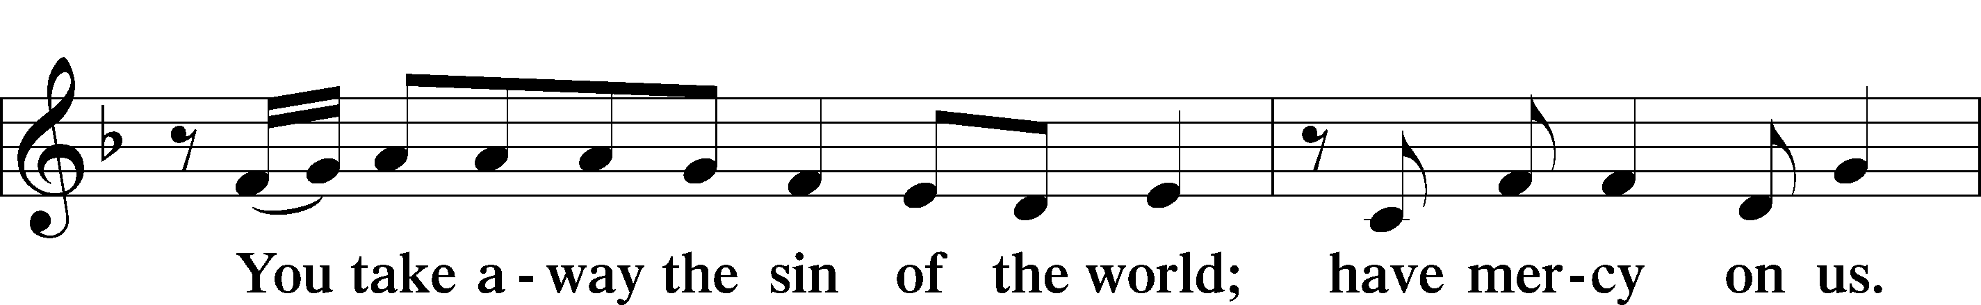

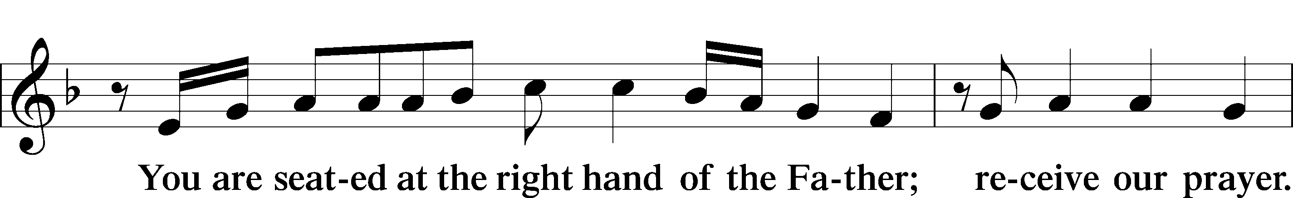

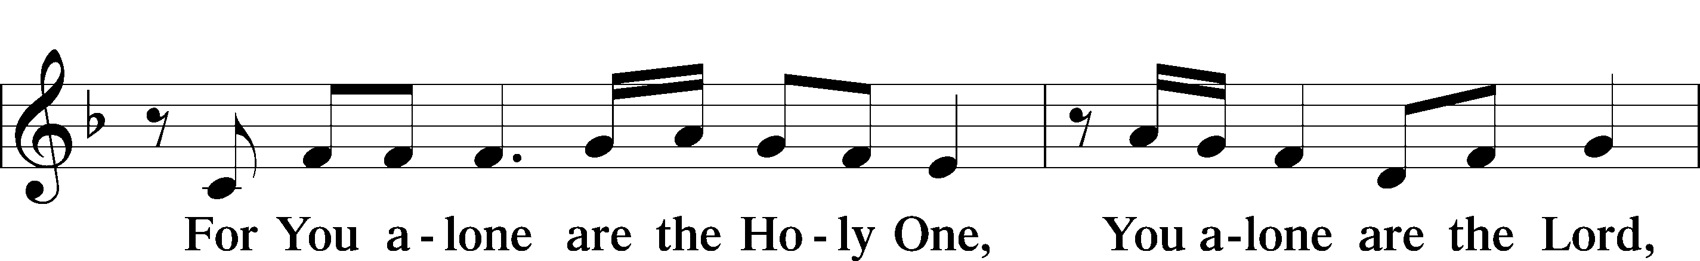

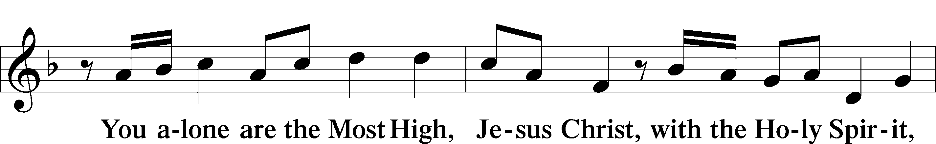

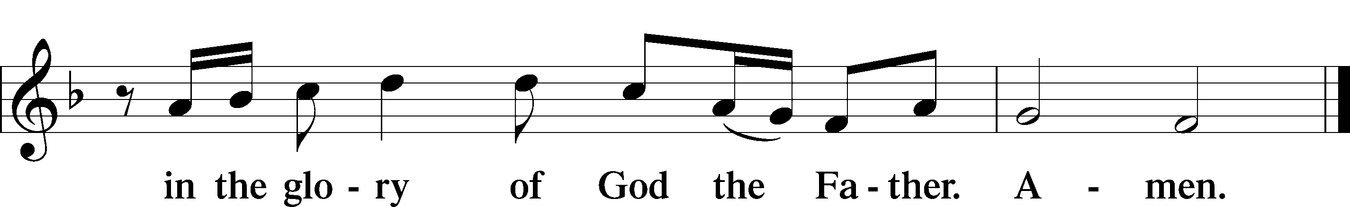

SALUTATION AND COLLECT OF THE DAY

L The Lord be with you.

C **And also with you.**

L Let us pray.

Lord Jesus, You are the Good Shepherd, without whom nothing is secure. Rescue and preserve us that we may not be lost forever but follow You, rejoicing in the way that leads to eternal life; for You live and reign with the Father and the Holy Spirit, one God, now and forever.

C **Amen.**

(Sit)

CHILDREN’S LESSON

OLD TESTAMENT READING Ezekiel 34:11–24

11“For thus says the Lord God: Behold, I, I myself will search for my sheep and will seek them out. 12As a shepherd seeks out his flock when he is among his sheep that have been scattered, so will I seek out my sheep, and I will rescue them from all places where they have been scattered on a day of clouds and thick darkness. 13And I will bring them out from the peoples and gather them from the countries, and will bring them into their own land. And I will feed them on the mountains of Israel, by the ravines, and in all the inhabited places of the country. 14I will feed them with good pasture, and on the mountain heights of Israel shall be their grazing land. There they shall lie down in good grazing land, and on rich pasture they shall feed on the mountains of Israel. 15I myself will be the shepherd of my sheep, and I myself will make them lie down, declares the Lord God. 16I will seek the lost, and I will bring back the strayed, and I will bind up the injured, and I will strengthen the weak, and the fat and the strong I will destroy. I will feed them in justice.

17“As for you, my flock, thus says the Lord God: Behold, I judge between sheep and sheep, between rams and male goats. 18Is it not enough for you to feed on the good pasture, that you must tread down with your feet the rest of your pasture; and to drink of clear water, that you must muddy the rest of the water with your feet? 19And must my sheep eat what you have trodden with your feet, and drink what you have muddied with your feet?

20“Therefore, thus says the Lord God to them: Behold, I, I myself will judge between the fat sheep and the lean sheep. 21Because you push with side and shoulder, and thrust at all the weak with your horns, till you have scattered them abroad, 22I will rescue my flock; they shall no longer be a prey. And I will judge between sheep and sheep. 23And I will set up over them one shepherd, my servant David, and he shall feed them: he shall feed them and be their shepherd. 24And I, the Lord, will be their God, and my servant David shall be prince among them. I am the Lord; I have spoken.”

L This is the Word of the Lord.

C **Thanks be to God.**

GRADUAL Psalm 34:9, 19, alt.

Fear the Lord, | you his saints,*  
 for those who fear him lack | nothing!  
Many are the afflictions of the | righteous,*  
 but the Lord delivers him out | of them all.

EPISTLE 1 Timothy 1:5–17

5The aim of our charge is love that issues from a pure heart and a good conscience and a sincere faith. 6Certain persons, by swerving from these, have wandered away into vain discussion, 7desiring to be teachers of the law, without understanding either what they are saying or the things about which they make confident assertions.

8Now we know that the law is good, if one uses it lawfully, 9understanding this, that the law is not laid down for the just but for the lawless and disobedient, for the ungodly and sinners, for the unholy and profane, for those who strike their fathers and mothers, for murderers, 10the sexually immoral, men who practice homosexuality, enslavers, liars, perjurers, and whatever else is contrary to sound doctrine, 11in accordance with the glorious gospel of the blessed God with which I have been entrusted.

12I thank him who has given me strength, Christ Jesus our Lord, because he judged me faithful, appointing me to his service, 13though formerly I was a blasphemer, persecutor, and insolent opponent. But I received mercy because I had acted ignorantly in unbelief, 14and the grace of our Lord overflowed for me with the faith and love that are in Christ Jesus. 15The saying is trustworthy and deserving of full acceptance, that Christ Jesus came into the world to save sinners, of whom I am the foremost. 16But I received mercy for this reason, that in me, as the foremost, Jesus Christ might display his perfect patience as an example to those who were to believe in him for eternal life. 17To the King of ages, immortal, invisible, the only God, be honor and glory forever and ever. Amen.

L This is the Word of the Lord.

C **Thanks be to God.**

(Stand)

ALLELUIA AND VERSE LSB 156

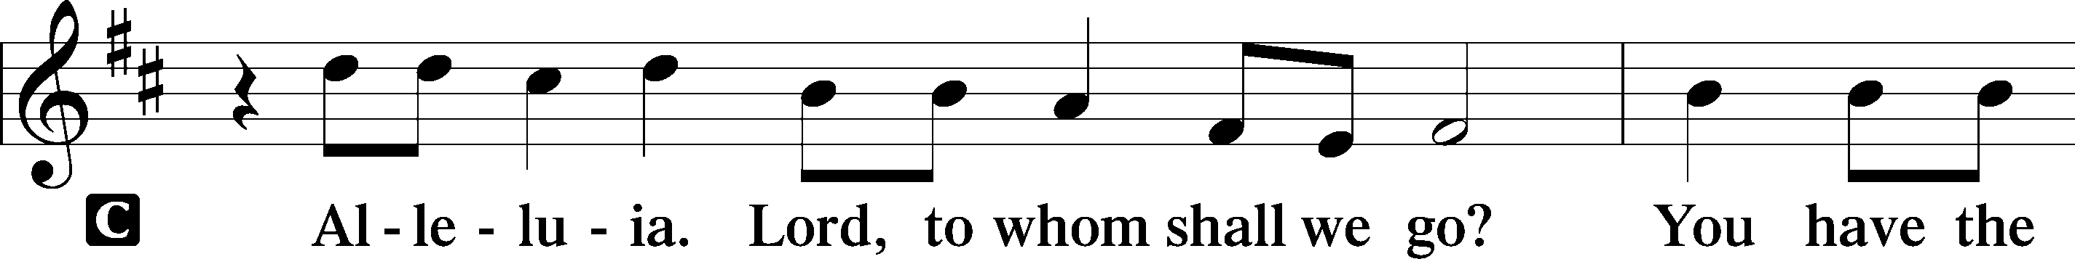

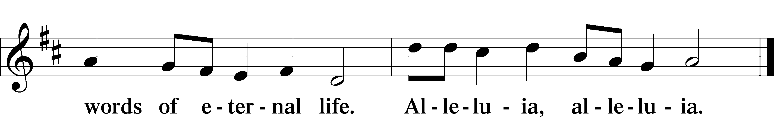

HOLY GOSPEL Luke 15:1–10

L The Holy Gospel according to St. Luke, the fifteenth chapter.

C **Glory to You, O Lord.**

1Now the tax collectors and sinners were all drawing near to hear [Jesus]. 2And the Pharisees and the scribes grumbled, saying, “This man receives sinners and eats with them.”

3So he told them this parable: 4“What man of you, having a hundred sheep, if he has lost one of them, does not leave the ninety-nine in the open country, and go after the one that is lost, until he finds it? 5And when he has found it, he lays it on his shoulders, rejoicing. 6And when he comes home, he calls together his friends and his neighbors, saying to them, ‘Rejoice with me, for I have found my sheep that was lost.’ 7Just so, I tell you, there will be more joy in heaven over one sinner who repents than over ninety-nine righteous persons who need no repentance.

8“Or what woman, having ten silver coins, if she loses one coin, does not light a lamp and sweep the house and seek diligently until she finds it? 9And when she has found it, she calls together her friends and neighbors, saying, ‘Rejoice with me, for I have found the coin that I had lost.’ 10Just so, I tell you, there is joy before the angels of God over one sinner who repents.”

L This is the Gospel of the Lord.

C **Praise to You, O Christ.**

(Sit)

609 JESUS SINNERS DOTH RECEIVE

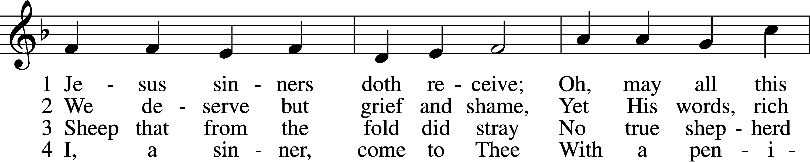

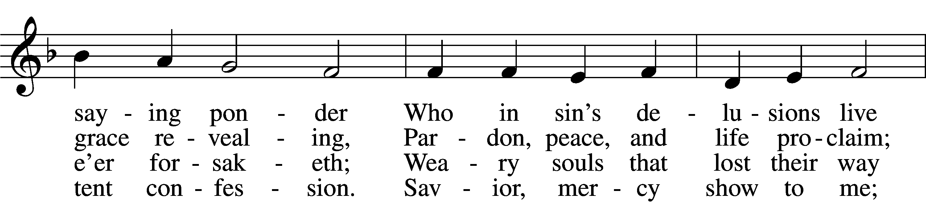

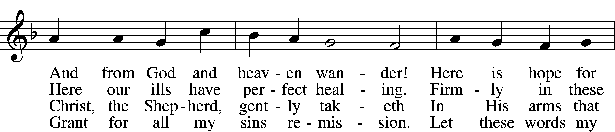

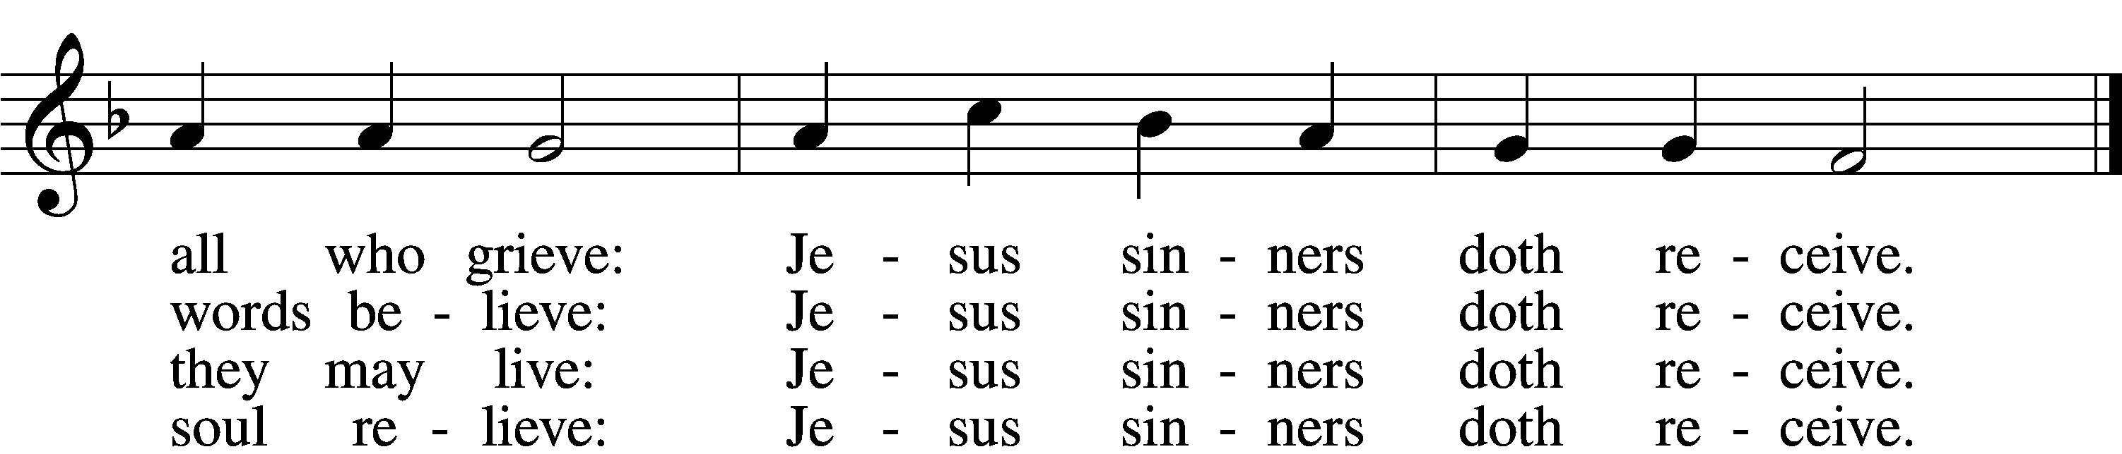

5 Oh, how blest it is to know:  
 Were as scarlet my transgression,  
It shall be as white as snow  
 By Thy blood and bitter passion;  
For these words I now believe:  
Jesus sinners doth receive.

6 Now my conscience is at peace;  
 From the Law I stand acquitted.  
Christ hath purchased my release  
 And my ev’ry sin remitted.  
Naught remains my soul to grieve:  
Jesus sinners doth receive.

7 Jesus sinners doth receive;  
 Also I have been forgiven;  
And when I this earth must leave,  
 I shall find an open heaven.  
Dying, still to Him I cleave:  
Jesus sinners doth receive.

Text: tr. The Lutheran Hymnal, 1941, alt.; Erdmann Neumeister, 1671–1756  
Tune: Neu-verfertigtes Darmstädtisches Gesang-Buch, 1699, Darmstadt  
Text and tune: Public domain

SERMON OR MEDITATION ON THE READINGS

(Stand)

APOSTLES’ CREED

C **I believe in God, the Father Almighty,**

**maker of heaven and earth.**

**And in Jesus Christ, His only Son, our Lord,**

**who was conceived by the Holy Spirit,**

**born of the virgin Mary,**

**suffered under Pontius Pilate,**

**was crucified, died and was buried.**

**He descended into hell.**

**The third day He rose again from the dead.**

**He ascended into heaven**

**and sits at the right hand of God the Father Almighty.**

**From thence He will come to judge the living and the dead.**

**I believe in the Holy Spirit,**

**the holy Christian Church,**

**the communion of saints,**

**the forgiveness of sins,**

**the resurrection of the body,**

**and the life** T **everlasting. Amen.**

**SHARING OF THE PEACE**

(Sit)

PRAYER OF THE CHURCH

OFFERING

*As a part of our expression of thanksgiving to God for the treasure of His salvation to us, we offer a portion of our treasure, according to what each has determined in their heart to give. Please place offerings in the collection plate at the back of the sanctuary before or after the service. Offerings can also be sent to Bethlehem Lutheran Church via U.S. Mail. Thank you!*

(Stand)

OFFERTORY LSB 159

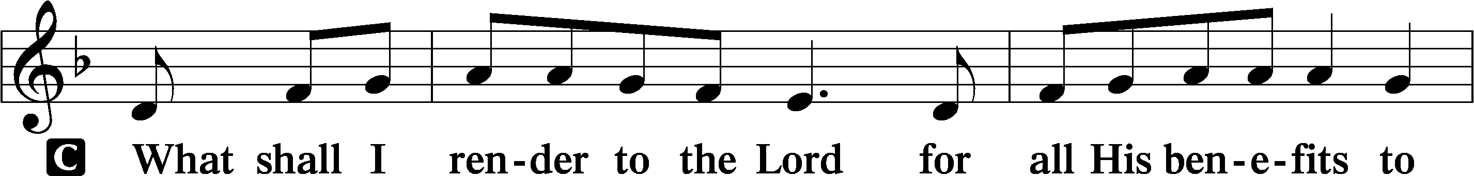

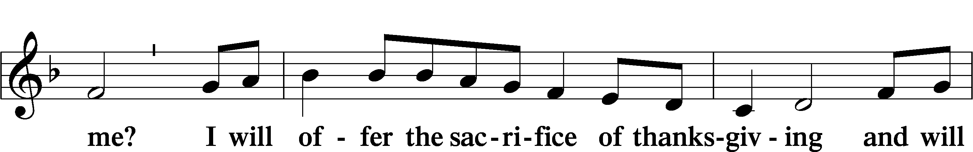

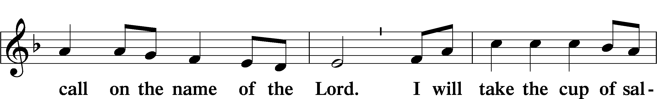

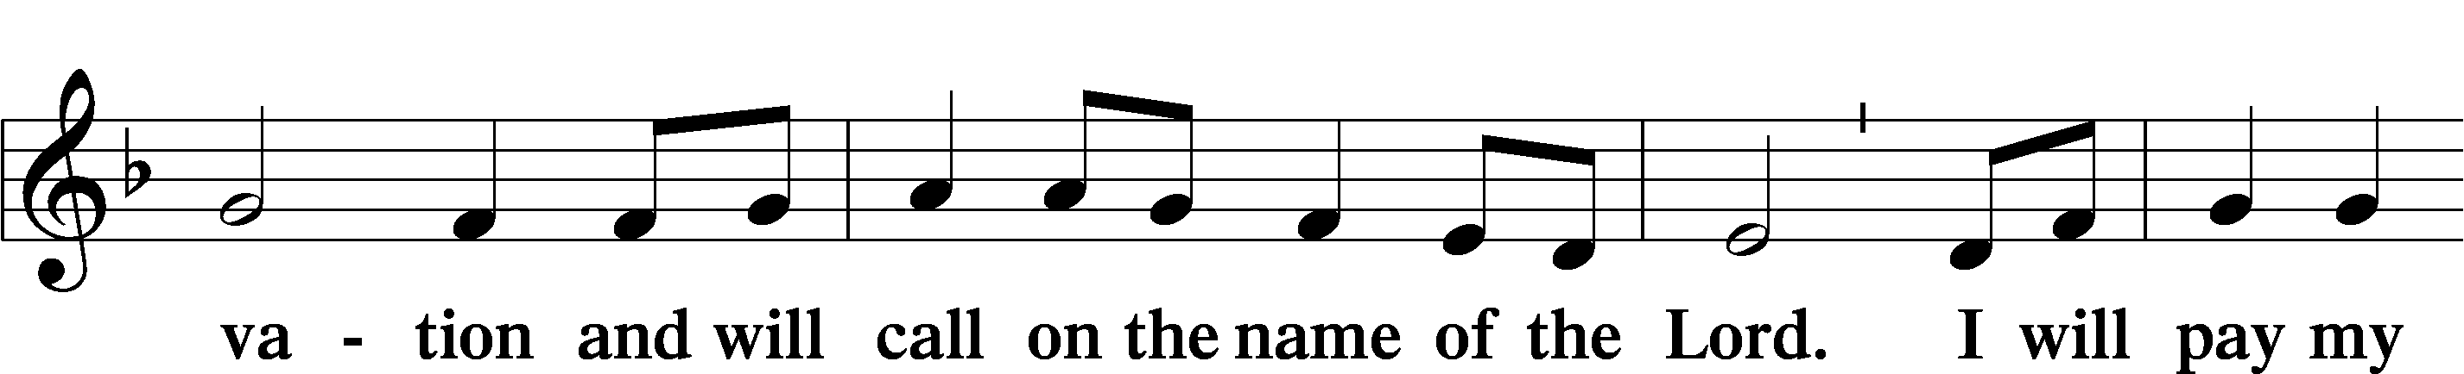

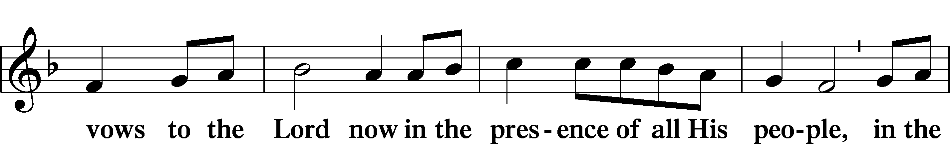

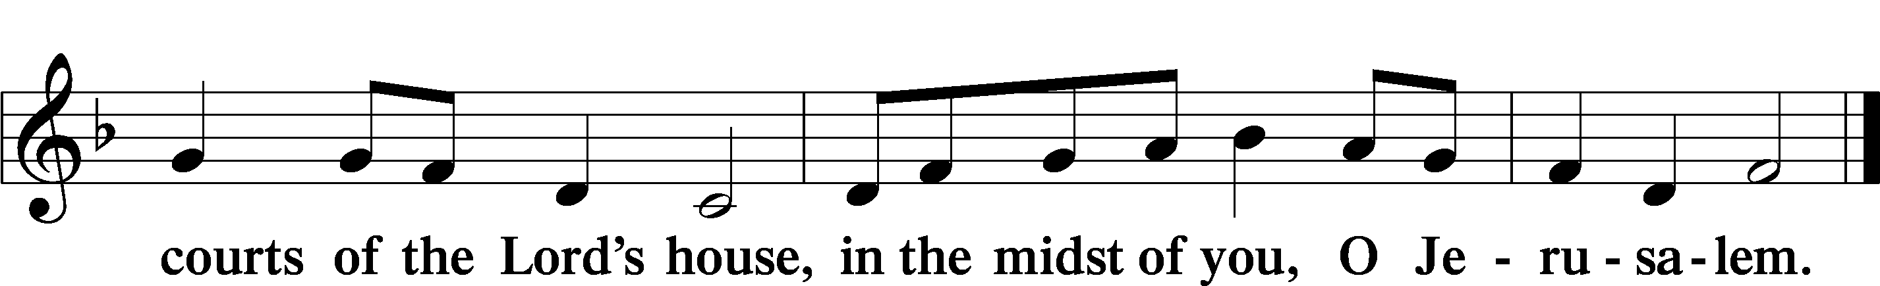

# + SERVICE OF THE SACRAMENT +

Note: The Service of The Sacrament is included in the lay bulletin solely as a viewers’ guide for those watching the livestream service; *Communicant members who are unable to attend the Divine Service in person are encouraged to make arrangements with Pastor Engwall to receive the Lord’s Supper.*

PREFACE LSB 160

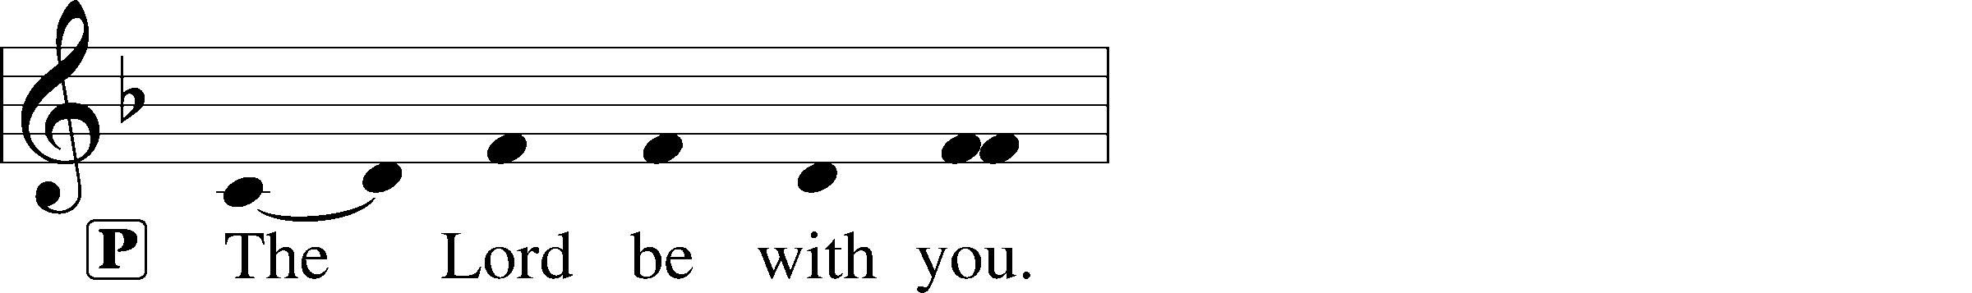



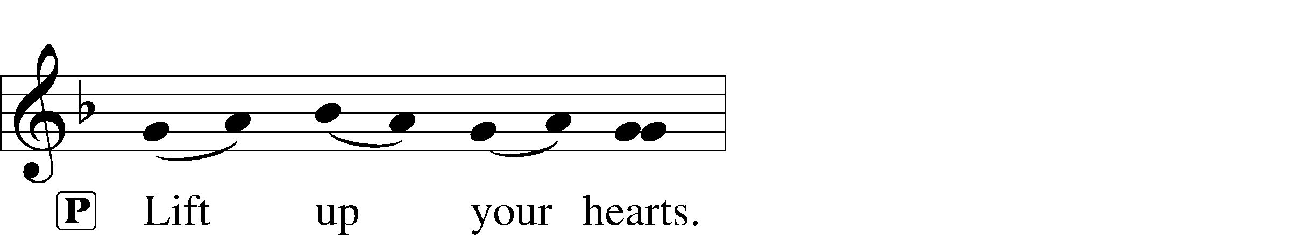





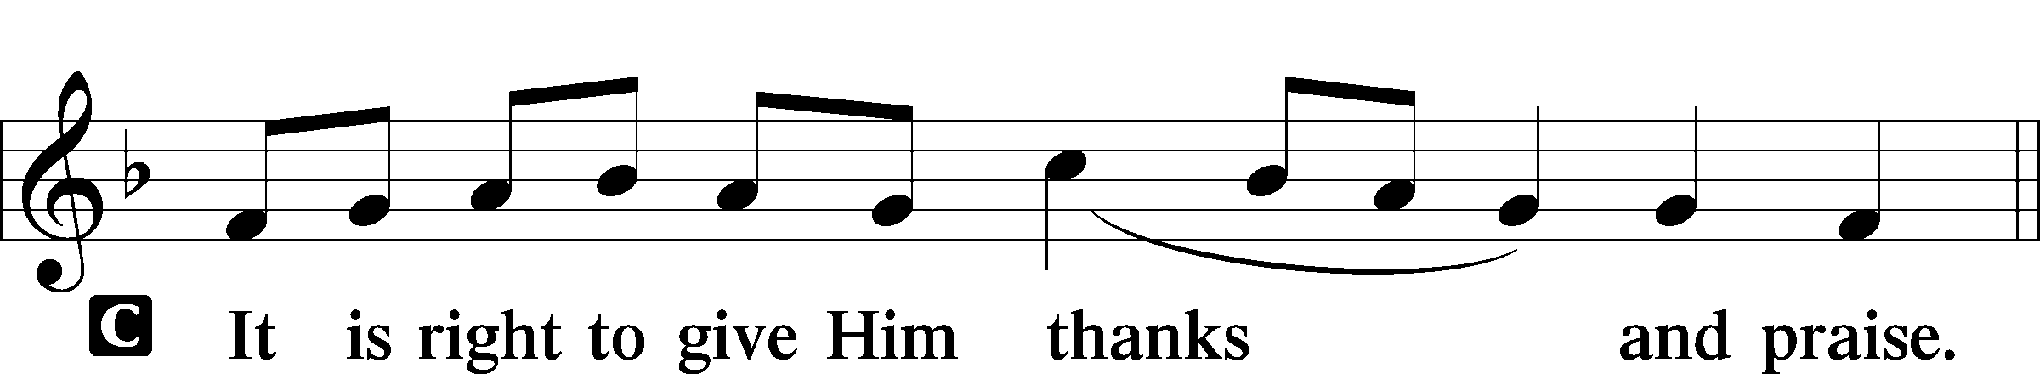

PROPER PREFACE (ABBREVIATED) LSB 161

P It is truly good, right, and salutary . . . evermore praising You and saying:

SANCTUS LSB 161

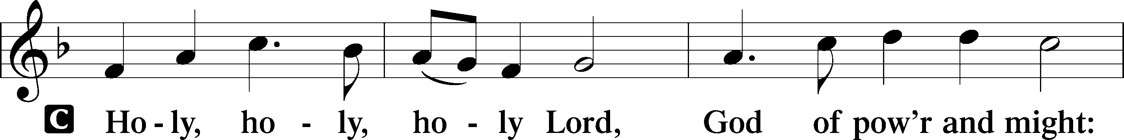

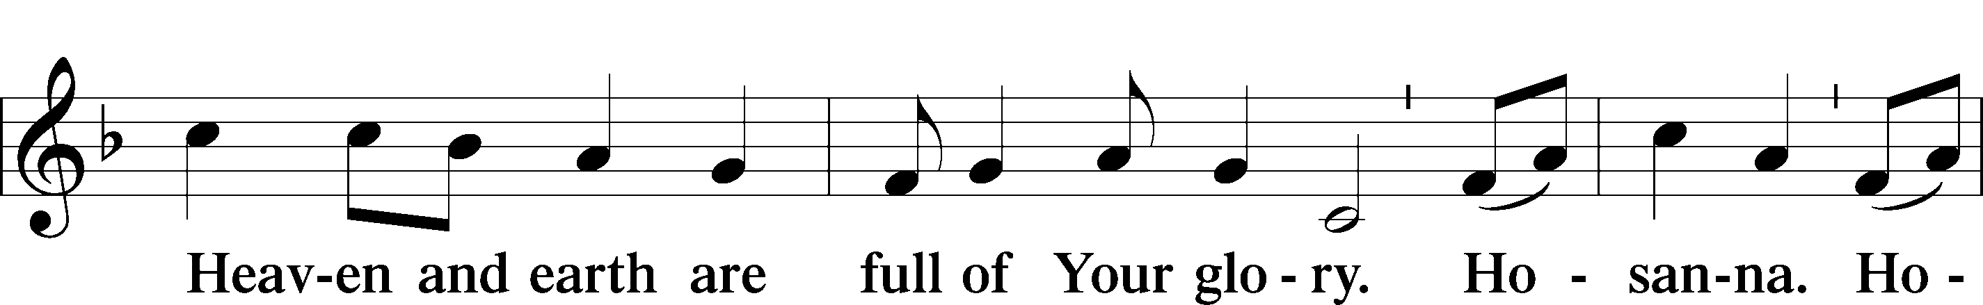

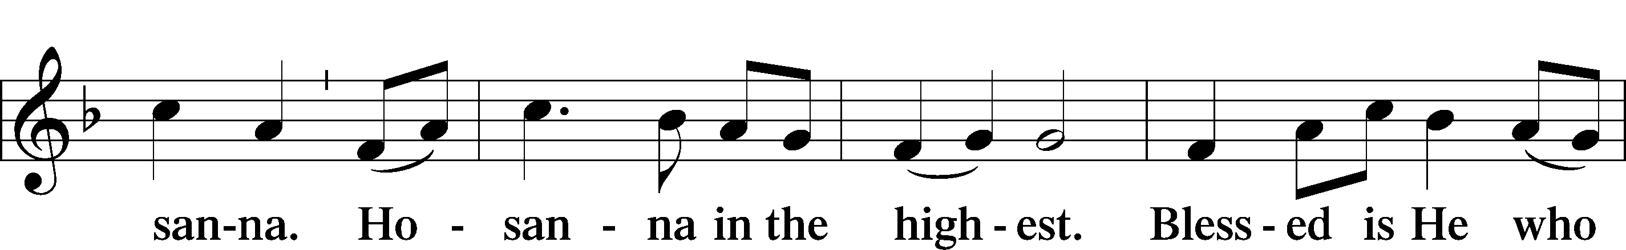

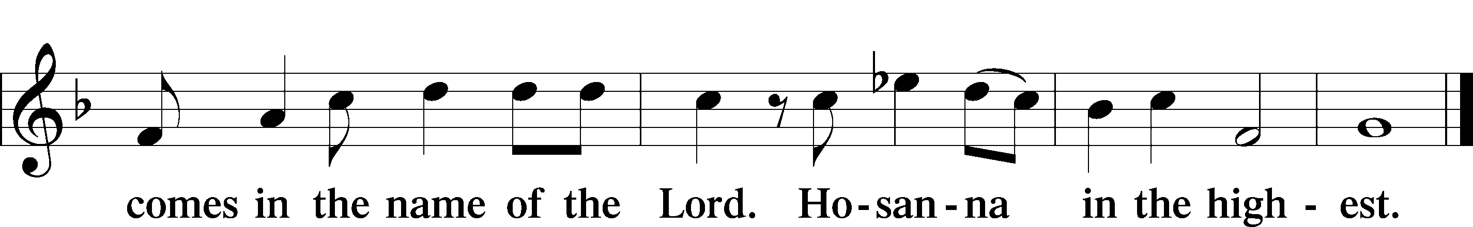

PRAYER OF THANKSGIVING LSB 161

LORD’S PRAYER

C **Our Father who art in heaven,**

**hallowed be Thy name,**

**Thy kingdom come,**

**Thy will be done on earth**

**as it is in heaven;**

**give us this day our daily bread;**

**and forgive us our trespasses**

**as we forgive those**

**who trespass against us;**

**and lead us not into temptation,**

**but deliver us from evil.**

**For Thine is the kingdom**

**and the power and the glory**

**forever and ever. Amen.**

THE WORDS OF OUR LORD

PAX DOMINI LSB 163

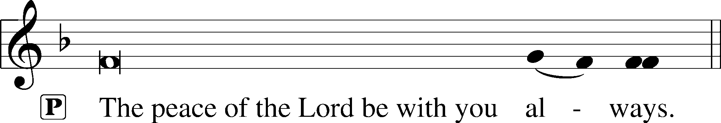



AGNUS DEI LSB 163

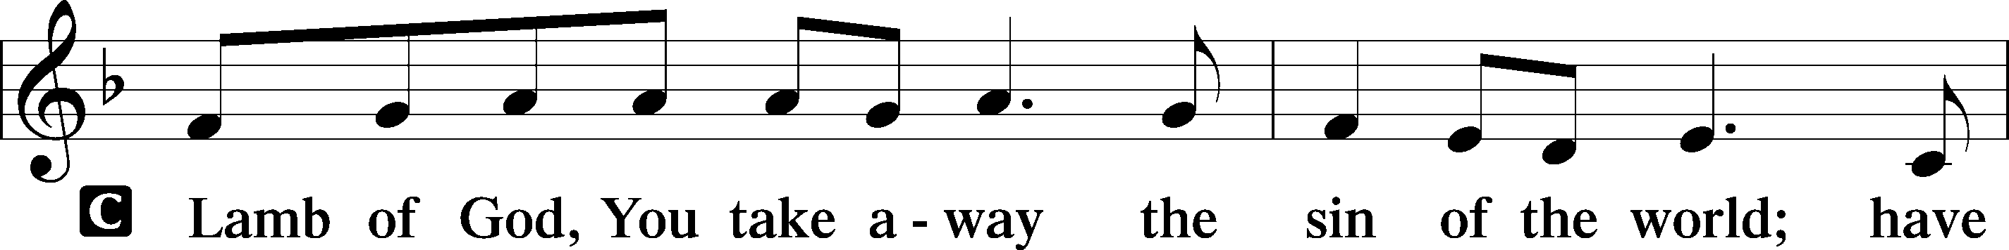

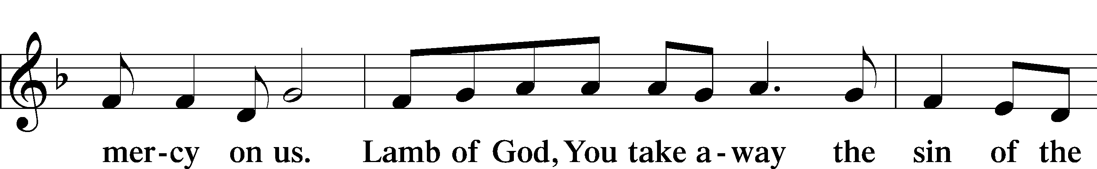

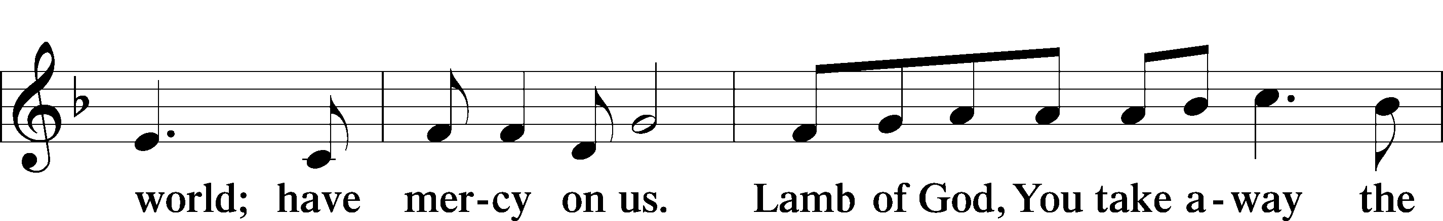

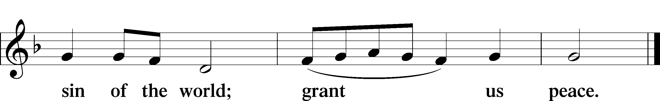

(Sit)

DISTRIBUTION

(The pastor and those who assist him receive the body and blood of Christ first and then distribute them to those who are unable to come to the altar. The ushers will then direct all other communicants to the altar.)

740 I AM JESUS’ LITTLE LAMB

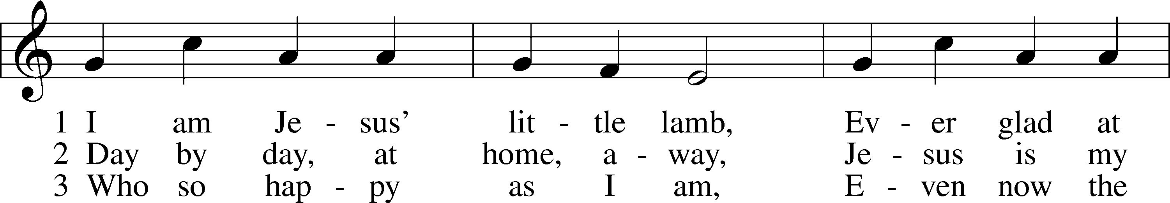

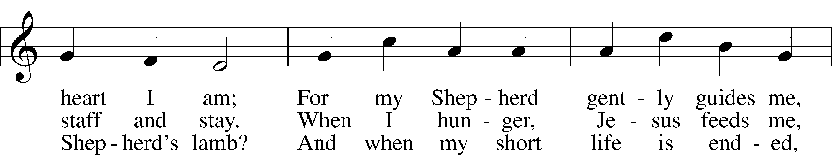

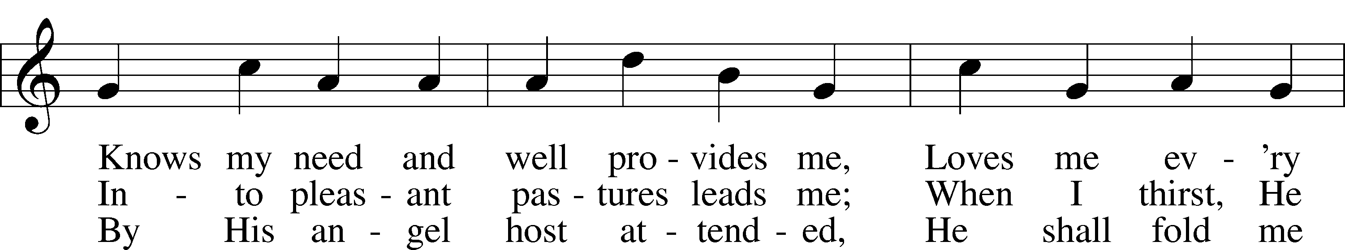

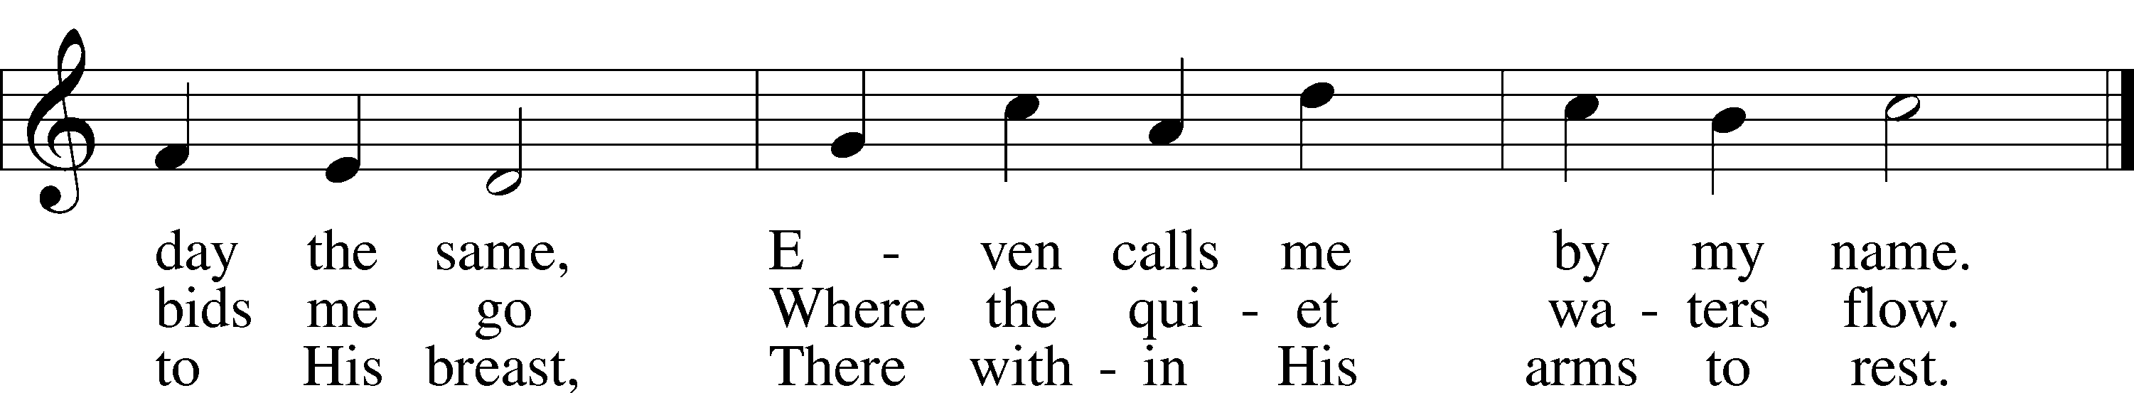

Text: Henrietta L. von Hayn, 1724–82; tr. The Lutheran Hymnal, 1941  
Tune: Choral-Buch . . . Brüder-Gemeinen, 1784, Leipzig  
Text and tune: Public domain

INSTRUMENTAL

(Stand)

THANK THE LORD LSB 164

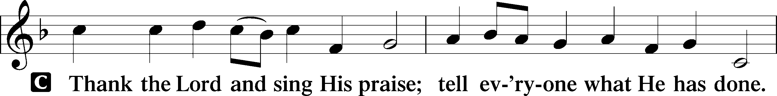

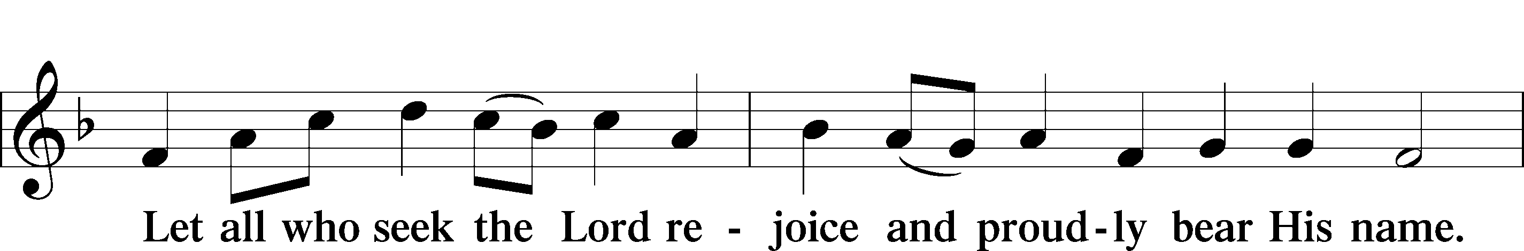

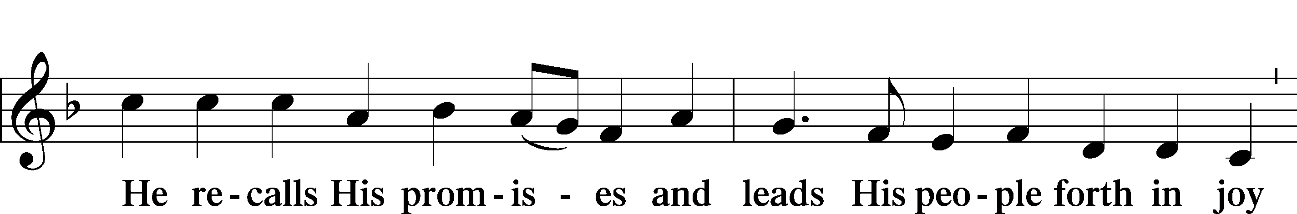

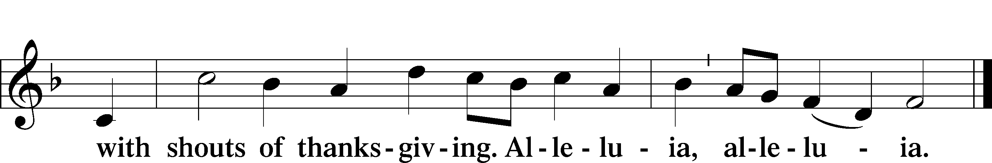

POST-COMMUNION COLLECT

**BENEDICTION**

L: The grace of our Lord T Jesus Christ, and the love of God, and the fellowship of the Holy Spirit, be with us all.

C: **Amen.**

611 CHIEF OF SINNERS THOUGH I BE

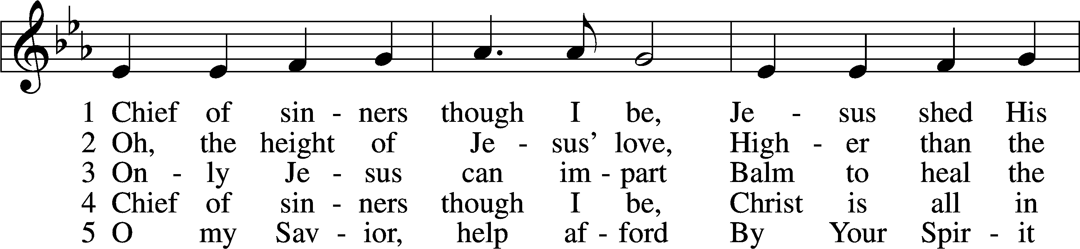

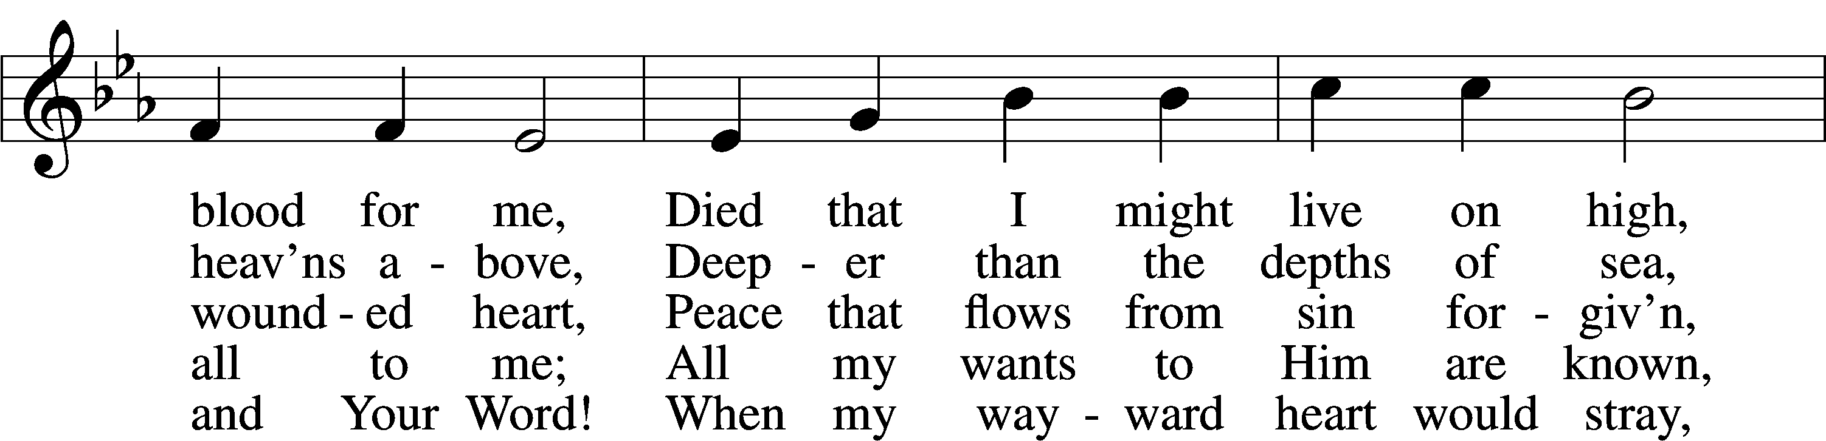

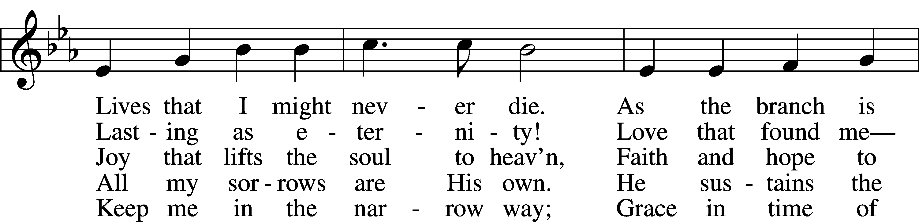

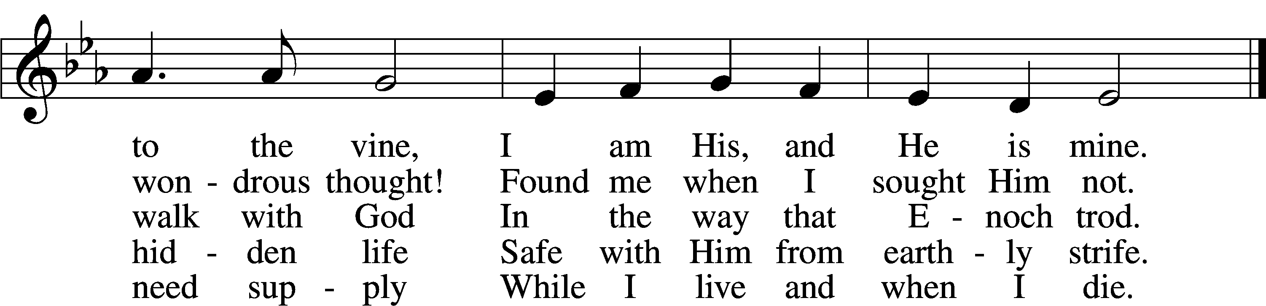

Text: William McComb, 1793–1873, alt.  
Tune: Richard Redhead, 1820–1901  
Text and tune: Public domain

ACKNOWLEDGMENTS

Unless otherwise indicated, Scripture quotations are from the ESV® Bible (The Holy Bible, English Standard Version®), copyright © 2001 by Crossway, a publishing ministry of Good News Publishers. Used by permission. All rights reserved.

Created by Lutheran Service Builder © 2025 Concordia Publishing House.