BETHLEHEM LUTHERAN CHURCH
A congregation of The Lutheran Church-Missouri Synod
902 Hitchcock Drive SW,
Aiken, South Carolina 29803
Church Phone: (803) 649-6417
blcaikensc@gmail.com
Pastor: Rev. John B. Engwall
Office Hours By Appointment
Note: The format of this bulletin has been modified for use in private devotion services.
Unable to join us in person? Please find us on Facebook live.
The service is also posted on our website; bethlehemlutheranaiken.org

+ + + + + + + + + + + + + + +
The Fourth Sunday in Advent
December 21, 2025
10:30 a.m.
+ + + + + + + + + + + + + + +

Our Policy and Practice Regarding Holy Communion
Hear the words of the Apostle Paul;
Anyone who eats and drinks without recognizing the body of the Lord eats and drinks judgment on himself. -1 Cor.11:29
Therefore, visitors are asked to please refrain from partaking of the Sacrament before speaking about this with the pastor; because we care about your spiritual well-being.
Also, because communing at this altar is a public confession that you agree with the doctrines of The Lutheran Church-Missouri Synod, and reject all contrary teachings.
Persons who are not communing today are always welcome to come forward during the distribution to receive an individual blessing; please cross your arms over your chest to indicate your desire for this. Thank you!
We commune in two alternating tables. The ushers will guide you. Non-alcoholic white wine is available in the center of the individual cup tray. Please leave empty individual cups at the altar rail.

+ SERVICE OF PREPARATION +
After the bell tolls, please observe a time of silence.

WELCOME AND ANNOUNCEMENTS
(Stand)

361 O LITTLE TOWN OF BETHLEHEM
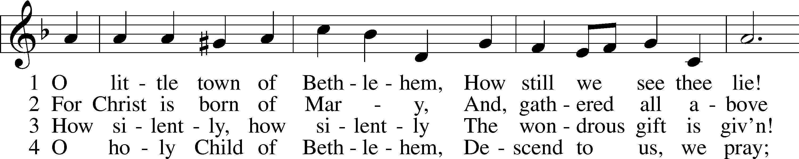
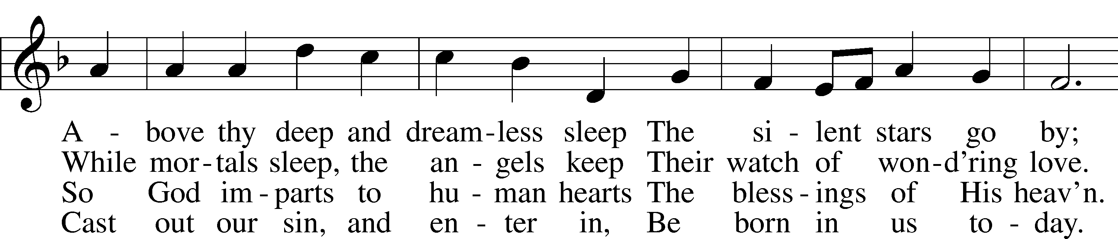
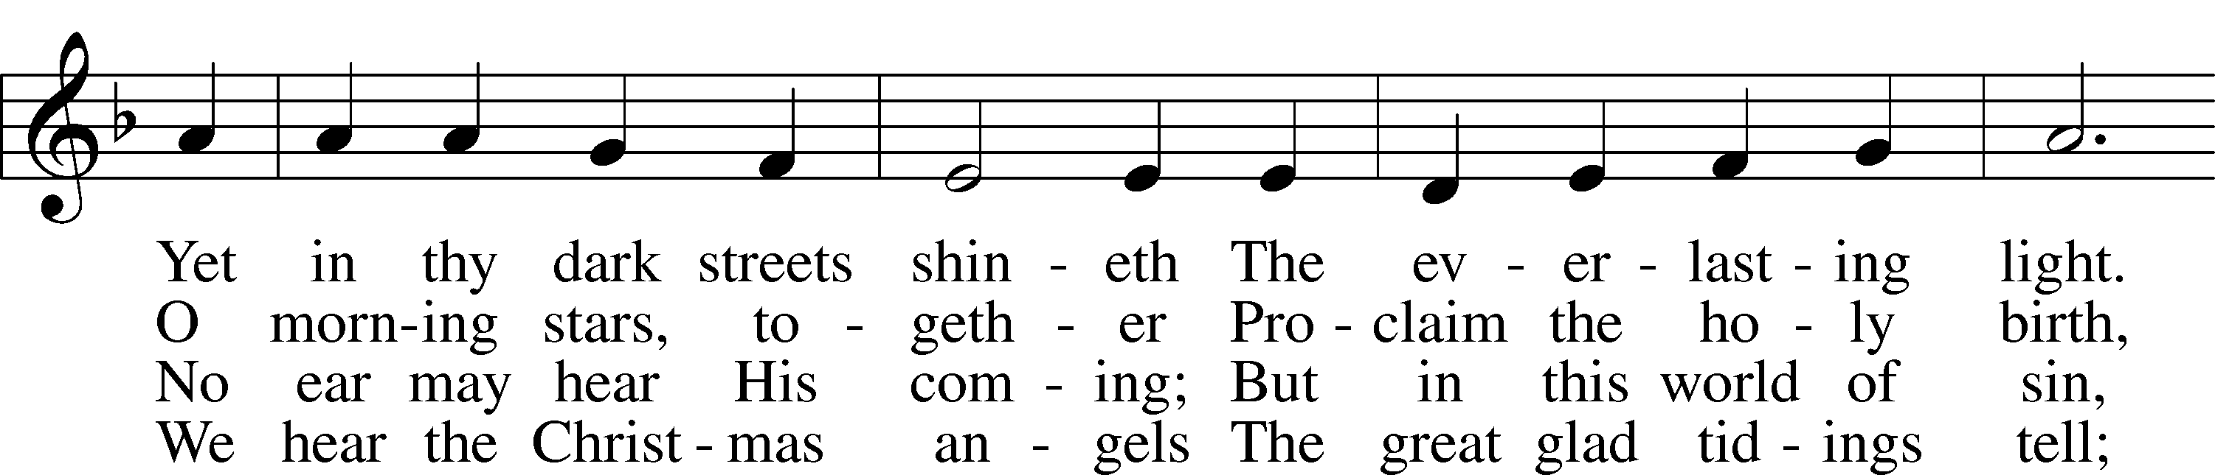
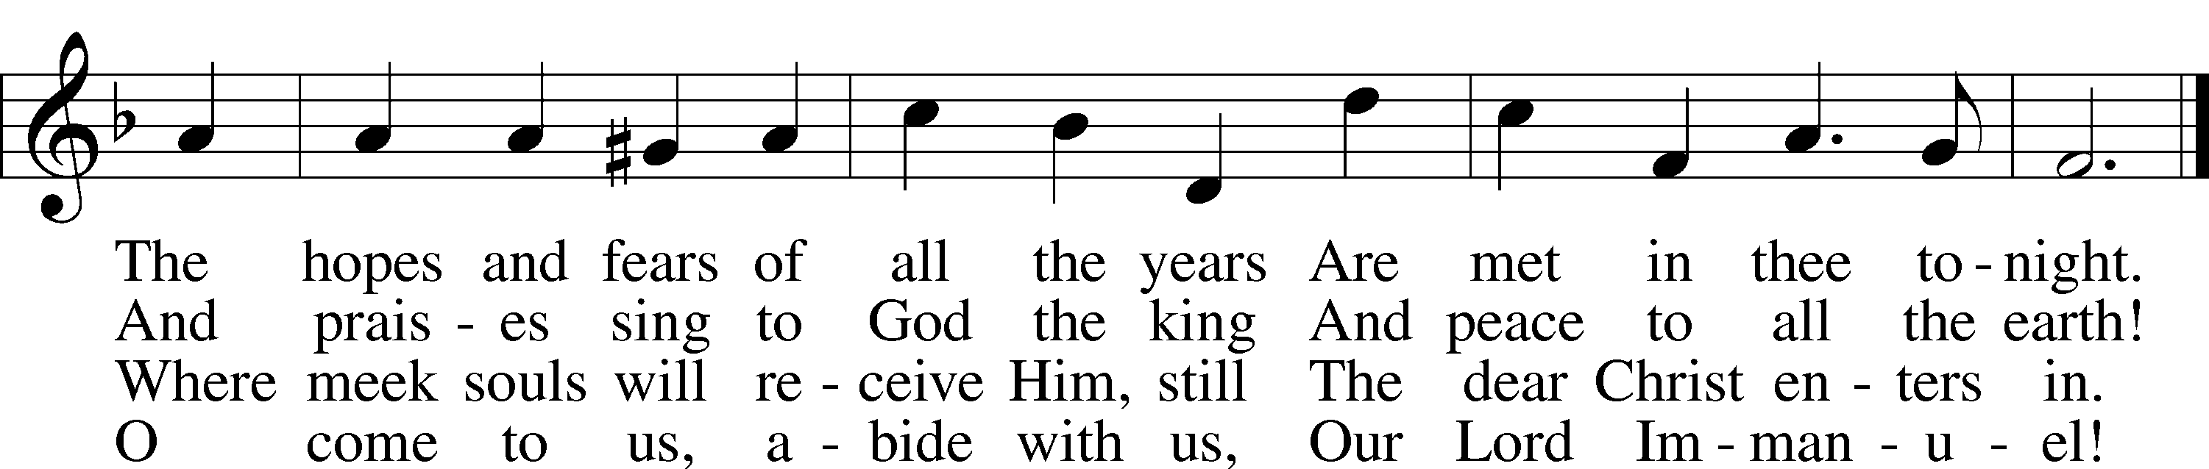
Text: Phillips Brooks, 1835–93
Tune: Lewis H. Redner, 1831–1908
Text and tune: Public domain

+ CONFESSION AND ABSOLUTION +

(The sign of the cross may be made by all in remembrance of their Baptism.)

INVOCATION
L In the name of the Father and of the T Son and of the Holy Spirit.
C Amen.

EXHORTATION LSB 151
L If we say we have no sin, we deceive ourselves, and the truth is not in us.
C But if we confess our sins, God, who is faithful and just, will forgive our sins and cleanse us from all unrighteousness.

(Silence for reflection on God’s Word and for self-examination.)

CONFESSION OF SINS LSB 151
L Let us then confess our sins to God our Father.
C Most merciful God, we confess that we are by nature sinful and unclean. We have sinned against You in thought, word, and deed, by what we have done and by what we have left undone. We have not loved You with our whole heart; we have not loved our neighbors as ourselves. We justly deserve Your present and eternal punishment. For the sake of Your Son, Jesus Christ, have mercy on us. Forgive us, renew us, and lead us, so that we may delight in Your will and walk in Your ways to the glory of Your holy name. Amen.

DECLARATION OF GRACE
L In the mercy of almighty God, Jesus Christ was given to die for us, and for His sake God forgives us all our sins. To those who believe in Jesus Christ He gives the power to become the children of God and bestows on them the Holy Spirit. May the Lord, who has begun this good work in us, bring it to completion in the day of our Lord Jesus Christ.
C Amen.

+ SERVICE OF THE WORD +

INTROIT Psalm 130:5–8; antiphon: Isaiah 64:1
Oh that you would rend the heavens | and come down,*
that the mountains might quake at your | presence.
I wait for the Lord, my | soul waits,*
and in his | word I hope;
my soul waits for the Lord more than watchmen for the | morning,*
more than watchmen for the | morning.
O Israel, hope in the Lord! For with the Lord there is | steadfast love,*
and with him is plentiful re- | demption.
And he will redeem | Israel*
from all his in- | iquities.
Glory be to the Father and | to the Son*
and to the Holy | Spirit;
as it was in the be- | ginning,*
is now, and will be forever. | Amen.
Oh that you would rend the heavens | and come down,*
that the mountains might quake at your | presence.

KYRIE LSB 152
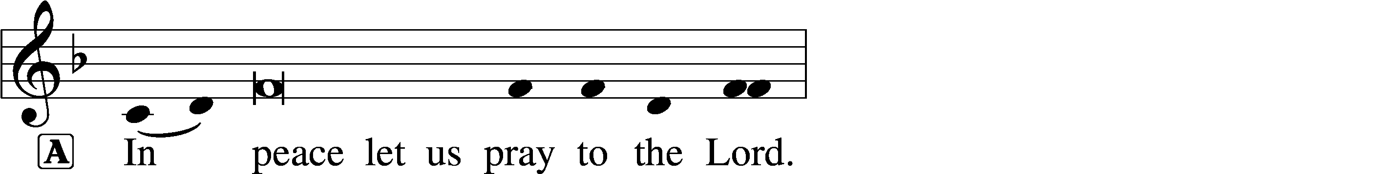
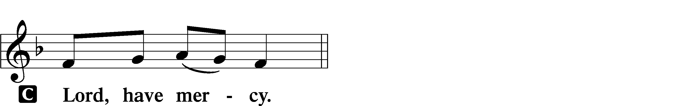

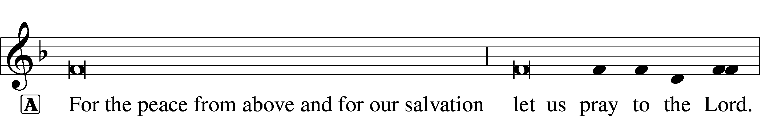

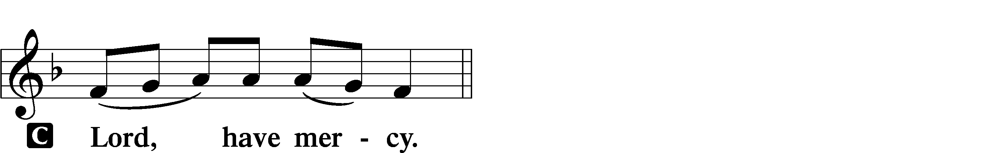

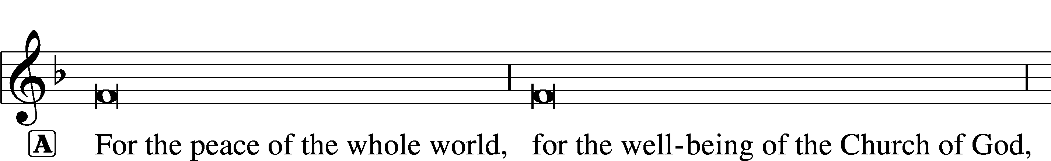
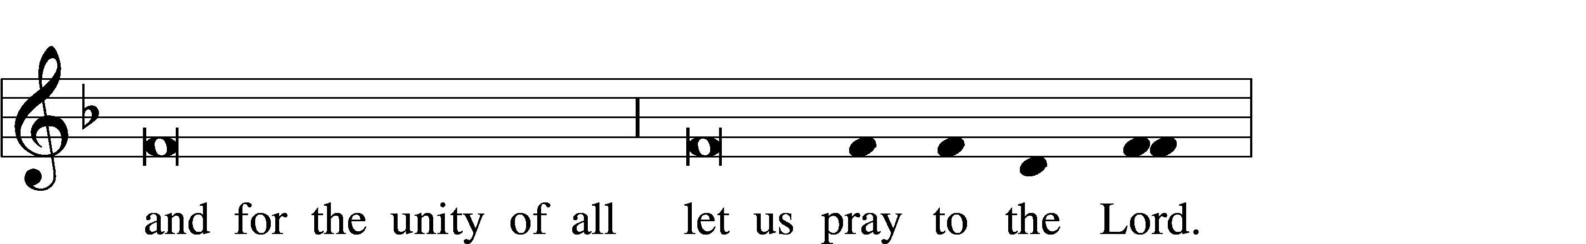
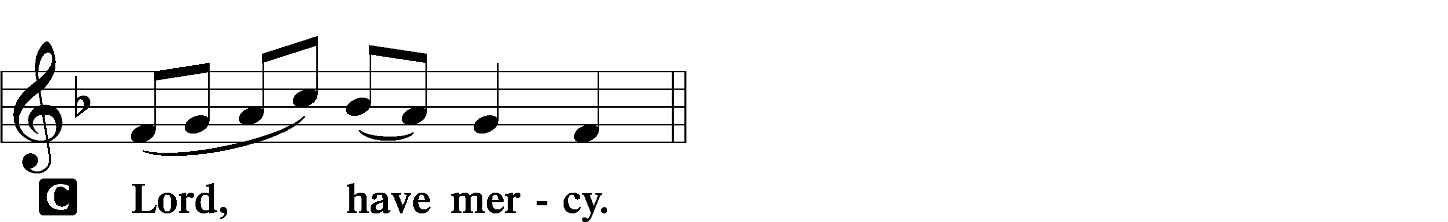

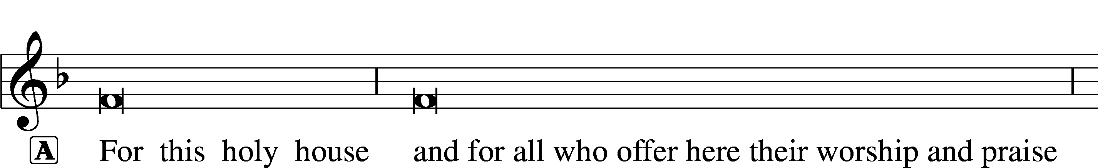
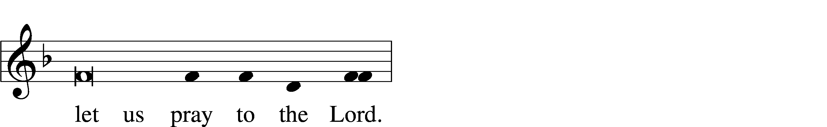
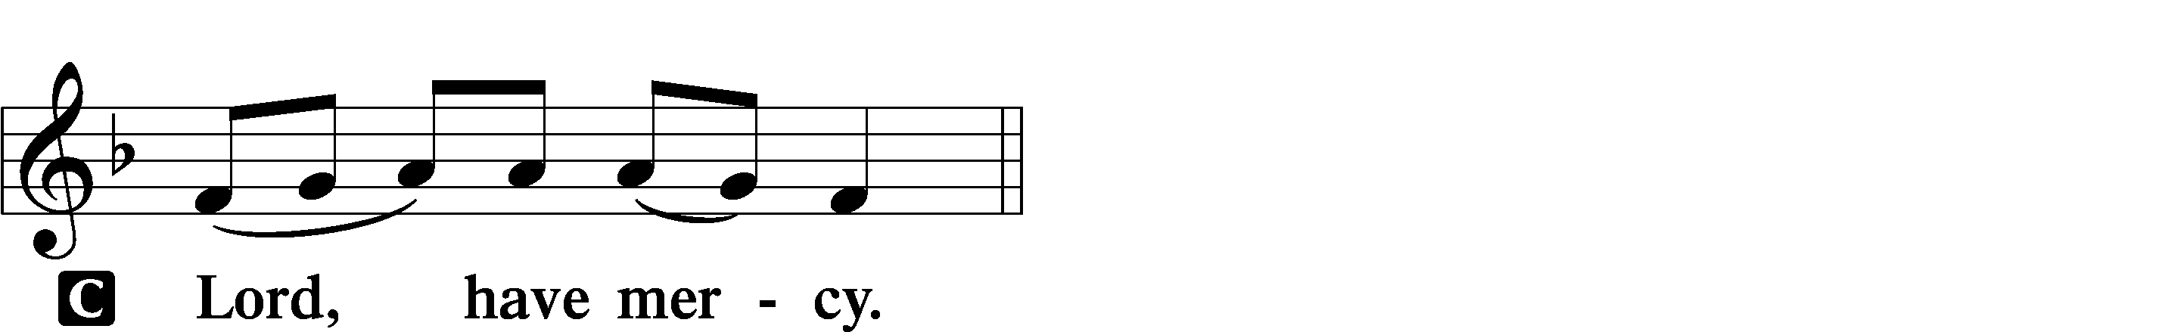

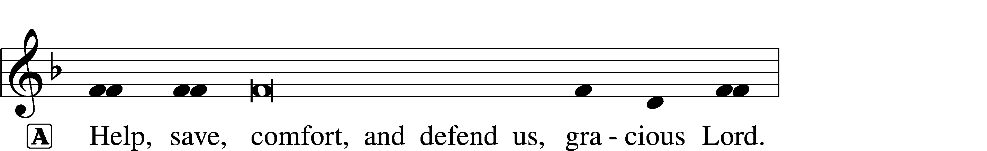
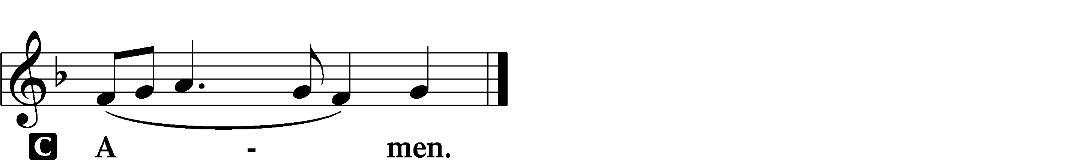

SALUTATION AND COLLECT OF THE DAY
L The Lord be with you.
C And also with you.

L Let us pray.
Stir up Your power, O Lord, and come and help us by Your might, that the sins which weigh us down may be quickly lifted by Your grace and mercy; for You live and reign with the Father and the Holy Spirit, one God, now and forever.

C Amen.

(Sit)

CHILDRENS LESSON

OLD TESTAMENT READING Isaiah 7:10–17
10Again the Lord spoke to Ahaz, 11“Ask a sign of the Lord your God; let it be deep as Sheol or high as heaven.” 12But Ahaz said, “I will not ask, and I will not put the Lord to the test.” 13And he said, “Hear then, O house of David! Is it too little for you to weary men, that you weary my God also? 14Therefore the Lord himself will give you a sign. Behold, the virgin shall conceive and bear a son, and shall call his name Immanuel. 15He shall eat curds and honey when he knows how to refuse the evil and choose the good. 16For before the boy knows how to refuse the evil and choose the good, the land whose two kings you dread will be deserted. 17The Lord will bring upon you and upon your people and upon your father’s house such days as have not come since the day that Ephraim departed from Judah—the king of Assyria.”

A This is the Word of the Lord.
C Thanks be to God.

GRADUAL Zechariah 9:9; Psalm 118:26, alt.
Rejoice greatly, O daughter of | Zion.*
Shout aloud, O daughter of Je- | rusalem.
Behold, your king is com- | ing to you;*
righteous and having sal- | vation.
Blessèd is he who comes in the name | of the Lord.*
From the house of the Lord we | bless you.

EPISTLE Romans 1:1–7
1Paul, a servant of Christ Jesus, called to be an apostle, set apart for the gospel of God, 2which he promised beforehand through his prophets in the holy Scriptures, 3concerning his Son, who was descended from David according to the flesh 4and was declared to be the Son of God in power according to the Spirit of holiness by his resurrection from the dead, Jesus Christ our Lord, 5through whom we have received grace and apostleship to bring about the obedience of faith for the sake of his name among all the nations, 6including you who are called to belong to Jesus Christ,
7To all those in Rome who are loved by God and called to be saints:
Grace to you and peace from God our Father and the Lord Jesus Christ.

A This is the Word of the Lord.
C Thanks be to God.

(Stand)

ALLELUIA AND VERSE LSB 156
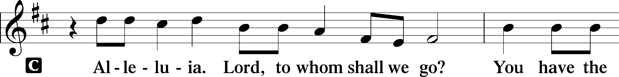
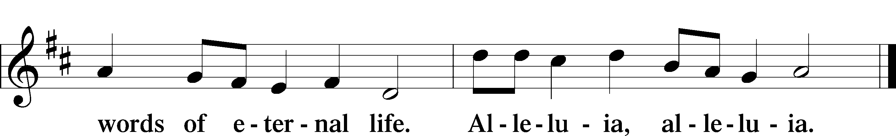

HOLY GOSPEL Matthew 1:18–25
L The Holy Gospel according to St. Matthew, the first chapter.

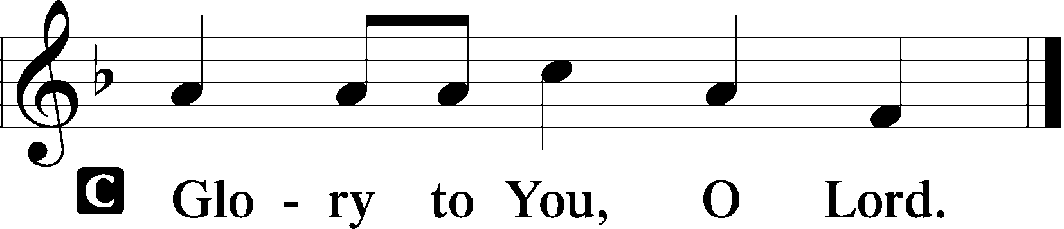

18Now the birth of Jesus Christ took place in this way. When his mother Mary had been betrothed to Joseph, before they came together she was found to be with child from the Holy Spirit. 19And her husband Joseph, being a just man and unwilling to put her to shame, resolved to divorce her quietly.

20But as he considered these things, behold, an angel of the Lord appeared to him in a dream, saying, “Joseph, son of David, do not fear to take Mary as your wife, for that which is conceived in her is from the Holy Spirit. 21She will bear a son, and you shall call his name Jesus, for he will save his people from their sins.” 22All this took place to fulfill what the Lord had spoken by the prophet:
23“Behold, the virgin shall conceive and bear a son,
and they shall call his name Immanuel”
(which means, God with us). 24When Joseph woke from sleep, he did as the angel of the Lord commanded him: he took his wife, 25but knew her not until she had given birth to a son. And he called his name Jesus.

L This is the Gospel of the Lord.

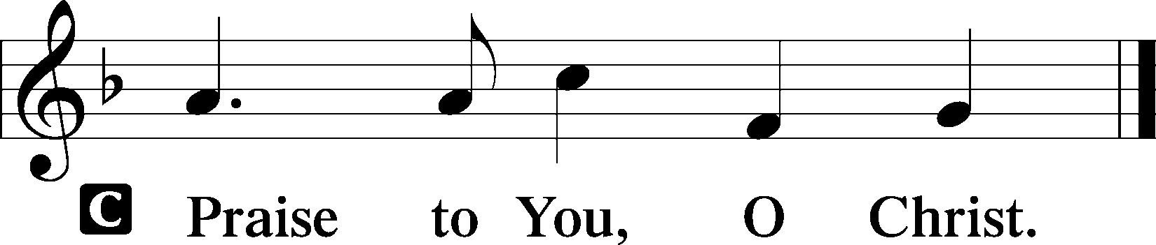

357 O COME, O COME, EMMANUEL
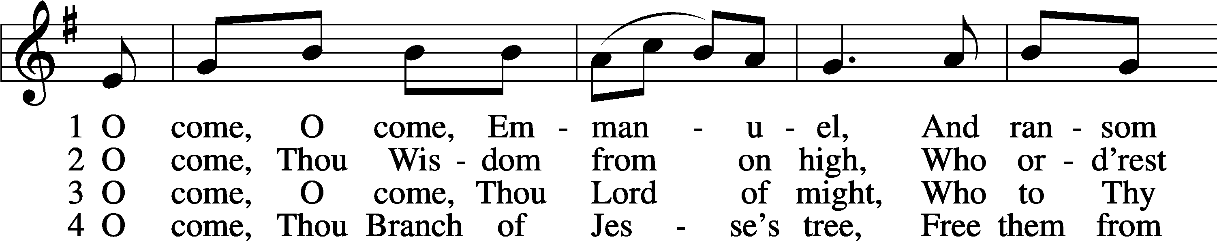
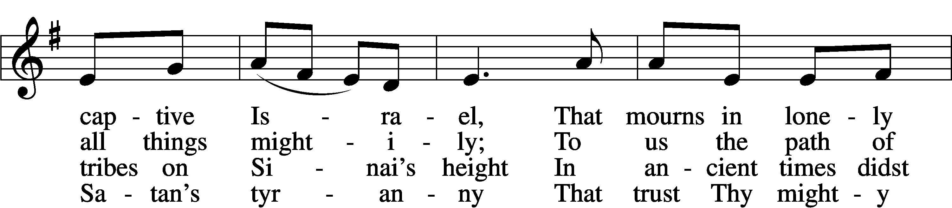
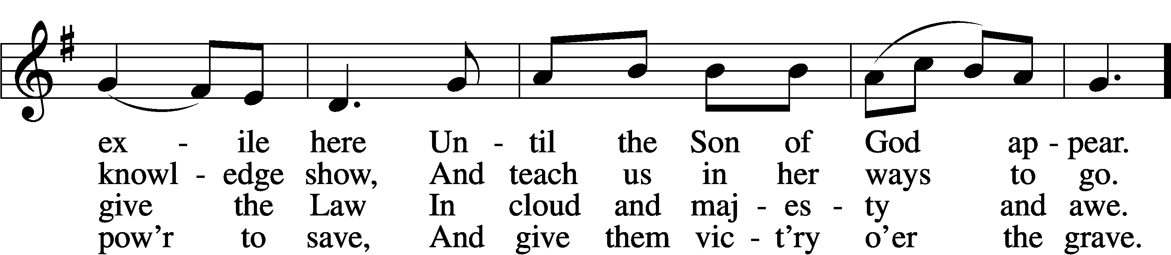
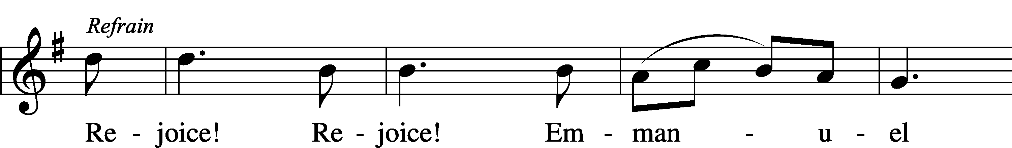
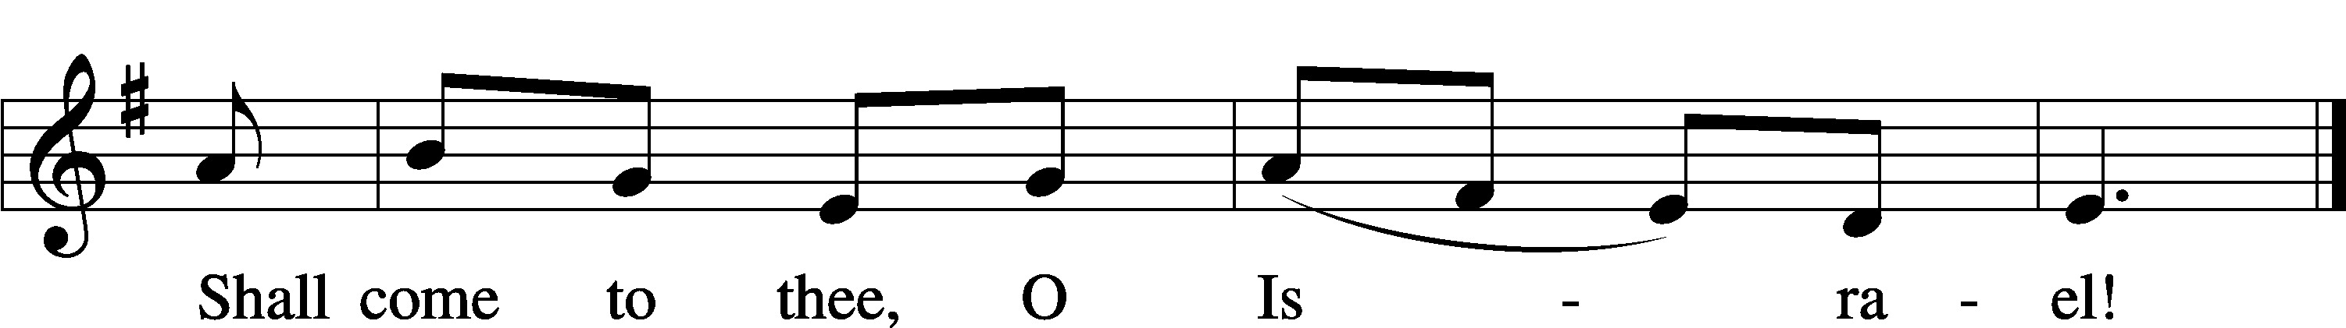

5 O come, Thou Key of David, come,
And open wide our heav’nly home;
Make safe the way that leads on high,
And close the path to misery. Refrain

6 O come, Thou Dayspring from on high,
And cheer us by Thy drawing nigh;
Disperse the gloomy clouds of night,
And death’s dark shadows put to flight. Refrain

7 O come, Desire of nations, bind
In one the hearts of all mankind;
Bid Thou our sad divisions cease,
And be Thyself our King of Peace. Refrain
Text: Latin, c. 12th cent.; Psalteriolum Cantionum Catholicarum, 1710, Köln; tr. John Mason Neale, 1818–66, alt.
Tune: French, 15th cent.
Text and tune: Public domain

SERMON OR MEDITATION ON THE READINGS

(Stand)

APOSTLES’ CREED
C I believe in God, the Father Almighty,
maker of heaven and earth.

And in Jesus Christ, His only Son, our Lord,
who was conceived by the Holy Spirit,
born of the virgin Mary,
suffered under Pontius Pilate,
was crucified, died and was buried.
He descended into hell.
The third day He rose again from the dead.
He ascended into heaven
and sits at the right hand of God the Father Almighty.
From thence He will come to judge the living and the dead.

I believe in the Holy Spirit,
the holy Christian Church,
the communion of saints,
the forgiveness of sins,
the resurrection of the body,
and the life T everlasting. Amen.

SHARING OF THE PEACE

(Sit)

PRAYER OF THE CHURCH

OFFERING

(Stand)

OFFERTORY LSB 159
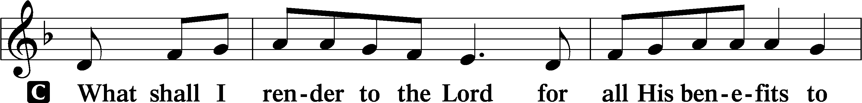
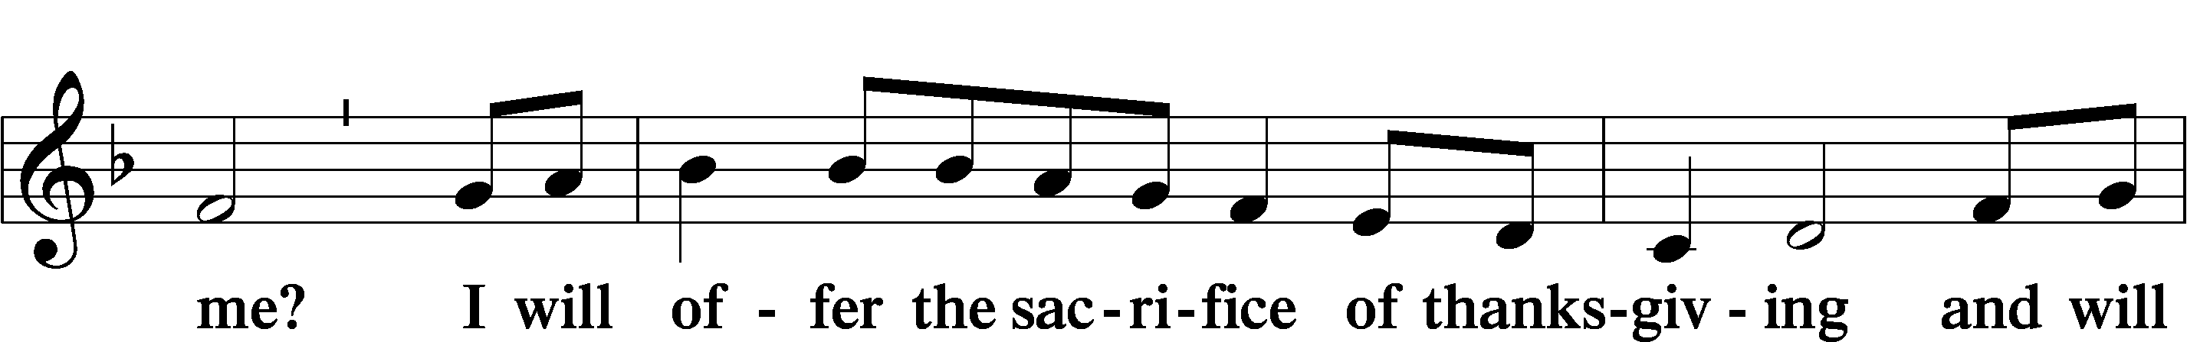
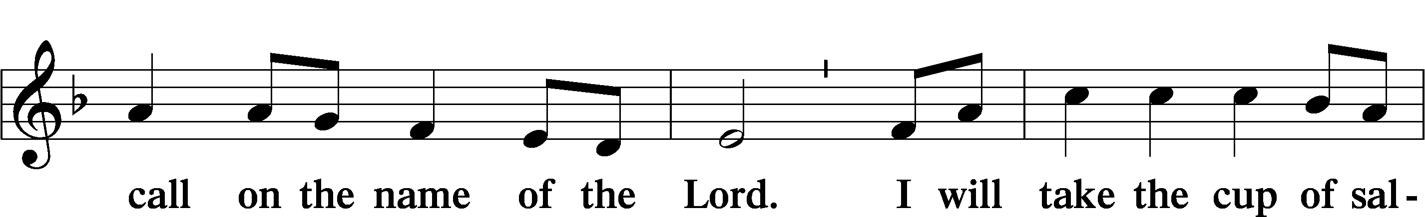
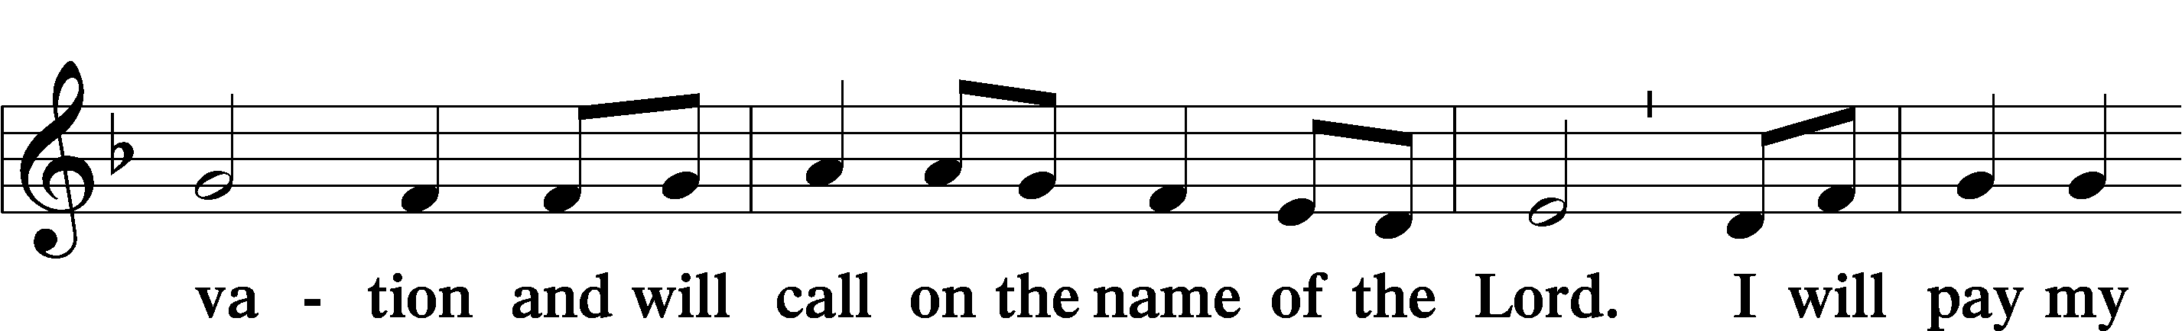
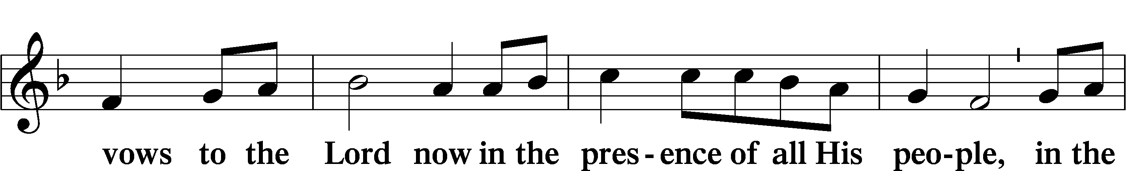
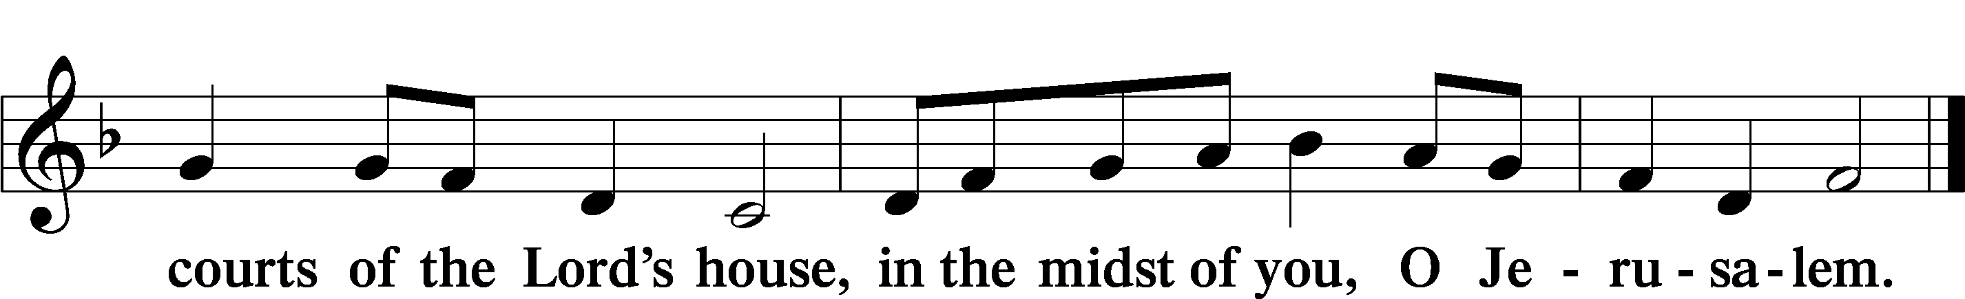

+ SERVICE OF THE SACRAMENT +
Note: The Service of The Sacrament is included in the lay bulletin solely as a viewers’ guide for those watching the livestream service; Communicant members who are unable to attend the Divine Service in person are encouraged to make arrangements with Pastor Engwall to receive the Lord’s Supper.

PROPER PREFACE (ABBREVIATED) LSB 161
L It is truly good, right, and salutary . . . evermore praising You and saying:

SANCTUS LSB 161
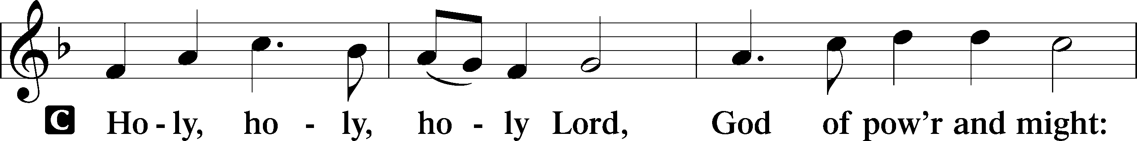
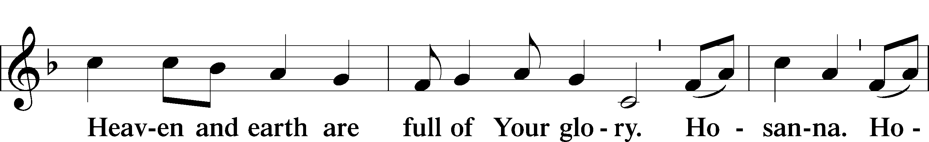
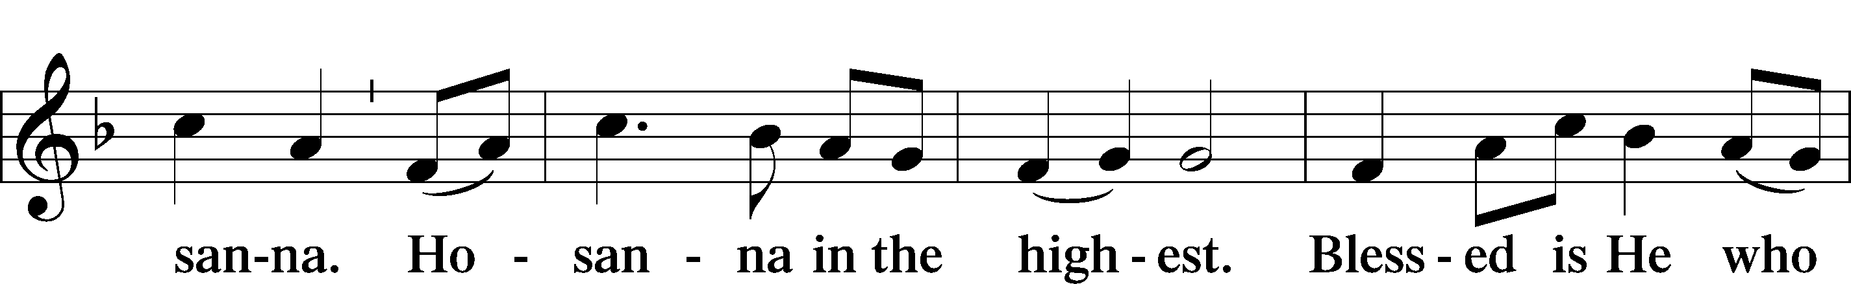
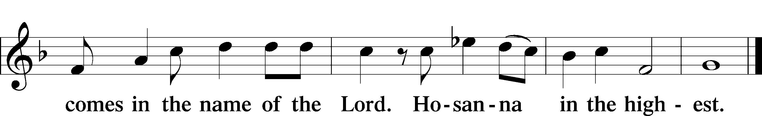

PRAYER OF THANKSGIVING 161

LORD’S PRAYER
C Our Father who art in heaven,
hallowed be Thy name,
Thy kingdom come,
Thy will be done on earth
as it is in heaven;
give us this day our daily bread;
and forgive us our trespasses
as we forgive those
who trespass against us;
and lead us not into temptation,
but deliver us from evil.
For Thine is the kingdom
and the power and the glory
forever and ever. Amen.

THE WORDS OF INSTITUTION

PAX DOMINI LSB 163
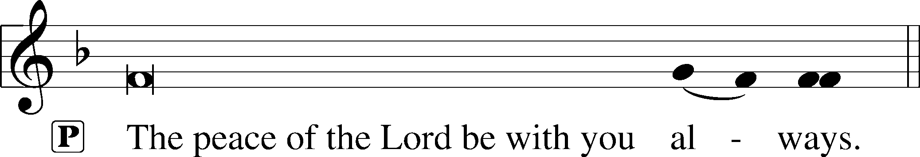
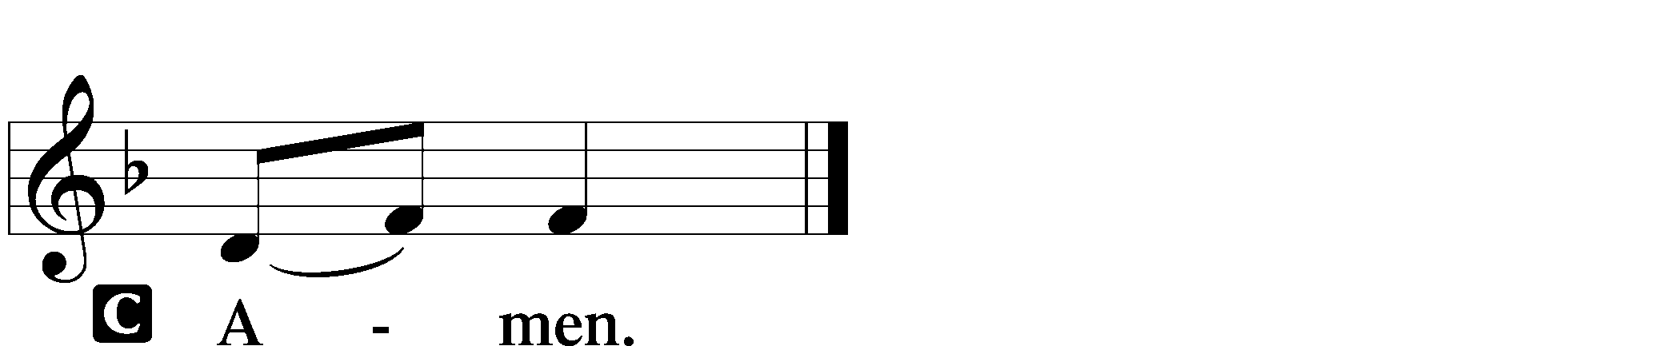

AGNUS DEI LSB 163
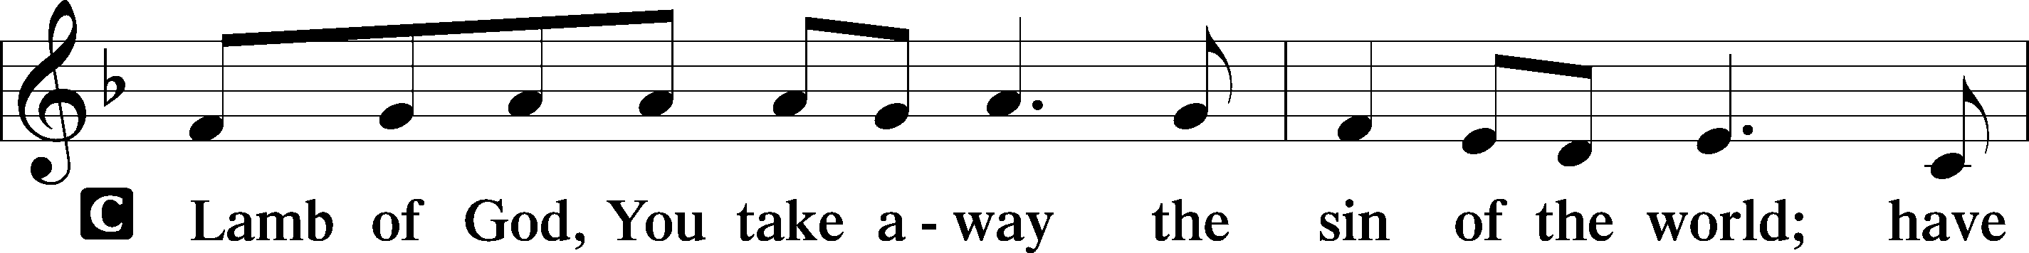
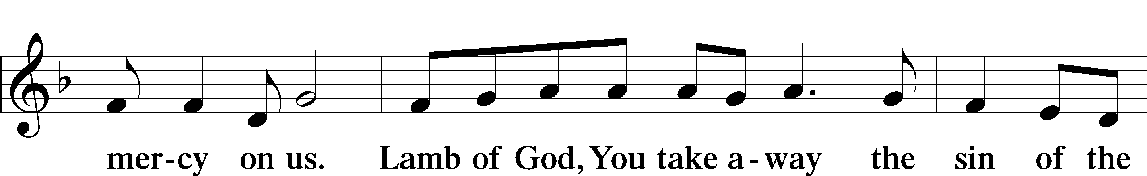
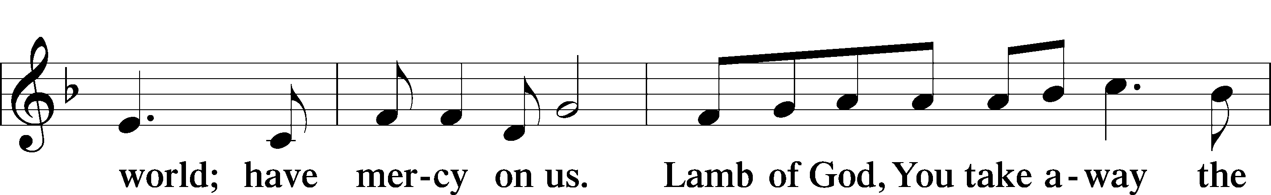
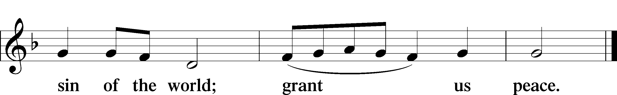

(Sit)

DISTRIBUTION

(The pastor and those who assist him receive the body and blood of Christ first and then distribute them to those who are unable to come to the altar. The ushers will then direct all other communicants to the altar..)

THE ANGEL GABRIEL FROM HEAVEN CAME LSB 356

INSTRUMENTAL

(Stand)

THANK THE LORD LSB 164
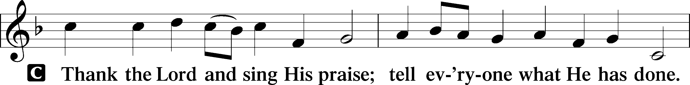
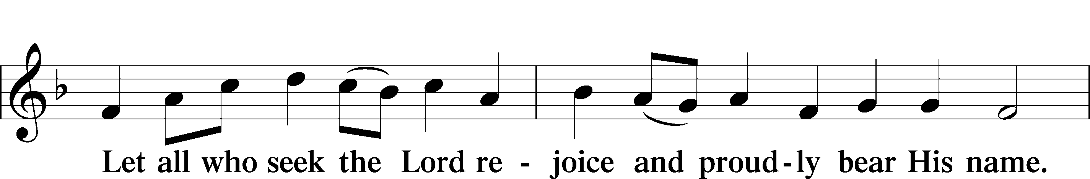
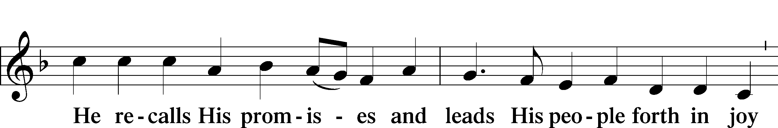
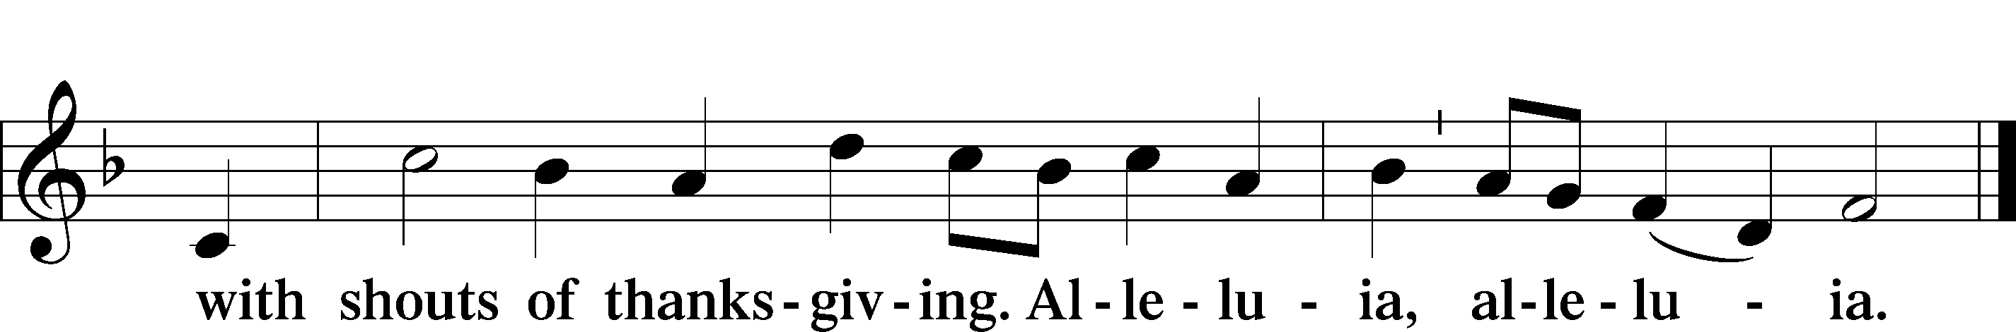

POST-COMMUNION COLLECT

BENEDICTION
L:The grace of our Lord T Jesus Christ, and the love of God, and the fellowship of the Holy Spirit, be with us all.
C: Amen.

512 AT THE NAME OF JESUS
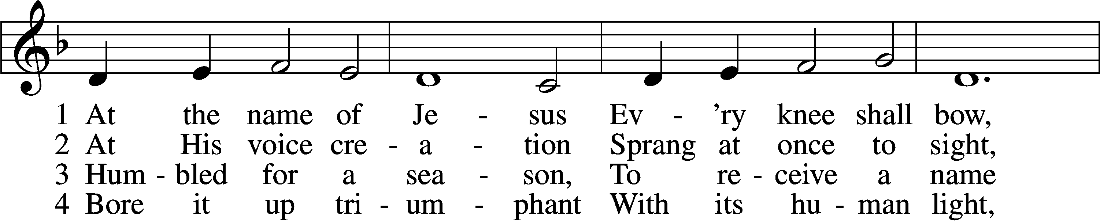
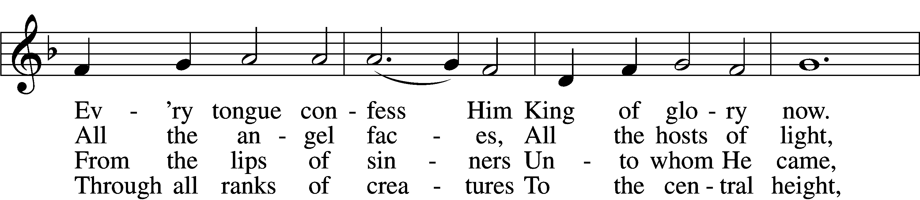
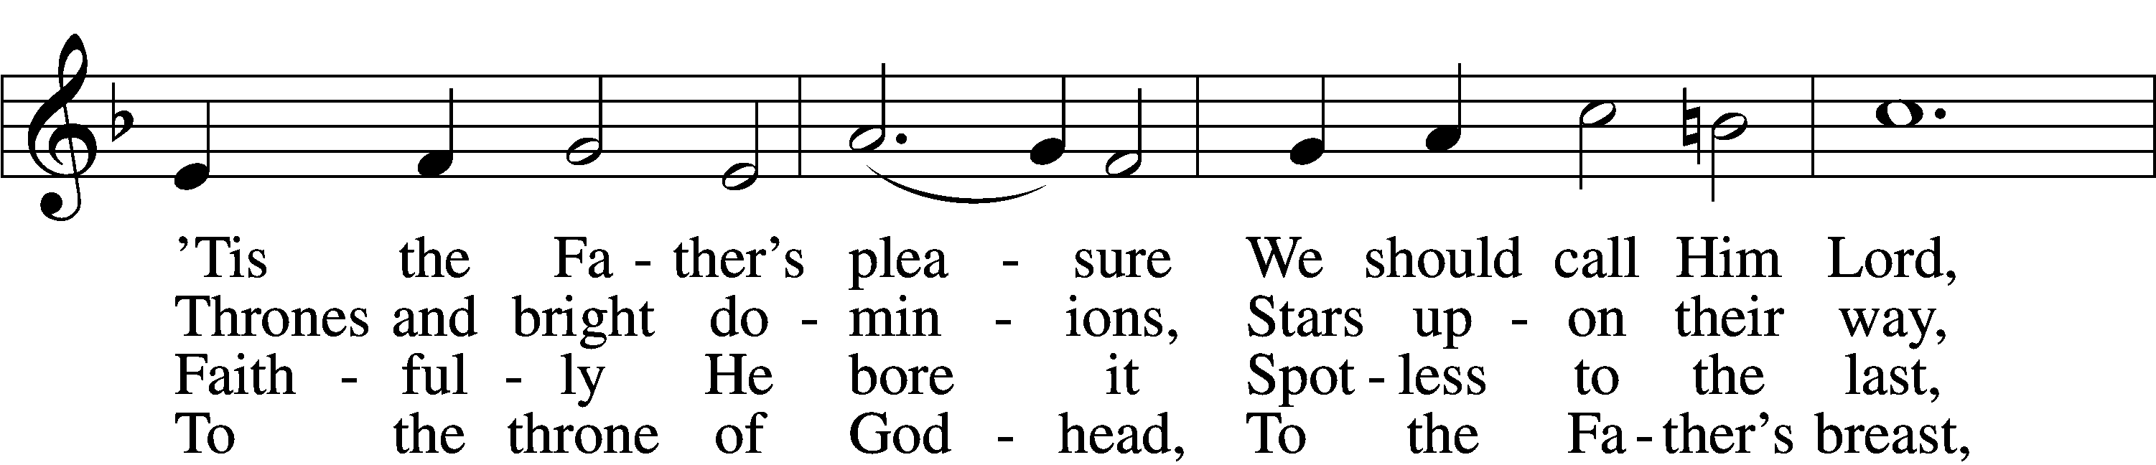
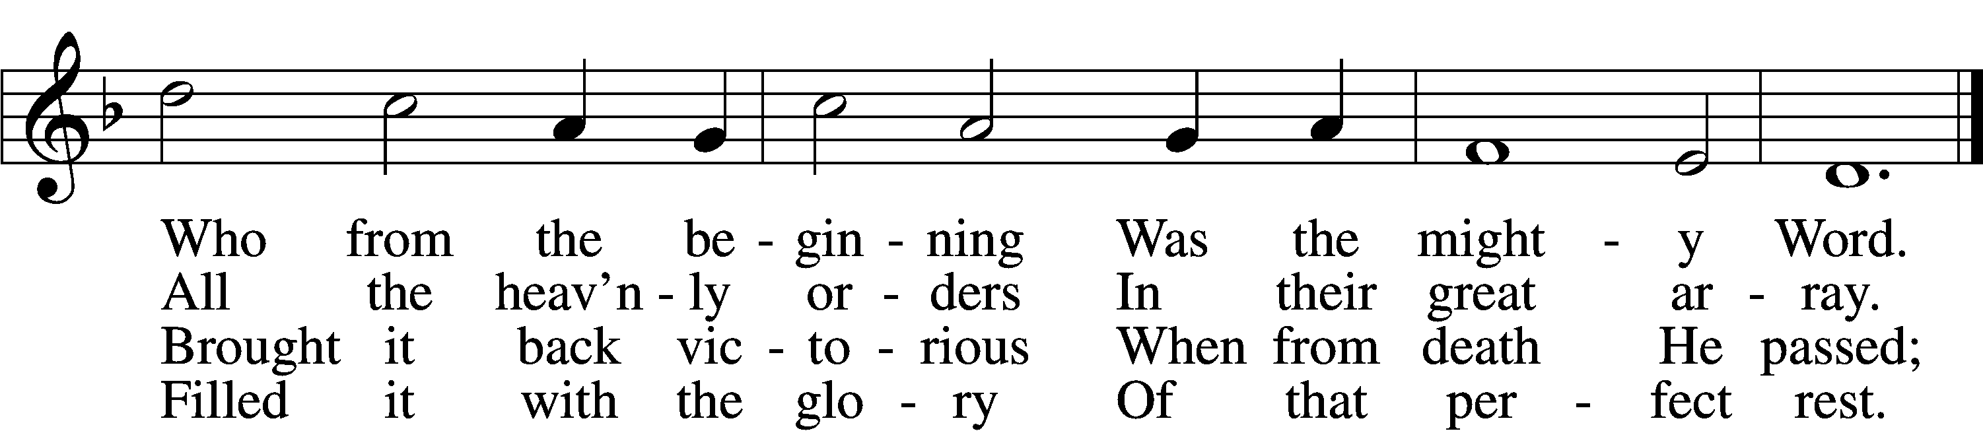

5 In your hearts enthrone Him;
There let Him subdue
All that is not holy,
All that is not true:
Crown Him as your captain
In temptation’s hour;
Let His will enfold you
In its light and pow’r.

6 Christians, this Lord Jesus
Shall return again
In His Father’s glory,
With His angel train;
For all wreaths of empire
Meet upon His brow,
And our hearts confess Him
King of glory now.
NEXT PAGE
D 7 Glory then to Jesus,
Who, the Prince of light,
To a world in darkness
Brought the gift of sight;
Praise to God the Father;
In the Spirit’s love
Praise we all together
Him who reigns above.
Text: Caroline M. Noel, 1817–77, alt.
Tune: Ralph Vaughan Williams, 1872–1958
Text and tune: Public domain

Unless otherwise indicated, Scripture quotations are from the ESV® Bible (The Holy Bible, English Standard Version®), copyright © 2001 by Crossway, a publishing ministry of Good News Publishers. Used by permission. All rights reserved.
Created by Lutheran Service Builder © 2025 Concordia Publishing House.

