BETHLEHEM LUTHERAN CHURCH
A congregation of The Lutheran Church-Missouri Synod
902 Hitchcock Drive SW,
Aiken, South Carolina 29803
Church Phone: (803) 649-6417
blcaikensc@gmail.com
Pastor: Rev. John B. Engwall
Office Hours By Appointment
Bethlehem Lutheran welcomes our members and guests to our worship service! Unable to join us in person? Please find us on Facebook live. The service is also posted on our website; bethlehemlutheranaiken.org.

+ + + + + + + + + + + + + + +
Ash Wednesday
February 18, 2026
11:00 a.m. and 7:00 p.m.
+ + + + + + + + + + + + + + +

Our Policy and Practice Regarding Holy Communion
Hear the words of the Apostle Paul;
Anyone who eats and drinks without recognizing the body of the Lord eats and drinks judgment on himself. -1 Cor.11:29
Therefore, visitors are asked to please refrain from partaking of the Sacrament before speaking about this with the pastor; because we care about your spiritual well-being.
Also, because communing at this altar is a public confession that you agree with the doctrines of The Lutheran Church-Missouri Synod, and reject all contrary teachings.
Persons who are not communing today are always welcome to come forward during the distribution to receive an individual blessing; please cross your arms over your chest to indicate your desire for this. Thank you!
We commune in two alternating tables. The ushers will guide you. Non-alcoholic white wine is available in the center of the individual cup tray. Please leave empty individual cups at the altar rail.

+ SERVICE OF PREPARATION +
After the bell tolls, please observe a time of silence.

WELCOME AND ANNOUNCEMENTS

(THE CONGREGATION WILL GATHER IN SILENCE))

ADDRESS
P Dear brothers and sisters of our Lord Jesus Christ, on this day the Church begins a holy season of prayerful and penitential reflection. Our attention is especially directed to the holy sufferings and death of our Lord Jesus Christ.

From ancient times the season of Lent has been kept as a time of special devotion, self-denial, and humble repentance born of a faithful heart that dwells confidently on His Word and draws from it life and hope.

Let us pray that our dear Father in heaven, for the sake of His beloved Son and in the power of His Holy Spirit, might richly bless this Lententide for us so that we may come to Easter with glad hearts and keep the feast in sincerity and truth.

(stand)

CONFESSION OF SINS 254
P I confess to God Almighty, before the whole company of heaven and to you, my brothers and sisters, that I have sinned in thought, word, and deed by my fault, by my own fault, by my own most grievous fault; wherefore I pray God Almighty to have mercy on me, forgive me all my sins, and bring me to everlasting life. Amen.
C The almighty and merciful Lord grant you pardon, forgiveness, and remission of all your sins. Amen.

C I confess to God Almighty, before the whole company of heaven and to you, my brothers and sisters, that I have sinned in thought, word, and deed by my fault, by my own fault, by my own most grievous fault; wherefore I pray God Almighty to have mercy on me, forgive me all my sins, and bring me to everlasting life. Amen.
P The almighty and merciful Lord grant you pardon, forgiveness, and remission of all your sins.
C Amen.

LITANY FOR ASH WEDNESDAY
P O Lord,
C have mercy.
P O Christ,
C have mercy.
P O Lord,
C have mercy.
P O Christ,
C hear us.
P God the Father in heaven,
C have mercy.
P God the Son, Redeemer of the world,
C have mercy.
P God the Holy Spirit,
C have mercy.
P Be gracious to us.
C Spare us, good Lord.
P Be gracious to us.
C Help us, good Lord.
P By the mystery of Your holy incarnation;
by Your holy nativity;
by Your baptism, fasting, and temptation;
by Your agony and bloody sweat;
by Your cross and passion;
by Your precious death and burial;
by Your glorious resurrection and ascension;
and by the coming of the Holy Spirit, the Comforter:
C Help us, good Lord.
P In all time of our tribulation;
in all time of our prosperity;
in the hour of death;
and in the day of judgment:
C Help us, good Lord.
P We poor sinners implore You
C to hear us, O Lord.
P To prosper the preaching of Your Word;
to bless our prayer and meditation; (Continued on Next Page)
to strengthen and preserve us in the true faith;
and to give heart to our sorrow and strength to our repentance:
C We implore You to hear us, good Lord.
P To draw all to Yourself;
to bless those who are instructed in the faith;
to watch over and console the poor, the sick, the distressed, the lonely, the forsaken, the abandoned, and all who stand in need of our prayers;
to give abundant blessing to all works of mercy;
and to have mercy on us all:
C We implore You to hear us, good Lord.
P To turn our hearts to You;
to turn the hearts of our enemies, persecutors, and slanderers;
and graciously to hear our prayers:
C We implore You to hear us, good Lord.
P Lord Jesus Christ, Son of God,
C we implore You to hear us.
P Christ, the Lamb of God, who takes away the sin of the world,
C have mercy.
P Christ, the Lamb of God, who takes away the sin of the world,
C have mercy.
P Christ, the Lamb of God, who takes away the sin of the world,
C grant us Your peace.
P O Christ,
C hear us.
P O Lord,
C have mercy.
P O Christ,
C have mercy.
P O Lord,
C have mercy. Amen.

(Sit)

+ THE IMPOSITION OF ASHES +

(The pastor and assistants receive ashes first, followed by the congregation. Using the right thumb, the pastor or an assistant places the ashes on the forehead of each person in the sign of the cross, saying:)

ADDRESS FOR IMPOSITION OF ASHES
P Remember that you are dust, and to dust you shall return.

(After receiving the ashes, each person returns to his place in silence. There is no statement of dismissal.)
915 TODAY YOUR MERCY CALLS US
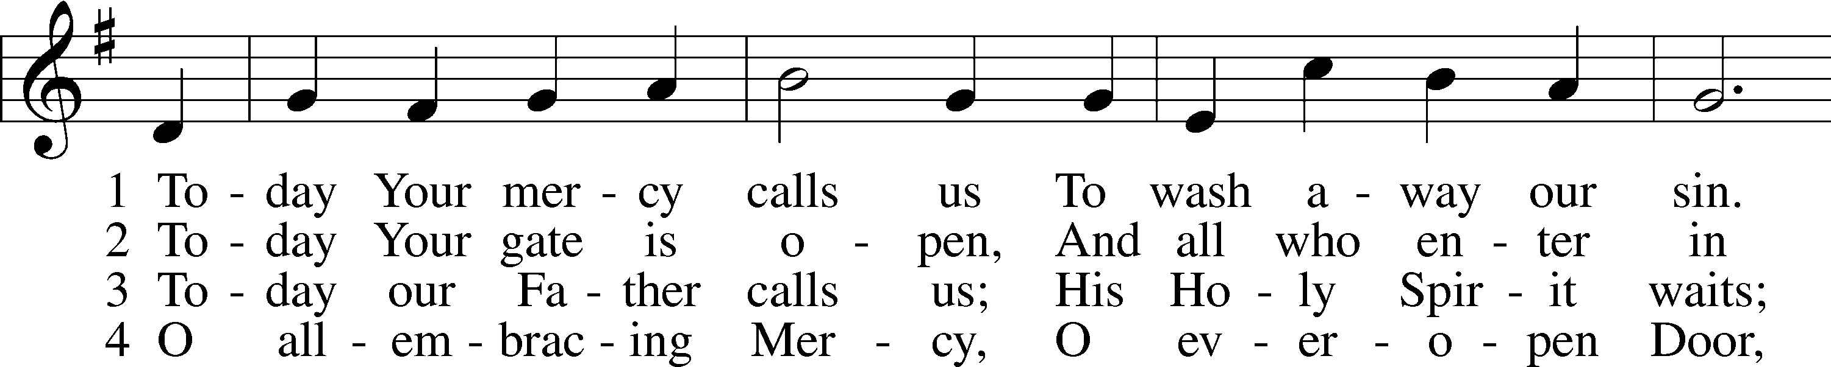
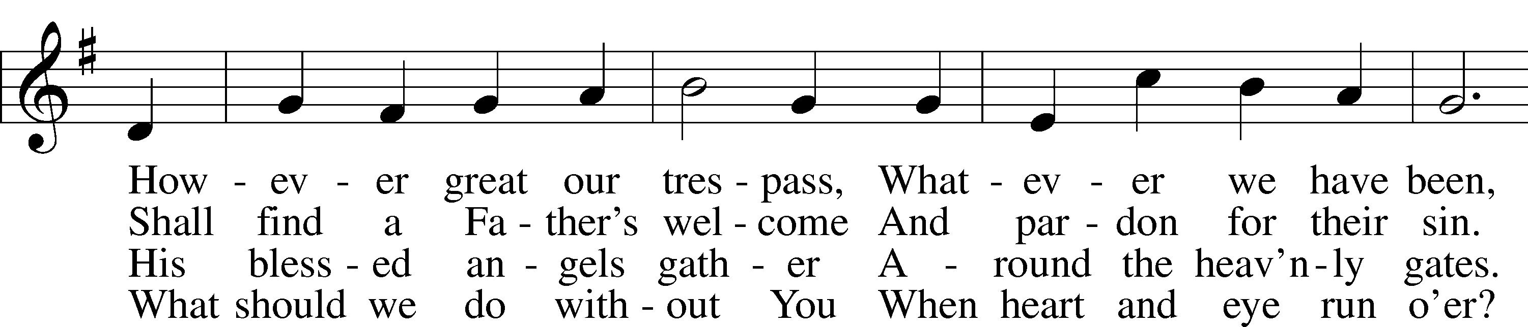
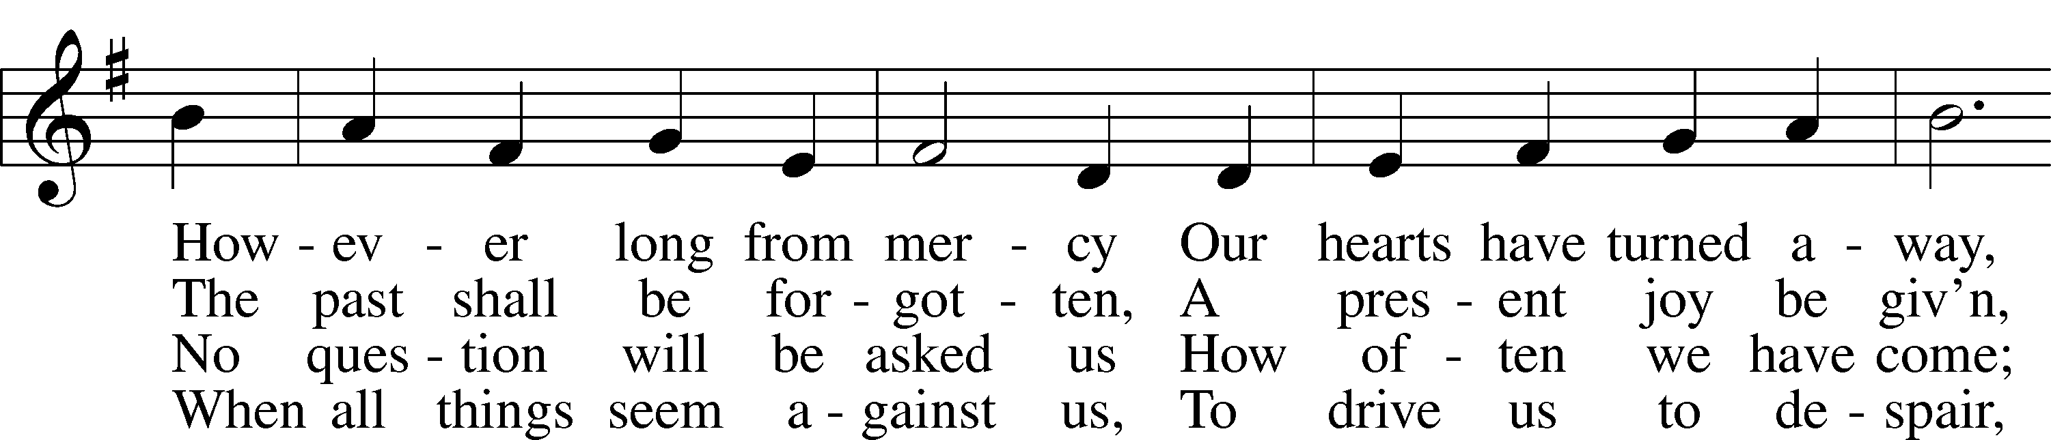
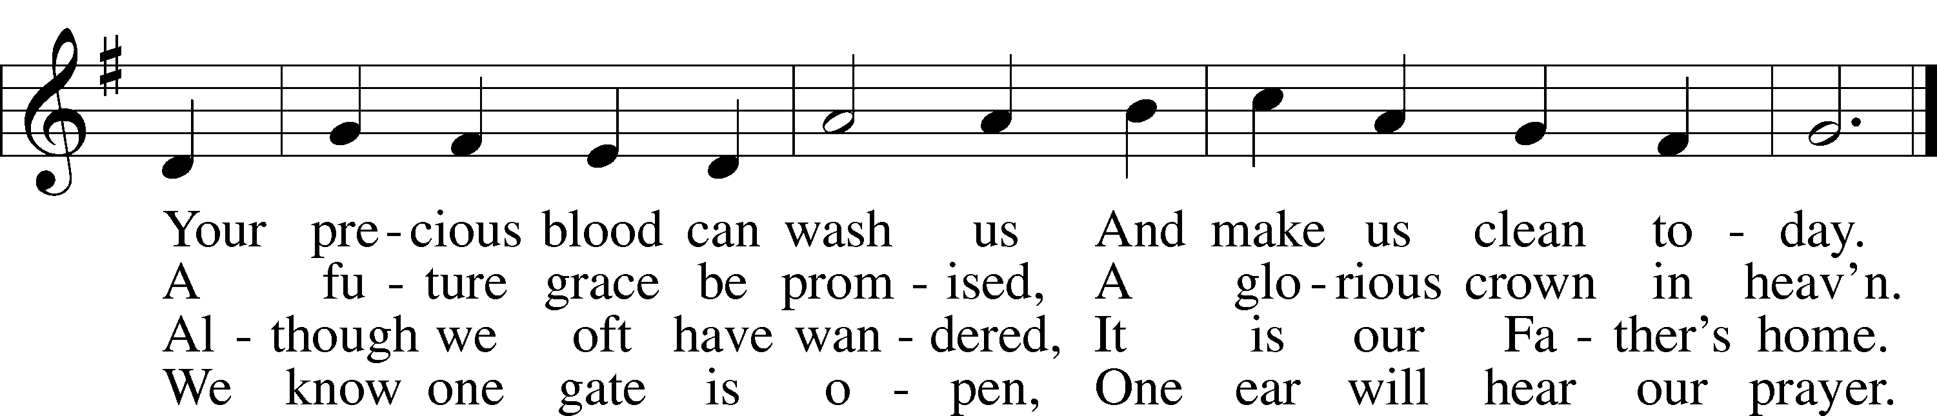
Text: Oswald Allen, 1816–78, alt.
Tune: Friedrich K. Anthes, 1812–after 1857
Text and tune: Public domain

READING Joel 2:12–19
12“Yet even now,” declares the Lord,
“return to me with all your heart,
with fasting, with weeping, and with mourning;
13and rend your hearts and not your garments.”
Return to the Lord, your God,
for he is gracious and merciful,
slow to anger, and abounding in steadfast love;
and he relents over disaster.
14Who knows whether he will not turn and relent,
and leave a blessing behind him,
a grain offering and a drink offering
for the Lord your God?
15Blow the trumpet in Zion;
consecrate a fast;
call a solemn assembly;
16gather the people.
Consecrate the congregation;
assemble the elders;
gather the children,
even nursing infants.
Let the bridegroom leave his room,
and the bride her chamber.
17Between the vestibule and the altar
let the priests, the ministers of the Lord, weep
and say, “Spare your people, O Lord,
and make not your heritage a reproach,
a byword among the nations.
Why should they say among the peoples,
‘Where is their God?’”
18Then the Lord became jealous for his land
and had pity on his people.
19The Lord answered and said to his people,
“Behold, I am sending to you
grain, wine, and oil,
and you will be satisfied;
and I will no more make you
a reproach among the nations.”

READING RESPONSE
P This is the Word of the Lord.
C Thanks be to God.

READING Psalm 51:1–13
1Have mercy on me, O God,
according to your | steadfast love;*
according to your abundant mercy
blot out my trans- | gressions.
2Wash me thoroughly from my in- | iquity,*
and cleanse me | from my sin!
3For I know my trans- | gressions,*
and my sin is ever be- | fore me.
4Against you, you only, have I sinned
and done what is evil | in your sight,*
so that you may be justified in your words
and blameless in your | judgment.
5Behold, I was brought forth in in- | iquity,*
and in sin did my mother con- | ceive me.
6Behold, you delight in truth in the inward | being,*
and you teach me wisdom in the | secret heart.
7Purge me with hyssop, and I | shall be clean;*
wash me, and I shall be whit- | er than snow.
8Let me hear joy and | gladness;*
let the bones that you have bro- | ken rejoice.
9Hide your face | from my sins,*
and blot out all my in- | iquities.
10Create in me a clean heart, | O God,*
and renew a right spirit with- | in me.
11Cast me not away from your | presence,*
and take not your Holy Spirit | from me.
12Restore to me the joy of your sal- | vation,*
and uphold me with a willing | spirit.
13Then I will teach transgressors | your ways,*
and sinners will re- | turn to you.

READING 2 Corinthians 5:20b—6:10
We implore you on behalf of Christ, be reconciled to God. 21For our sake he made him to be sin who knew no sin, so that in him we might become the righteousness of God.
1Working together with him, then, we appeal to you not to receive the grace of God in vain. 2For he says,
“In a favorable time I listened to you,
and in a day of salvation I have helped you.”
Behold, now is the favorable time; behold, now is the day of salvation. 3We put no obstacle in anyone’s way, so that no fault may be found with our ministry, 4but as servants of God we commend ourselves in every way: by great endurance, in afflictions, hardships, calamities, 5beatings, imprisonments, riots, labors, sleepless nights, hunger; 6by purity, knowledge, patience, kindness, the Holy Spirit, genuine love; 7by truthful speech, and the power of God; with the weapons of righteousness for the right hand and for the left; 8through honor and dishonor, through slander and praise. We are treated as impostors, and yet are true; 9as unknown, and yet well known; as dying, and behold, we live; as punished, and yet not killed; 10as sorrowful, yet always rejoicing; as poor, yet making many rich; as having nothing, yet possessing everything.

READING RESPONSE
P This is the Word of the Lord.
C Thanks be to God.

READING Matthew 6:1–6, 16–21
1[Jesus said:] “Beware of practicing your righteousness before other people in order to be seen by them, for then you will have no reward from your Father who is in heaven.
2“Thus, when you give to the needy, sound no trumpet before you, as the hypocrites do in the synagogues and in the streets, that they may be praised by others. Truly, I say to you, they have received their reward. 3But when you give to the needy, do not let your left hand know what your right hand is doing, 4so that your giving may be in secret. And your Father who sees in secret will reward you.
5“And when you pray, you must not be like the hypocrites. For they love to stand and pray in the synagogues and at the street corners, that they may be seen by others. Truly, I say to you, they have received their reward. 6But when you pray, go into your room and shut the door and pray to your Father who is in secret. And your Father who sees in secret will reward you. . . .
16“And when you fast, do not look gloomy like the hypocrites, for they disfigure their faces that their fasting may be seen by others. Truly, I say to you, they have received their reward. 17But when you fast, anoint your head and wash your face, 18that your fasting may not be seen by others but by your Father who is in secret. And your Father who sees in secret will reward you.
19“Do not lay up for yourselves treasures on earth, where moth and rust destroy and where thieves break in and steal, 20but lay up for yourselves treasures in heaven, where neither moth nor rust destroys and where thieves do not break in and steal. 21For where your treasure is, there your heart will be also.”

READING RESPONSE
P This is the Word of the Lord.
C Thanks be to God.

843 “FORGIVE OUR SINS AS WE FORGIVE”
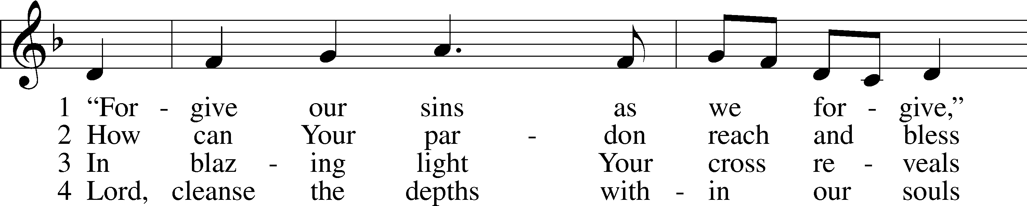
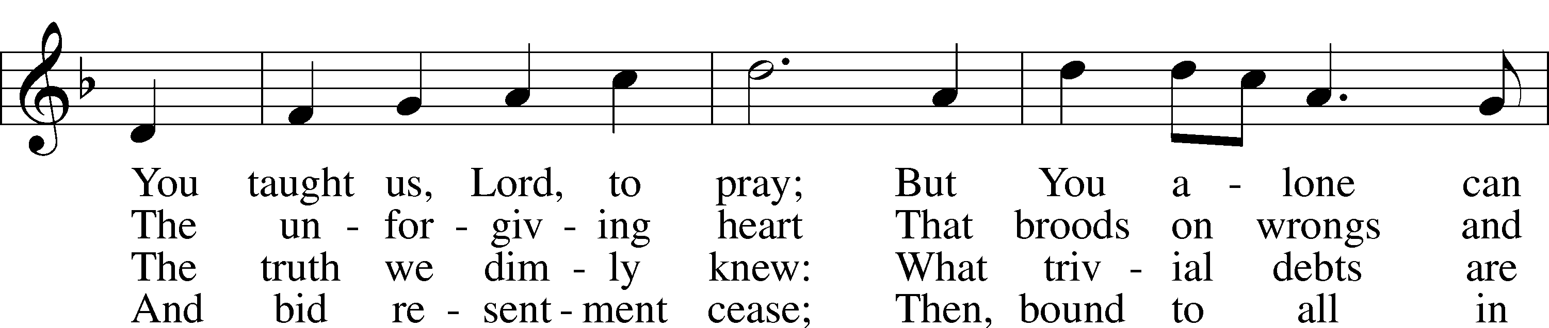
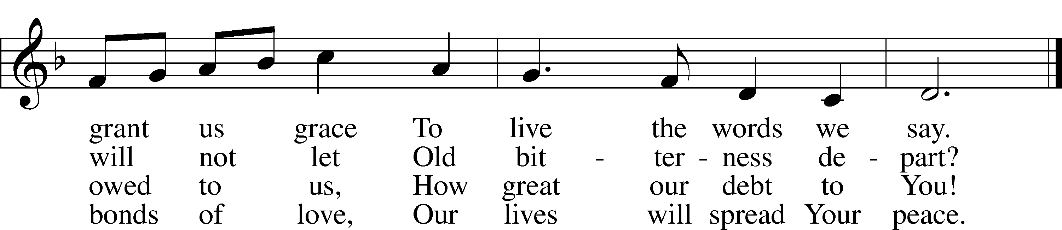
Text: Rosamond E. Herklots, 1905–87, alt.
Tune: A Supplement to the Kentucky Harmony, 1820, Harrisonburg
Text: © Oxford University Press. Used by permission: LSB Hymn License no. 110004798
Tune: Public domain

SERMON

(stand)

LORD’S PRAYER
C Our Father who art in heaven,
hallowed be Thy name,
Thy kingdom come,
Thy will be done on earth
as it is in heaven;
give us this day our daily bread;
and forgive us our trespasses
as we forgive those
who trespass against us;
and lead us not into temptation,
but deliver us from evil.
For Thine is the kingdom
and the power and the glory
forever and ever. Amen.

CONCLUDING COLLECT
P O God, You desire not the death of sinners, but rather that they turn from their wickedness and live. We implore You to have compassion on the frailty of our mortal nature, for we acknowledge that we are dust and to dust we shall return. Mercifully pardon our sins that we may obtain the promises You have laid up for those who are repentant; through Jesus Christ, Your Son, our Lord, who lives and reigns with You and the Holy Spirit, one God, now and forever.
C Amen.

BENEDICTION (PAULINE)
P The grace of our Lord T Jesus Christ and the love of God and the communion of the Holy Spirit be with you all.
C Amen.

421 JESUS, GRANT THAT BALM AND HEALING
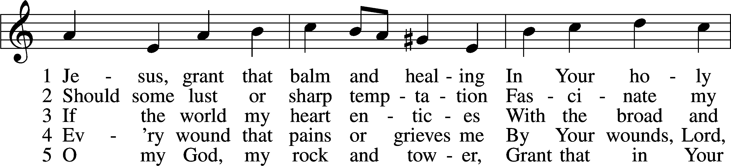
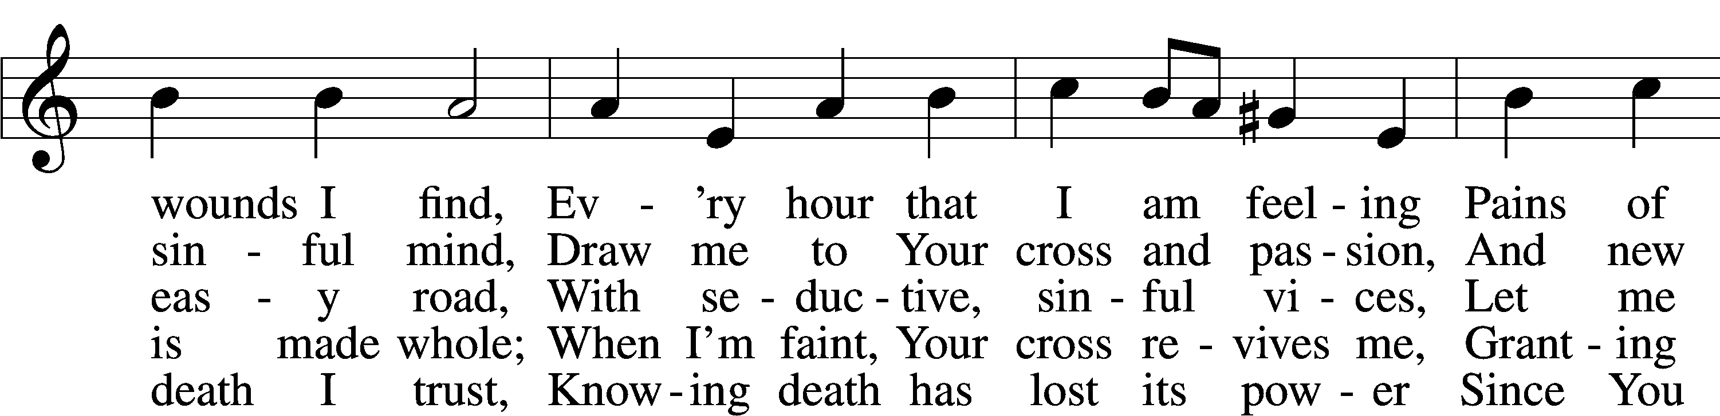
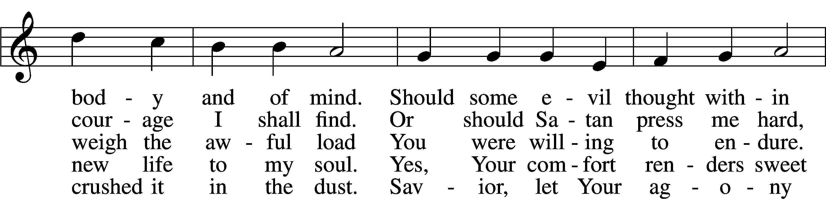
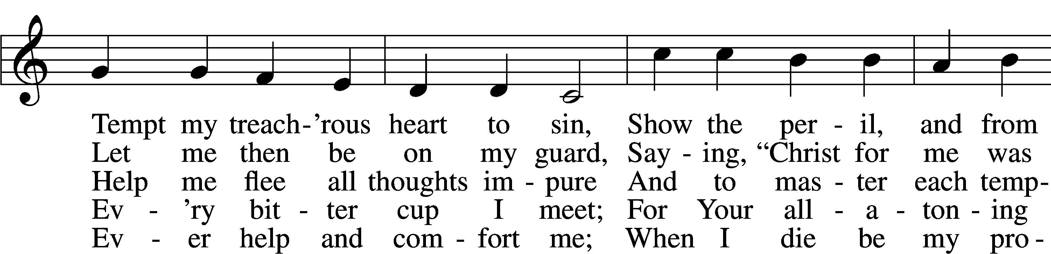
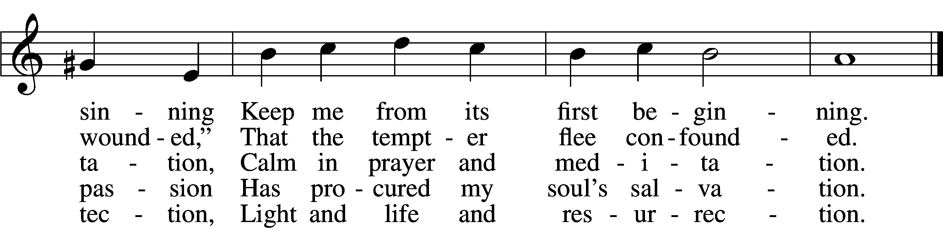
Text: Johann Heermann, 1585–1647; tr. composite, alt.
Tune: Johann Balthasar König, 1691–1758
Text and tune: Public domain

ACKNOWLEDGMENTS
Unless otherwise indicated, Scripture quotations are from the ESV® Bible (The Holy Bible, English Standard Version®), copyright © 2001 by Crossway, a publishing ministry of Good News Publishers. Used by permission. All rights reserved.
Created by Lutheran Service Builder © 2026 Concordia Publishing House.

