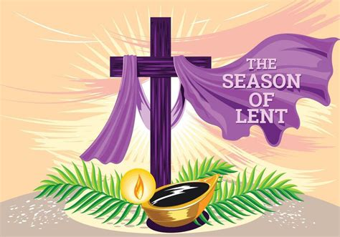

BETHLEHEM LUTHERAN CHURCH
A congregation of The Lutheran Church-Missouri Synod
902 Hitchcock Drive SW,
Aiken, South Carolina 29803
Church Phone: (803) 649-6417
blcaikensc@gmail.com
Pastor: Rev. John B. Engwall
Office Hours By Appointment
Bethlehem Lutheran welcomes our members and guests to our worship service! Unable to join us in person? Please find us on Facebook live. The service is also posted on our website; bethlehemlutheranaiken.org.

+ + + + + + + + + + + + + + +
The First Wednesday in Lent
February 25, 2026
11:00 a.m. and 7:00 p.m.
+ + + + + + + + + + + + + + +

718 JESUS, LEAD THOU ON
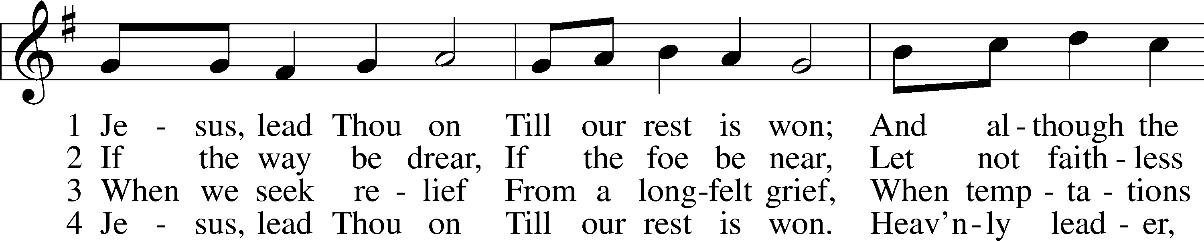
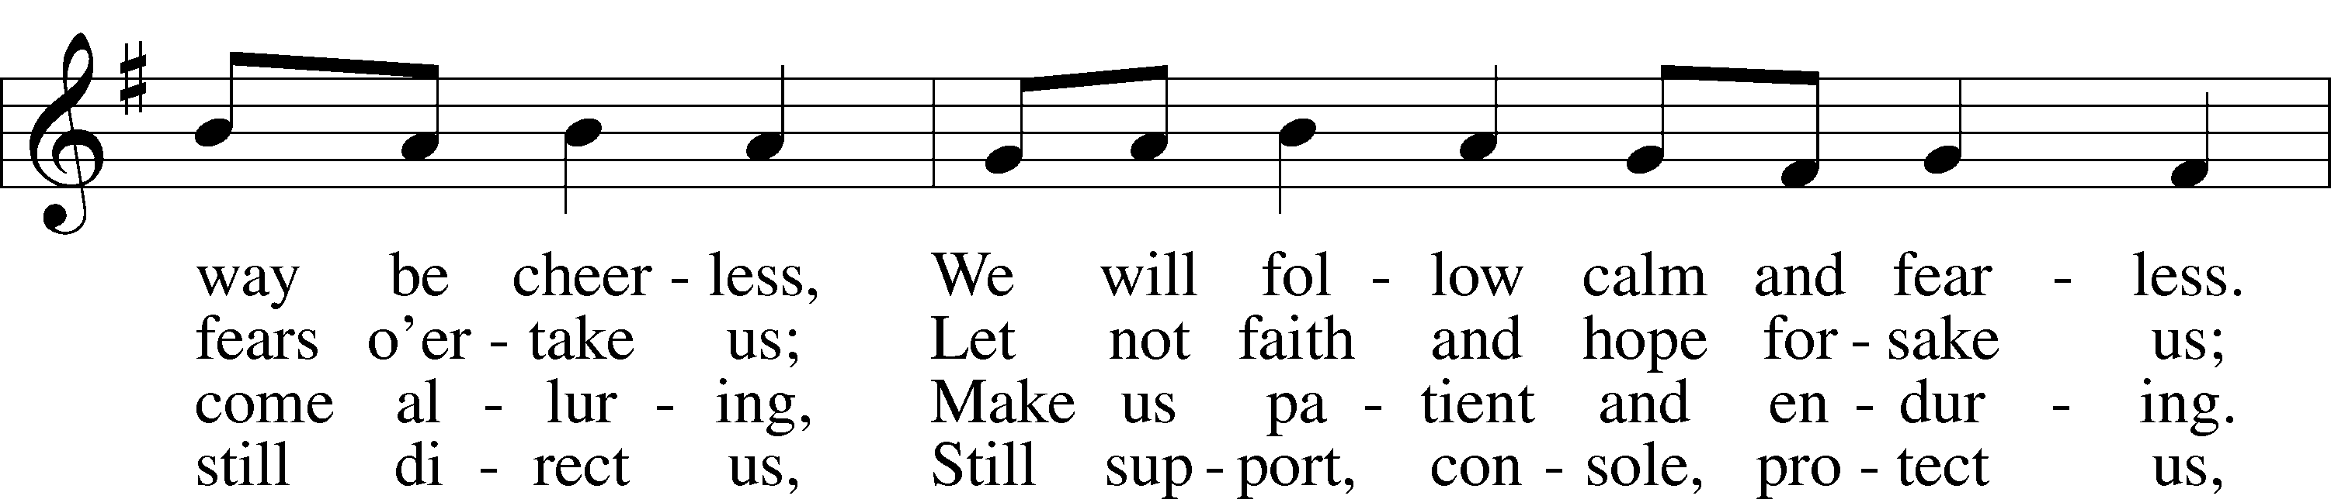
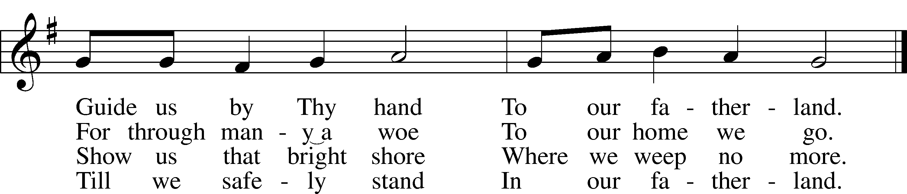
Text: Nicolaus Ludwig von Zinzendorf, 1700–60; tr. Jane L. Borthwick, 1813–97, alt.
Tune: Adam Drese, 1620–1701
Text and tune: Public domain

PRAYER
O God, You resist the proud and give grace to the humble. Grant us true humility after the likeness of Your only Son that we may never be arrogant and prideful and thus provoke Your wrath, but in all lowliness be made partakers of the gifts of Your grace; through Jesus Christ, our Lord.

READING Genesis 3:1–21
1Now the serpent was more crafty than any other beast of the field that the Lord God had made.
He said to the woman, “Did God actually say, ‘You shall not eat of any tree in the garden’?” 2And the woman said to the serpent, “We may eat of the fruit of the trees in the garden, 3but God said, ‘You shall not eat (Next Page)
of the fruit of the tree that is in the midst of the garden, neither shall you touch it, lest you die.’” 4But the serpent said to the woman, “You will not surely die. 5For God knows that when you eat of it your eyes will be opened, and you will be like God, knowing good and evil.” 6So when the woman saw that the tree was good for food, and that it was a delight to the eyes, and that the tree was to be desired to make one wise, she took of its fruit and ate, and she also gave some to her husband who was with her, and he ate. 7Then the eyes of both were opened, and they knew that they were naked. And they sewed fig leaves together and made themselves loincloths. (next page)
8And they heard the sound of the Lord God walking in the garden in the cool of the day, and the man and his wife hid themselves from the presence of the Lord God among the trees of the garden. 9But the Lord God called to the man and said to him, “Where are you?” 10And he said, “I heard the sound of you in the garden, and I was afraid, because I was naked, and I hid myself.” 11He said, “Who told you that you were naked? Have you eaten of the tree of which I commanded you not to eat?” 12The man said, “The woman whom you gave to be with me, she gave me fruit of the tree, and I ate.” 13Then the Lord God said to the woman, “What is this that you have done?” The woman said, “The serpent deceived me, and I ate.”
14The Lord God said to the serpent,
“Because you have done this,
cursed are you above all livestock
and above all beasts of the field;
on your belly you shall go,
and dust you shall eat
all the days of your life.
15I will put enmity between you and the woman,
and between your offspring and her offspring;
he shall bruise your head,
and you shall bruise his heel.”
16To the woman he said,
“I will surely multiply your pain in childbearing;
in pain you shall bring forth children.
Your desire shall be for your husband,
and he shall rule over you.”
17And to Adam he said,
“Because you have listened to the voice of your wife
and have eaten of the tree
of which I commanded you,
‘You shall not eat of it,’
cursed is the ground because of you;
in pain you shall eat of it all the days of your life;
18thorns and thistles it shall bring forth for you;
and you shall eat the plants of the field.
19By the sweat of your face
you shall eat bread,
till you return to the ground,
for out of it you were taken; (next page)
for you are dust,
and to dust you shall return.”
20The man called his wife’s name Eve, because she was the mother of all living. 21And the Lord God made for Adam and for his wife garments of skins and clothed them.

SERMON OR MEDITATION

APOSTLES’ CREED
C I believe in God, the Father Almighty,
maker of heaven and earth.

And in Jesus Christ, His only Son, our Lord,
who was conceived by the Holy Spirit,
born of the virgin Mary,
suffered under Pontius Pilate,
was crucified, died and was buried.
He descended into hell.
The third day He rose again from the dead.
He ascended into heaven
and sits at the right hand of God the Father Almighty.
From thence He will come to judge the living and the dead.

I believe in the Holy Spirit,
the holy Christian Church,
the communion of saints,
the forgiveness of sins,
the resurrection of the body,
and the life T everlasting. Amen.

LORD’S PRAYER
L Taught by our Lord and trusting His promises, we are bold to pray:
C Our Father who art in heaven,
hallowed be Thy name,
Thy kingdom come,
Thy will be done on earth
as it is in heaven;
give us this day our daily bread;
and forgive us our trespasses
as we forgive those
who trespass against us;
and lead us not into temptation,
but deliver us from evil.
For Thine is the kingdom
and the power and the glory
forever and ever. Amen.

BLESSING
L The grace of our Lord T Jesus Christ and the love of God and the communion of the Holy Spirit be with you all.
C Amen.

655 LORD, KEEP US STEADFAST IN YOUR WORD
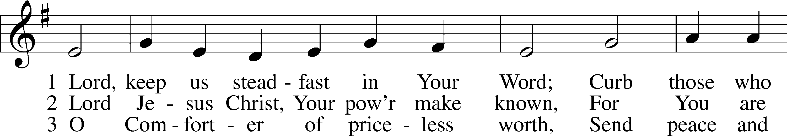
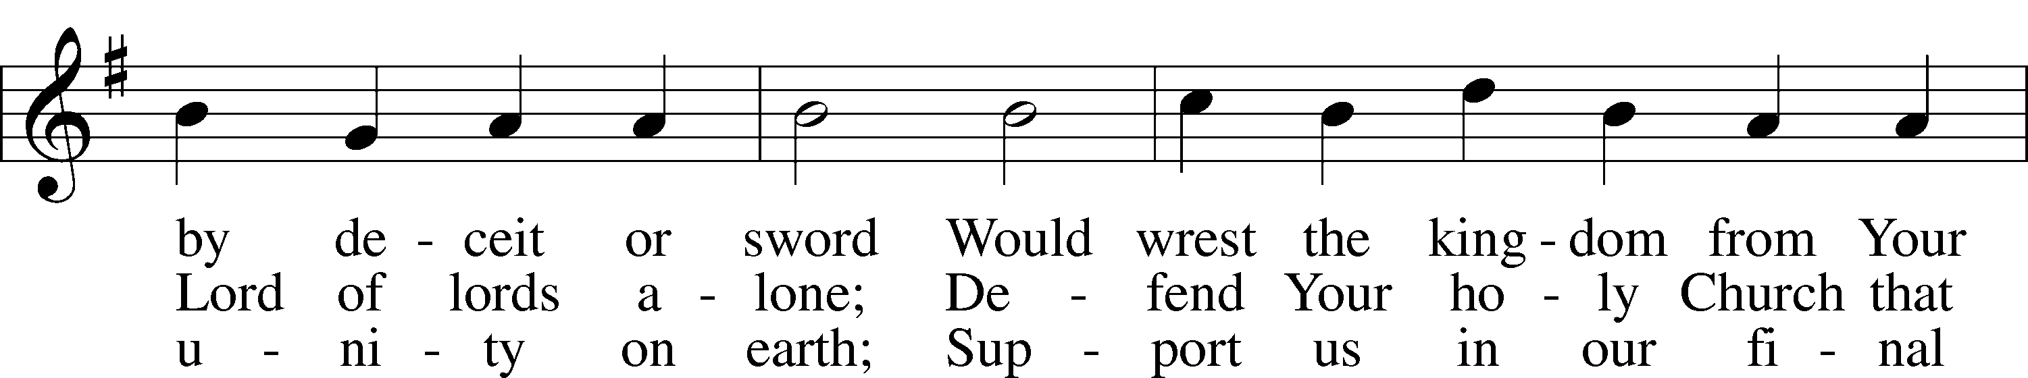
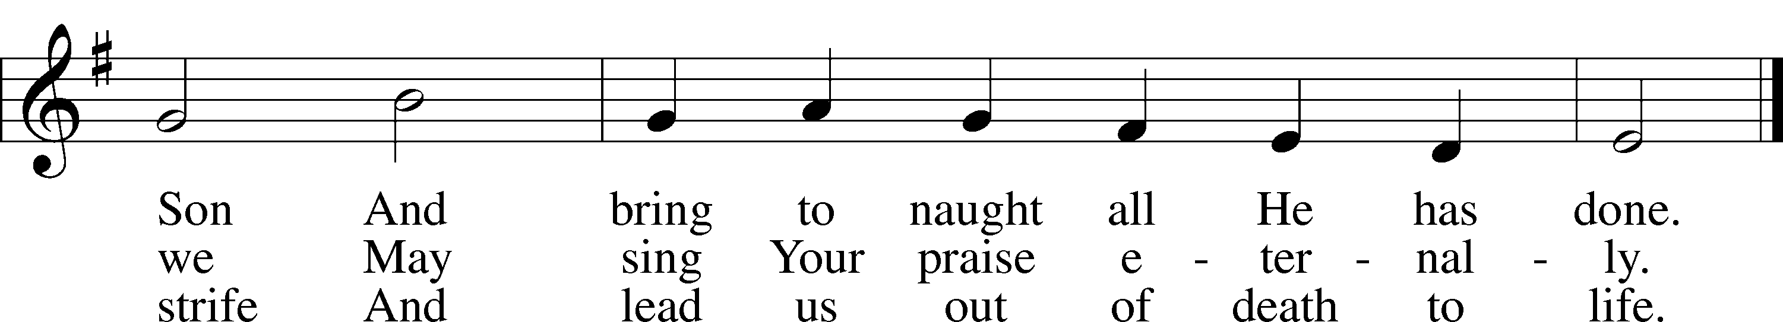
Text: Martin Luther, 1483–1546; tr. Catherine Winkworth, 1827–78, alt.
Tune: Geistliche Lieder auffs new gebessert, 1543, Wittenberg, ed. Joseph Klug
Text and tune: Public domain

ACKNOWLEDGMENTS
Unless otherwise indicated, Scripture quotations are from the ESV® Bible (The Holy Bible, English Standard Version®), copyright © 2001 by Crossway, a publishing ministry of Good News Publishers. Used by permission. All rights reserved.
Created by Lutheran Service Builder © 2026 Concordia Publishing House.

