

+ + + + + + + + + + + + + + +
The Second Wednesday in Lent
March 19, 2025
11:00a.m. and 7:00 p.m.
+ + + + + + + + + + + + + + +

BETHLEHEM LUTHERAN CHURCH
A congregation of The Lutheran Church-Missouri Synod
902 Hitchcock Drive SW,
Aiken, South Carolina 29803
Church Phone: (803) 649-6417
blcaikensc@gmail.com
Pastor: Rev. John B. Engwall
Office Hours By Appointment
Bethlehem Lutheran welcomes our members and guests to our worship service! Unable to join us in person? Please find us on Facebook live. The service is also posted on our website; bethlehemlutheranaiken.org.

579 THE LAW OF GOD IS GOOD AND WISE
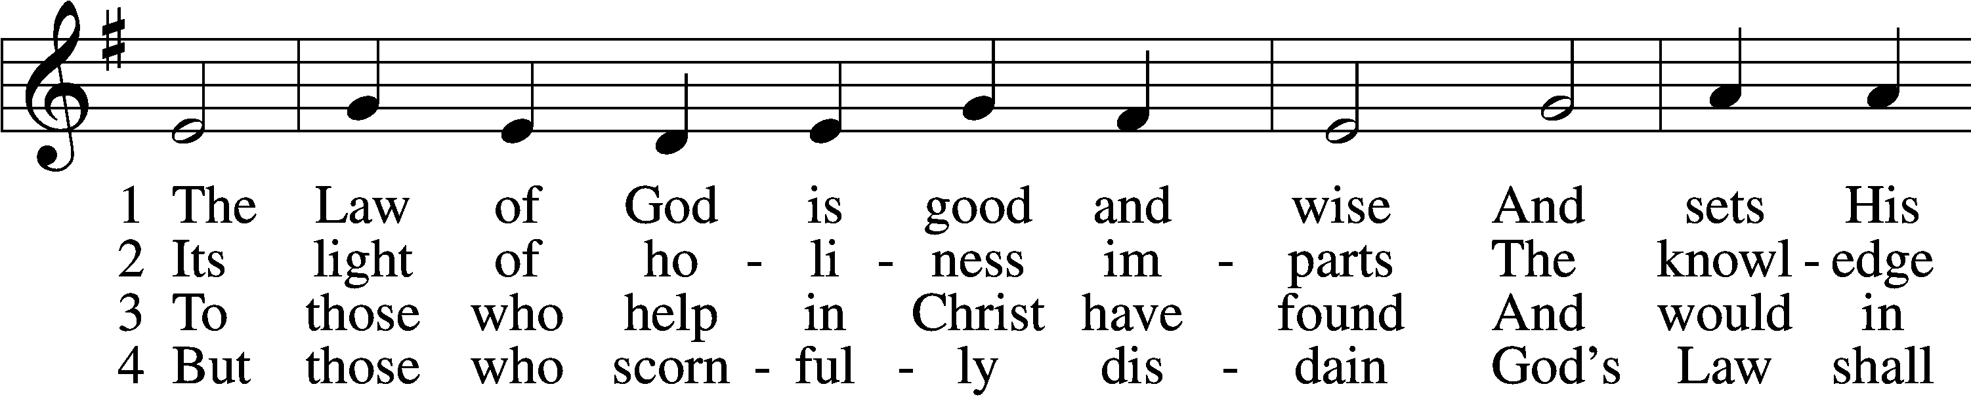
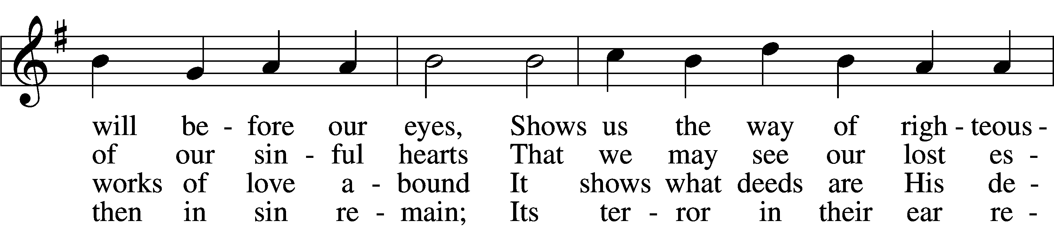
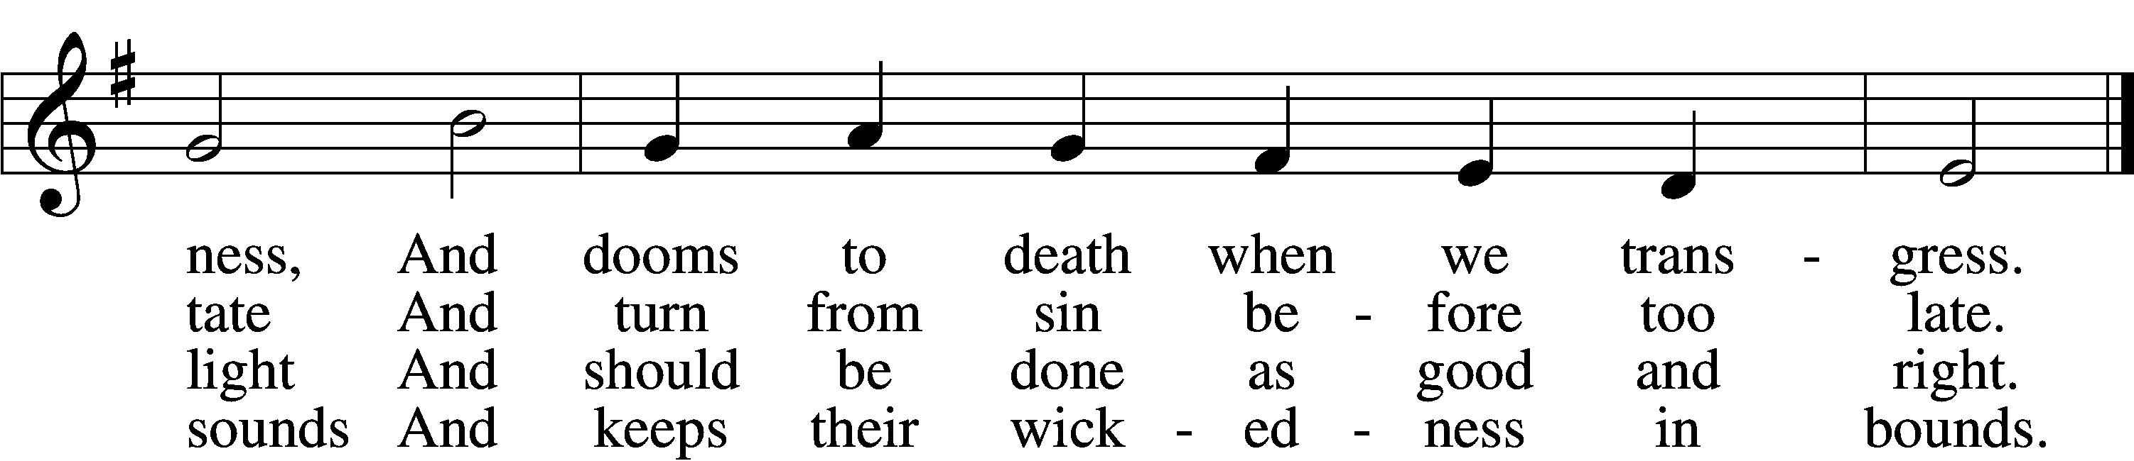

5 The Law is good; but since the fall
Its holiness condemns us all;
It dooms us for our sin to die
And has no pow’r to justify.

6 To Jesus we for refuge flee,
Who from the curse has set us free,
And humbly worship at His throne,
Saved by His grace through faith alone.
Text: Matthias Loy, 1828–1915, alt.
Tune: Geistliche Lieder auffs new gebessert, 1543, Wittenberg, ed. Joseph Klug
Text and tune: Public domain

PRAYER
L O God, You resist the proud and give grace to the humble. Grant us true humility after the likeness of Your only Son that we may never be arrogant and prideful and thus provoke Your wrath, but in all lowliness be made partakers of the gifts of Your grace; through Jesus Christ, our Lord.
C Amen.

READING Jeremiah 26:8–15
8When Jeremiah had finished speaking all that the Lord had commanded him to speak to all the people, then the priests and the prophets and all the people laid hold of him, saying, “You shall die! 9Why have you prophesied in the name of the Lord, saying, ‘This house shall be like Shiloh, and this city shall be desolate, without inhabitant’?” And all the people gathered around Jeremiah in the house of the Lord.
10When the officials of Judah heard these things, they came up from the king’s house to the house of the Lord and took their seat in the entry of the New Gate of the house of the Lord. 11Then the priests and the prophets said to the officials and to all the people, “This man deserves the sentence of death, because he has prophesied against this city, as you have heard with your own ears.”
12Then Jeremiah spoke to all the officials and all the people, saying, “The Lord sent me to prophesy against this house and this city all the words you have heard. 13Now therefore mend your ways and your deeds, and obey the voice of the Lord your God, and the Lord will relent of the disaster that he has pronounced against you. 14But as for me, behold, I am in your hands. Do with me as seems good and right to you. 15Only know for certain that if you put me to death, you will bring innocent blood upon yourselves and upon this city and its inhabitants, for in truth the Lord sent me to you to speak all these words in your ears.”

L O Lord, have mercy upon us.
C Thanks be to God.

SERMON OR MEDITATION ON THE READING

APOSTLES’ CREED
C I believe in God, the Father Almighty,
maker of heaven and earth.
And in Jesus Christ, His only Son, our Lord,
who was conceived by the Holy Spirit,
born of the virgin Mary,
suffered under Pontius Pilate,
was crucified, died and was buried.
He descended into hell.
The third day He rose again from the dead.
He ascended into heaven
and sits at the right hand of God the Father Almighty.
From thence He will come to judge the living and the dead.
I believe in the Holy Spirit,
the holy Christian Church,
the communion of saints,
the forgiveness of sins,
the resurrection of the body,
and the life T everlasting. Amen.

COLLECT OF THE DAY
L O God, You see that of ourselves we have no strength. By Your mighty power defend us from all adversities that may happen to the body and from all evil thoughts that may assault and hurt the soul; through Jesus Christ, Your Son, our Lord, who lives and reigns with You and the Holy Spirit, one God, now and forever.
C Amen.

LORD’S PRAYER
L Taught by our Lord and trusting His promises, we are bold to pray:
C Our Father who art in heaven,
hallowed be Thy name,
Thy kingdom come,
Thy will be done on earth
as it is in heaven;
give us this day our daily bread;
and forgive us our trespasses
as we forgive those
who trespass against us;
and lead us not into temptation,
but deliver us from evil.
For Thine is the kingdom
and the power and the glory
forever and ever. Amen.

BLESSING
L The grace of our Lord T Jesus Christ and the love of God and the communion of the Holy Spirit be with us all.
C Amen.

508 THE DAY IS SURELY DRAWING NEAR
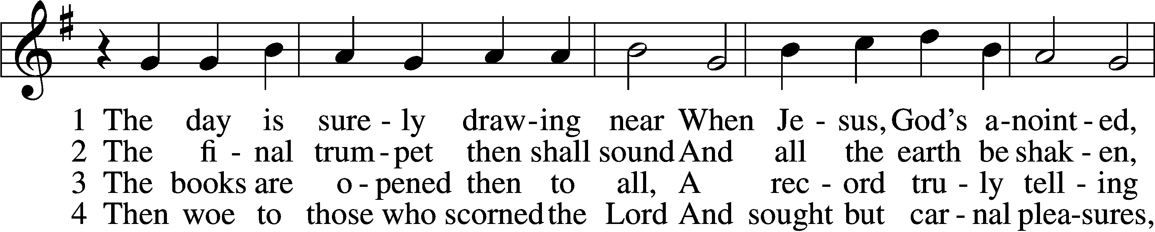
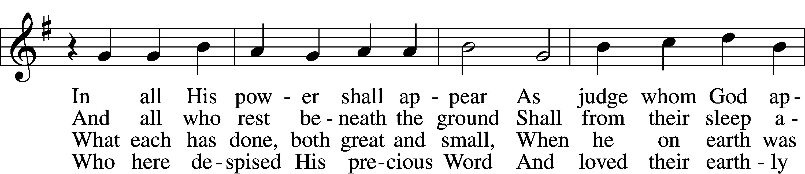
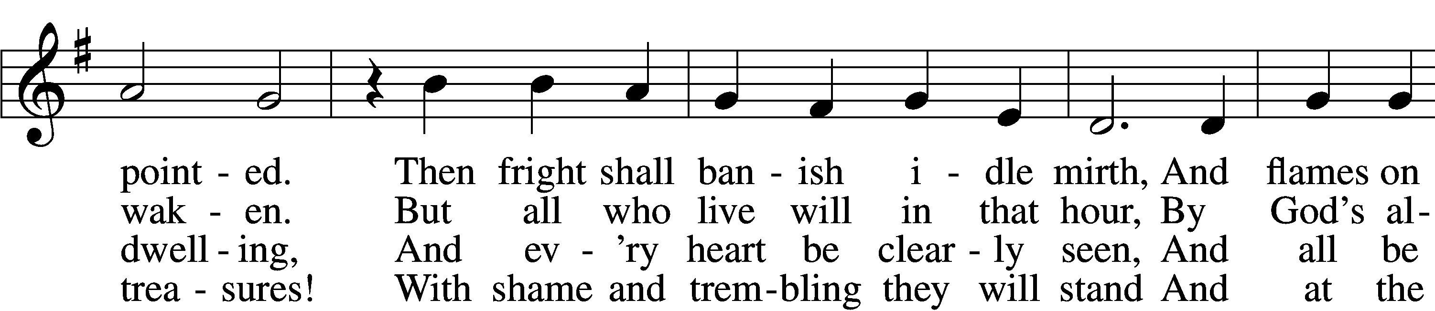
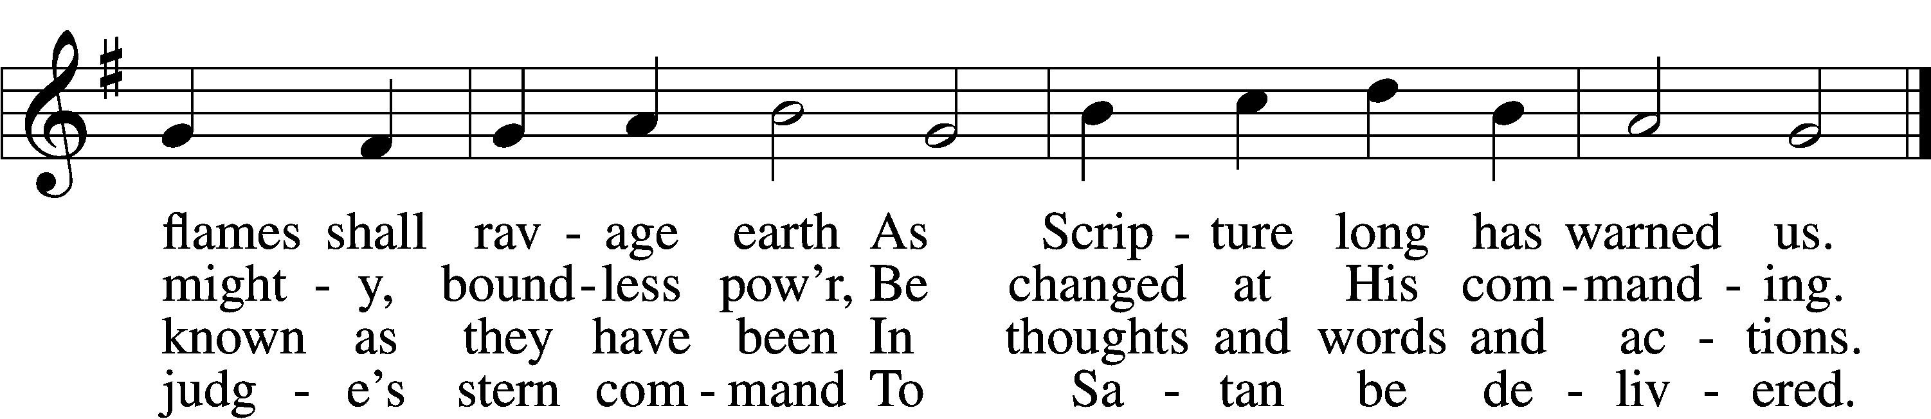

5 My Savior paid the debt I owe
And for my sin was smitten;
Within the Book of Life I know
My name has now been written.
I will not doubt, for I am free,
And Satan cannot threaten me;
There is no condemnation!

6 May Christ our intercessor be
And through His blood and merit
Read from His book that we are free
With all who life inherit.
Then we shall see Him face to face,
With all His saints in that blest place
Which He has purchased for us.

7 O Jesus Christ, do not delay,
But hasten our salvation;
We often tremble on our way
In fear and tribulation.
O hear and grant our fervent plea:
Come, mighty judge, and set us free
From death and ev’ry evil.
Text: Bartholomäus Ringwaldt, 1532–99; tr. Philip A. Peter, 1832–1919, alt.
Tune: Geistliche Lieder auffs new gebessert, 1535, Wittenberg, ed. Joseph Klug
Text and tune: Public domain

ACKNOWLEDGMENTS
Unless otherwise indicated, Scripture quotations are from the ESV® Bible (The Holy Bible, English Standard Version®), copyright © 2001 by Crossway, a publishing ministry of Good News Publishers. Used by permission. All rights reserved.
Created by Lutheran Service Builder © 2025 Concordia Publishing House.

