BETHLEHEM LUTHERAN CHURCH
A congregation of The Lutheran Church-Missouri Synod
902 Hitchcock Drive SW,
Aiken, South Carolina 29803
Church Phone: (803) 649-6417
blcaikensc@gmail.com
Pastor: Rev. John B. Engwall
Office Hours By Appointment

Note: The format of this bulletin has been modified for use in private devotion services. Unable to join us in person? Please find us on Facebook live. The service is also posted on our website: bethlehemlutheranaiken.org

+ + + + + + + + + + + + + + +
The Nativity of Our Lord (Christmas Day)
December 25, 2025
10:30 a.m.
+ + + + + + + + + + + + + + +

Our Policy and Practice Regarding Holy Communion
Hear the words of the Apostle Paul;
Anyone who eats and drinks without recognizing the body of the Lord eats and drinks judgment on himself. -1 Cor.11:29
Therefore, visitors are asked to please refrain from partaking of the Sacrament before speaking about this with the pastor; because we care about your spiritual well-being.
Also, because communing at this altar is a public confession that you agree with the doctrines of The Lutheran Church-Missouri Synod, and reject all contrary teachings.
Persons who are not communing today are always welcome to come forward during the distribution to receive an individual blessing; please cross your arms over your chest to indicate your desire for this. Thank you!
We commune in two alternating tables. The ushers will guide you. Non-alcoholic white wine is available in the center of the individual cup tray. Please leave empty individual cups at the altar rail.
+ SERVICE OF PREPARATION +
After the bell tolls, please observe a time of silence.

WELCOME AND ANNOUNCEMENTS

(Stand)

387 JOY TO THE WORLD
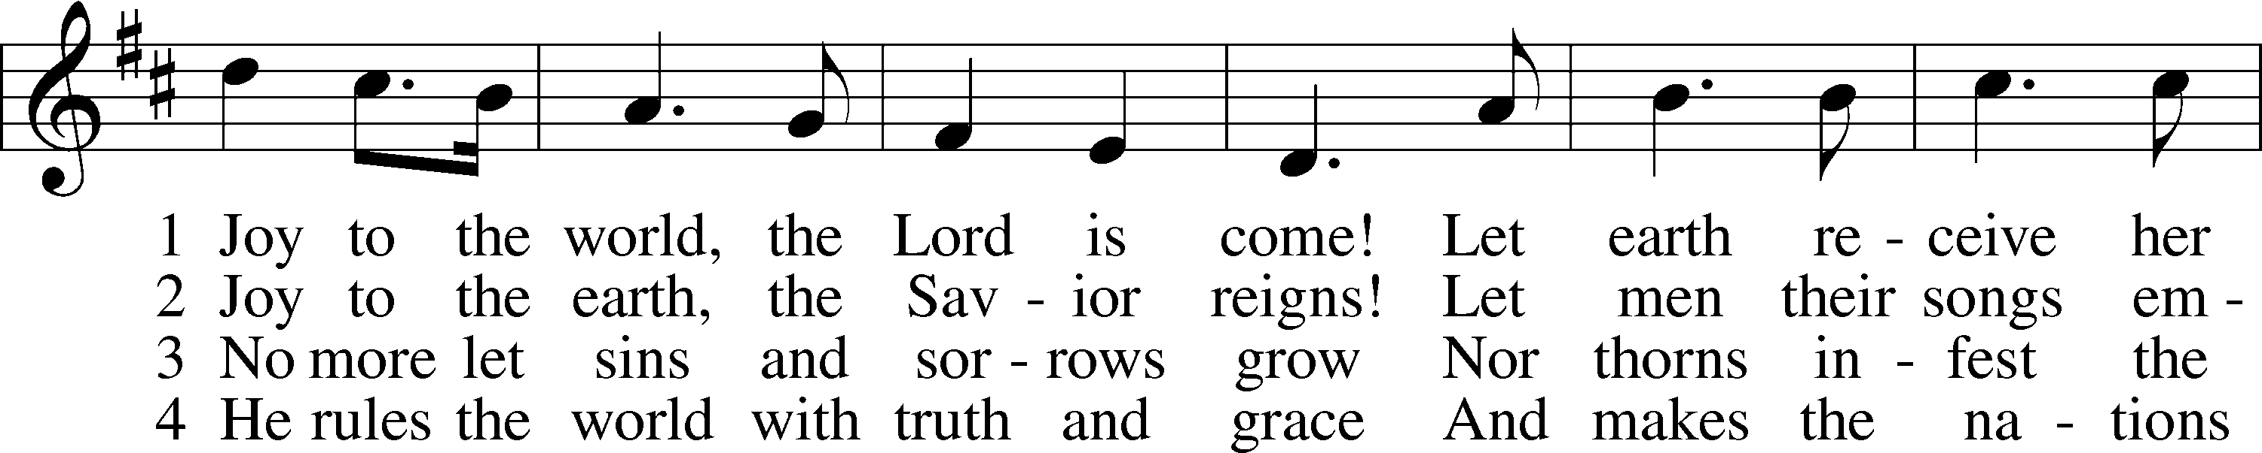
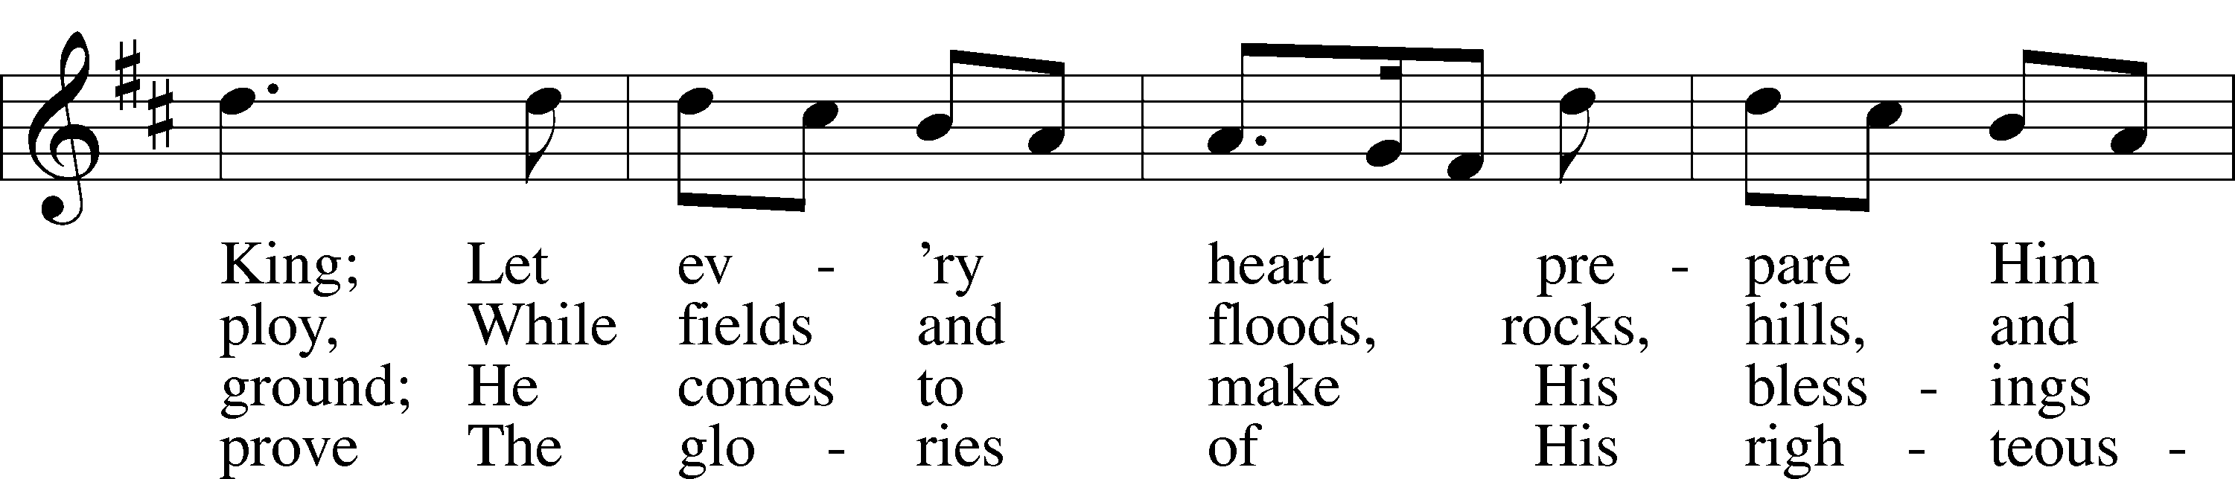
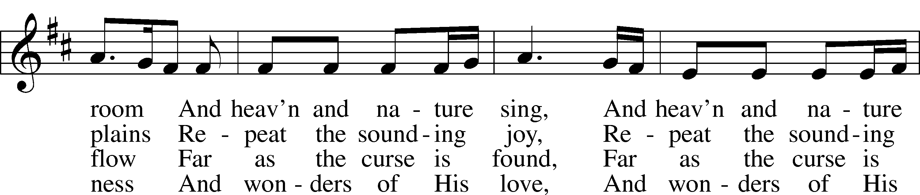
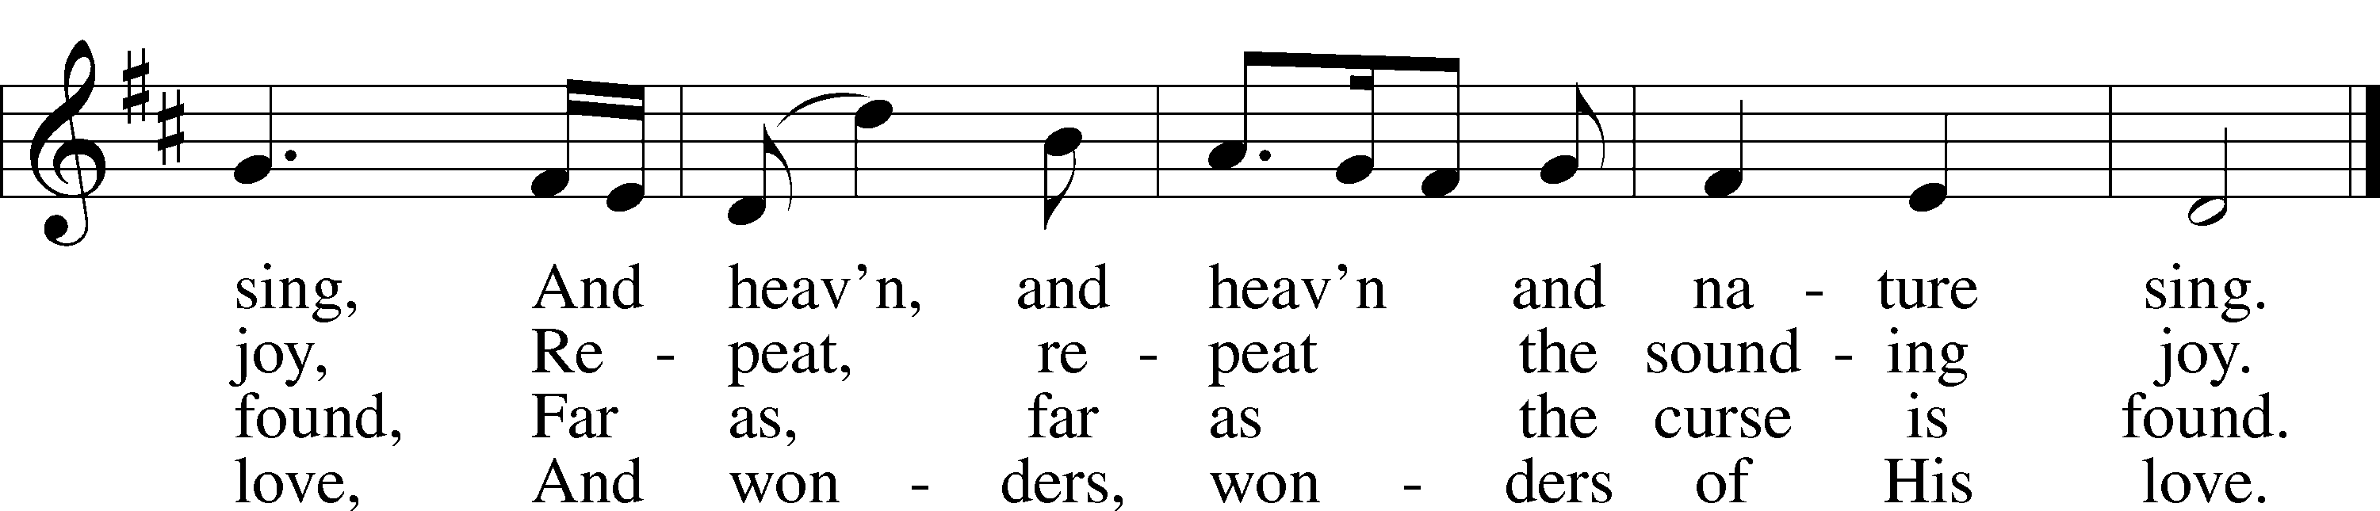
Text: Isaac Watts, 1674–1748
Tune: George Frideric Handel, 1685–1759, adapt.
Text and tune: Public domain

+ CONFESSION AND ABSOLUTION +

(The sign of the cross may be made by all in remembrance of their Baptism.)

INVOCATION
L In the name of the Father and of the T Son and of the Holy Spirit.
C Amen.

EXHORTATION LSB 151
L If we say we have no sin, we deceive ourselves, and the truth is not in us.
C But if we confess our sins, God, who is faithful and just, will forgive our sins and cleanse us from all unrighteousness.

(Silence for reflection on God’s Word and for self-examination.)

CONFESSION OF SINS LSB 151
L Let us then confess our sins to God our Father.
C Most merciful God, we confess that we are by nature sinful and unclean. We have sinned against You in thought, word, and deed, by what we have done and by what we have left undone. We have not loved You with our whole heart; we have not loved our neighbors as ourselves. We justly deserve Your present and eternal punishment. For the sake of Your Son, Jesus Christ, have mercy on us. Forgive us, renew us, and lead us, so that we may delight in Your will and walk in Your ways to the glory of Your holy name. Amen.

DECLARATION OF GRACE
L In the mercy of almighty God, Jesus Christ was given to die for us, and for His sake God forgives us all our sins. To those who believe in Jesus Christ He gives the power to become the children of God and bestows on them the Holy Spirit. May the Lord, who has begun this good work in us, bring it to completion in the day of our Lord Jesus Christ.
C Amen.

(Stand)

+ SERVICE OF THE WORD +

INTROIT Psalm 98:1–4; antiphon: Isaiah 9:6
For to us a child is born, to us a son is | given;*
and the government shall be upon his | shoulder,
and his name shall be called Wonderful | Counselor,*
Mighty God, Everlasting Father, | Prince of Peace.
Oh sing to the Lord a new song, for he has done | marvelous things!*
His right hand and his holy arm have worked salva- | tion for him.
The Lord has made known his sal- | vation;*
he has revealed his righteousness in the sight of the | nations.
He has remembered his steadfast love and faithfulness to the house of | Israel.*
All the ends of the earth have seen the salvation | of our God.
Make a joyful noise to the Lord, | all the earth;*
break forth into joyous song and sing | praises!
Glory be to the Father and | to the Son*
and to the Holy | Spirit;
as it was in the be- | ginning,*
is now, and will be forever. | Amen.
For to us a child is born, to us a son is | given;*
and the government shall be upon his | shoulder,
and his name shall be called Wonderful | Counselor,*
Mighty God, Everlasting Father, | Prince of Peace.

KYRIE LSB 152
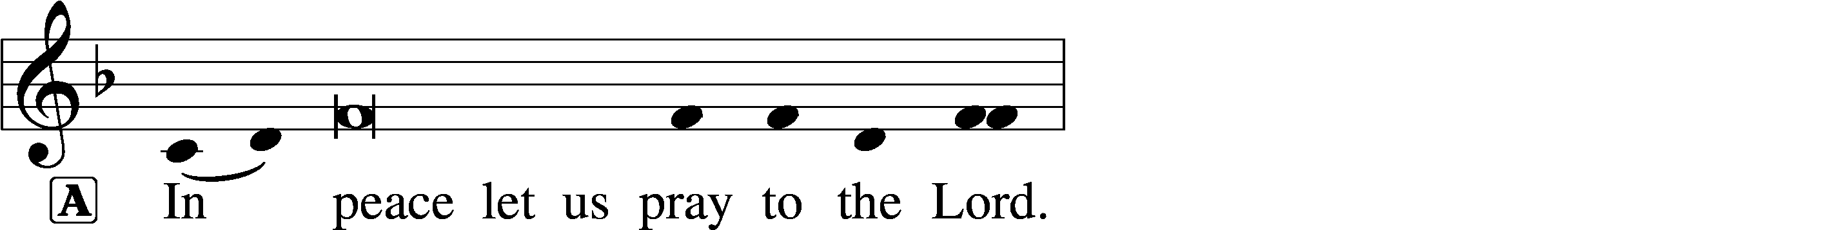
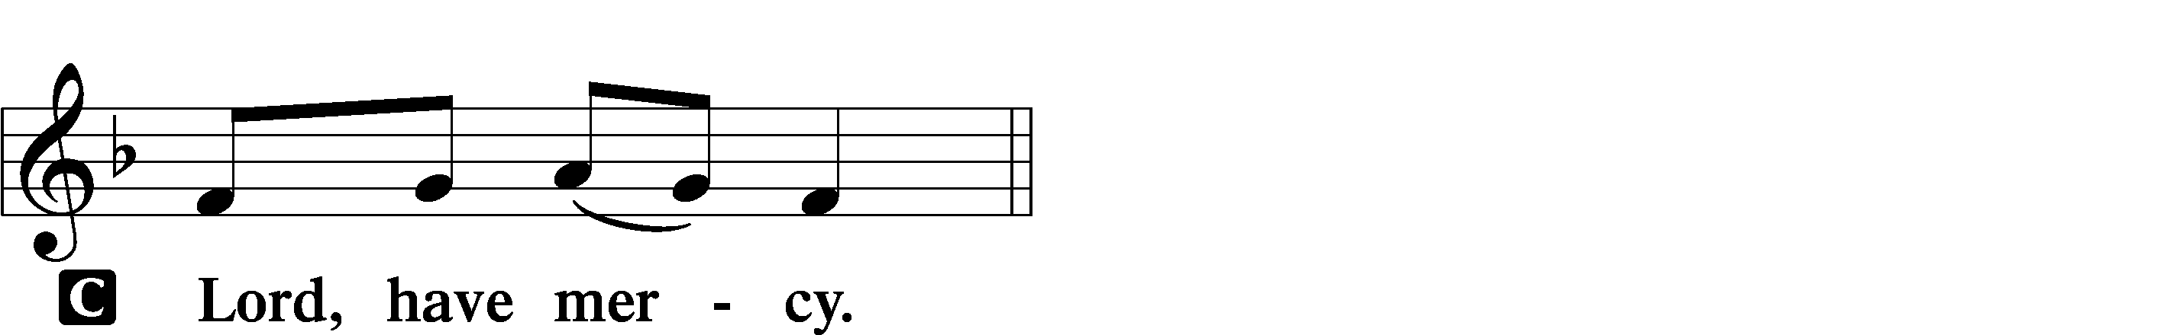

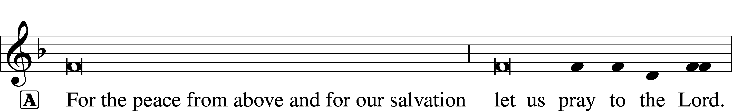
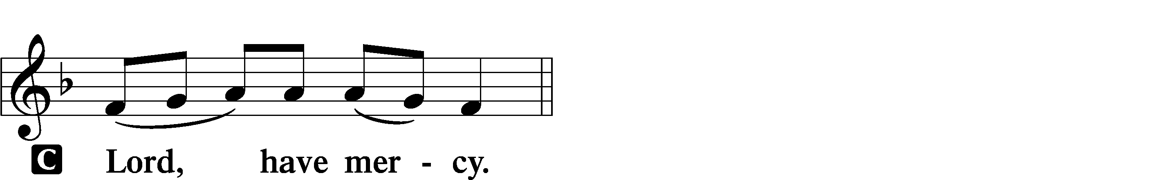

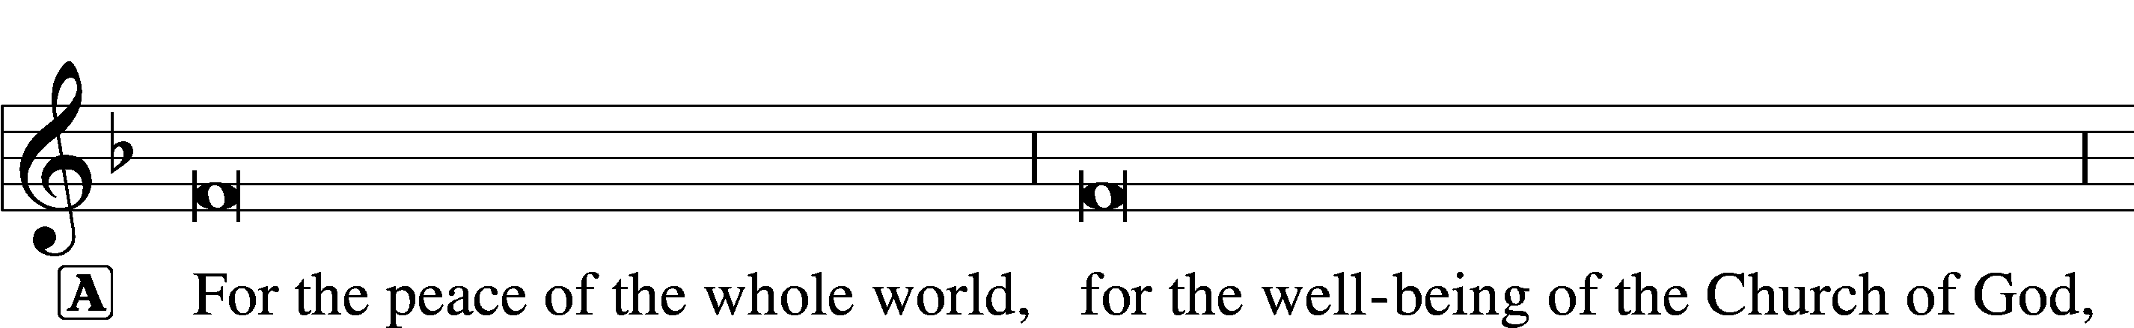
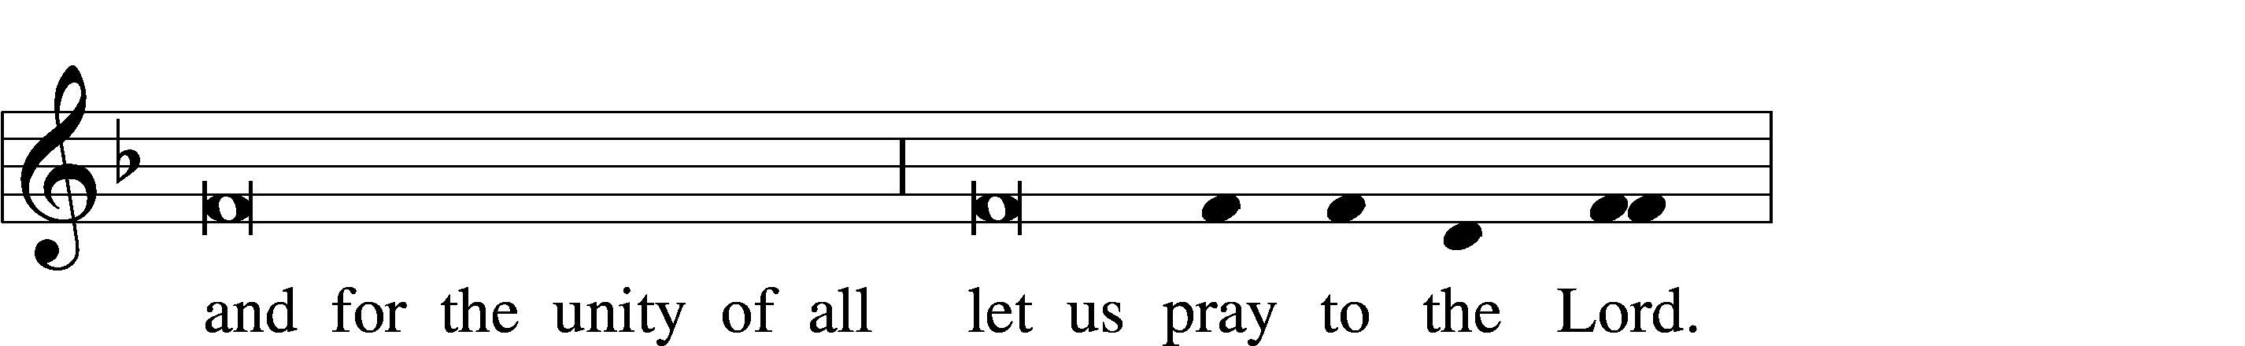
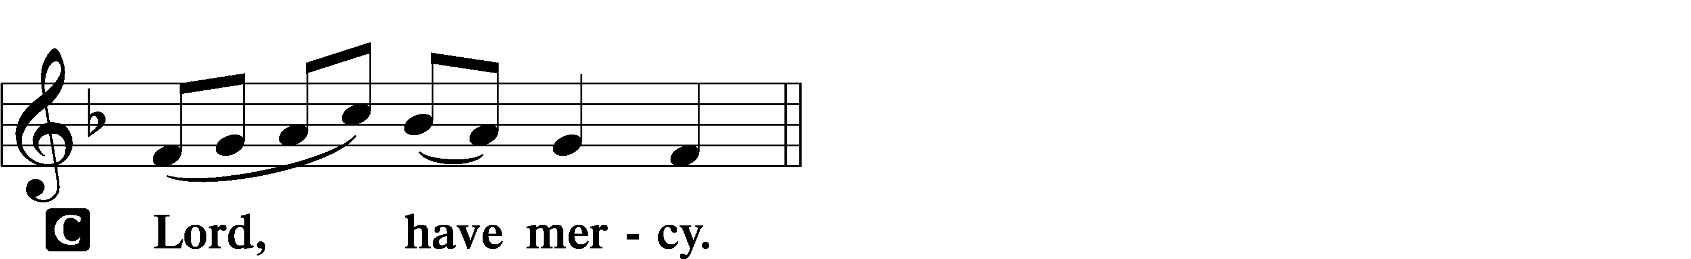

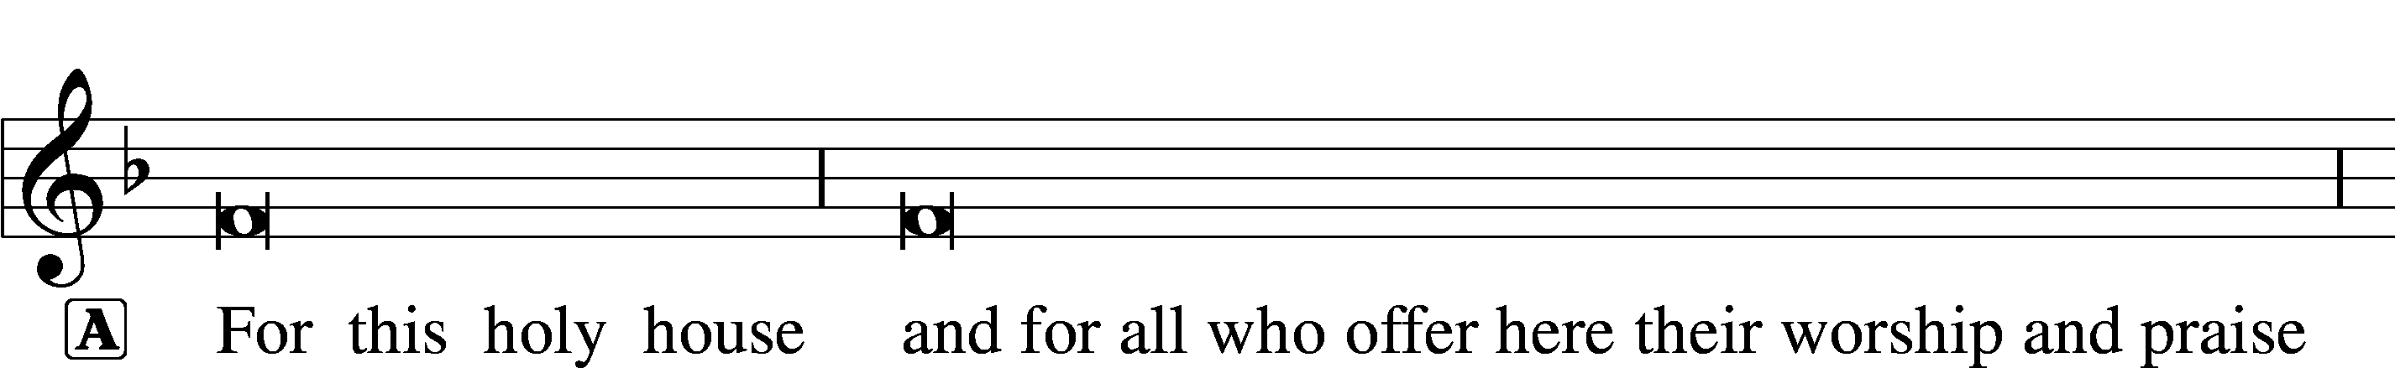
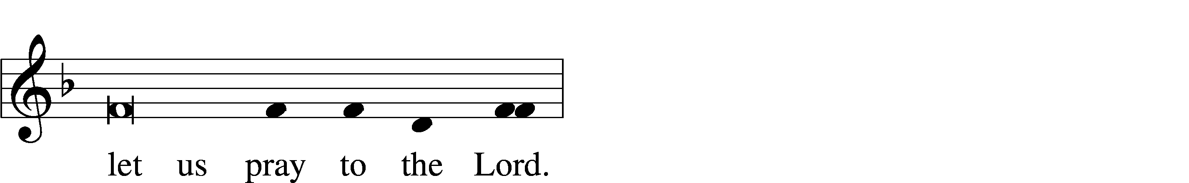
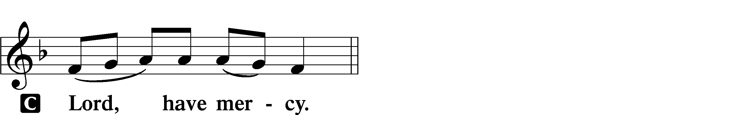

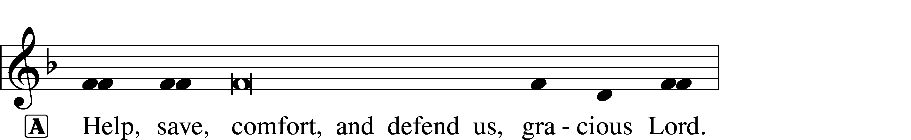


GLORIA IN EXCELSIS LSB 154
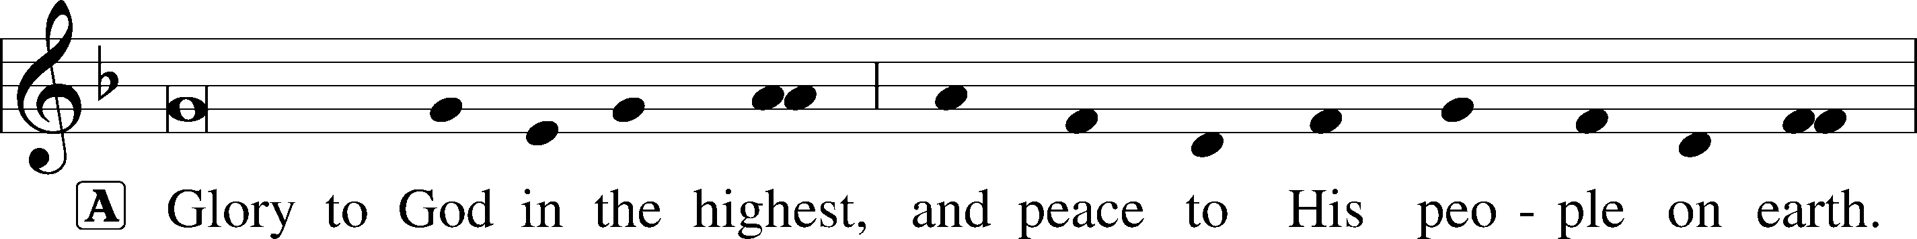
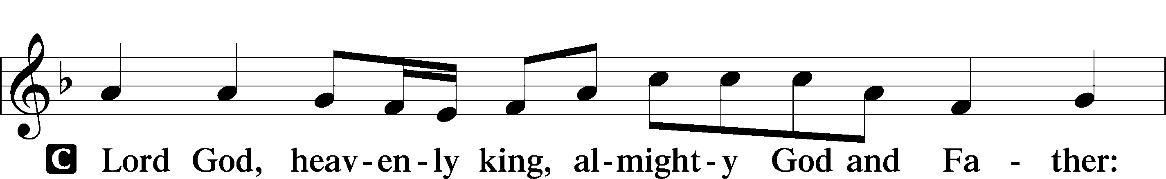
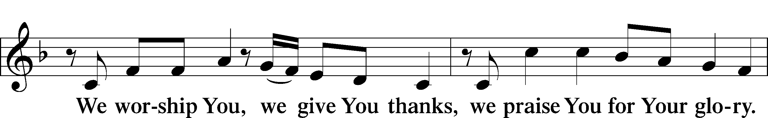
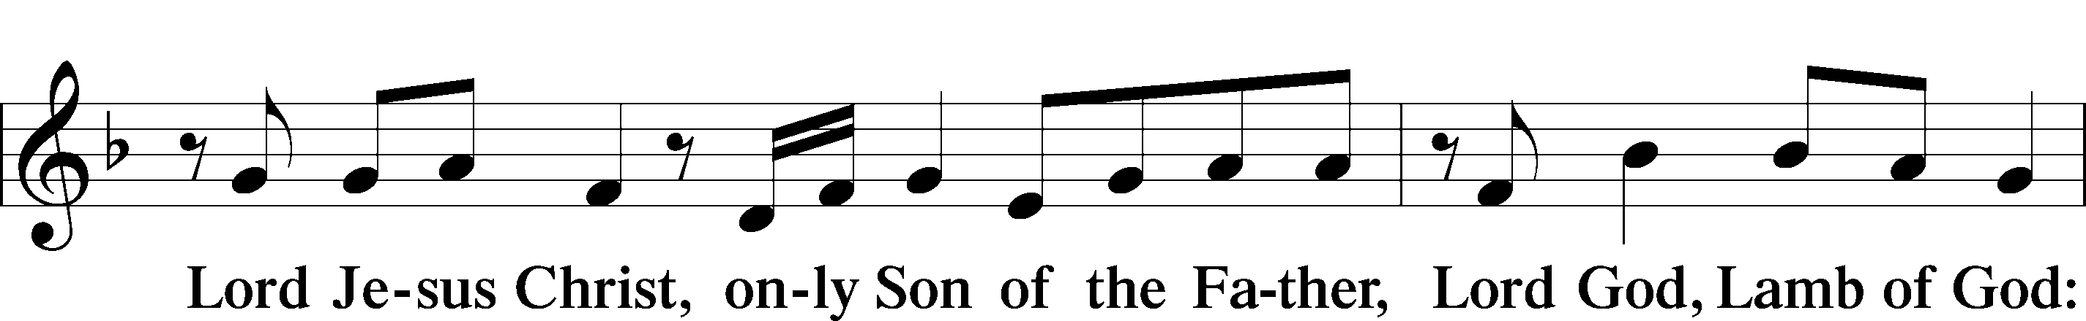
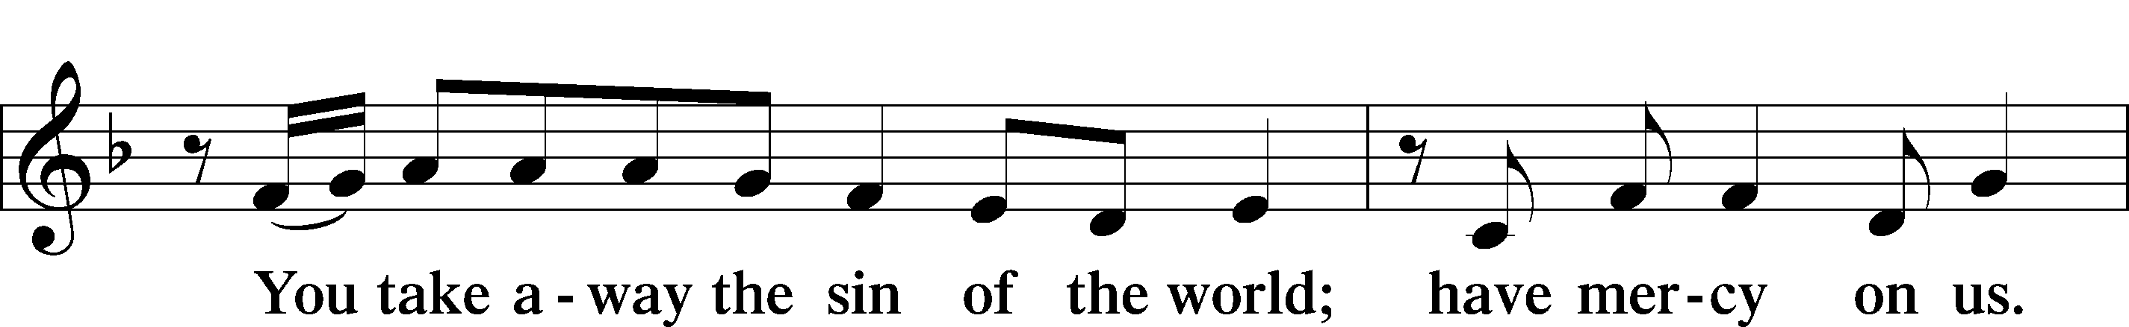
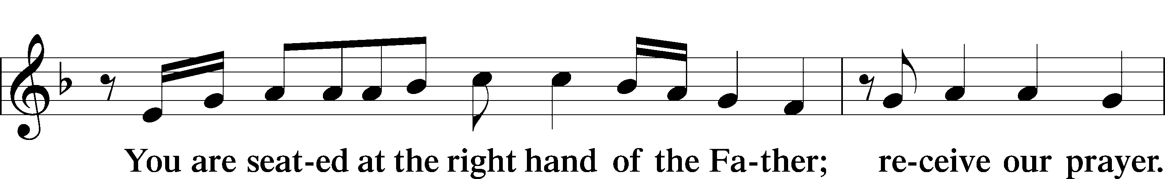
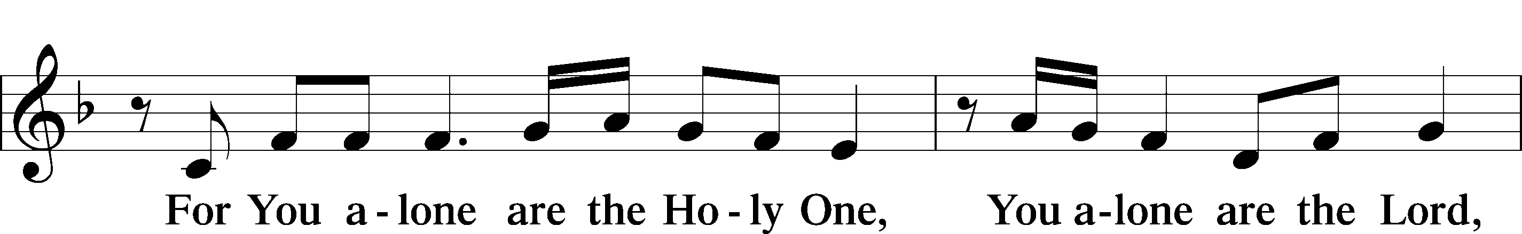
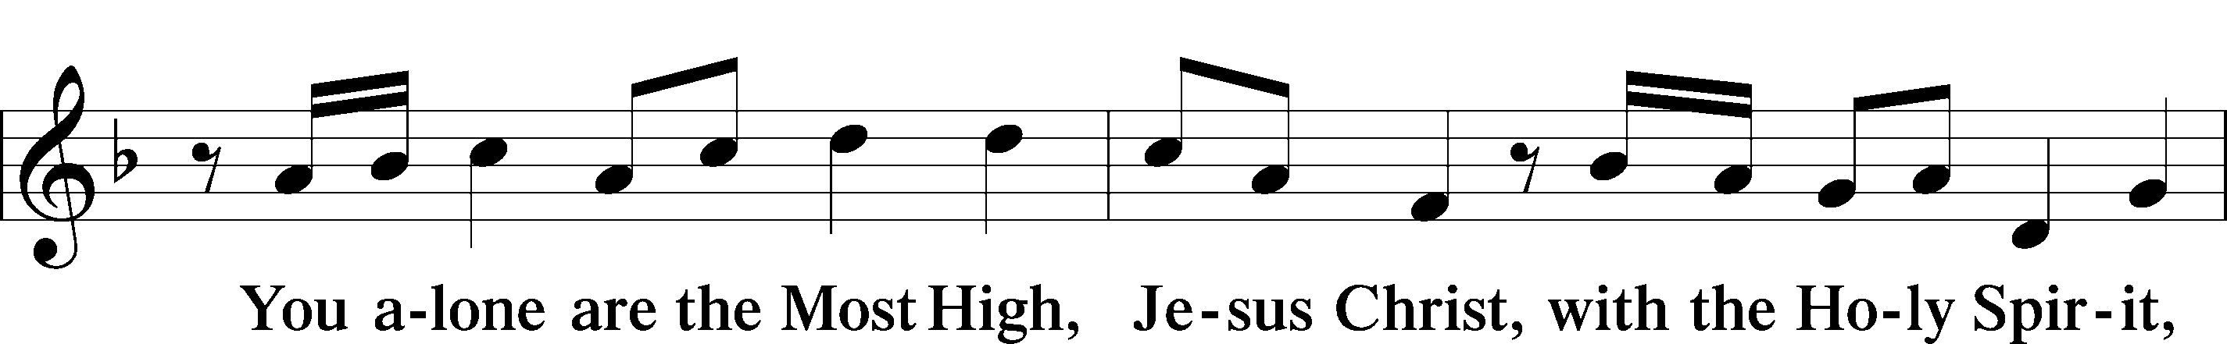
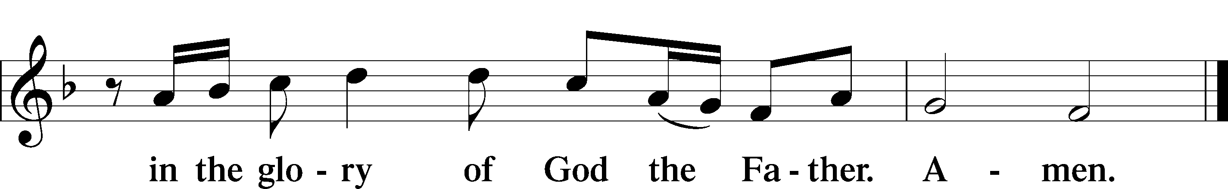

SALUTATION AND COLLECT OF THE DAY
L The Lord be with you.
C And also with you.

L Let us pray.
Almighty God, grant that the birth of Your only-begotten Son in the flesh may set us free from the bondage of sin; through Jesus Christ, Your Son, our Lord, who lives and reigns with You and the Holy Spirit, one God, now and forever.
C Amen.

(Sit)

CHILDREN’S LESSON

OLD TESTAMENT READING Isaiah 52:7–10
7How beautiful upon the mountains
are the feet of him who brings good news,
who publishes peace, who brings good news of happiness,
who publishes salvation,
who says to Zion, “Your God reigns.”
8The voice of your watchmen—they lift up their voice;
together they sing for joy;
for eye to eye they see
the return of the Lord to Zion.
9Break forth together into singing,
you waste places of Jerusalem,
for the Lord has comforted his people;
he has redeemed Jerusalem.
10The Lord has bared his holy arm
before the eyes of all the nations,
and all the ends of the earth shall see
the salvation of our God.

L This is the Word of the Lord.
C Thanks be to God.

GRADUAL Isaiah 9:6; Psalm 98:1a
To us a child is born, to us a son is | given;*
and the government shall be upon his | shoulder.
And his name shall be called Wonderful Counselor, | Mighty God,*
Everlasting Father, | Prince of Peace.
Sing to the Lord a | new song,*
for he has done | marvelous things!

361 O LITTLE TOWN OF BETHLEHEM
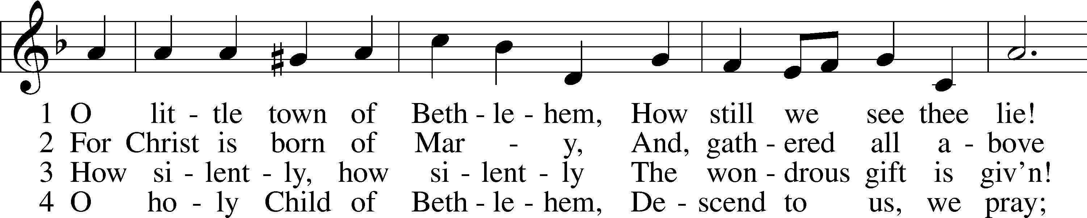
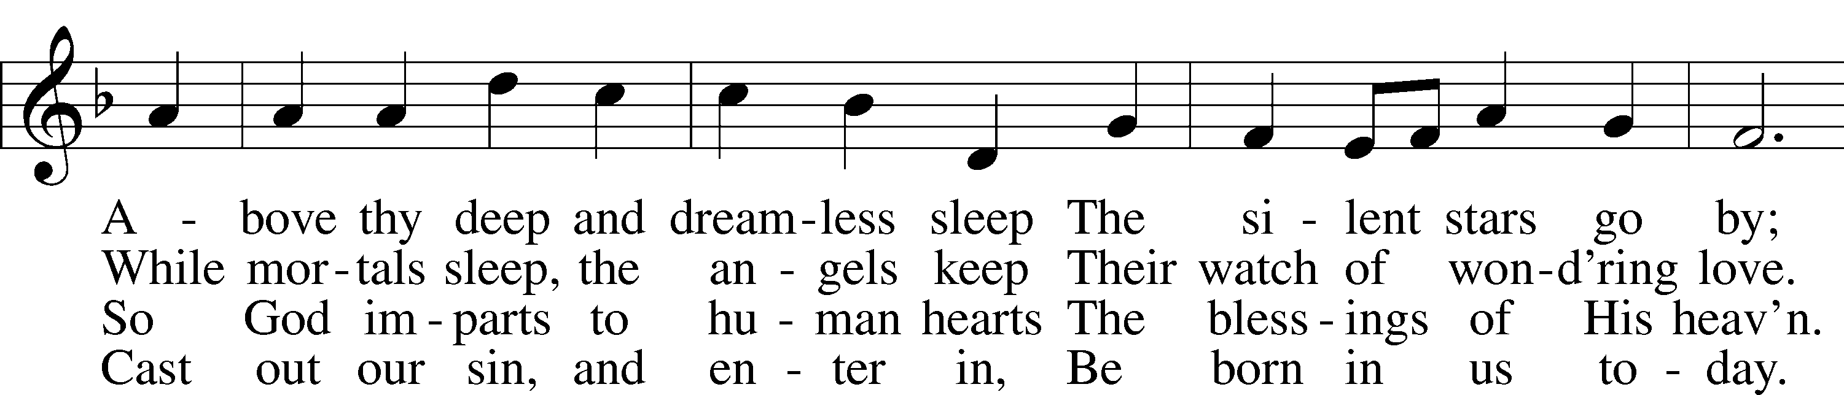
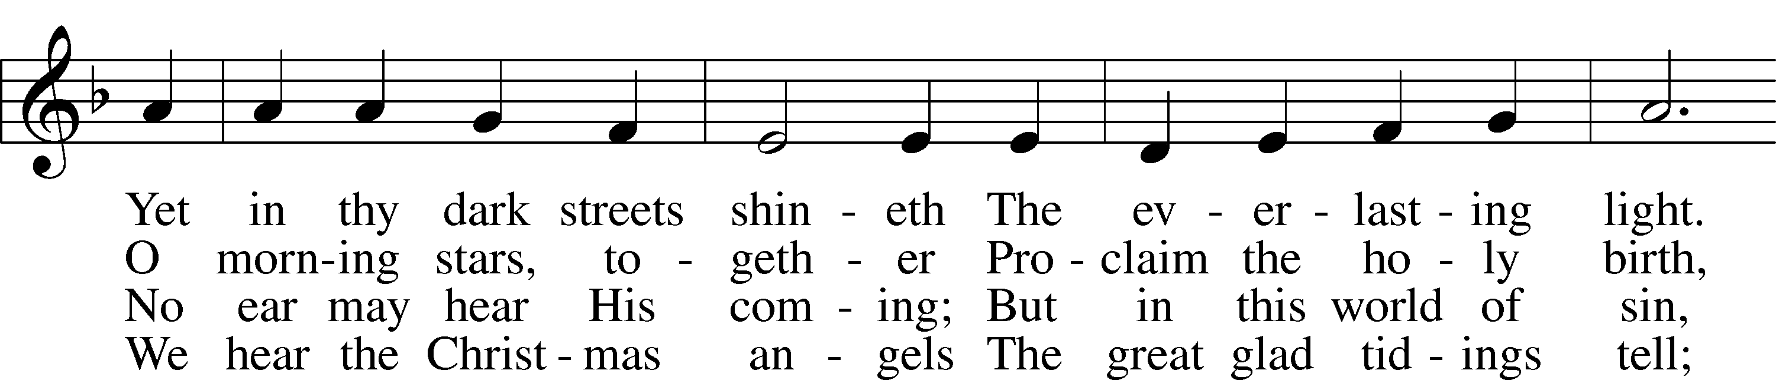
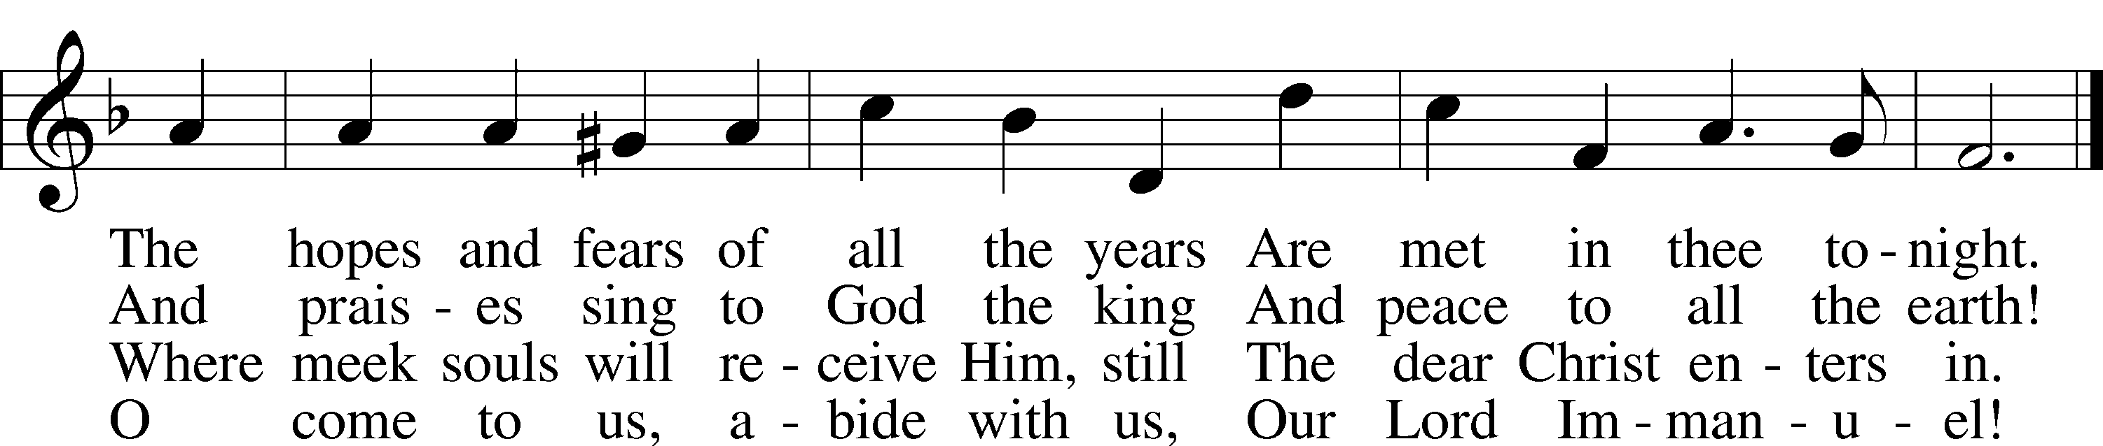
Text: Phillips Brooks, 1835–93
Tune: Lewis H. Redner, 1831–1908
Text and tune: Public domain

EPISTLE Hebrews 1:1–12
1Long ago, at many times and in many ways, God spoke to our fathers by the prophets, 2but in these last days he has spoken to us by his Son, whom he appointed the heir of all things, through whom also he created the world. 3He is the radiance of the glory of God and the exact imprint of his nature, and he upholds the universe by the word of his power. After making purification for sins, he sat down at the right hand of the Majesty on high, 4having become as much superior to angels as the name he has inherited is more excellent than theirs.
5For to which of the angels did God ever say,
“You are my Son,
today I have begotten you”?
Or again,
“I will be to him a father,
and he shall be to me a son”?
6And again, when he brings the firstborn into the world, he says,
“Let all God’s angels worship him.”
7Of the angels he says,
“He makes his angels winds,
and his ministers a flame of fire.”
8But of the Son he says,
“Your throne, O God, is forever and ever,
the scepter of uprightness is the scepter of your kingdom.
9You have loved righteousness and hated wickedness;
therefore God, your God, has anointed you
with the oil of gladness beyond your companions.”
10And,
“You, Lord, laid the foundation of the earth in the beginning,
and the heavens are the work of your hands;
11they will perish, but you remain;
they will all wear out like a garment,
12like a robe you will roll them up,
like a garment they will be changed.
But you are the same,
and your years will have no end.”

L This is the Word of the Lord.
C Thanks be to God.

(Stand)

ALLELUIA AND VERSE LSB 156
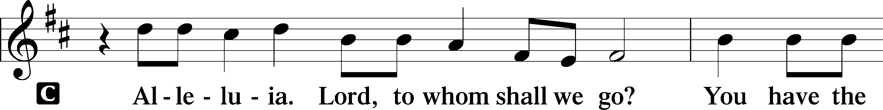
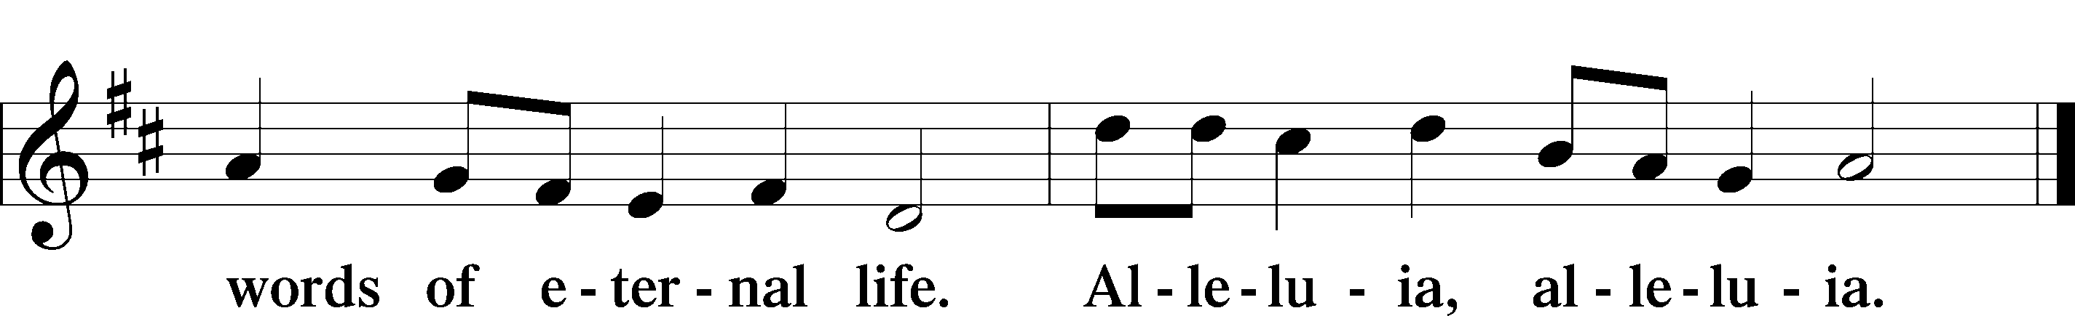

HOLY GOSPEL John 1:1–18
L The Holy Gospel according to St. John, the first chapter.
C Glory to You, O Lord.

1In the beginning was the Word, and the Word was with God, and the Word was God. 2He was in the beginning with God. 3All things were made through him, and without him was not any thing made that was made. 4In him was life, and the life was the light of men. 5The light shines in the darkness, and the darkness has not overcome it.
6There was a man sent from God, whose name was John. 7He came as a witness, to bear witness about the light, that all might believe through him. 8He was not the light, but came to bear witness about the light.
9The true light, which enlightens everyone, was coming into the world. 10He was in the world, and the world was made through him, yet the world did not know him. 11He came to his own, and his own people did not receive him. 12But to all who did receive him, who believed in his name, he gave the right to become children of God, 13who were born, not of blood nor of the will of the flesh nor of the will of man, but of God.
14And the Word became flesh and dwelt among us, and we have seen his glory, glory as of the only Son from the Father, full of grace and truth. 15(John bore witness about him, and cried out, “This was he of whom I said, ‘He who comes after me ranks before me, because he was before me.’”) 16And from his fullness we have all received, grace upon grace. 17For the law was given through Moses; grace and truth came through Jesus Christ. 18No one has ever seen God; the only God, who is at the Father’s side, he has made him known.

L This is the Gospel of the Lord.
C Praise to You, O Christ.

(Sit)

364 AWAY IN A MANGER
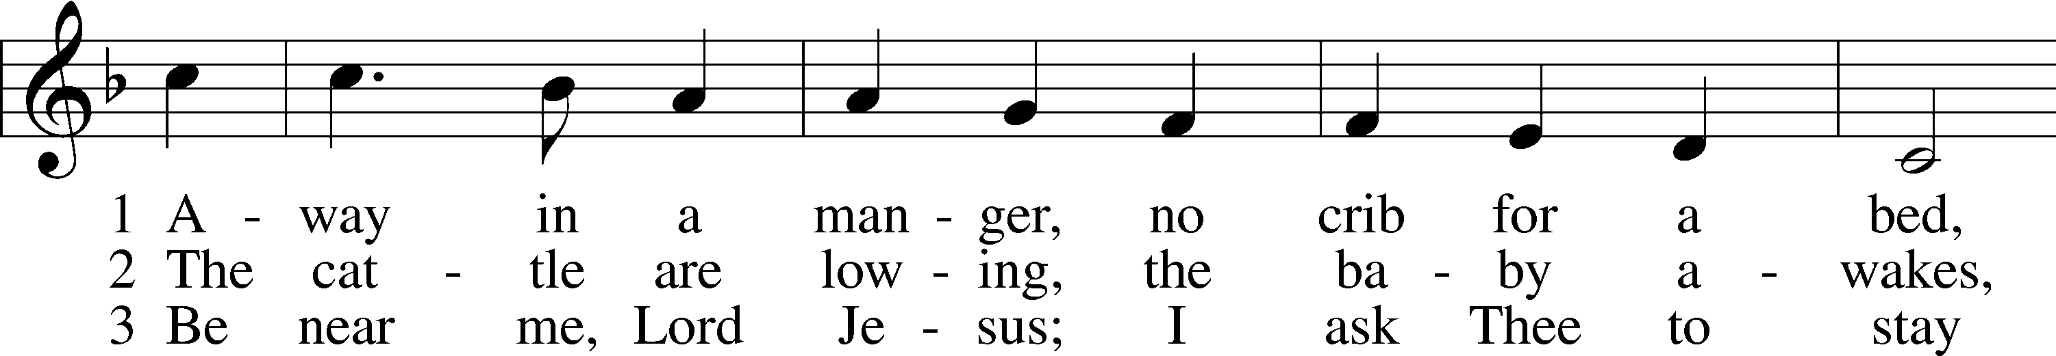
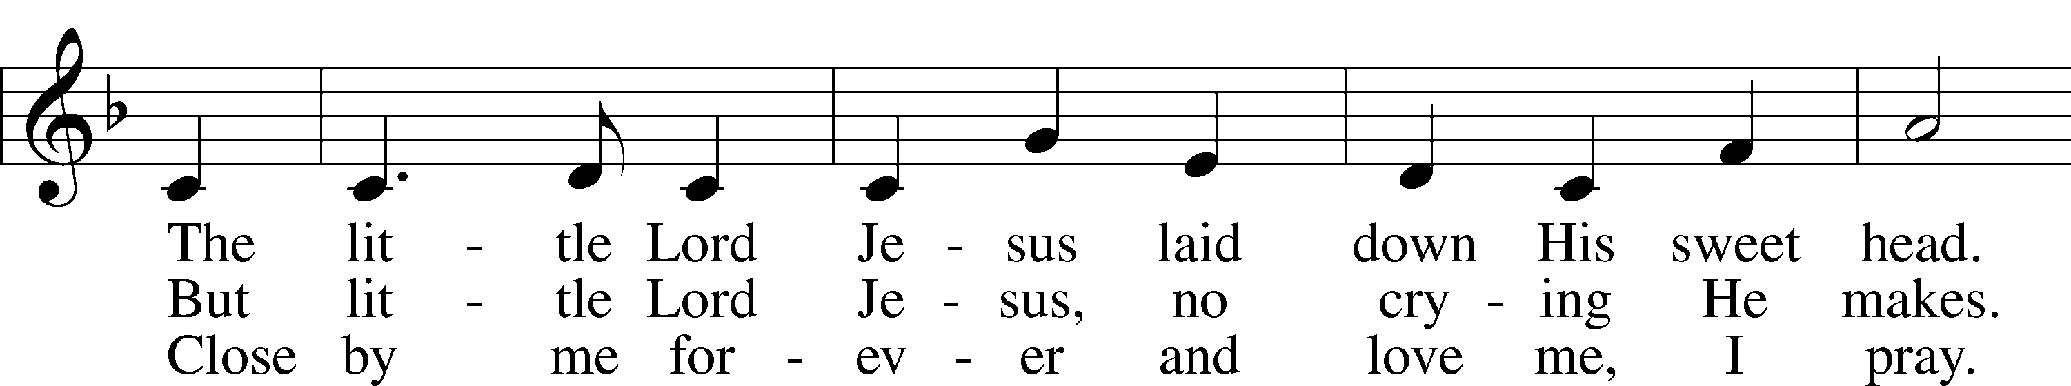
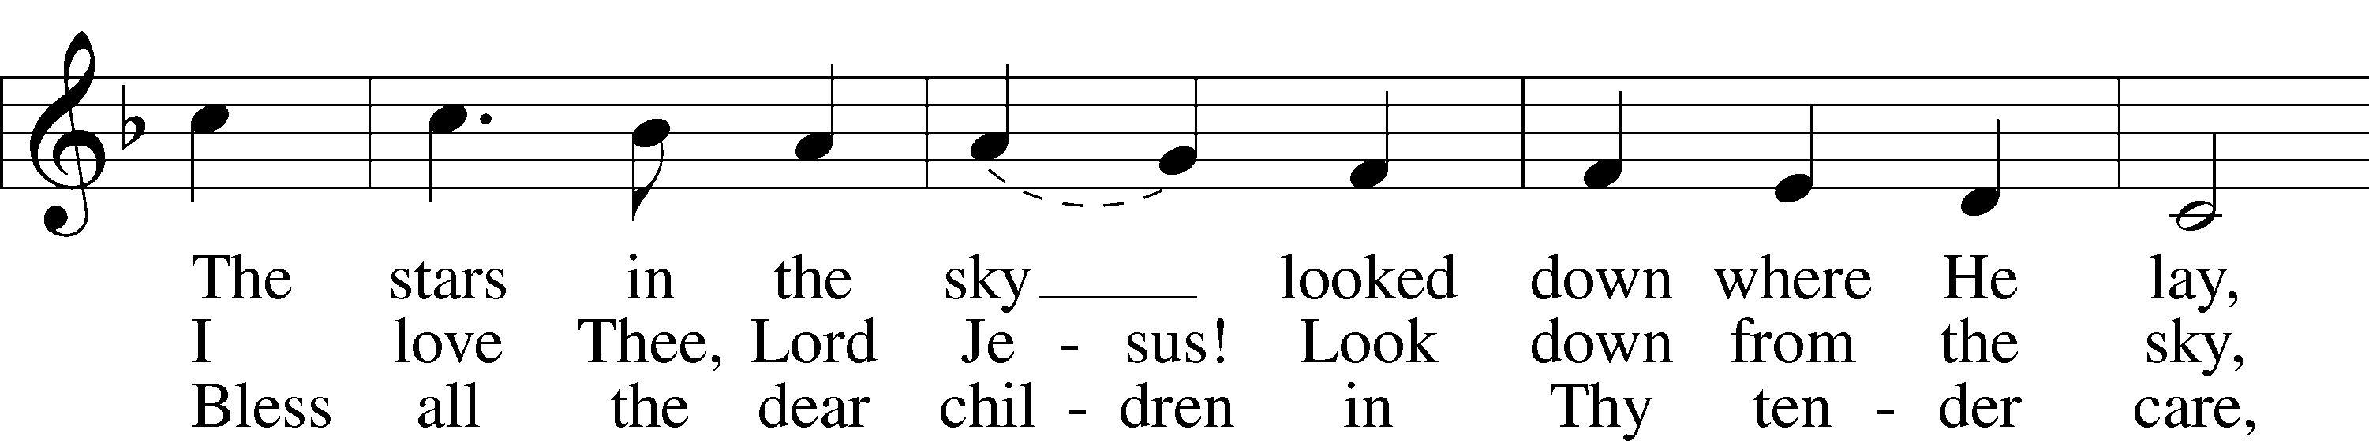
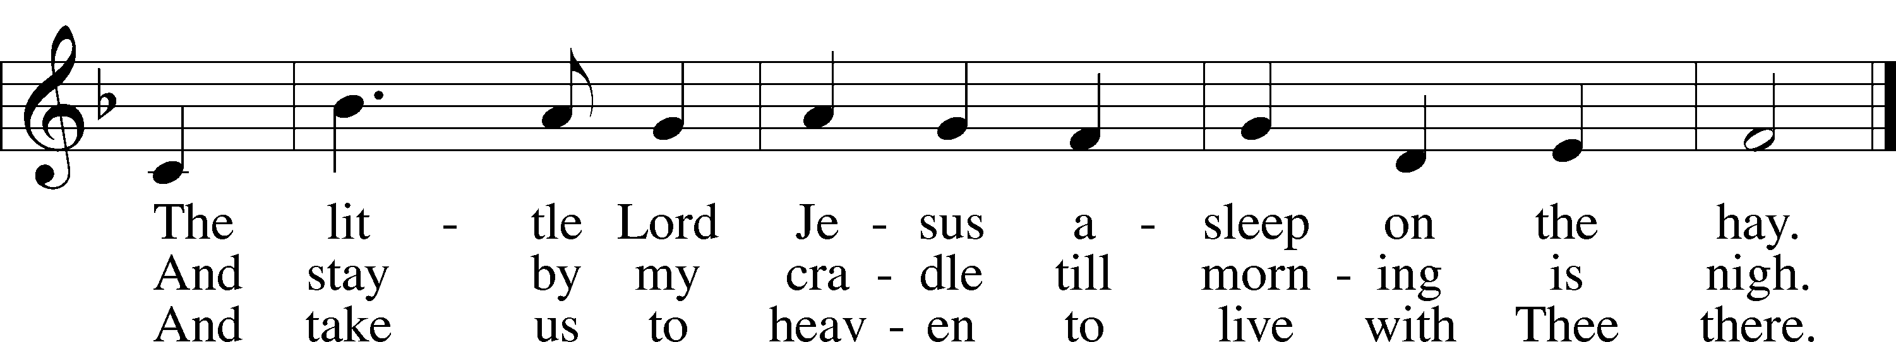
Text (sts. 1–2): Little Children’s Book, 1885, Philadelphia; (st. 3): Vineyard Songs, 1892, Louisville, alt.
Tune: James R. Murray, 1841–1905
Text and tune: Public domain

SERMON OR MEDITATION ON THE READINGS

403 O SAVIOR OF OUR FALLEN RACE
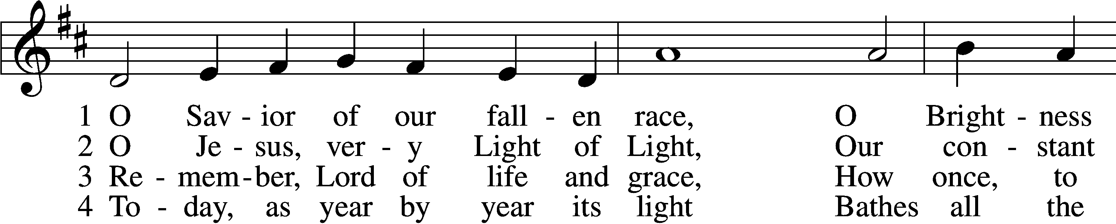
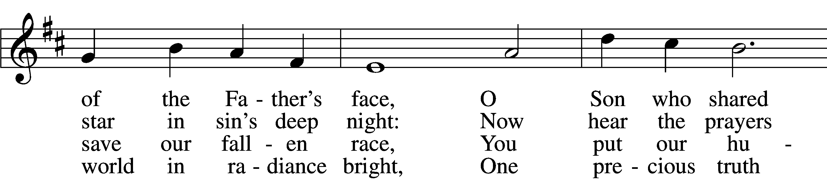
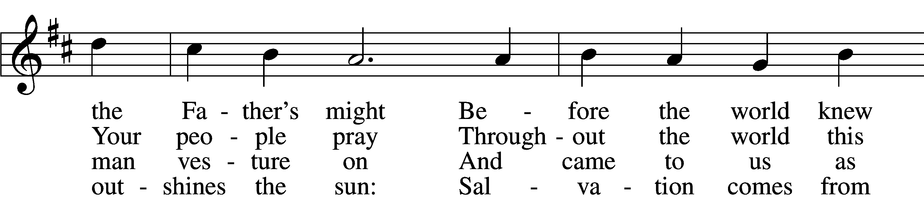
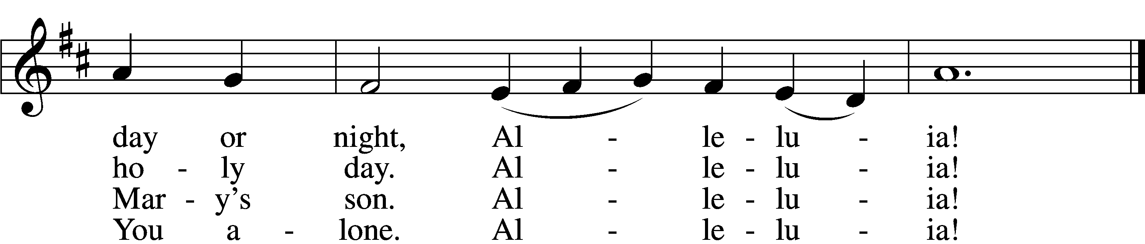

5 For from the Father’s throne You came,
His banished children to reclaim;
And earth and sea and sky revere
The love of Him who sent You here.
Alleluia!

6 And we are jubilant today,
For You have washed our guilt away.
O hear the glad new song we sing
On this, the birthday of our King!
Alleluia!

D 7 O Christ, Redeemer virgin-born,
Let songs of praise Your name adorn,
Whom with the Father we adore
And Holy Spirit evermore.
Alleluia!
Text: Latin, c. 5th–10th cent.; tr. Gilbert E. Doan, 1930–2024
Tune: Stephen R. Johnson, 1966
Text: © 1978 Lutheran Book of Worship. Used by permission: LSB Hymn License no. 110004798
Tune: © 2002 Stephen R. Johnson. Used by permission: LSB Hymn License no. 110004798

(Stand)

NICENE CREED
C I believe in one God,
the Father Almighty,
maker of heaven and earth
and of all things visible and invisible.

And in one Lord Jesus Christ,
the only-begotten Son of God,
begotten of His Father before all worlds,
God of God, Light of Light,
very God of very God,
begotten, not made,
being of one substance with the Father,
by whom all things were made;
who for us men and for our salvation came down from heaven
and was incarnate by the Holy Spirit of the virgin Mary
and was made man;
and was crucified also for us under Pontius Pilate.
He suffered and was buried.
And the third day He rose again according to the Scriptures
and ascended into heaven
and sits at the right hand of the Father.
And He will come again with glory to judge both the living and the dead,
whose kingdom will have no end.

And I believe in the Holy Spirit,
the Lord and giver of life,
who proceeds from the Father and the Son,
who with the Father and the Son together is worshiped and glorified,
who spoke by the prophets.
And I believe in one holy Christian and apostolic Church,
I acknowledge one Baptism for the remission of sins,
and I look for the resurrection of the dead
and the life T of the world to come. Amen.

SHARING OF THE PEACE

(Sit)

PRAYER OF THE CHURCH

OFFERING
As a part of our expression of thanksgiving to God for the treasure of His salvation to us, we offer a portion of our treasure, according to what each has determined in their heart to give. Please place offerings in the collection plate at the back of the sanctuary before or after the service. Offerings can also be sent to Bethlehem Lutheran Church via U.S. Mail. Thank you!

(Stand)

OFFERTORY LSB 159
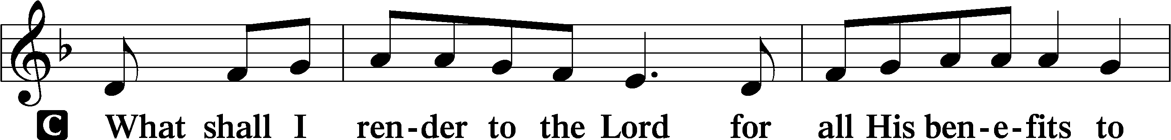
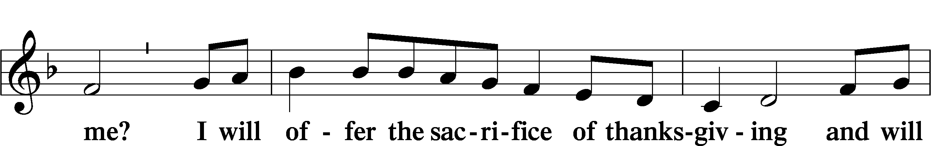
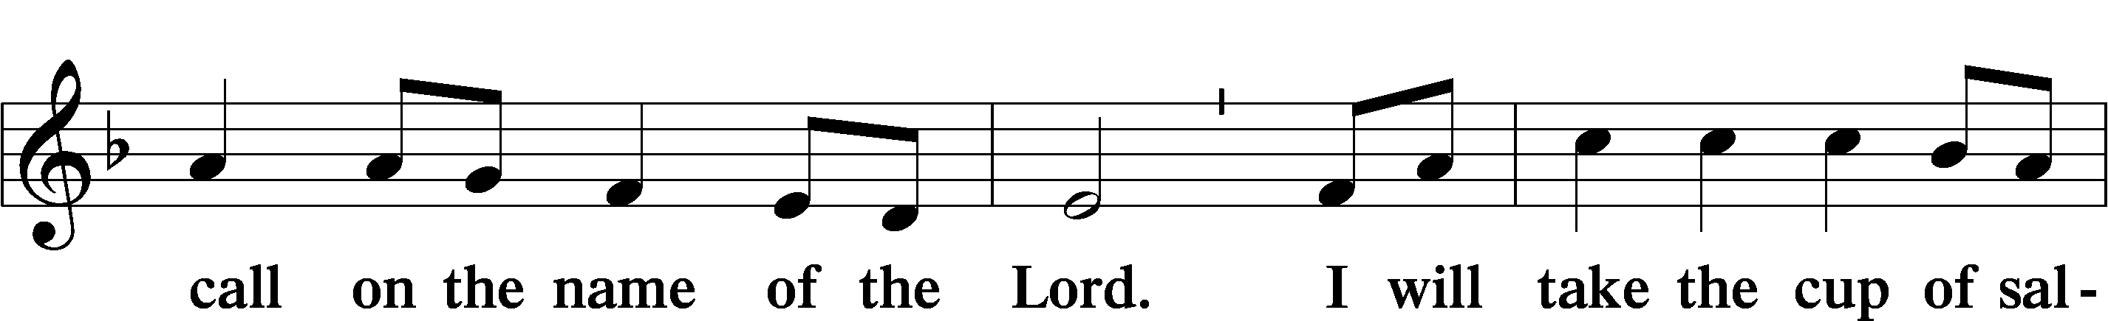
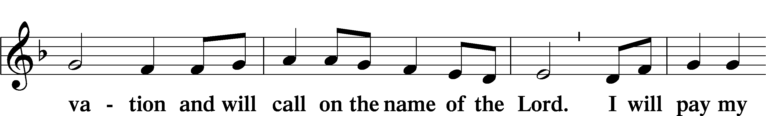
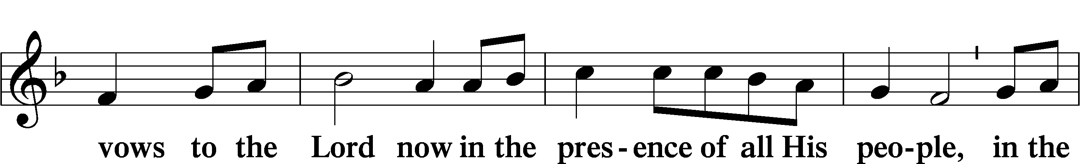
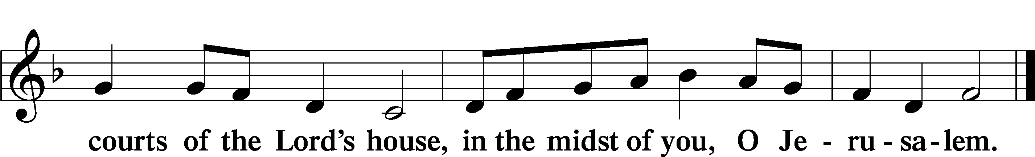

+ SERVICE OF THE SACRAMENT +
Note: The Service of The Sacrament is included in the lay bulletin solely as a viewers’ guide for those watching the livestream service; Communicant members who are unable to attend the Divine Service in person are encouraged to make arrangements with Pastor Engwall to receive the Lord’s Supper.

PREFACE LSB 160
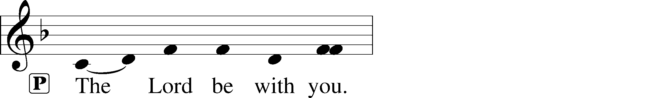
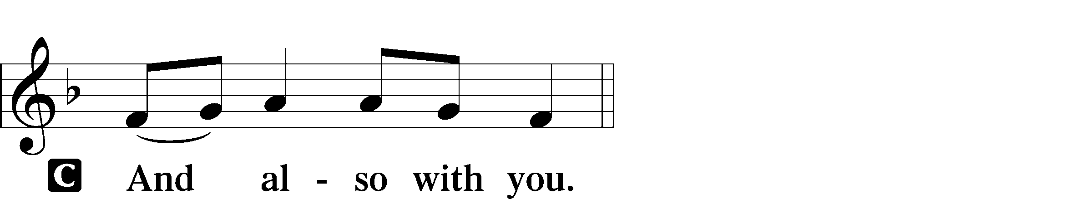
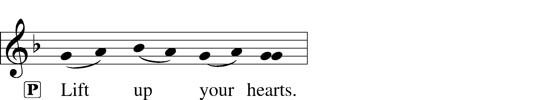

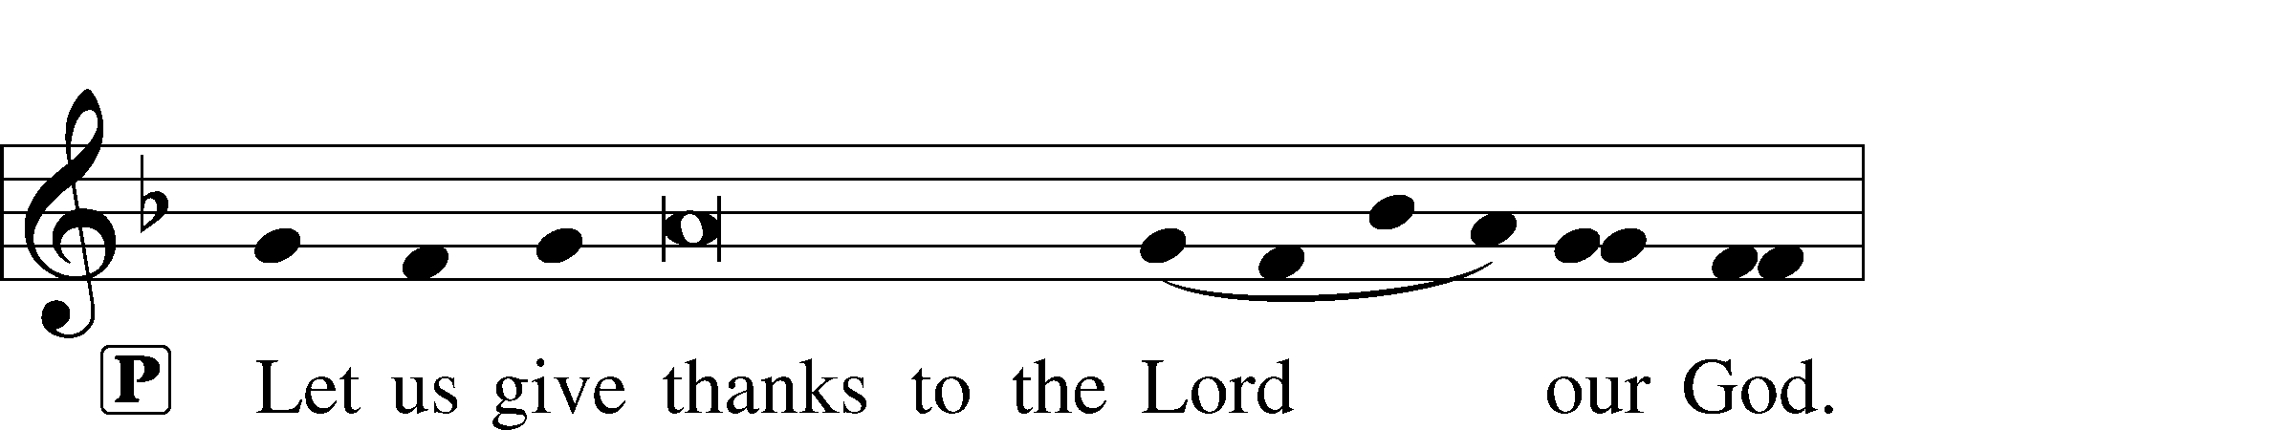
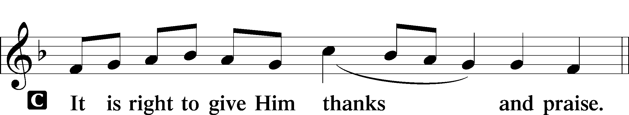

PROPER PREFACE (ABBREVIATED) LSB 161
P It is truly good, right, and salutary . . . evermore praising You and saying:

SANCTUS LSB 161
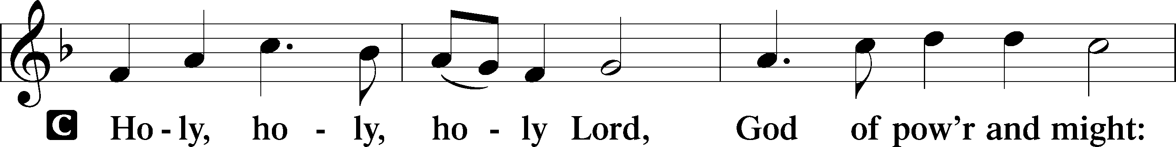
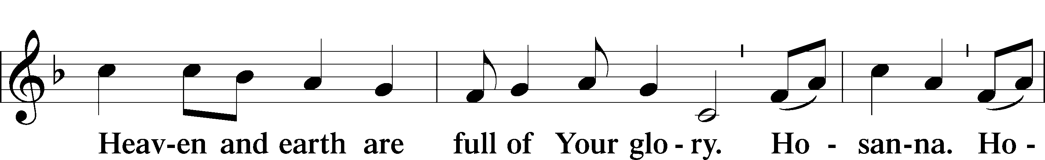
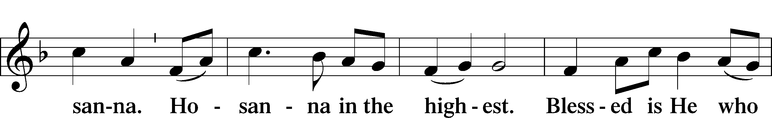
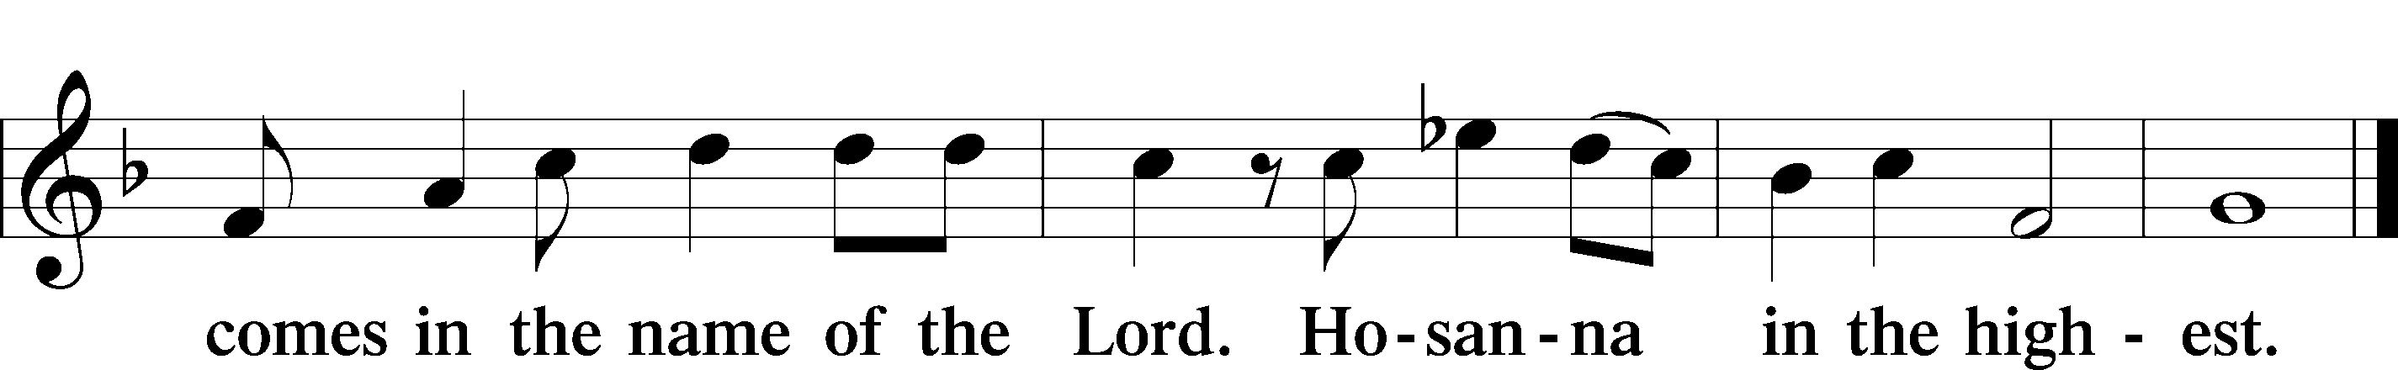

PRAYER OF THANKSGIVING LSB 161

LORD’S PRAYER LSB 162
P Lord, remember us in Your kingdom and teach us to pray:
C Our Father who art in heaven,
hallowed be Thy name,
Thy kingdom come,
Thy will be done on earth
as it is in heaven;
give us this day our daily bread;
and forgive us our trespasses
as we forgive those
who trespass against us;
and lead us not into temptation,
but deliver us from evil.
For Thine is the kingdom
and the power and the glory
forever and ever. Amen.

THE WORDS OF OUR LORD

PAX DOMINI LSB 163
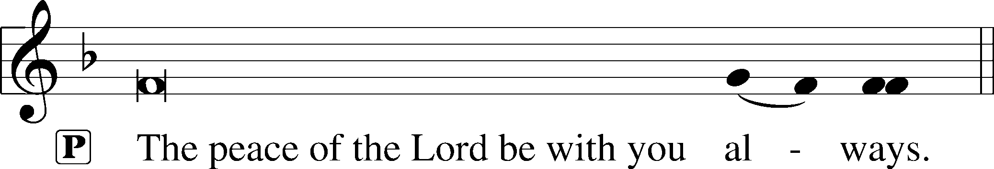


AGNUS DEI LSB 163
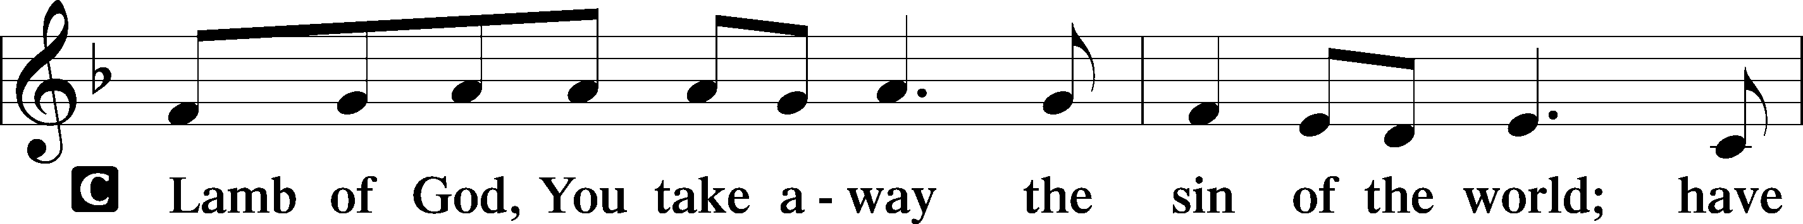
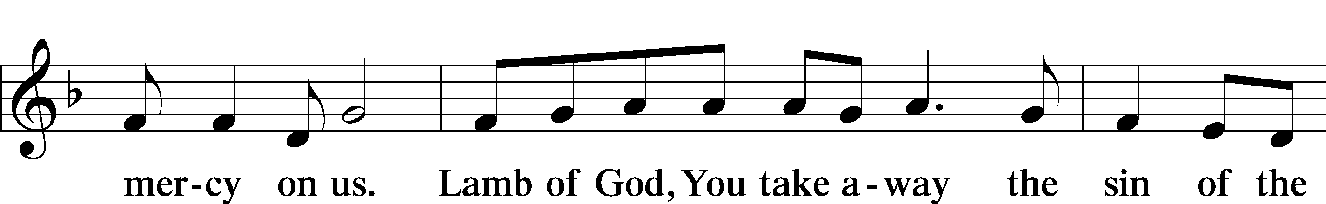
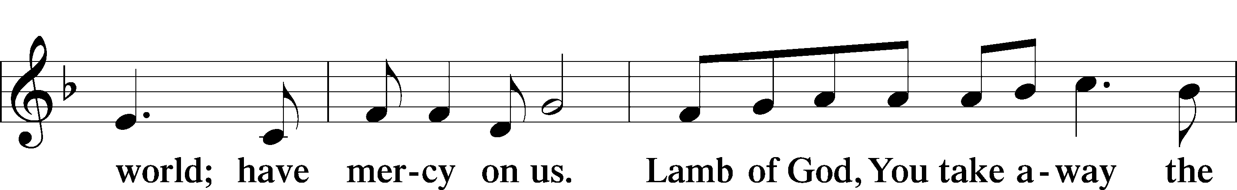
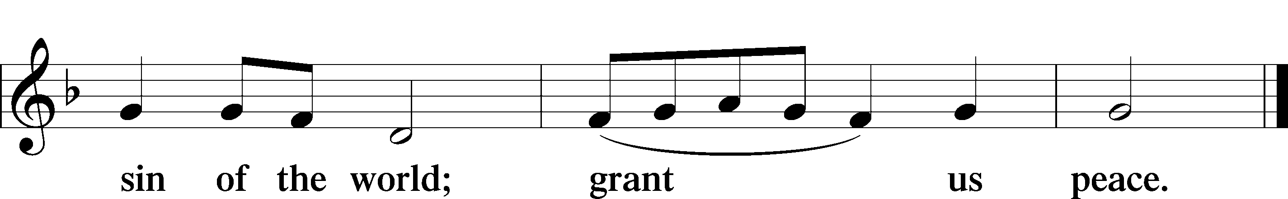

(Sit)

DISTRIBUTION
(The pastor and those who assist him receive the body and blood of Christ first and then distribute them to those who are unable to come to the altar. The ushers will then direct all other communicants to the altar.)

370 WHAT CHILD IS THIS
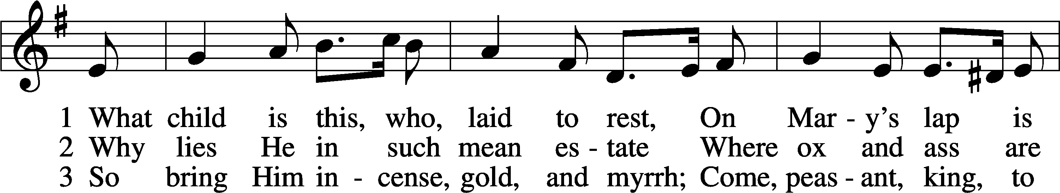
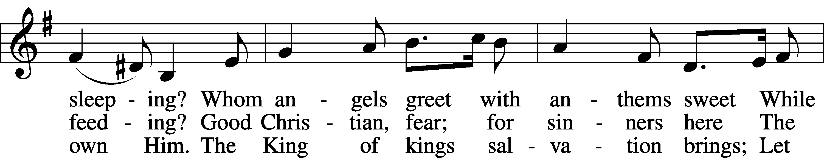
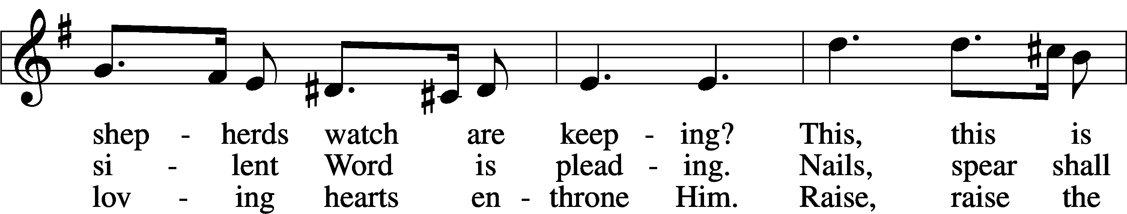
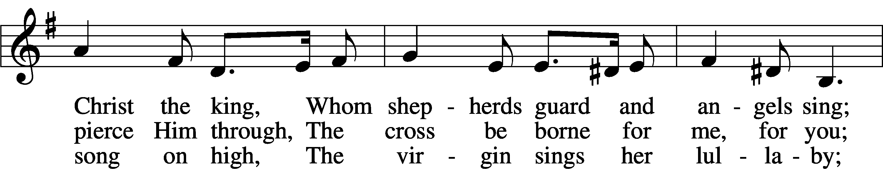
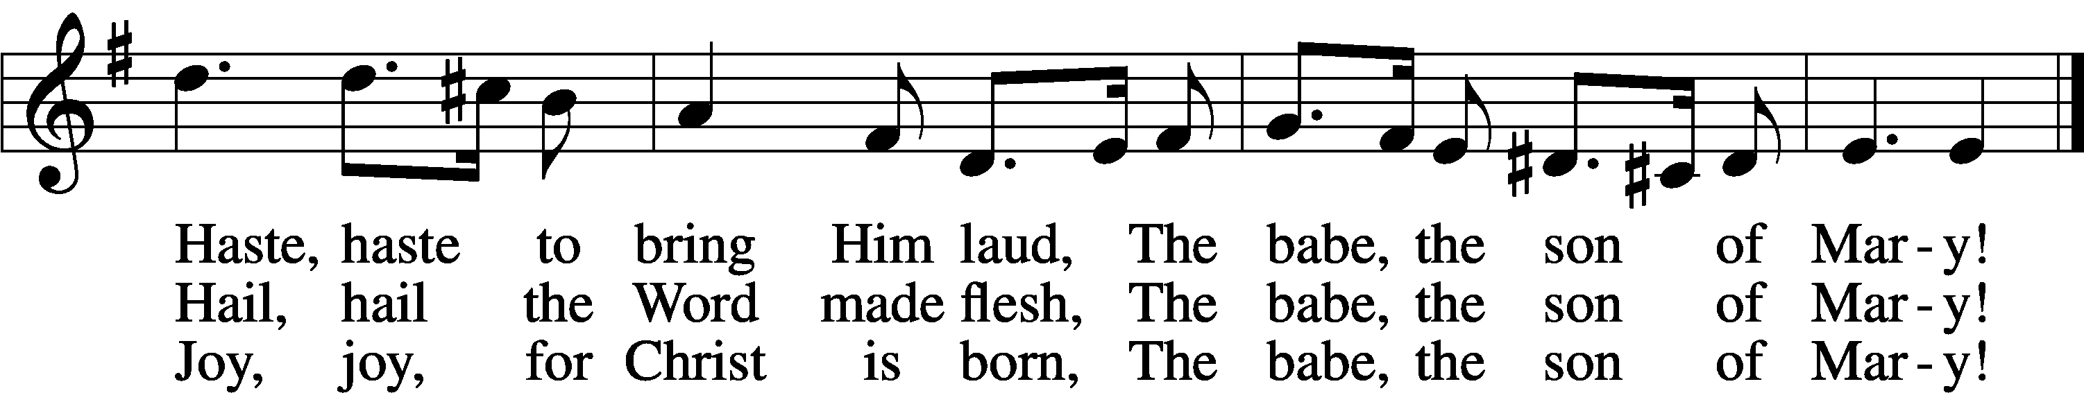
Text: William C. Dix, 1837–98
Tune: English, 16th cent.
Text and tune: Public domain

379 O COME, ALL YE FAITHFUL sts. 1, ref, 2–4
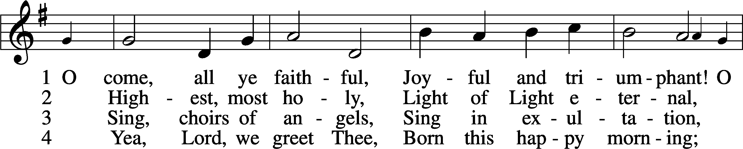
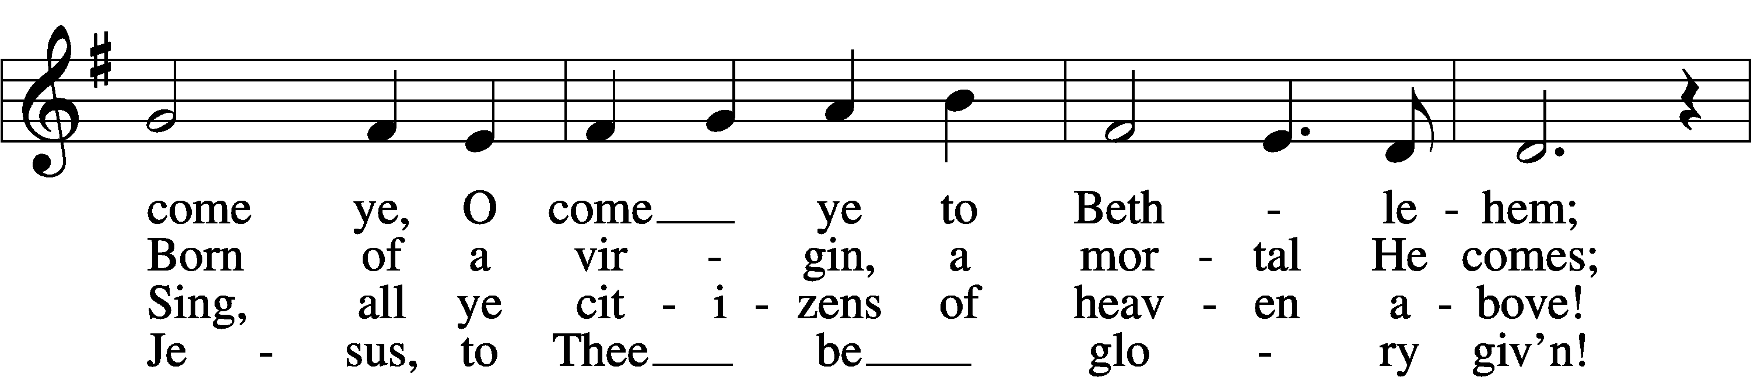
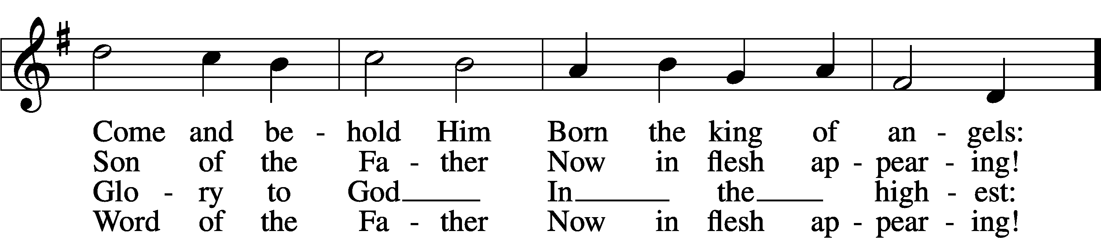
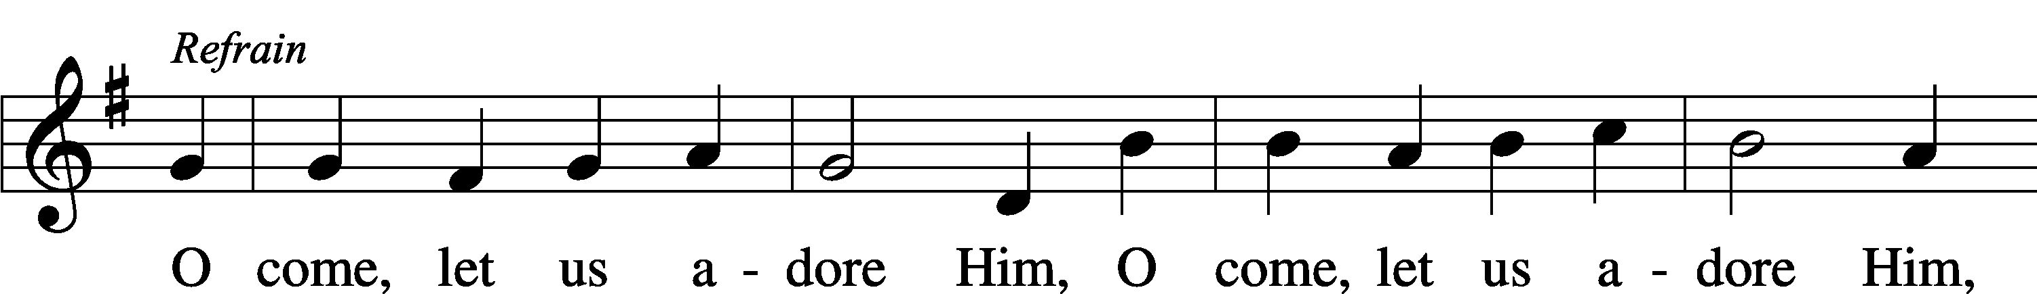
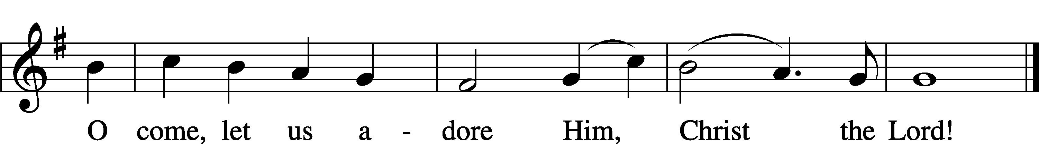
Text: tr. Frederick Oakeley, 1802–80, alt.
Text and tune: John F. Wade, c. 1711–1786
Text and tune: Public domain

INSTRUMENTAL

(Stand)

NUNC DIMITTIS LSB 165
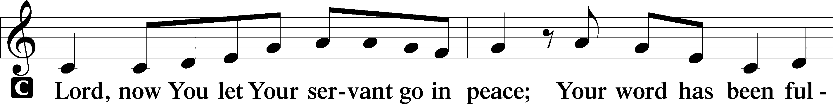
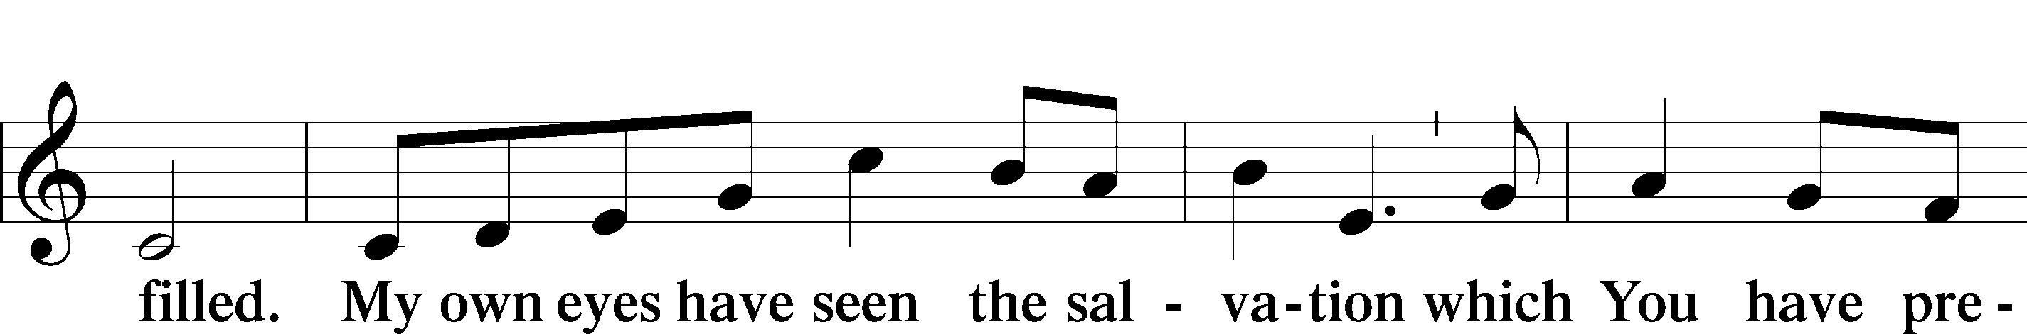
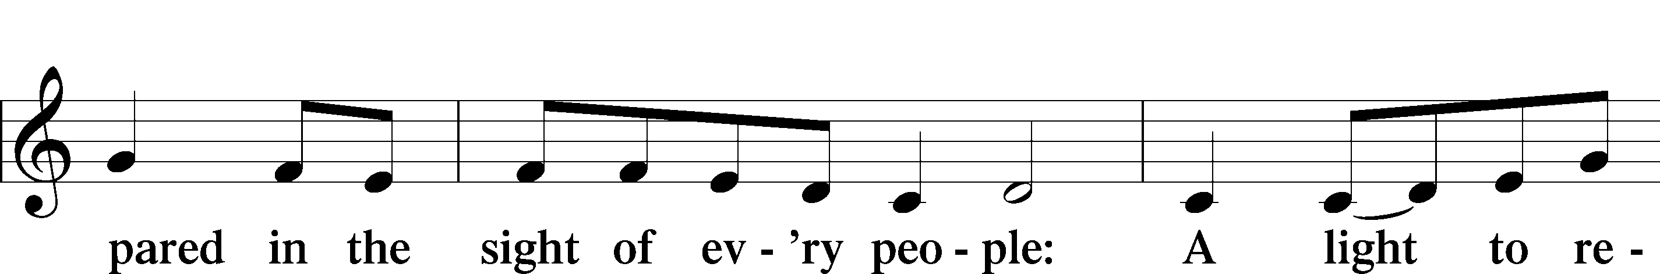
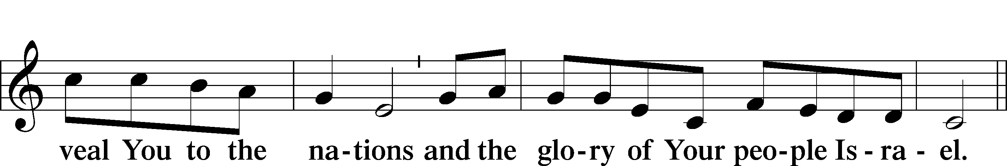
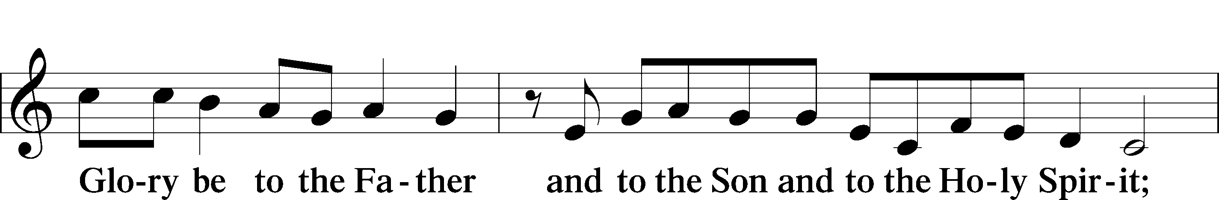
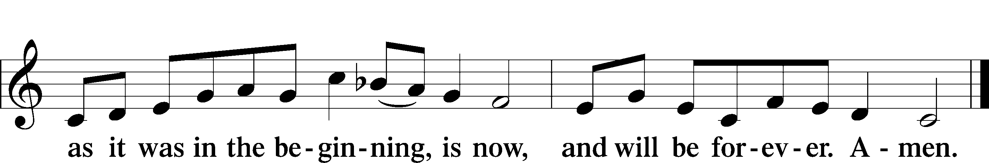

POST-COMMUNION COLLECT
A Let us pray.
We give thanks to You, almighty God, that You have refreshed us through this salutary gift, and we implore You that of Your mercy You would strengthen us through the same in faith toward You and in fervent love toward one another; through Jesus Christ, Your Son, our Lord, who lives and reigns with You and the Holy Spirit, one God, now and forever.
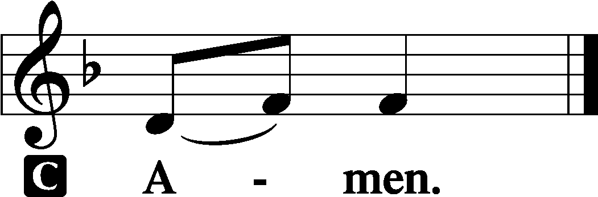

BENEDICTION
L: The grace of our Lord T Jesus Christ, and the love of God, and the fellowship of the Holy Spirit, be with us all.
C: Amen.

368 ANGELS WE HAVE HEARD ON HIGH
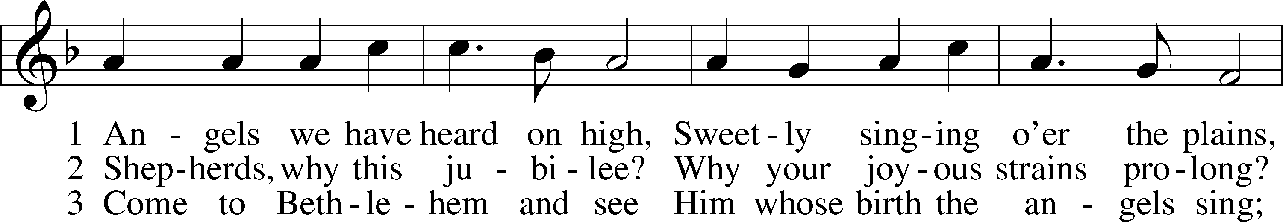
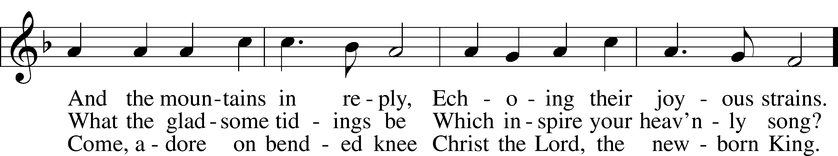
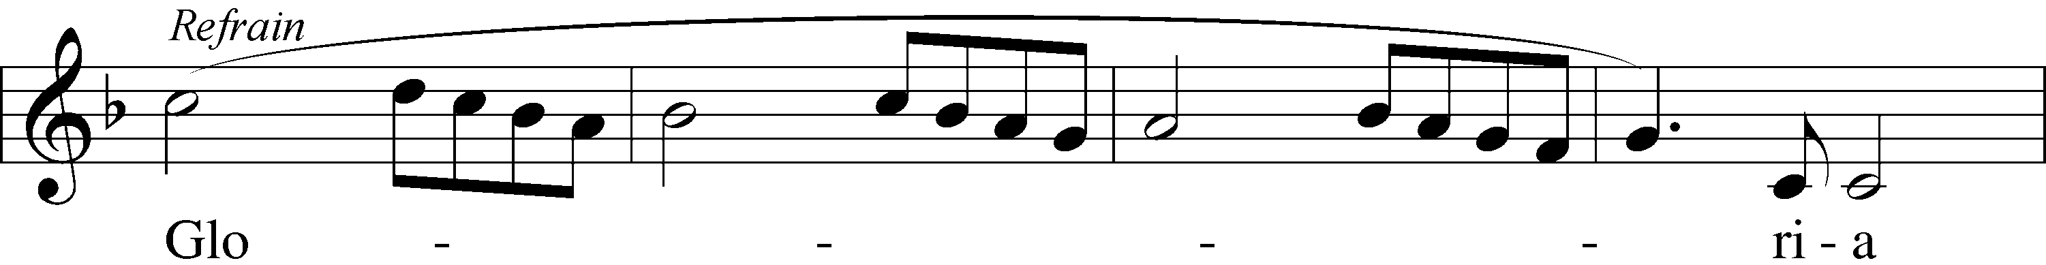
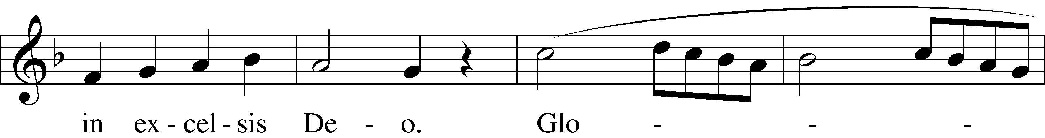
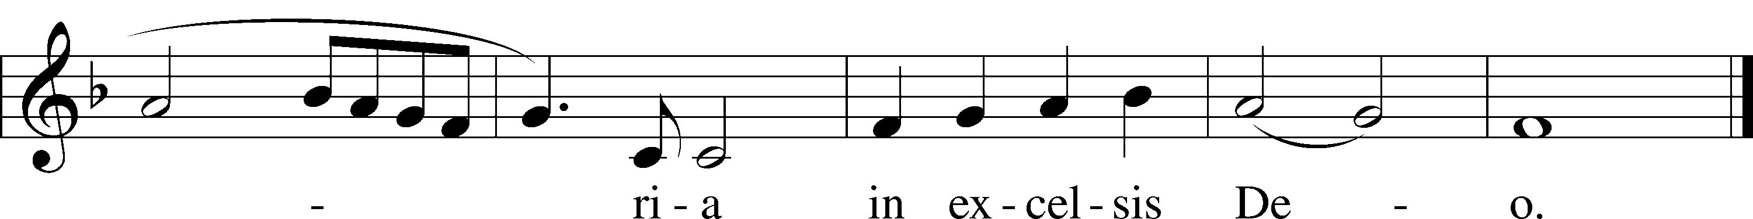
Text: tr. The Crown of Jesus, 1862, Part 2, London, alt.
Text and tune: French
Text and tune: Public domain

ACKNOWLEDGMENTS
Unless otherwise indicated, Scripture quotations are from the ESV® Bible (The Holy Bible, English Standard Version®), copyright © 2001 by Crossway, a publishing ministry of Good News Publishers. Used by permission. All rights reserved.
Created by Lutheran Service Builder © 2025 Concordia Publishing House.

