BETHLEHEM LUTHERAN CHURCH
A congregation of The Lutheran Church-Missouri Synod
902 Hitchcock Drive SW,
Aiken, South Carolina 29803
Church Phone: (803) 649-6417
blcaikensc@gmail.com
Pastor: Rev. John B. Engwall
Office Hours By Appointment
Note: The format of this bulletin has been modified for use in private devotion services.
Unable to join us in person? Please find us on Facebook live.
The service is also posted on our website; bethlehemlutheranaiken.org

+ + + + + + + + + + + + + + +
The Fourth Sunday in Lent
March 15, 2026
10:30 a.m.
+ + + + + + + + + + + + + + +

Our Policy and Practice Regarding Holy Communion
Hear the words of the Apostle Paul;
Anyone who eats and drinks without recognizing the body of the Lord eats and drinks judgment on himself. -1 Cor.11:29
Therefore, visitors are asked to please refrain from partaking of the Sacrament before speaking about this with the pastor; because we care about your spiritual well-being.
Also, because communing at this altar is a public confession that you agree with the doctrines of The Lutheran Church-Missouri Synod, and reject all contrary teachings.
Persons who are not communing today are always welcome to come forward during the distribution to receive an individual blessing; please cross your arms over your chest to indicate your desire for this. Thank you!
We commune in two alternating tables. The ushers will guide you. Non-alcoholic white wine is available in the center of the individual cup tray. Please leave empty individual cups at the altar rail.

+ SERVICE OF PREPARATION +
After the bell tolls, please observe a time of silence.

WELCOME AND ANNOUNCEMENTS
(Stand)

545 WORD OF GOD, COME DOWN ON EARTH
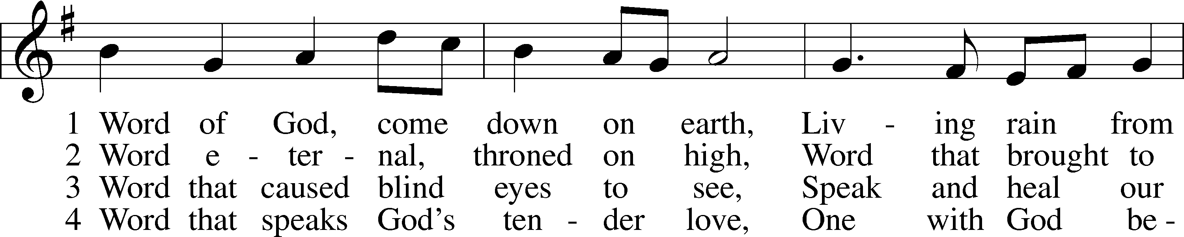
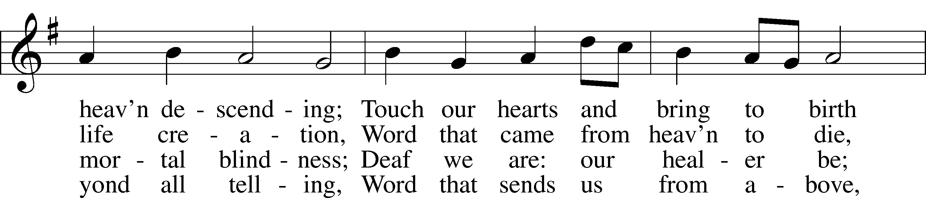
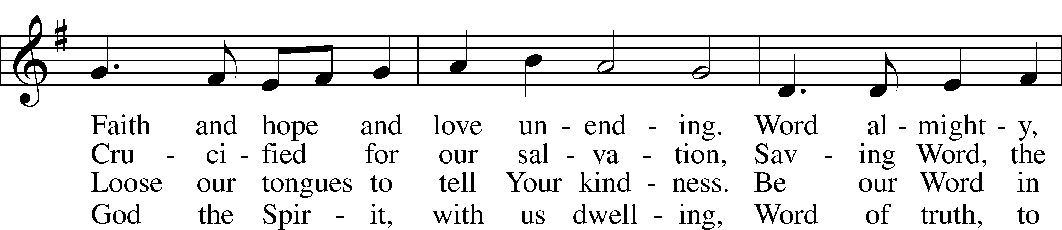
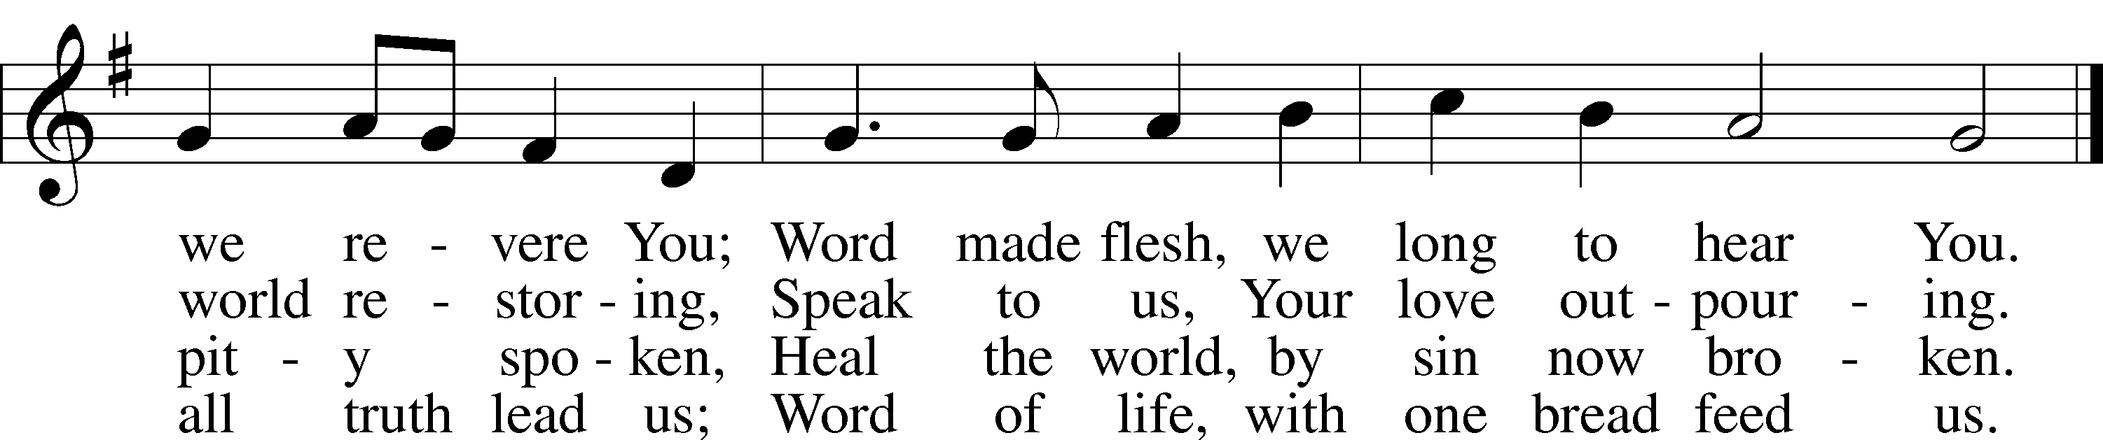
Text: James Quinn, 1919–2010
Tune: Johann Rudolph Ahle, 1625–73, alt.
Text: © 1969 OCP Publications. Used by permission: LSB Hymn License no. 110004798
Tune: Public domain

+ CONFESSION AND ABSOLUTION +

(The sign of the cross may be made by all in remembrance of their Baptism.)

INVOCATION
L In the name of the Father and of the T Son and of the Holy Spirit.
C Amen.

EXHORTATION LSB 184
L Beloved in the Lord! Let us draw near with a true heart and confess our sins unto God our Father, beseeching Him in the name of our Lord Jesus Christ to grant us forgiveness.

L Our help is in the name of the Lord,
C who made heaven and earth.
L I said, I will confess my transgressions unto the Lord,
C and You forgave the iniquity of my sin.

(Silence for reflection on God’s Word and for self-examination.)

CONFESSION OF SINS LSB 184
L O almighty God, merciful Father,
C I, a poor, miserable sinner, confess unto You all my sins and iniquities with which I have ever offended You and justly deserved Your temporal and eternal punishment. But I am heartily sorry for them and sincerely repent of them, and I pray You of Your boundless mercy and for the sake of the holy, innocent, bitter sufferings and death of Your beloved Son, Jesus Christ, to be gracious and merciful to me, a poor, sinful being.

DECLARATION OF GRACE
L In the mercy of almighty God, Jesus Christ was given to die for us, and for His sake God forgives us all our sins. To those who believe in Jesus Christ He gives the power to become the children of God and bestows on them the Holy Spirit. May the Lord, who has begun this good work in us, bring it to completion in the day of our Lord Jesus Christ.
C Amen.

+ SERVICE OF THE WORD +

INTROIT Psalm 27:4–6; antiphon: Psalm 25:15
My eyes are ever | toward the Lord,*
for he will pluck my feet out | of the net.
One thing have I asked of the Lord, that will I seek | after:*
that I may dwell in the house of the Lord all the days of my life, to gaze upon the beauty of the Lord and to inquire in his | temple.
For he will hide me in his shelter in the day of | trouble;*
he will conceal me under the cover of his tent; he will lift me high up- | on a rock.
And now my head shall be lifted up above my enemies all around me, and I will offer in his tent sacrifices with | shouts of joy;*
I will sing and make melody | to the Lord.
Glory be to the Father and | to the Son*
and to the Holy | Spirit;
as it was in the be- | ginning,*
is now, and will be forever. | Amen.
My eyes are ever | toward the Lord,*
for he will pluck my feet out | of the net.

KYRIE LSB 186
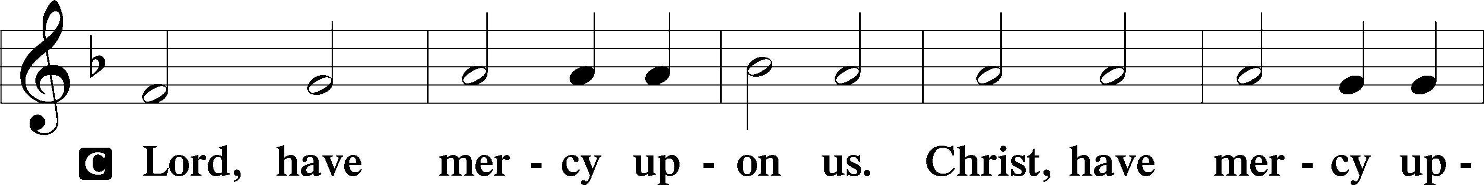
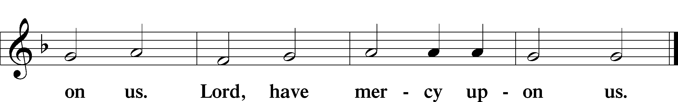

SALUTATION AND COLLECT OF THE DAY
L The Lord be with you.
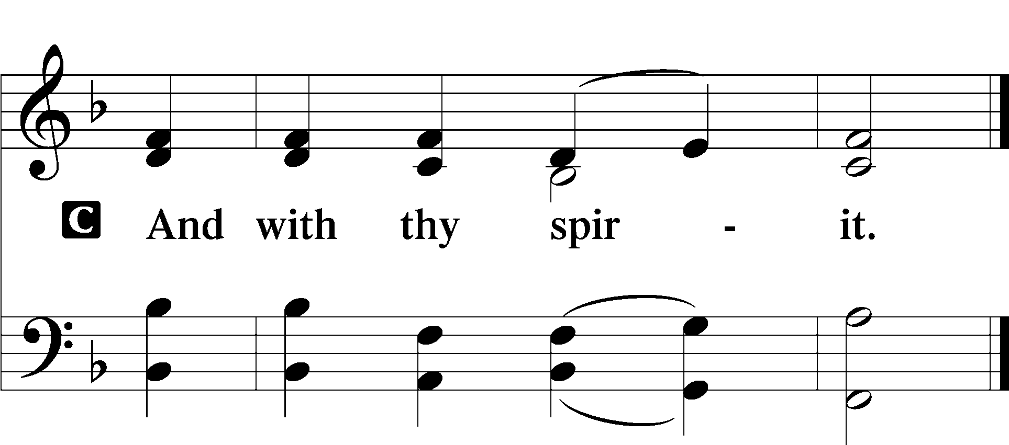
L Let us pray.
Almighty God, our heavenly Father, Your mercies are new every morning; and though we deserve only punishment, You receive us as Your children and provide for all our needs of body and soul. Grant that we may heartily acknowledge Your merciful goodness, give thanks for all Your benefits, and serve You in willing obedience; through Jesus Christ, Your Son, our Lord, who lives and reigns with You and the Holy Spirit, one God, now and forever.

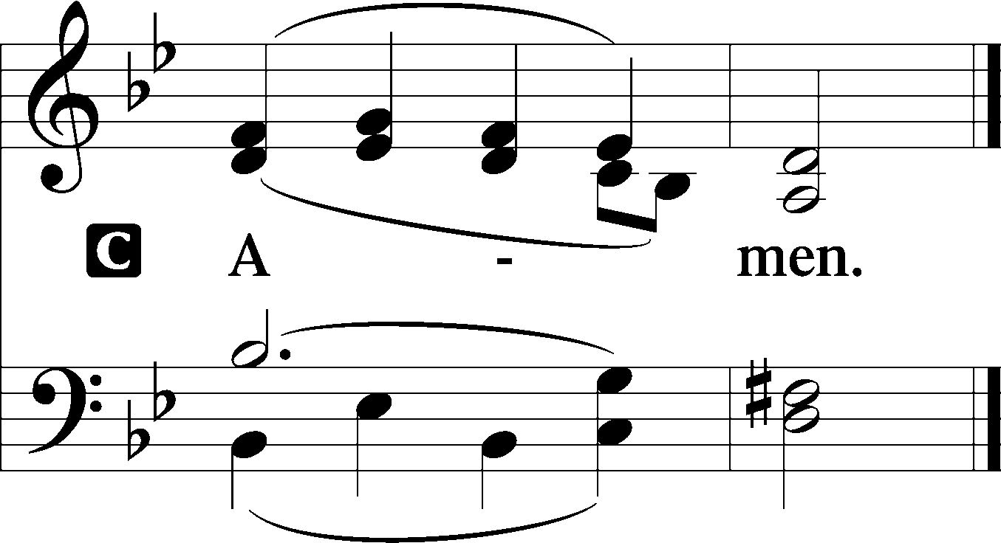

(Sit)

CHILDREN'S LESSON

OLD TESTAMENT READING Isaiah 42:14–21
14For a long time I have held my peace;
I have kept still and restrained myself;
now I will cry out like a woman in labor;
I will gasp and pant.
15I will lay waste mountains and hills,
and dry up all their vegetation;
I will turn the rivers into islands,
and dry up the pools.
16And I will lead the blind
in a way that they do not know,
in paths that they have not known
I will guide them.
I will turn the darkness before them into light,
the rough places into level ground.
These are the things I do,
and I do not forsake them.
17They are turned back and utterly put to shame,
who trust in carved idols,
who say to metal images,
“You are our gods.”
18Hear, you deaf,
and look, you blind, that you may see!
19Who is blind but my servant,
or deaf as my messenger whom I send?
Who is blind as my dedicated one,
or blind as the servant of the Lord?
20He sees many things, but does not observe them;
his ears are open, but he does not hear.
21The Lord was pleased, for his righteousness’ sake,
to magnify his law and make it glorious.

L This is the Word of the Lord.
C Thanks be to God.

GRADUAL Hebrews 12:2
[O come, let us fix our eyes on] | Jesus,*
the founder and perfecter | of our faith,
who for the joy that was set before him endured the cross, despis- | ing the shame,*
and is seated at the right hand of the | throne of God.
EPISTLE Ephesians 5:8–14
8For at one time you were darkness, but now you are light in the Lord. Walk as children of light 9(for the fruit of light is found in all that is good and right and true), 10and try to discern what is pleasing to the Lord. 11Take no part in the unfruitful works of darkness, but instead expose them. 12For it is shameful even to speak of the things that they do in secret. 13But when anything is exposed by the light, it becomes visible, 14for anything that becomes visible is light. Therefore it says,
“Awake, O sleeper,
and arise from the dead,
and Christ will shine on you.”

L This is the Word of the Lord.
C Thanks be to God.

(Stand)

HOLY GOSPEL John 9:1–41
L The Holy Gospel according to St. John, the ninth chapter.

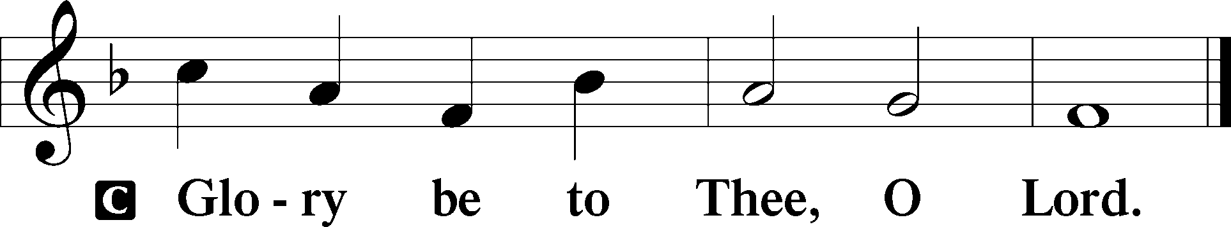

1As [Jesus] passed by, he saw a man blind from birth. 2And his disciples asked him, “Rabbi, who sinned, this man or his parents, that he was born blind?” 3Jesus answered, “It was not that this man sinned, or his parents, but that the works of God might be displayed in him. 4We must work the works of him who sent me while it is day; night is coming, when no one can work. 5As long as I am in the world, I am the light of the world.” 6Having said these things, he spat on the ground and made mud with the saliva. Then he anointed the man’s eyes with the mud 7and said to him, “Go, wash in the pool of Siloam” (which means Sent). So he went and washed and came back seeing.
8The neighbors and those who had seen him before as a beggar were saying, “Is this not the man who used to sit and beg?” 9Some said, “It is he.” Others said, “No, but he is like him.” He kept saying, “I am the man.” 10So they said to him, “Then how were your eyes opened?” 11He answered, “The man called Jesus made mud and anointed my eyes and said to me, ‘Go to Siloam and wash.’ So I went and washed and received my sight.” 12They said to him, “Where is he?” He said, “I do not know.” (Continued on Next Page)
13They brought to the Pharisees the man who had formerly been blind. 14Now it was a Sabbath day when Jesus made the mud and opened his eyes. 15So the Pharisees again asked him how he had received his sight. And he said to them, “He put mud on my eyes, and I washed, and I see.” 16Some of the Pharisees said, “This man is not from God, for he does not keep the Sabbath.” But others said, “How can a man who is a sinner do such signs?” And there was a division among them. 17So they said again to the blind man, “What do you say about him, since he has opened your eyes?” He said, “He is a prophet.”
18The Jews did not believe that he had been blind and had received his sight, until they called the parents of the man who had received his sight 19and asked them, “Is this your son, who you say was born blind? How then does he now see?” 20His parents answered, “We know that this is our son and that he was born blind. 21But how he now sees we do not know, nor do we know who opened his eyes. Ask him; he is of age. He will speak for himself.”

22(His parents said these things because they feared the Jews, for the Jews had already agreed that if anyone should confess Jesus to be Christ, he was to be put out of the synagogue.) 23Therefore his parents said, “He is of age; ask him.”
24So for the second time they called the man who had been blind and said to him, “Give glory to God. We know that this man is a sinner.” 25He answered, “Whether he is a sinner I do not know. One thing I do know, that though I was blind, now I see.” 26They said to him, “What did he do to you? How did he open your eyes?” 27He answered them, “I have told you already, and you would not listen. Why do you want to hear it again? Do you also want to become his disciples?” 28And they reviled him, saying, “You are his disciple, but we are disciples of Moses. 29We know that God has spoken to Moses, but as for this man, we do not know where he comes from.” 30The man answered, “Why, this is an amazing thing! You do not know where he comes from, and yet he opened my eyes. 31We know that God does not listen to sinners, but if anyone is a worshiper of God and does his will, God listens to him. 32Never since the world began has it been heard that anyone opened the eyes of a man born blind. 33If this man were not from God, he could do nothing.” 34They answered him, “You were born in utter sin, and would you teach us?” And they cast him out.
35Jesus heard that they had cast him out, and having found him he said, “Do you believe in the Son of Man?” 36He answered, “And who is he, sir, that I may believe in him?” 37Jesus said to him, “You have seen him, and it is he who is speaking to you.” 38He said, “Lord, I believe,” and he worshiped him. 39Jesus said, “For judgment I came into this world, that those who do not see may see, and those who see may become blind.” 40Some of the Pharisees near him heard these things, and said to him, “Are we also blind?” 41Jesus said to them, “If you were blind, you would have no guilt; but now that you say, ‘We see,’ your guilt remains.”

L This is the Gospel of the Lord.

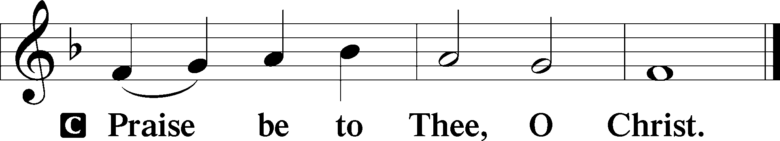

NICENE CREED
C I believe in one God,
the Father Almighty,
maker of heaven and earth
and of all things visible and invisible.

And in one Lord Jesus Christ,
the only-begotten Son of God,
begotten of His Father before all worlds,
God of God, Light of Light,
very God of very God,
begotten, not made,
being of one substance with the Father,
by whom all things were made;
who for us men and for our salvation came down from heaven
and was incarnate by the Holy Spirit of the virgin Mary
and was made man;
and was crucified also for us under Pontius Pilate.
He suffered and was buried.
And the third day He rose again according to the Scriptures
and ascended into heaven
and sits at the right hand of the Father.
And He will come again with glory to judge both the living and the dead,
whose kingdom will have no end.

And I believe in the Holy Spirit,
the Lord and giver of life,
who proceeds from the Father and the Son,
who with the Father and the Son together is worshiped and glorified,
who spoke by the prophets. (Continued on Next Page)
And I believe in one holy Christian and apostolic Church,
I acknowledge one Baptism for the remission of sins,
and I look for the resurrection of the dead
and the life T of the world to come. Amen.

(Sit)

571 GOD LOVED THE WORLD SO THAT HE GAVE
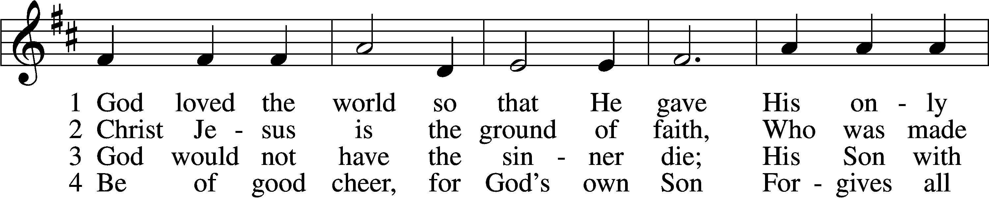
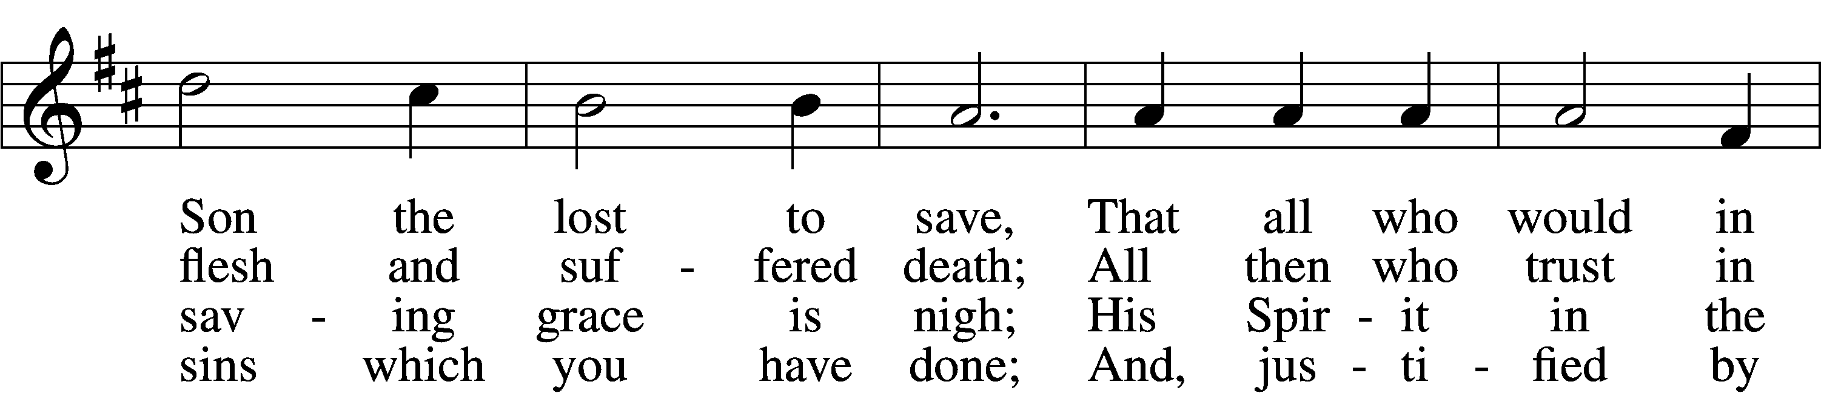
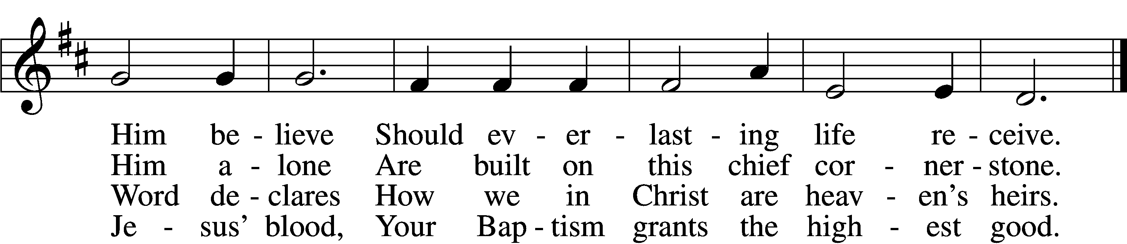

5 If you are sick, if death is near,
This truth your troubled heart can cheer:
Christ Jesus saves your soul from death;
That is the firmest ground of faith.

D 6 Glory to God the Father, Son,
And Holy Spirit, Three in One!
To You, O blessèd Trinity,
Be praise now and eternally!
Text: Heiliges Lippen- und Hertzens-Opffer, c. 1778, Stettin; tr. August Crull, 1845–1923, alt.
Tune: George J. Elvey, 1816–93
Text and tune: Public domain

SERMON OR MEDITATION ON THE READINGS

(Stand)

OFFERING
As a part of our expression of thanksgiving to God for the treasure of His salvation to us, we offer a portion of our treasure, according to what each has determined in their heart to give. Please place offerings in the collection plate at the back of the sanctuary before or after the service. Offerings can also be sent to Bethlehem Lutheran Church via U.S. Mail. Thank you!

OFFERTORY LSB 192
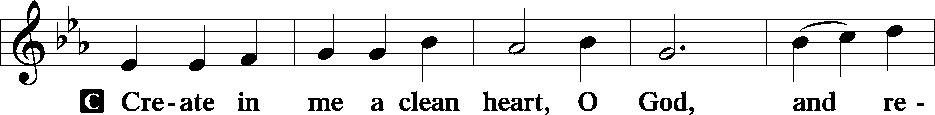
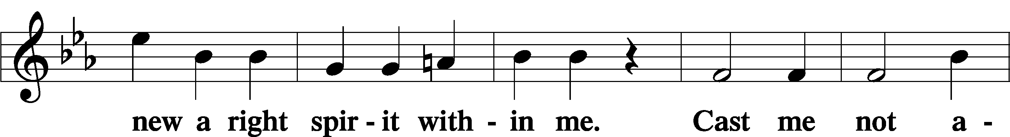
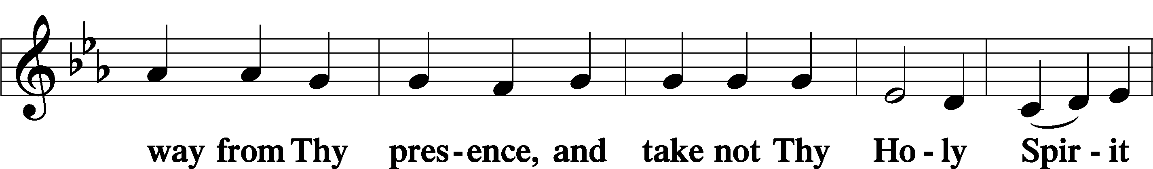
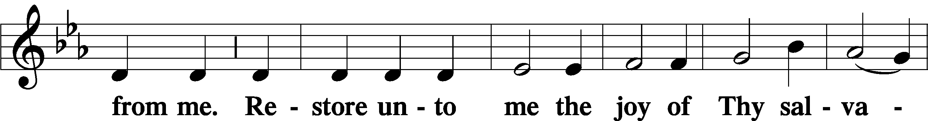
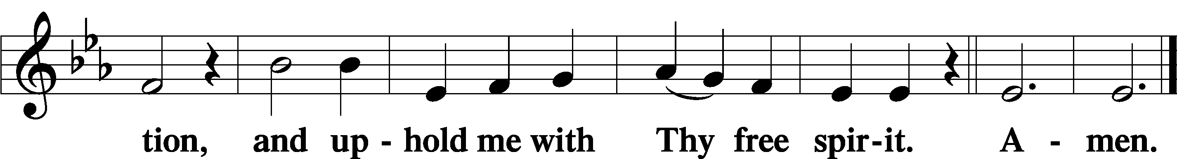

SHARING OF THE PEACE

(Sit)

PRAYER OF THE CHURCH

+ SERVICE OF THE SACRAMENT +
Note: The Service of The Sacrament is included in the lay bulletin solely as a viewers’ guide for those watching the livestream service; Communicant members who are unable to attend the Divine Service in person are encouraged to make arrangements with Pastor Engwall to receive the Lord’s Supper.

PREFACE LSB 194




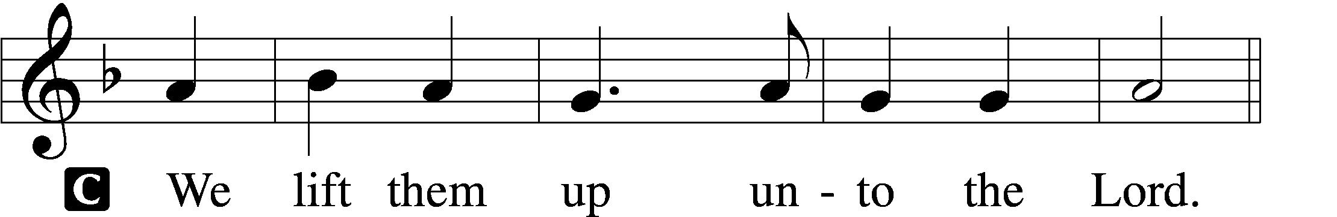

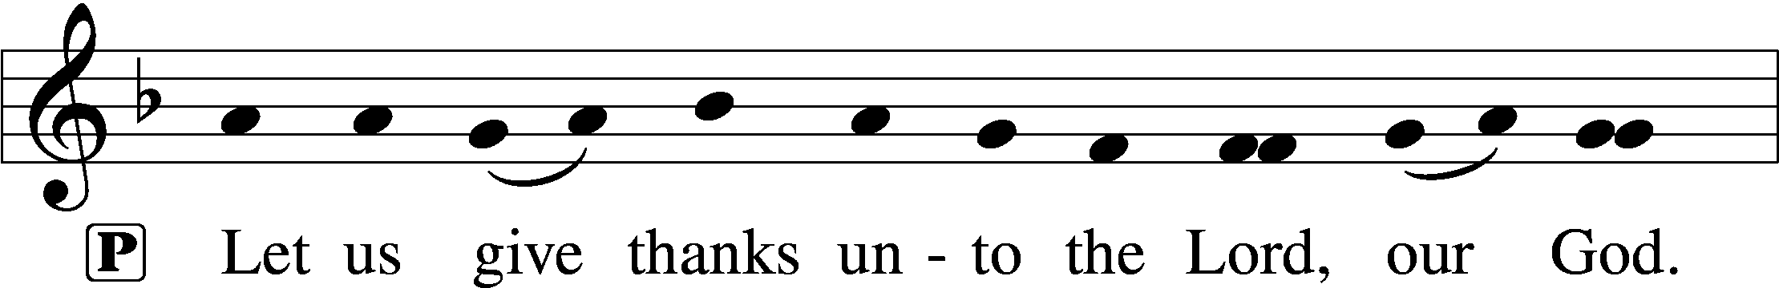
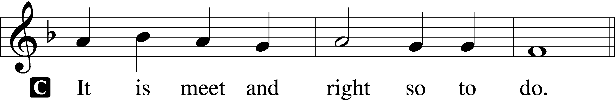

PROPER PREFACE (ABBREVIATED) LSB 194
P It is truly meet, right, and salutary . . . evermore praising You and saying:

SANCTUS LSB 195
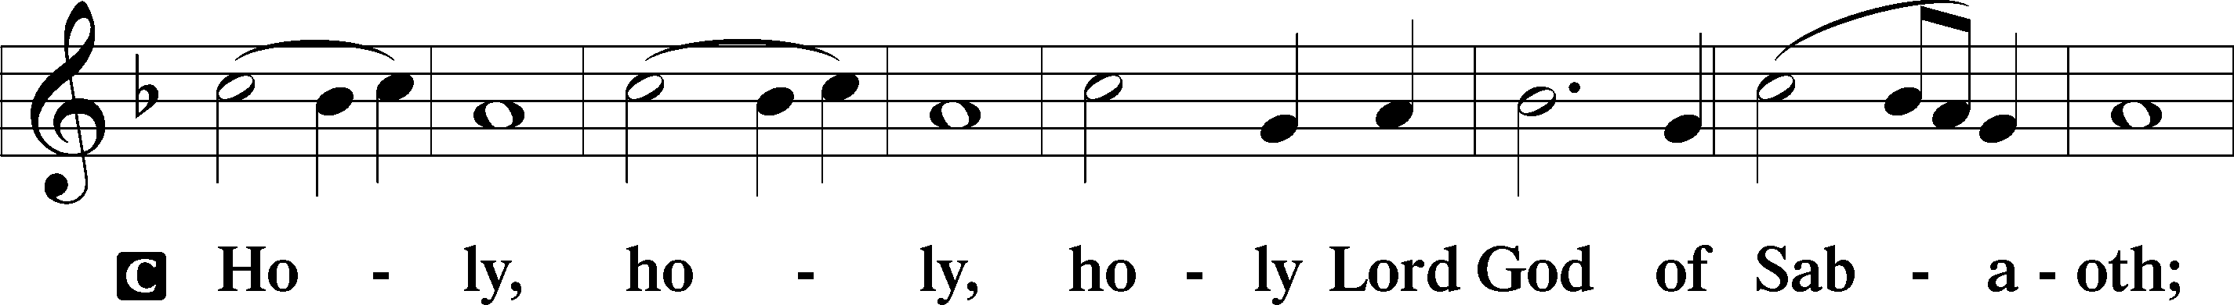
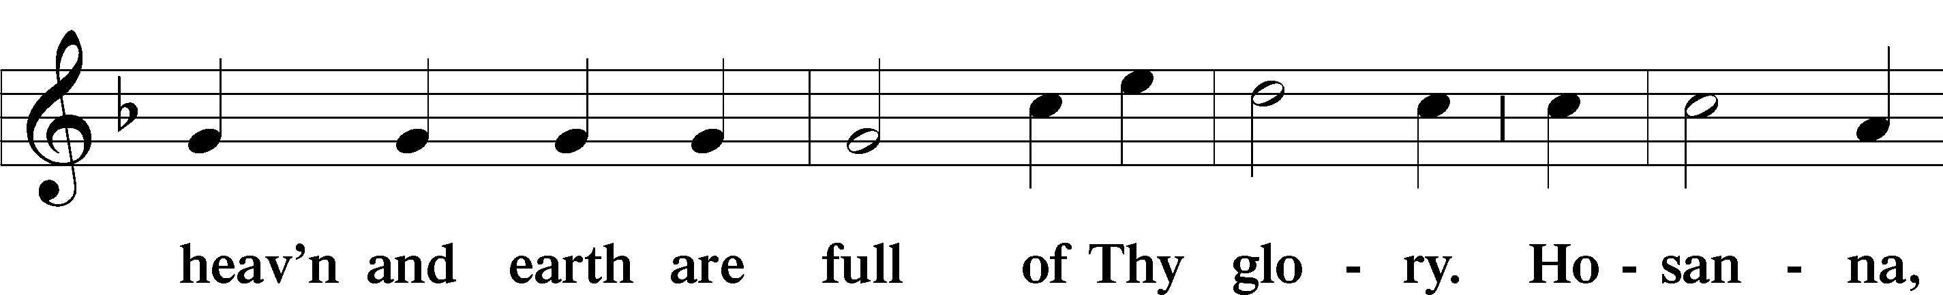
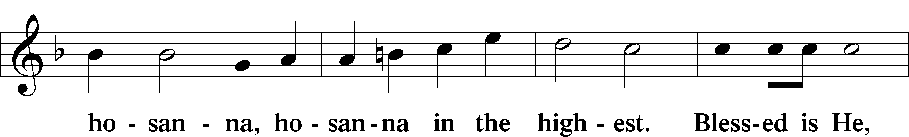
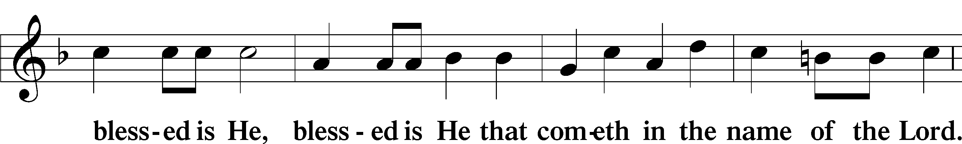
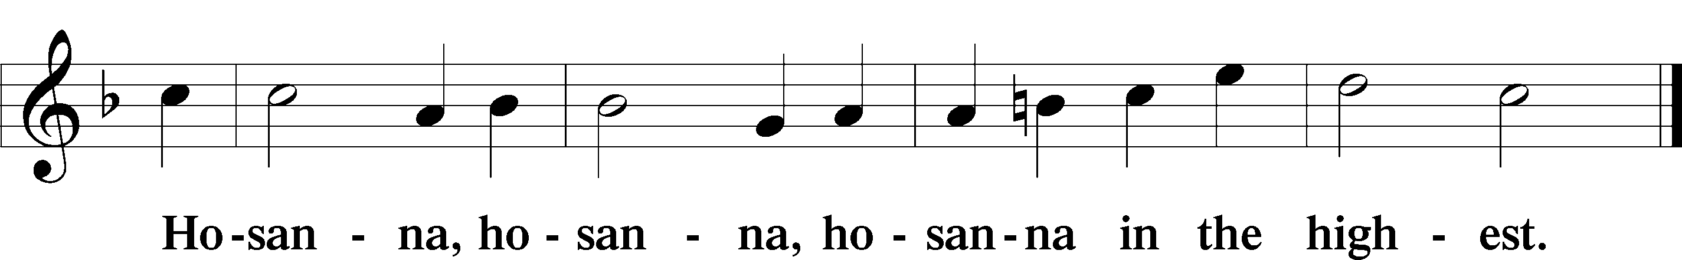

LORD’S PRAYER 162
C Our Father who art in heaven,
hallowed be Thy name,
Thy kingdom come,
Thy will be done on earth
as it is in heaven;
give us this day our daily bread;
and forgive us our trespasses
as we forgive those
who trespass against us;
and lead us not into temptation,
but deliver us from evil.
For Thine is the kingdom
and the power and the glory
forever and ever. Amen.

THE WORDS OF OUR LORD LSB 197

PAX DOMINI LSB 197
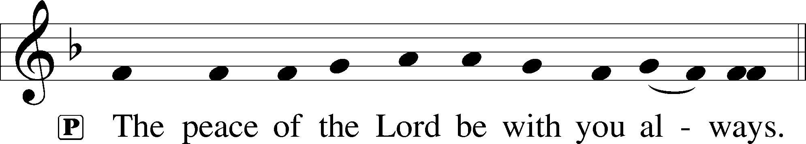

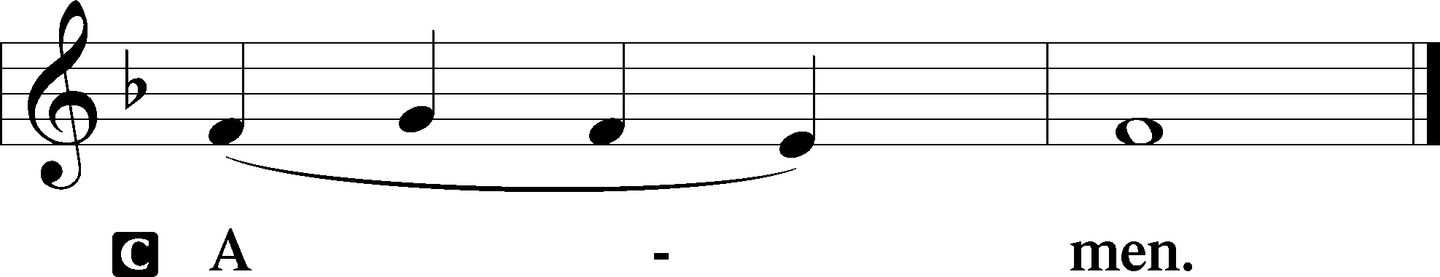

AGNUS DEI LSB 198
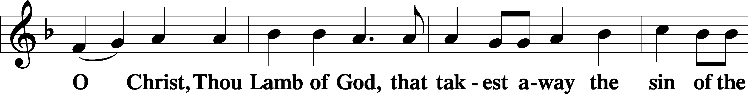
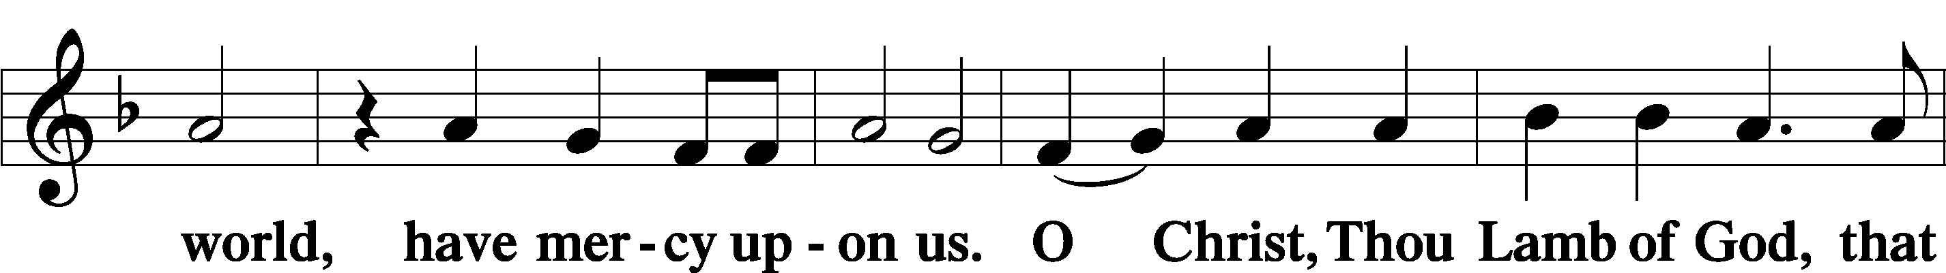
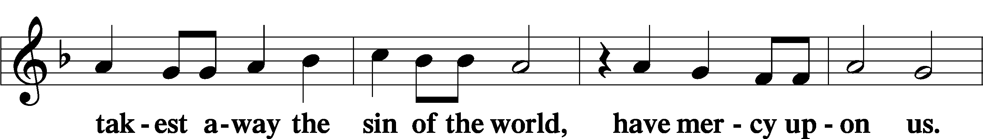
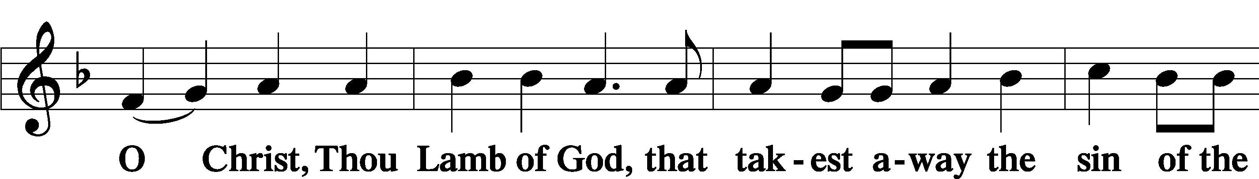


DISTRIBUTION
(The pastor and those who assist him receive the body and blood of Christ first, then commune those who are unable to come to the altar. The ushers will then direct all other communicants to the altar.)

851 LORD OF GLORY, YOU HAVE BOUGHT US
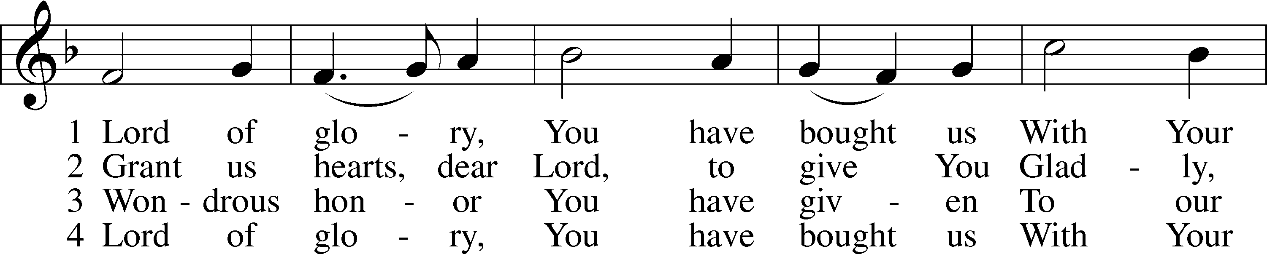
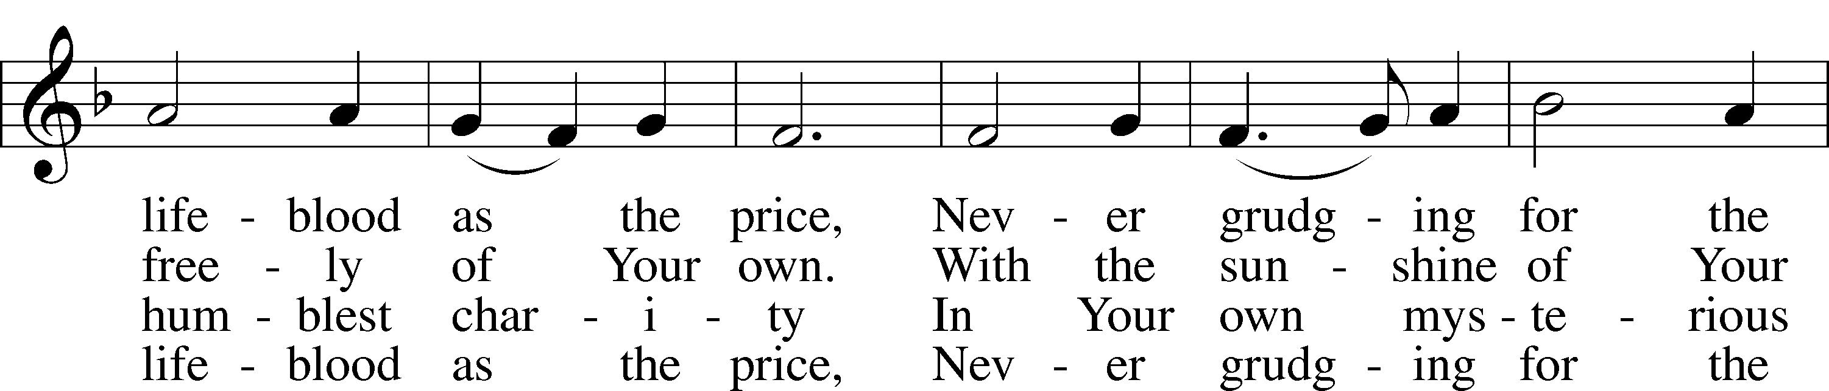
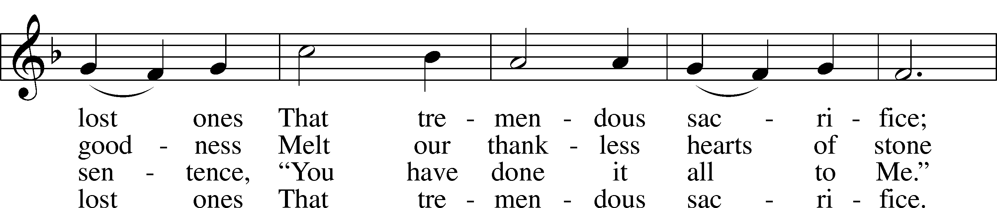
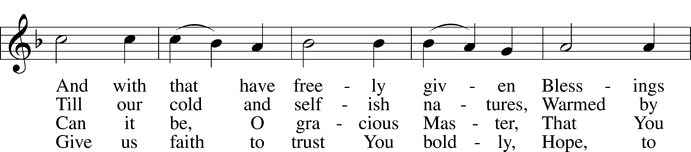
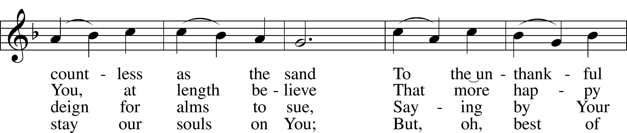
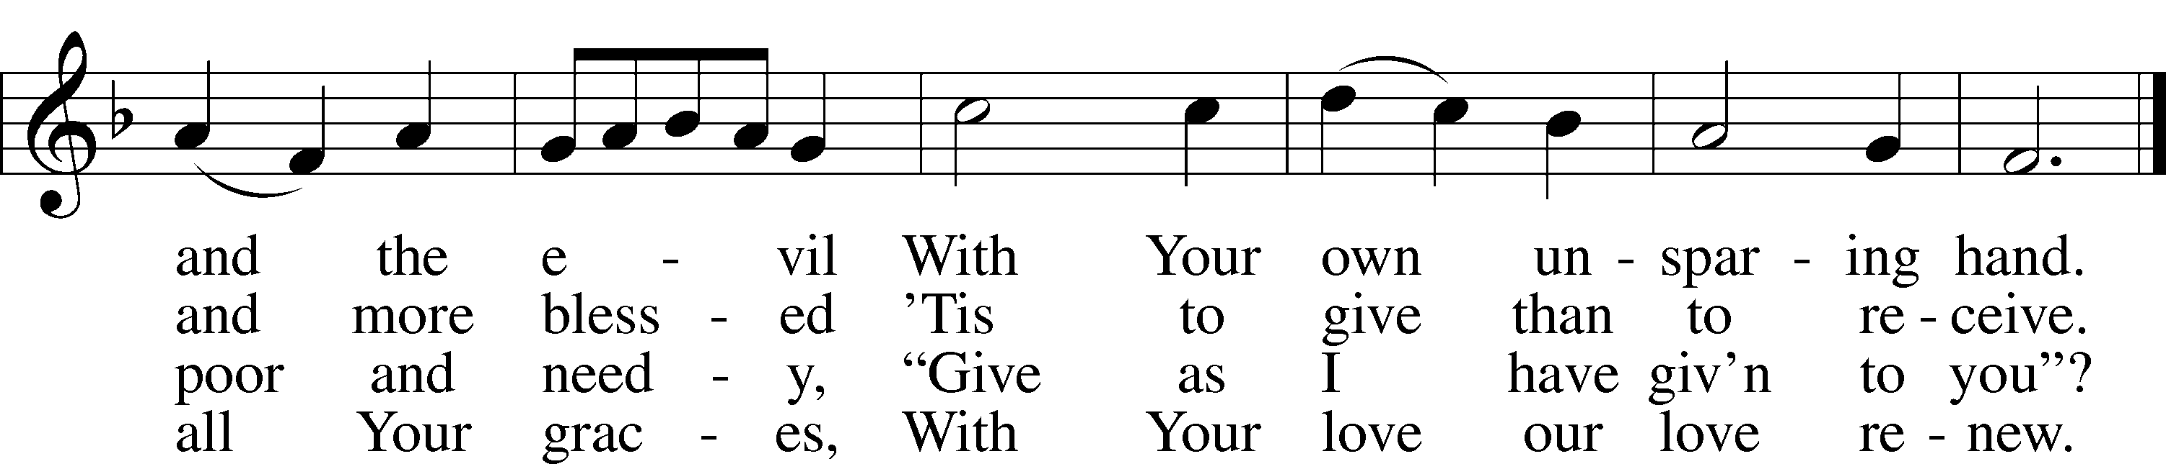
Text: Eliza S. Alderson, 1818–89, alt.
Tune: Rowland H. Prichard, 1811–87
Text and tune: Public domain

INSTRUMENTAL

(Stand)

NUNC DIMITTIS LSB 199
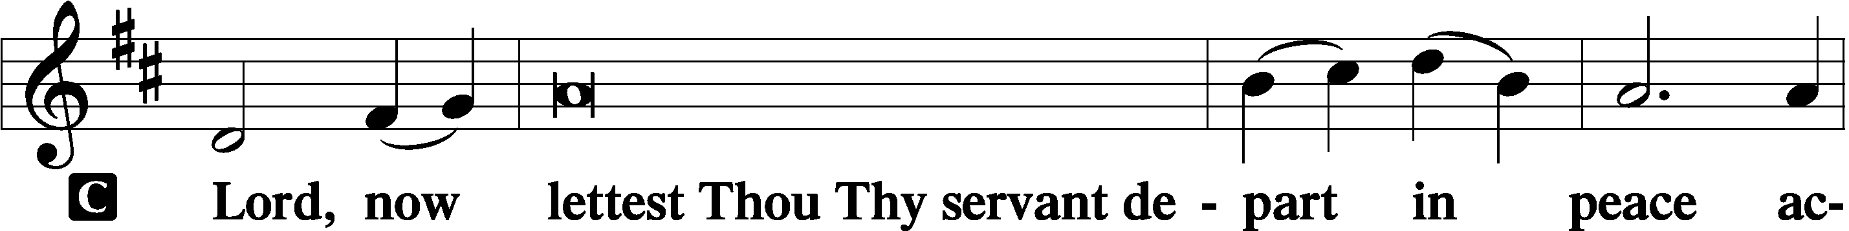

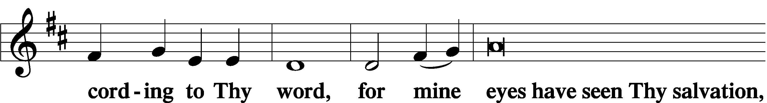

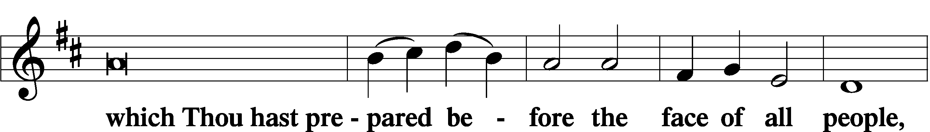

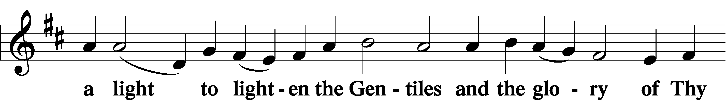

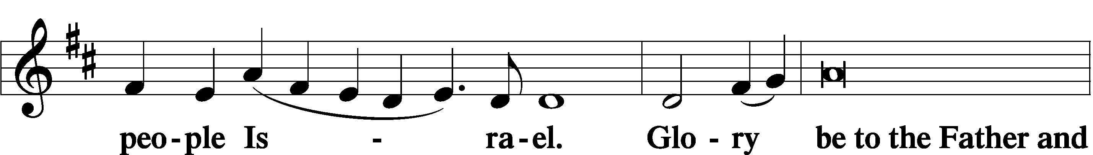

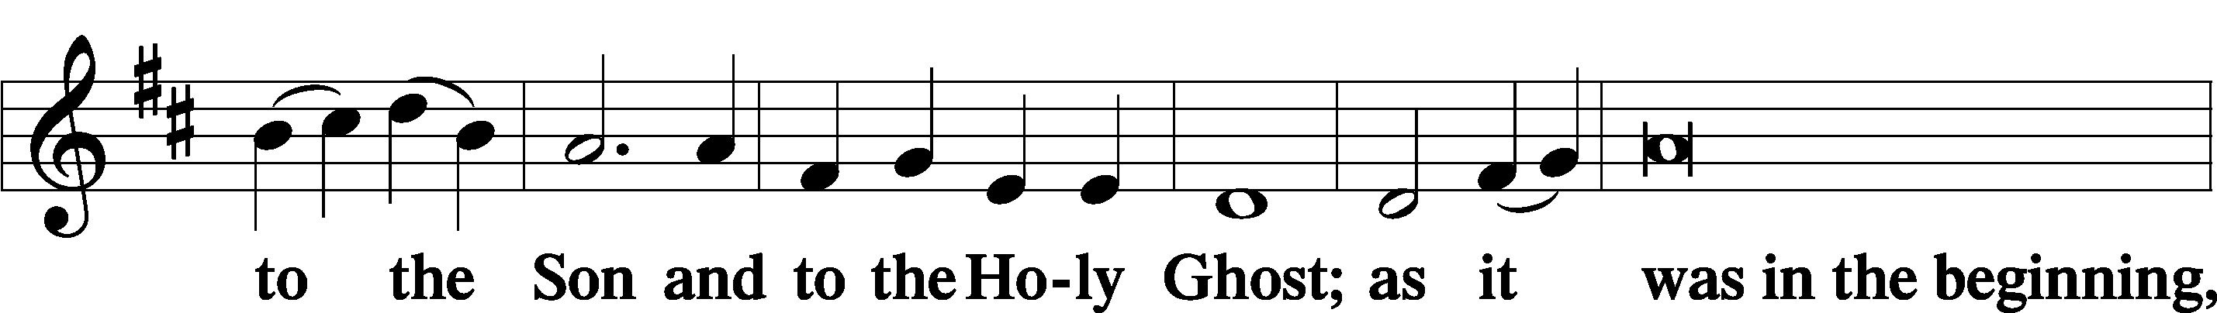

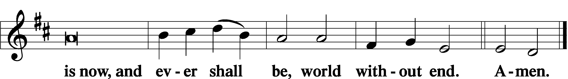

THANKSGIVING LSB 200
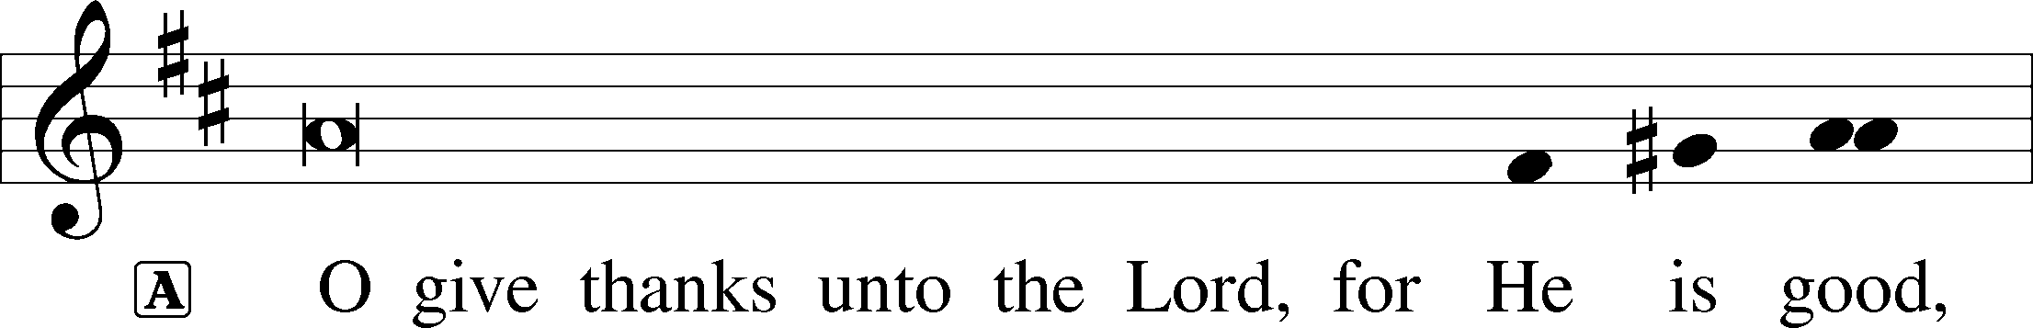

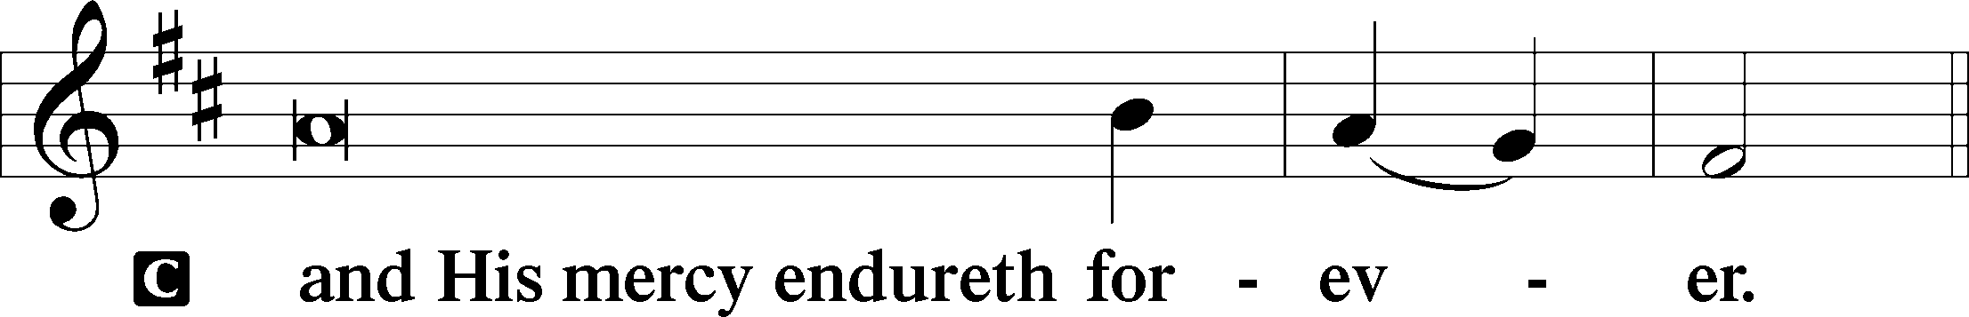
POST-COMMUNION COLLECT

SALUTATION LSB 201
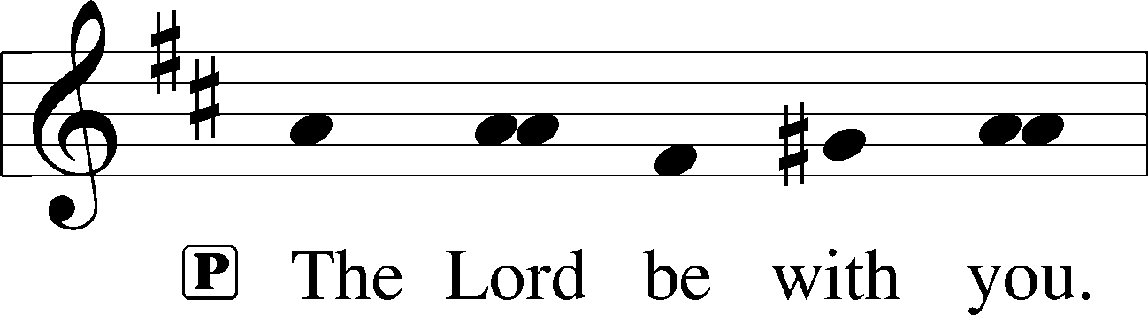

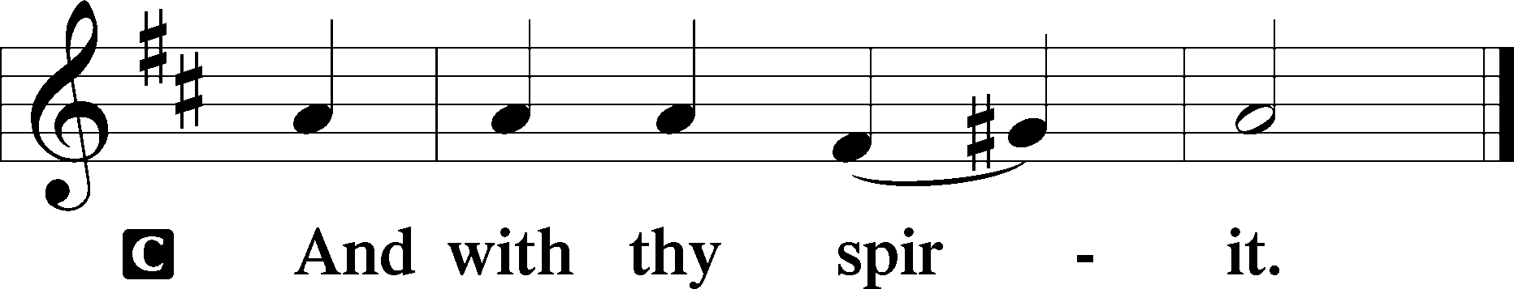

BENEDICAMUS LSB 202
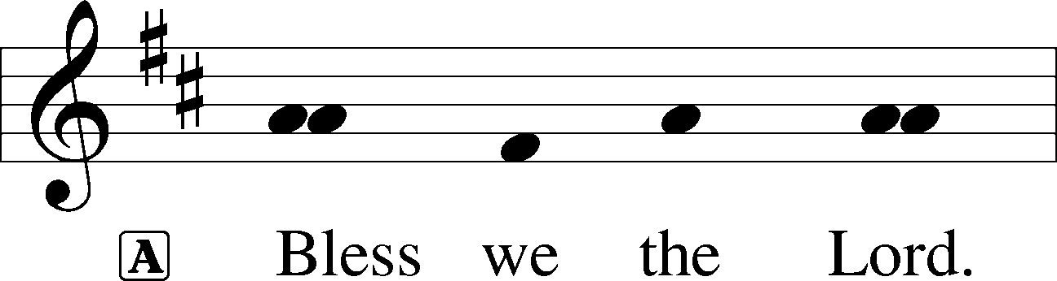

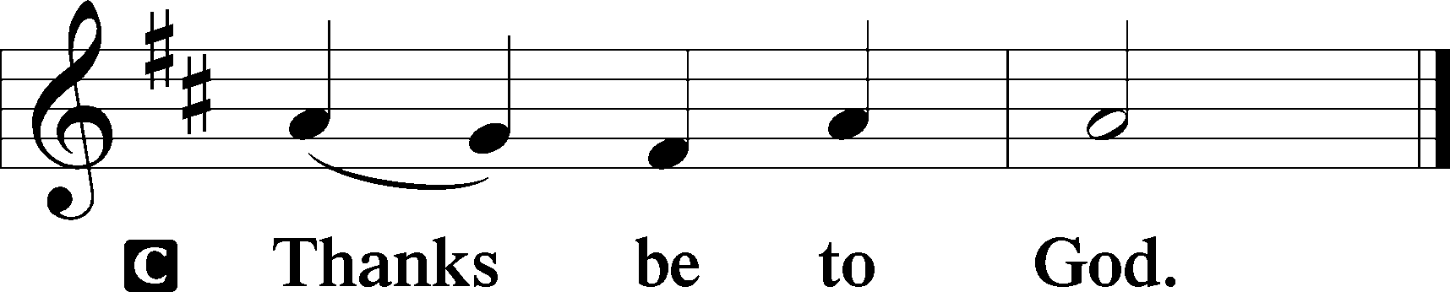

BENEDICTION
L:The grace of our Lord T Jesus Christ, and the love of God, and the fellowship of the Holy Spirit, be with us all.
C: Amen.

411 I WANT TO WALK AS A CHILD OF THE LIGHT
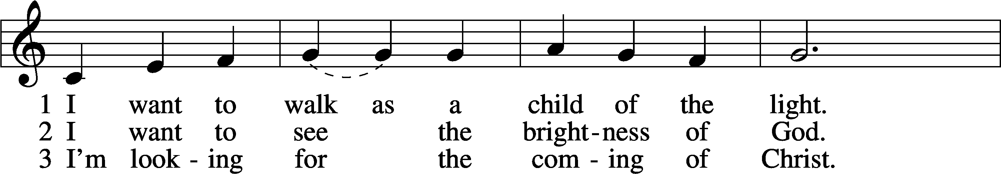
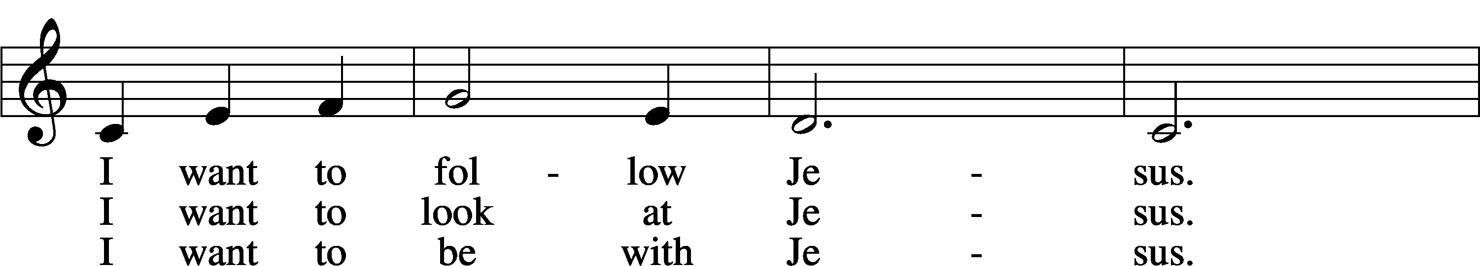
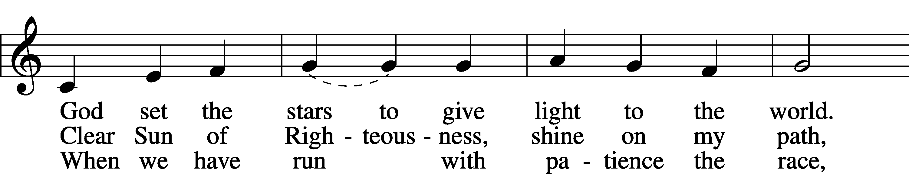
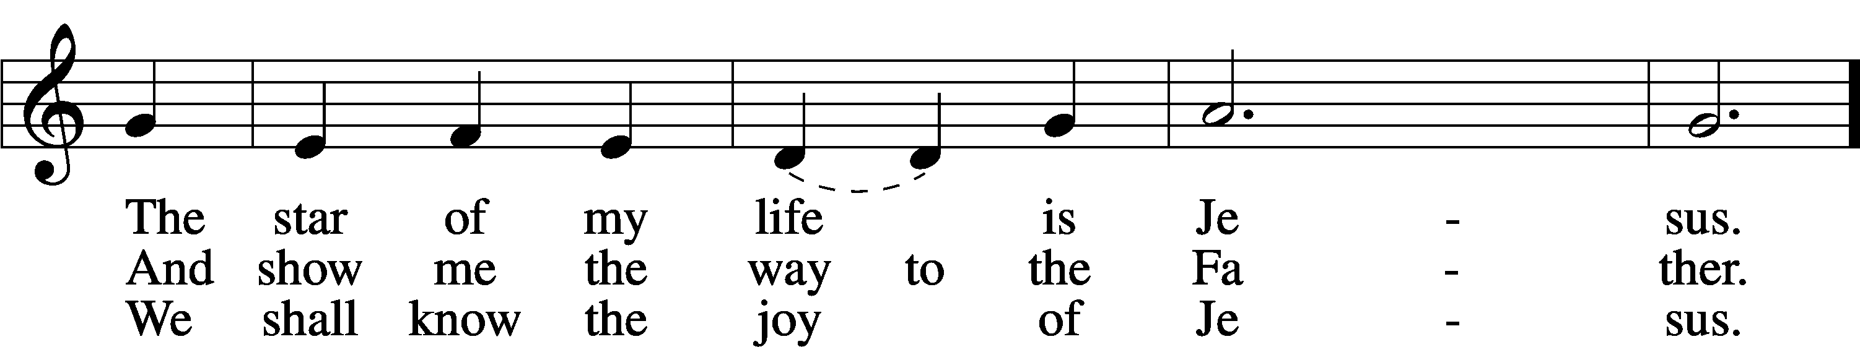
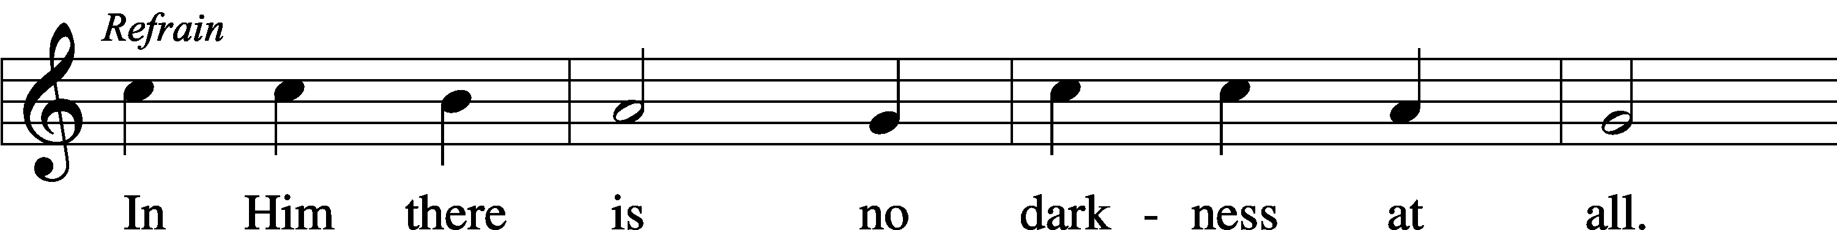
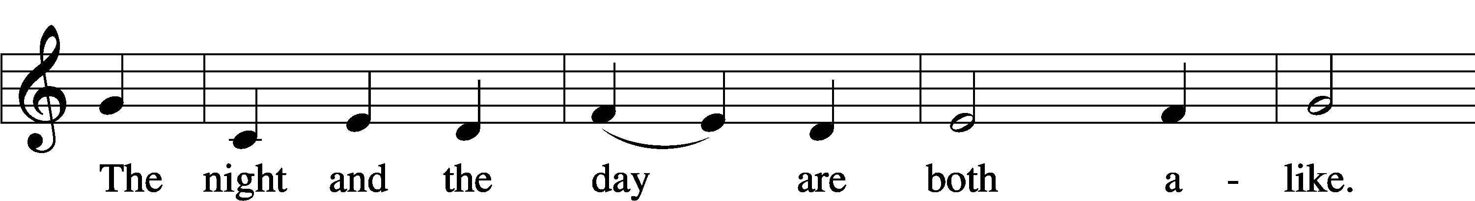
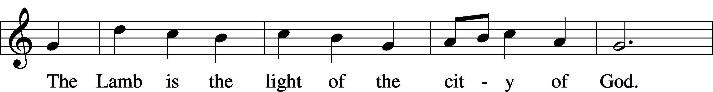
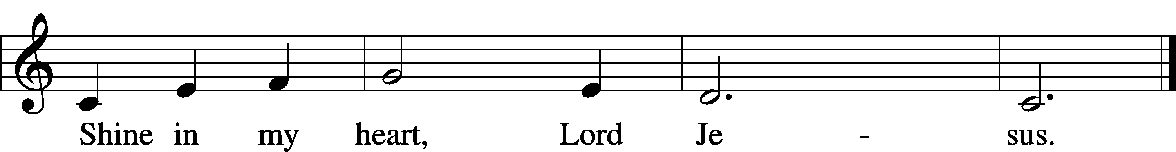
Text and tune: Kathleen Thomerson, 1934–2025
Text and tune: © 1970, 1975 Celebration. Used by permission: LSB Hymn License no. 110004798

ACKNOWLEDGMENTS
Unless otherwise indicated, Scripture quotations are from the ESV® Bible (The Holy Bible, English Standard Version®), copyright © 2001 by Crossway, a publishing ministry of Good News Publishers. Used by permission. All rights reserved.
Created by Lutheran Service Builder © 2026 Concordia Publishing House.

IN OUR PRAYERS:
Submitted petitions are included for two consecutive Sundays
For Those suffering afflictions of mind, body, or spirit:

All of our Shut- Ins:

For missionaries
Deaconess Sandra Rhein, Rev. Jonathan Anderson

ANNOUNCEMENTS
Please email announcements for Sunday bulletins by 8:00 a.m. Tuesday to pastorblcaiken@gmail.com
ALTAR FLOWERS:
Flowers are donated today by Kathy

EASTER LILY ORDER FORMS:
Time to order Easter lilies! They are $15.00 each. Order forms are in the East Narthex. The deadline to order is March 22nd.

PARISH COUNCIL:
Meets today, after the service

MEMORIAL SERVICE FOR SANDY ANDREWS
Will be conducted here on Saturday, March 21st at 11:00 a.m.

POTLUCK NEXT SUNDAY
March 22nd after the service

ACTS DONATION FOR MARCH :
CANNED FRUIT

CHURCH CLEAN-UP DAY!!
Saturday, March 28th 8:00 a.m. ‘til noon-ish

FELLOWSHIP COFFEE HOUR:
Every Sunday morning, during Bible Study and after the Divine Service, coffee, treats and good fellowship are waiting for you in our Fellowship Hall!

Attendance: Wednesday, March 4th: 32 Sunday, March 8th: 38

Offering: Wednesday: $165 Sunday: $1,385

Average weekly offering needed to make budget: $2,579

OUR VALUE STATEMENT: Bethlehem Lutheran Church exists under God’s grace to save the lost and to strengthen the saved so that they may live bold and courageous lives of Christian witness before a non-believing world.
Therefore, our purpose is:
- to glorify God in Word and deed,
- to nurture each other in Christian love,
- to reach out to others with our Savior’s Gospel of life and salvation.
(Rom 5:8, Matt. 28:18-20).

OUR VISION: By the Grace of God, Bethlehem Lutheran Church, is a loving family united in Christ, learning, living, and spreading His Word.

OUR MISSION: Learn the Word. Live the Word. Spread the Word.

Lent, Holy Week, and Easter Schedule of services
Lenten Wednesdays:
Feb. 25th; Mar. 4th,11th,18th, 25th
-Meals at 11:30 a.m. and 6:00 p.m.;
services at 11:00 a.m. and 7:00 p.m.

Palm/ Passion Sunday:
March 29th
Maundy Thursday: April 2nd;
7:00 p.m. Communion service
Good Friday: April 3rd;
7:00 p.m. Tenebrae service
Easter Sunday: April 5th;
9:00 a.m. breakfast, (no Bible study)
- 10:30 a.m. Divine Service (outside, weather permitting)

