BETHLEHEM LUTHERAN CHURCH
A congregation of The Lutheran Church-Missouri Synod
902 Hitchcock Drive SW,
Aiken, South Carolina 29803
Church Phone: (803) 649-6417
blcaikensc@gmail.com
Pastor: Rev. John B. Engwall
Office Hours By Appointment

Bethlehem Lutheran welcomes our members and guests to our worship service! Unable to join us in person? Please find us on Facebook live. The service is also posted on our website: bethlehemlutheranaiken.org.

+ + + + + + + + + + + + + + +
The 3rd Wednesday in Advent
Dec 17, 2025
11:00 a.m. & 7:00 p.m.
+ + + + + + + + + + + + + + +

(stand)

348 THE KING SHALL COME WHEN MORNING DAWNS
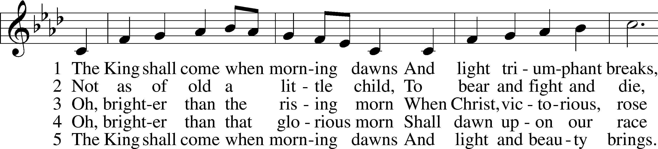
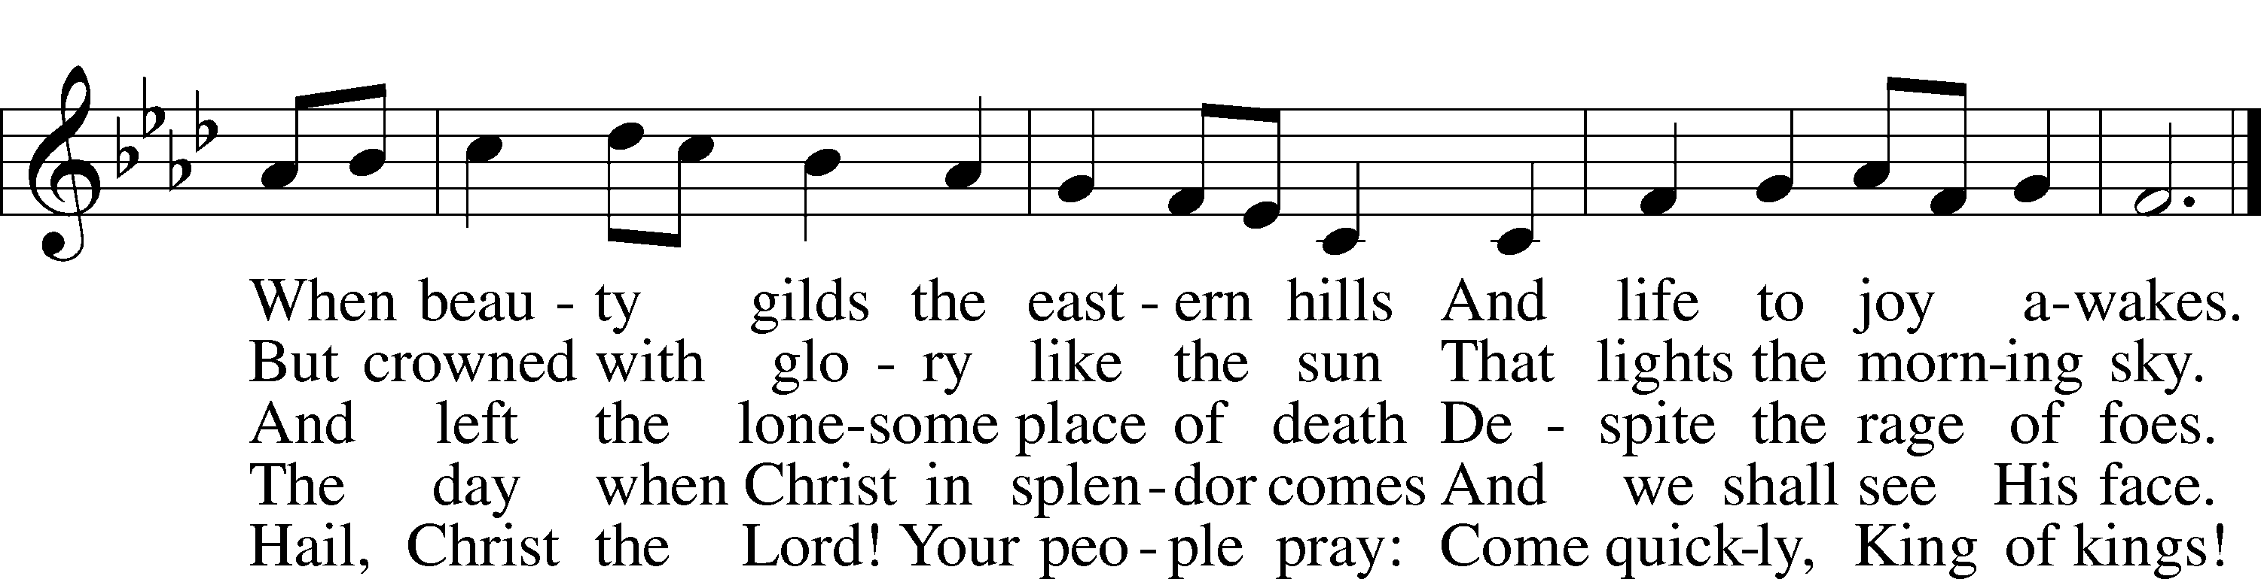
Text: John Brownlie, 1859–1925, alt.
Tune: Repository of Sacred Music, Part Second, 1813, Harrisburg, ed. John Wyeth
Text and tune: Public domain

INVOCATION
L In the name of the Father and of the T Son and of the Holy Spirit.
C Amen.

COLLECT OF THE DAY
Lord Jesus Christ, we implore You to hear our prayers and to lighten the darkness of our hearts by Your gracious visitation; for You live and reign with the Father and the Holy Spirit, one God, now and forever.
C Amen.

(sit)

READING Isaiah 35
L A reading from Isaiah, the thirty-fifth chapter.
1The wilderness and the dry land shall be glad;
the desert shall rejoice and blossom like the crocus;
2it shall blossom abundantly
and rejoice with joy and singing.
The glory of Lebanon shall be given to it,
the majesty of Carmel and Sharon.
They shall see the glory of the Lord,
the majesty of our God.
3Strengthen the weak hands,
and make firm the feeble knees.
4Say to those who have an anxious heart,
“Be strong; fear not!
Behold, your God
will come with vengeance,
with the recompense of God.
He will come and save you.”
5Then the eyes of the blind shall be opened,
and the ears of the deaf unstopped;
6then shall the lame man leap like a deer,
and the tongue of the mute sing for joy.
For waters break forth in the wilderness,
and streams in the desert;
7the burning sand shall become a pool,
and the thirsty ground springs of water;
in the haunt of jackals, where they lie down,
the grass shall become reeds and rushes.
8And a highway shall be there,
and it shall be called the Way of Holiness;
the unclean shall not pass over it.
It shall belong to those who walk on the way;
even if they are fools, they shall not go astray.
9No lion shall be there,
nor shall any ravenous beast come up on it;
they shall not be found there,
but the redeemed shall walk there. (next page)

10And the ransomed of the Lord shall return
and come to Zion with singing;
everlasting joy shall be upon their heads;
they shall obtain gladness and joy,
and sorrow and sighing shall flee away.
L This is the Word of the Lord.
C Thanks be to God.

SERMON OR MEDITATION

(stand)

APOSTLES’ CREED
C I believe in God, the Father Almighty,
maker of heaven and earth.

And in Jesus Christ, His only Son, our Lord,
who was conceived by the Holy Spirit,
born of the virgin Mary,
suffered under Pontius Pilate,
was crucified, died and was buried.
He descended into hell.
The third day He rose again from the dead.
He ascended into heaven
and sits at the right hand of God the Father Almighty.
From thence He will come to judge the living and the dead.

I believe in the Holy Spirit,
the holy Christian Church,
the communion of saints,
the forgiveness of sins,
the resurrection of the body,
and the life T everlasting. Amen.

LORD’S PRAYER
L Taught by our Lord and trusting His promises, we are bold to pray:
C Our Father who art in heaven,
hallowed be Thy name,
Thy kingdom come,
Thy will be done on earth
as it is in heaven;
give us this day our daily bread;
and forgive us our trespasses
as we forgive those
who trespass against us;
and lead us not into temptation,
but deliver us from evil.
For Thine is the kingdom
and the power and the glory
forever and ever. Amen.

BLESSING
L The grace of our Lord T Jesus Christ and the love of God and the communion of the Holy Spirit be with us all.
C Amen.

602 THE GIFTS CHRIST FREELY GIVES
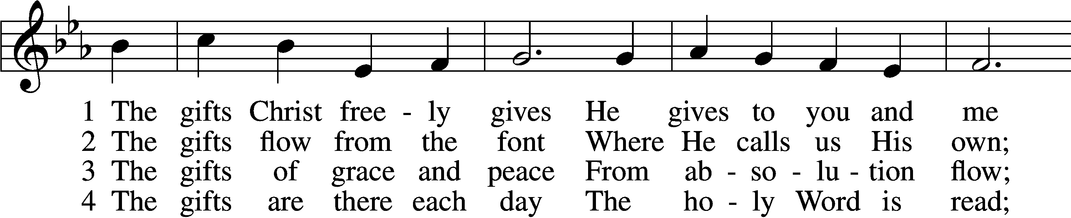
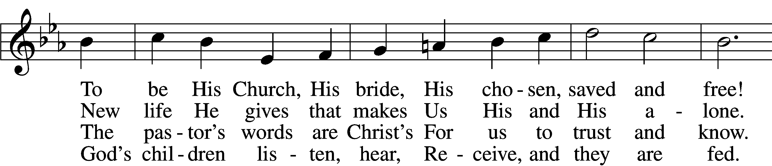
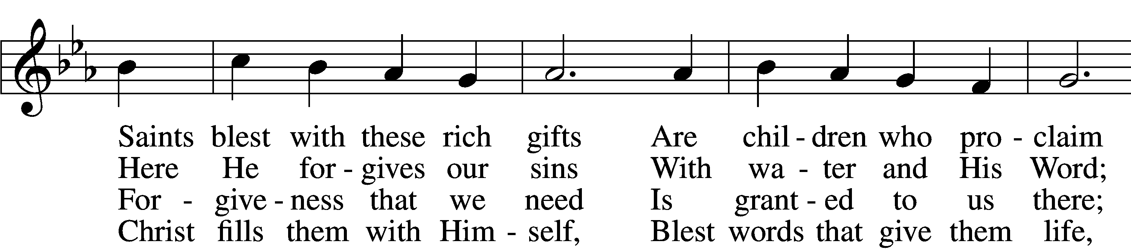
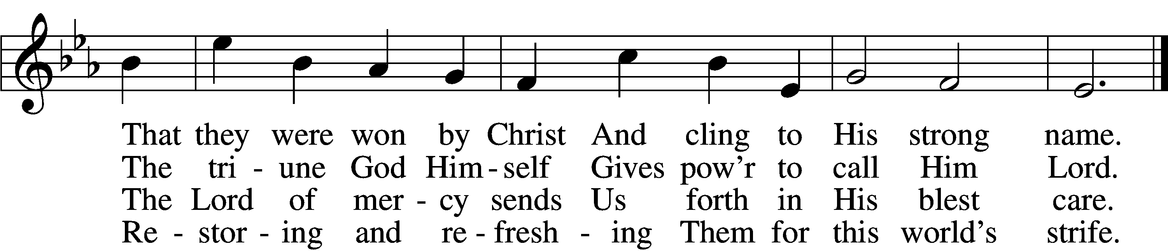

5 The gifts are in the feast,
Gifts far more than we see;
Beneath the bread and wine
Is food from Calvary.
The body and the blood
Remove our ev’ry sin;
We leave His presence in
His peace, renewed again.

6 All glory to the One
Who lavishes such love;
The triune God in love
Assures our life above.
His means of grace for us
Are gifts He loves to give;
All thanks and praise for His
Great love by which we live!
Text: Richard C. Resch, 1947
Tune: Charles J. Dale, 1842–1912, alt.
Text: © 2001 Richard C. Resch. Used by permission: LSB Hymn License no. 110004798
Tune: Public domain
ACKNOWLEDGMENTS
Unless otherwise indicated, Scripture quotations are from the ESV® Bible (The Holy Bible, English Standard Version®), copyright © 2001 by Crossway, a publishing ministry of Good News Publishers. Used by permission. All rights reserved.
Created by Lutheran Service Builder © 2025 Concordia Publishing House.

