

+ + + + + + + + + + + + + + +
Second Wednesday in Advent
December 10th, 2025
11:00 a.m. and 7:00 p.m.
+ + + + + + + + + + + + + + +

BETHLEHEM LUTHERAN CHURCH
A congregation of The Lutheran Church-Missouri Synod
902 Hitchcock Drive SW,
Aiken, South Carolina 29803
Church Phone: (803) 649-6417
blcaikensc@gmail.com
Pastor: Rev. John B. Engwall
Office Hours By Appointment
Bethlehem Lutheran welcomes our members and guests to our worship service! Unable to join us in person? Please find us on Facebook live. The service is also posted on our website; bethlehemlutheranaiken.org.

+ + + + + + + + + + + + + + +
Second Wednesday in Advent
December 10th, 2025
11:00 a.m. and 7:00 p.m.
+ + + + + + + + + + + + + + +

(stand)

357 O COME, O COME, EMMANUEL
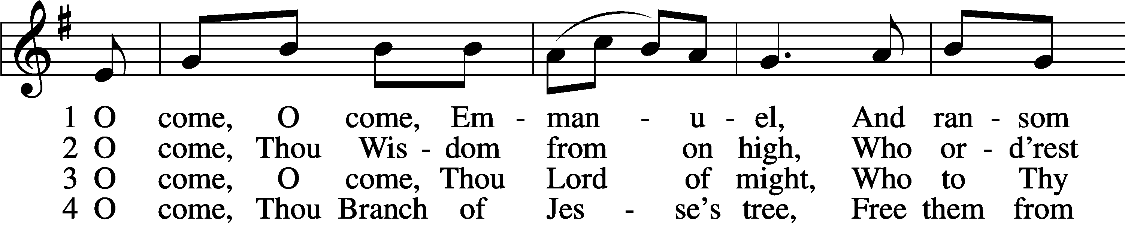
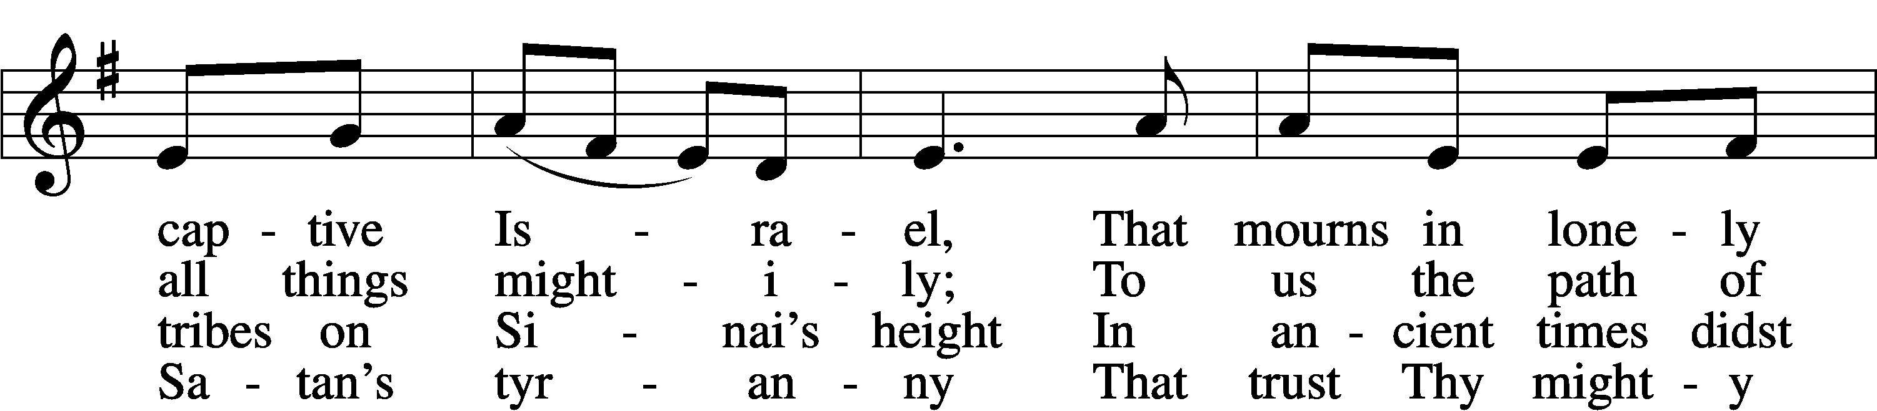
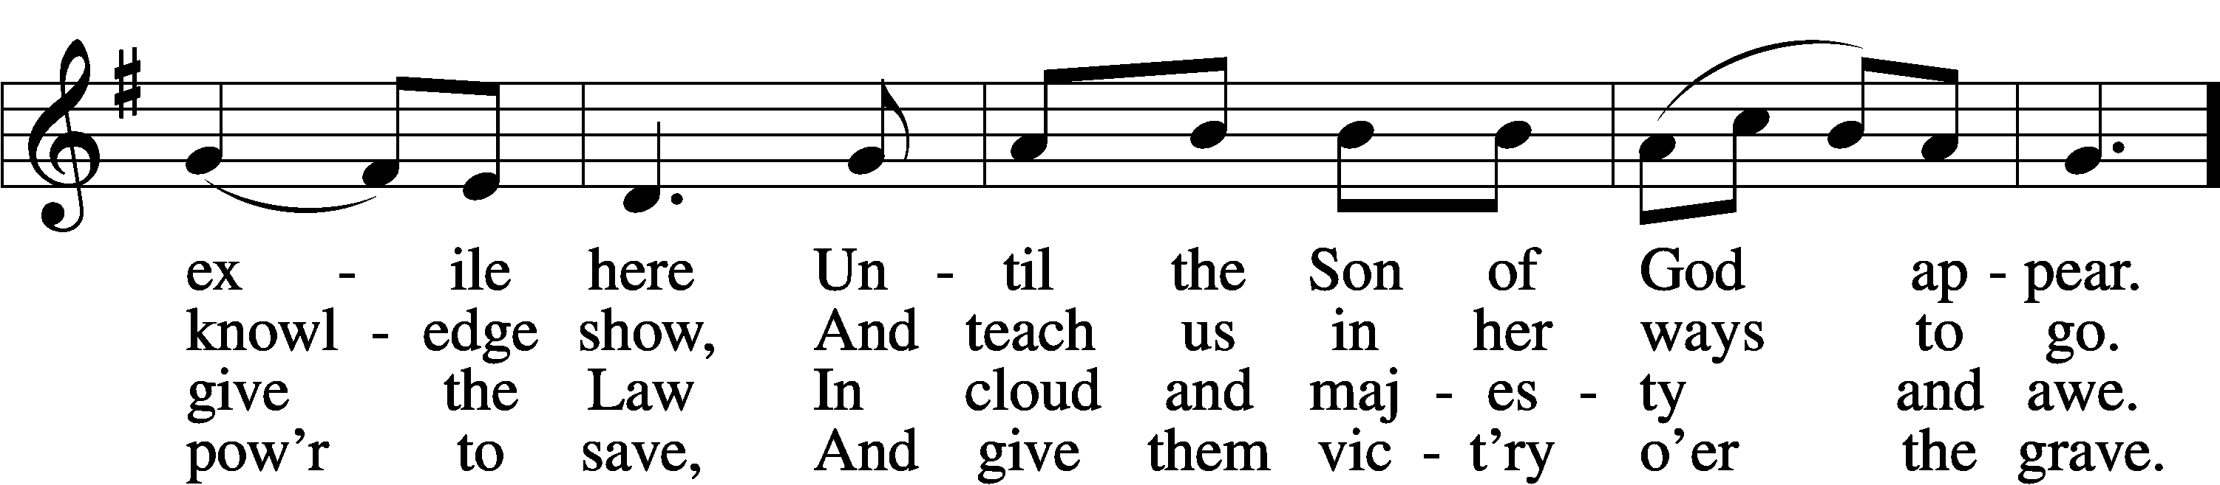
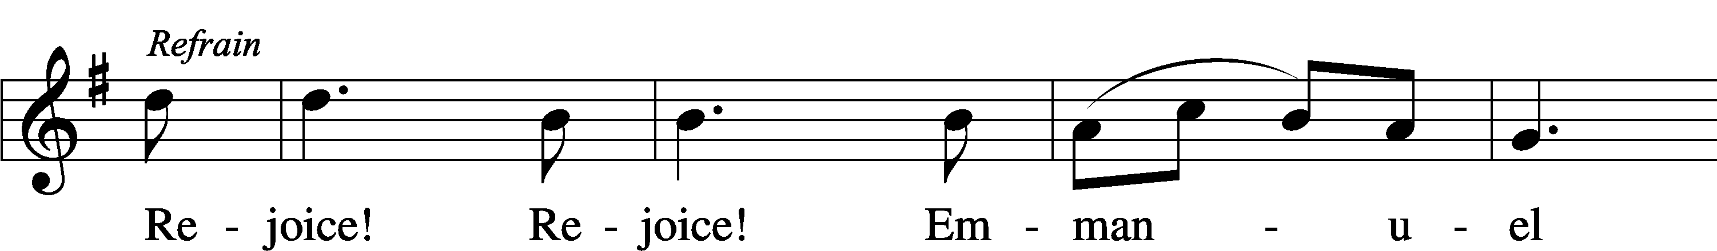
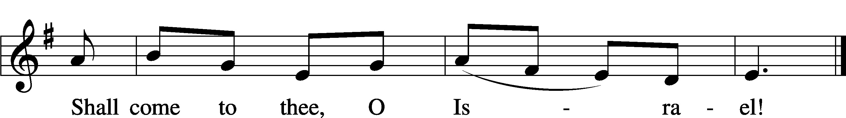

5 O come, Thou Key of David, come,
And open wide our heav’nly home;
Make safe the way that leads on high,
And close the path to misery. Refrain

6 O come, Thou Dayspring from on high,
And cheer us by Thy drawing nigh;
Disperse the gloomy clouds of night,
And death’s dark shadows put to flight. Refrain

7 O come, Desire of nations, bind
In one the hearts of all mankind;
Bid Thou our sad divisions cease,
And be Thyself our King of Peace. Refrain
Text: Latin, c. 12th cent.; Psalteriolum Cantionum Catholicarum, 1710, Köln; tr. John Mason Neale, 1818–66, alt.
Tune: French, 15th cent.
Text and tune: Public domain

INVOCATION
P In the name of the Father and of the T Son and of the Holy Spirit.
C Amen.

COLLECT OF THE DAY
Stir up our hearts, O Lord, to make ready the way of Your only-begotten Son, that by His coming we may be enabled to serve You with pure minds; through the same Jesus Christ, our Lord, who lives and reigns with You and the Holy Spirit, one God, now and forever.
C Amen.

(sit)

READING Isaiah 11:1–10
P A reading from Isaiah, the eleventh chapter.
¹There shall come forth a shoot from the stump of Jesse,
and a branch from his roots shall bear fruit.
²And the Spirit of the Lord shall rest upon him,
the Spirit of wisdom and understanding,
the Spirit of counsel and might,
the Spirit of knowledge and the fear of the Lord.
³And his delight shall be in the fear of the Lord.
He shall not judge by what his eyes see,
or decide disputes by what his ears hear,
⁴but with righteousness he shall judge the poor,
and decide with equity for the meek of the earth;
and he shall strike the earth with the rod of his mouth,
and with the breath of his lips he shall kill the wicked.
⁵Righteousness shall be the belt of his waist,
and faithfulness the belt of his loins.
⁶The wolf shall dwell with the lamb,
and the leopard shall lie down with the young goat,
and the calf and the lion and the fattened calf together;
and a little child shall lead them.
⁷The cow and the bear shall graze;
their young shall lie down together;
and the lion shall eat straw like the ox. (next page)

⁸The nursing child shall play over the hole of the cobra,
and the weaned child shall put his hand on the adder’s den.
⁹They shall not hurt or destroy in all my holy mountain; for the earth shall be full of the knowledge of the Lord as the waters cover the sea.
¹⁰In that day the root of Jesse, who shall stand as a signal for the peoples—of him shall the nations inquire, and his resting place shall be glorious.
P This is the Word of the Lord.
C Thanks be to God.

SERMON

(stand)

APOSTLES’ CREED
C I believe in God, the Father Almighty,
maker of heaven and earth.

And in Jesus Christ, His only Son, our Lord,
who was conceived by the Holy Spirit,
born of the virgin Mary,
suffered under Pontius Pilate,
was crucified, died and was buried.
He descended into hell.
The third day He rose again from the dead.
He ascended into heaven
and sits at the right hand of God the Father Almighty.
From thence He will come to judge the living and the dead.

I believe in the Holy Spirit,
the holy Christian Church,
the communion of saints,
the forgiveness of sins,
the resurrection of the body,
and the life T everlasting. Amen.

LORD’S PRAYER
P Taught by our Lord and trusting His promises, we are bold to pray:
C Our Father who art in heaven,
hallowed be Thy name,
Thy kingdom come,
Thy will be done on earth
as it is in heaven;
give us this day our daily bread;
and forgive us our trespasses
as we forgive those
who trespass against us;
and lead us not into temptation,
but deliver us from evil.
For Thine is the kingdom
and the power and the glory
forever and ever. Amen.

BLESSING
P The grace of our Lord T Jesus Christ and the love of God and the communion of the Holy Spirit be with you all.
C Amen.

342 WHAT HOPE! AN EDEN PROPHESIED
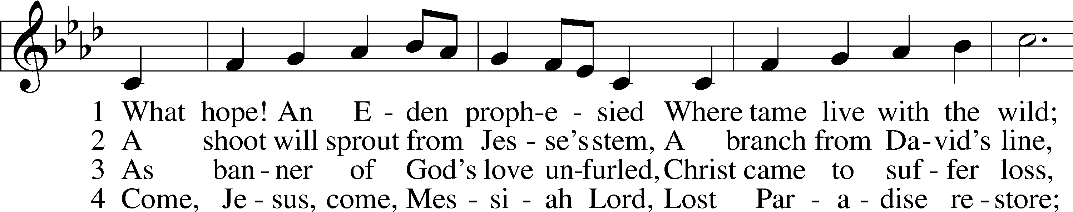
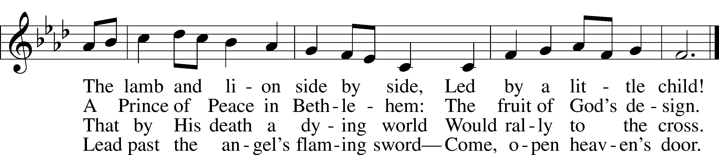
Text: Stephen P. Starke, 1955
Tune: Repository of Sacred Music, Part Second, 1813, Harrisburg, ed. John Wyeth
Text: © 1998 Stephen P. Starke, admin. Concordia Publishing House. Used by permission: LSB Hymn License no. 110004798
Tune: Public domain

ACKNOWLEDGMENTS
Unless otherwise indicated, Scripture quotations are from the ESV® Bible (The Holy Bible, English Standard Version®), copyright © 2001 by Crossway, a publishing ministry of Good News Publishers. Used by permission. All rights reserved.
Created by Lutheran Service Builder © 2025 Concordia Publishing House.

Please return this bulletin to the narthex for the evening service. Thank you!

