BETHLEHEM LUTHERAN CHURCH
A congregation of The Lutheran Church-Missouri Synod
902 Hitchcock Drive SW,
Aiken, South Carolina 29803
Church Phone: (803) 649-6417
blcaikensc@gmail.com
Pastor: Rev. John B. Engwall
Office Hours By Appointment
Bethlehem Lutheran welcomes our members and guests to our worship service! Unable to join us in person? Please find us on Facebook live. The service is also posted on our website; bethlehemlutheranaiken.org.

+ + + + + + + + + + + + + + +
The Fifth Wednesday in Lent
March 25, 2026
11:00 a.m. and 7:00 p.m.
+ + + + + + + + + + + + + + +

+ SERVICE OF PREPARATION +
After the bell tolls, please observe a time of silence.

WELCOME AND ANNOUNCEMENTS

(Stand)

686 COME, THOU FOUNT OF EVERY BLESSING
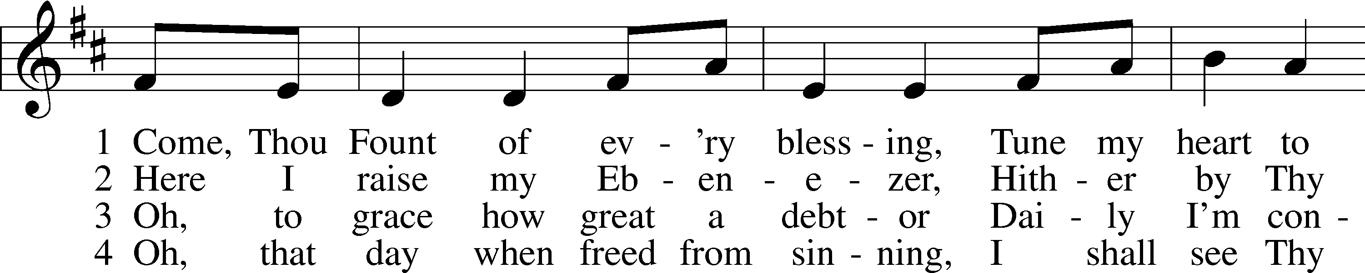
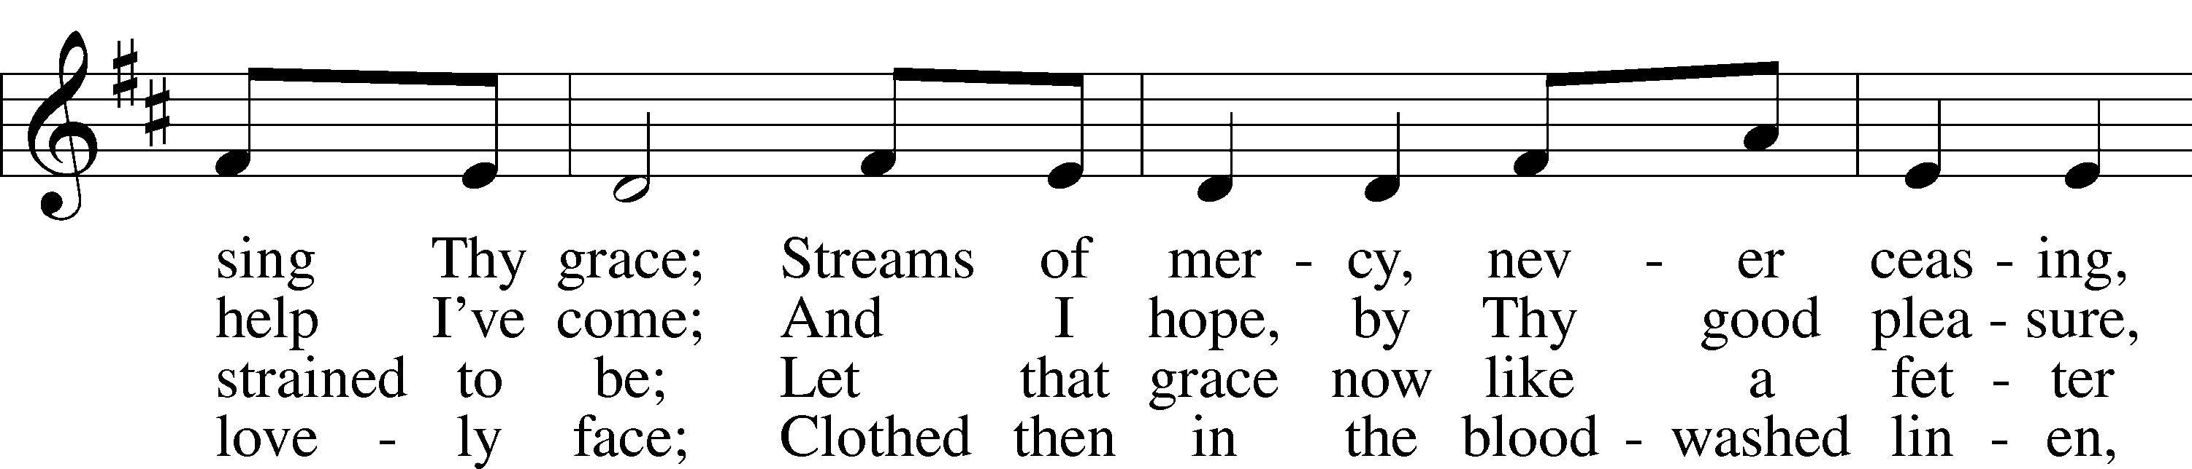
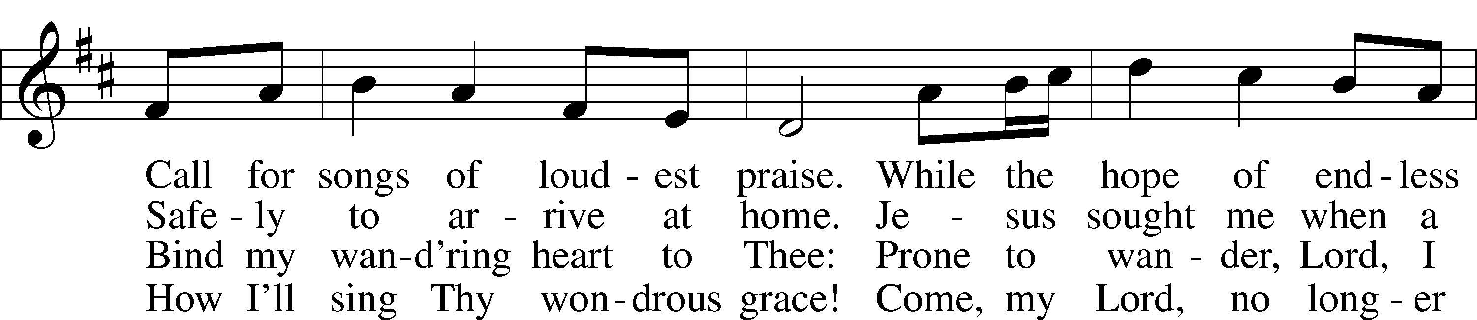
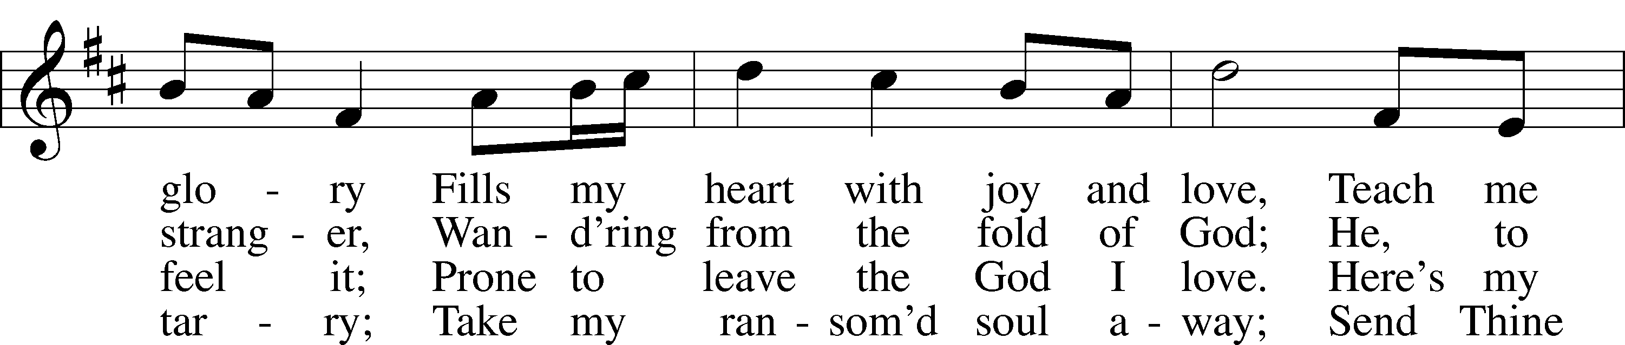
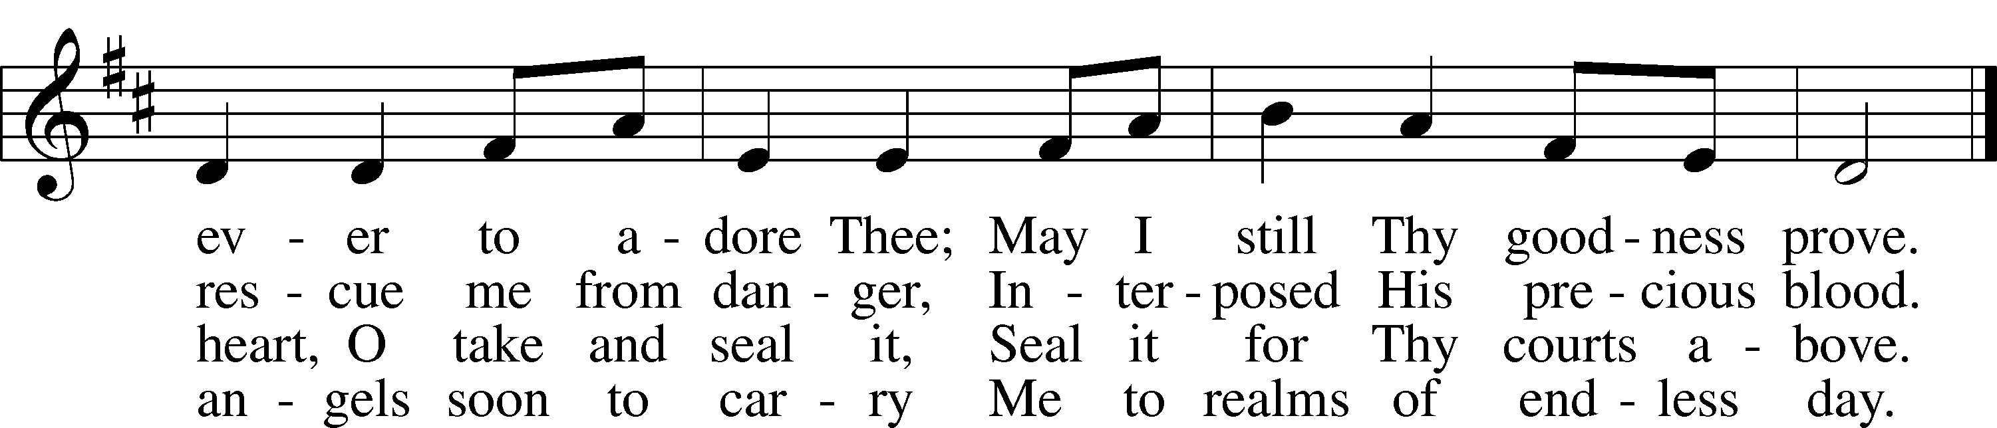
Text: Robert Robinson, 1735–90, alt.
Tune: Repository of Sacred Music, Part Second, 1813, Harrisburg
Text and tune: Public domain

COLLECT OF THE DAY
Almighty God, by Your great goodness mercifully look upon Your people that we may be governed and preserved evermore in body and soul; through Jesus Christ, Your Son, our Lord, who lives and reigns with You and the Holy Spirit, one God, now and forever.

(Sit)

READING Ezekiel 37:1–14
1The hand of the Lord was upon me, and he brought me out in the Spirit of the Lord and set me down in the middle of the valley; it was full of bones. 2And he led me around among them, and behold, there were very many on the surface of the valley, and behold, they were very dry. 3And he said to me, “Son of man, can these bones live?” And I answered, “O Lord God, you know.” 4Then he said to me, “Prophesy over these bones, and say to them, O dry bones, hear the word of the Lord. 5Thus says the Lord God to these bones: Behold, I will cause breath to enter you, and you shall live. 6And I will lay sinews upon you, and will cause flesh to come upon you, and cover you with skin, and put breath in you, and you shall live, and you shall know that I am the Lord.”
7So I prophesied as I was commanded. And as I prophesied, there was a sound, and behold, a rattling, and the bones came together, bone to its bone. 8And I looked, and behold, there were sinews on them, and flesh had come upon them, and skin had covered them. But there was no breath in them. 9Then he said to me, “Prophesy to the breath; prophesy, son of man, and say to the breath, Thus says the Lord God: Come from the four winds, O breath, and breathe on these slain, that they may live.” 10So I prophesied as he commanded me, and the breath came into them, and they lived and stood on their feet, an exceedingly great army.
11Then he said to me, “Son of man, these bones are the whole house of Israel. Behold, they say, ‘Our bones are dried up, and our hope is lost; we are clean cut off.’ 12Therefore prophesy, and say to them, Thus says the Lord God: Behold, I will open your graves and raise you from your graves, O my people. And I will bring you into the land of Israel. 13And you shall know that I am the Lord, when I open your graves, and raise you from your graves, O my people. 14And I will put my Spirit within you, and you shall live, and I will place you in your own land. Then you shall know that I am the Lord; I have spoken, and I will do it, declares the Lord.”

SERMON OR MEDITATION ON THE READINGS

(Stand)

APOSTLES’ CREED
C I believe in God, the Father Almighty,
maker of heaven and earth.

And in Jesus Christ, His only Son, our Lord,
who was conceived by the Holy Spirit,
born of the virgin Mary,
suffered under Pontius Pilate,
was crucified, died and was buried.
He descended into hell.
The third day He rose again from the dead.
He ascended into heaven
and sits at the right hand of God the Father Almighty.
From thence He will come to judge the living and the dead.

I believe in the Holy Spirit,
the holy Christian Church,
the communion of saints,
the forgiveness of sins,
the resurrection of the body,
and the life T everlasting. Amen.

LORD’S PRAYER
C Our Father who art in heaven,
hallowed be Thy name,
Thy kingdom come,
Thy will be done on earth
as it is in heaven;
give us this day our daily bread;
and forgive us our trespasses
as we forgive those
who trespass against us;
and lead us not into temptation,
but deliver us from evil.
For Thine is the kingdom
and the power and the glory
forever and ever. Amen.

BLESSING
L The grace of our Lord T Jesus Christ and the love of God and the communion of the Holy Spirit be with you all.
C Amen.

543 WHAT WONDROUS LOVE IS THIS
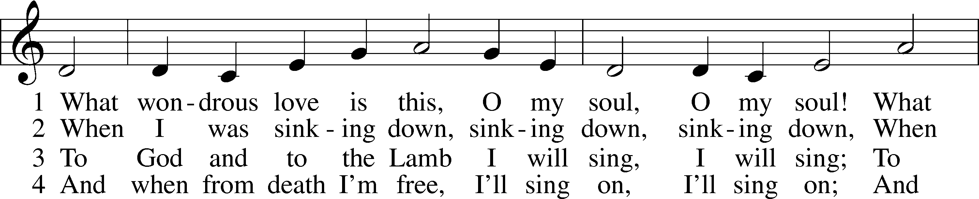
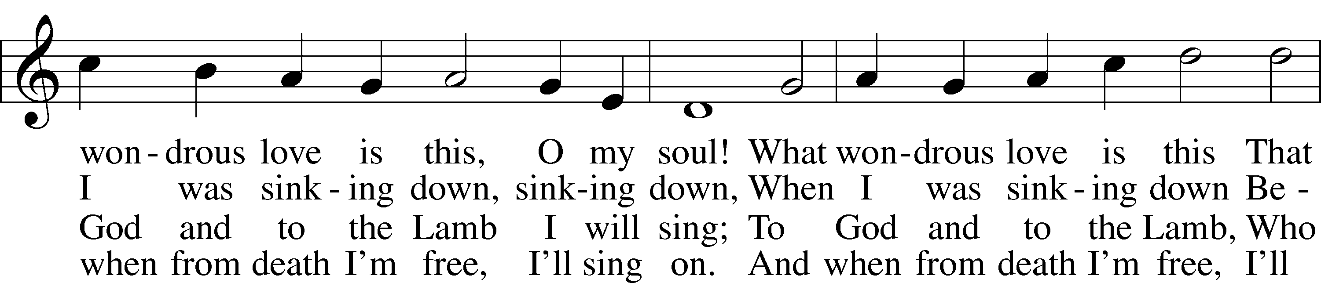
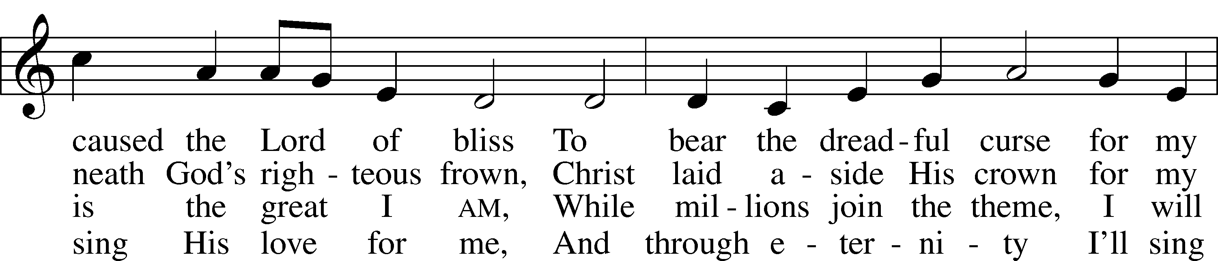
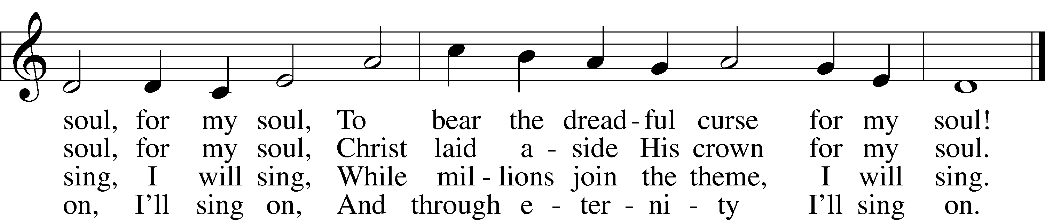
Text: A General Selection of . . . Hymns and Spiritual Songs, 1811, Lynchburg, alt.
Tune: Southern Harmony, 1835, New Haven
Text and tune: Public domain

ACKNOWLEDGMENTS
Unless otherwise indicated, Scripture quotations are from the ESV® Bible (The Holy Bible, English Standard Version®), copyright © 2001 by Crossway, a publishing ministry of Good News Publishers. Used by permission. All rights reserved.
Created by Lutheran Service Builder © 2026 Concordia Publishing House.

